Digital Forensics, Spring 2023
Christopher Phan
Dr. Renita Murimi
January 22, 2023
Recognizing the Use of Steganography in Forensic Evidence Lab 02
Section 2
- 
- The suspicious file is “dB9olser.gif”.
- 
- 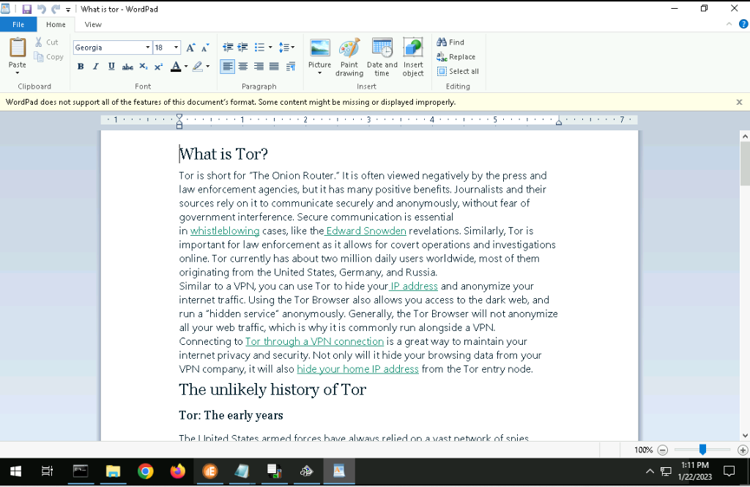
- 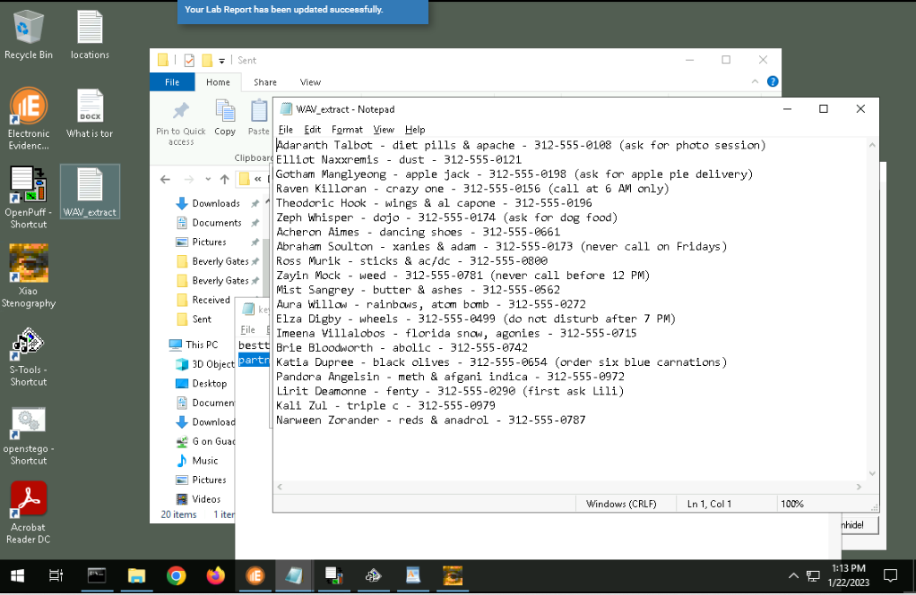
- Based on the two hidden files that were found, one shows a multitude of addresses while the other shows contact information and secret code words for what they supply. With this, it can be inferred that the locations are drop-off points for the supplies while the contact information is used to show who to contact for said supplies.
In the case of Commonwealth vs. Purdy, digital evidence was severely mishandled. Duncan Purdy was convicted of earning funds through prostitution and maintaining a house of prostitution under the guise of a massage parlor in 2011. During the investigation, Purdy’s laptop at the parlor was seized as evidence for the case. This laptop shows the main ties of Purdy’s involvement in this prostitution organization, being the one in control of the operation.
The digital evidence that was submitted consisted of emails that were sent from the prostitutes, such as recruitment emails to elicit their services, and clients who were willing to pay for said services. These emails showed how Purdy was tied to the prostitution ring and how he was conducting business. Though the error occurred where the investigators did not demonstrate any authentication that it was absolutely Purdy who was sending these emails or overseeing them. The judge of the trial had concluded that due to the lack of confirmation that was Purdy in charge of these emails, the evidence had to be dismissed since emails simply bearing the defendant’s name does not sufficiently mean that it was the defendant who sent the email. Even though the laptop was confirmed to be owned by the defendant, since there was no verification of the contents within the laptop, the defendant can deny ownership or knowledge of the emails, as such investigations did not prove that Purdy had authored said emails. The judge claimed that electronic messages or messages from social networking sites that simply had the defendant's name did not sufficiently support or authenticated communication from the defendant since messages and profiles could be so easily fabricated.
The investigation digital forensics team should have collected all the data from the messages, such as timestamps, signatures, source code, metadata, etc. They had the obligation to dig deeper than the defendant’s name on the message to submit for evidence. Due to their mishandling of the digital evidence, it had to be dismissed from the case.
References
Commonwealth v. Purdy, 459 mass. 442: Mass., Judgment, law, Casemine.com. Casemine. (2011, April 15). Retrieved January 25, 2023, from https://www.casemine.com/judgement/us/591460e9add7b0493423649b

