Digital Forensics, Spring 2023
Christopher Phan
Dr. Renita Murimi
March 4, 2023
Conducting Forensic Investigations on System Memory Lab 10
Section 2
- 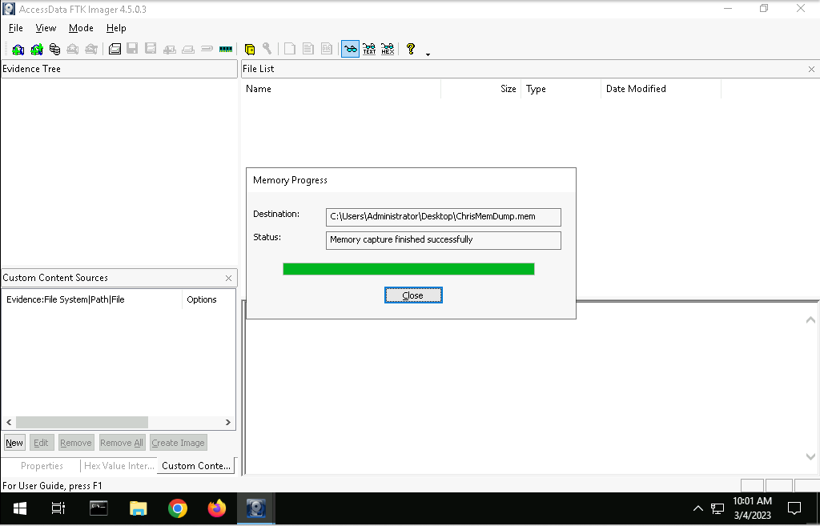
- Executable rvlkl.exe is a keylogger, used to record keyboard and mouse inputs and monitor applications.
- Based on the pslist and psscan volatility, there are no hidden processes flagged by Command.
- The netscan does not display if Hooker.exe or rvlkl.exe is using the network currently as they are not listed from the scan.
- Port 56610 is mainly associated with trojans and application use, a known security risk port with TCP/UDP.
- 