Digital Forensics, Spring 2023
Christopher Phan
Dr. Renita Murimi
January 28, 2023
Recovering Deleted and Damaged Files Lab 03
Section 2
- 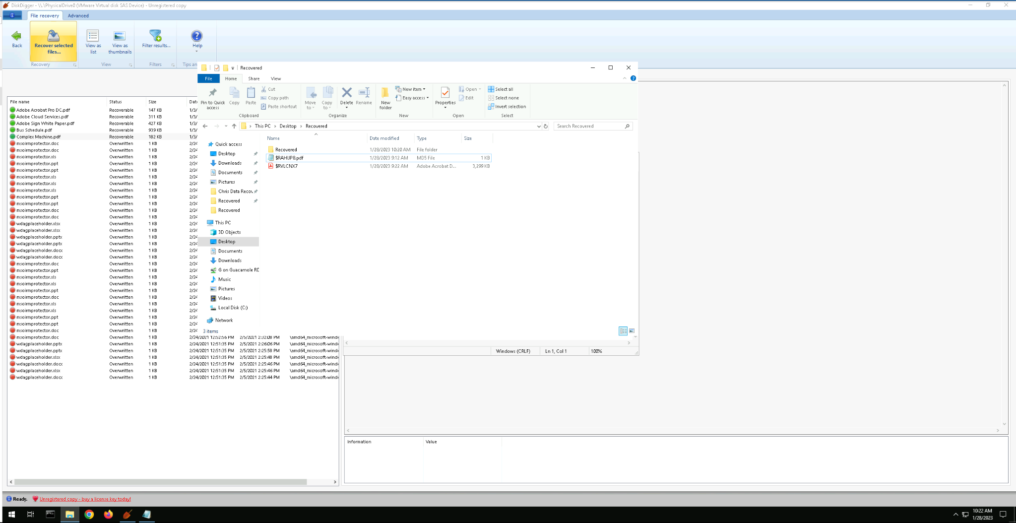
- 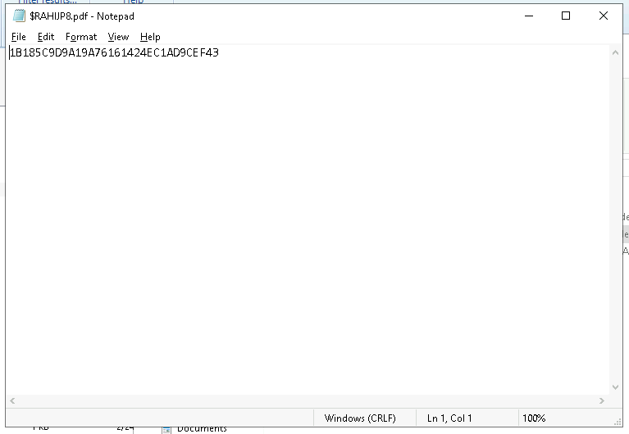
  - Note: I was following the directions as stated on lab reports, but DiskDigger was not showing the exact files I was emptying in the Recycle Bin for both files in Section 1. This was the only file that was successfully recovered, the original 2 pdf patent files would not show. I had done all the steps correctly and properly for Section 1 and Section 2, yet DiskDigger was not detecting the files that were emptied out from the Recycling Bin. I experimented with other files within the computer with the Recycling Bin, but it seemed DiskDigger was having issues with detecting the deleted files, as nothing from the Recycling Bin appeared.
- 
 