Digital Forensics, Spring 2023
Christopher Phan
Dr. Renita Murimi
January 29, 2023
Conducting an Incident Response Investigation Lab 04
Section 2
- 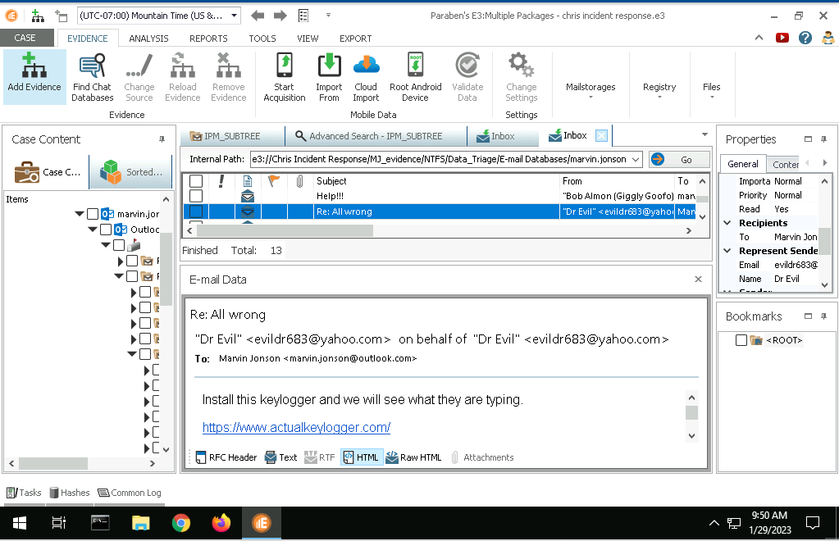
- 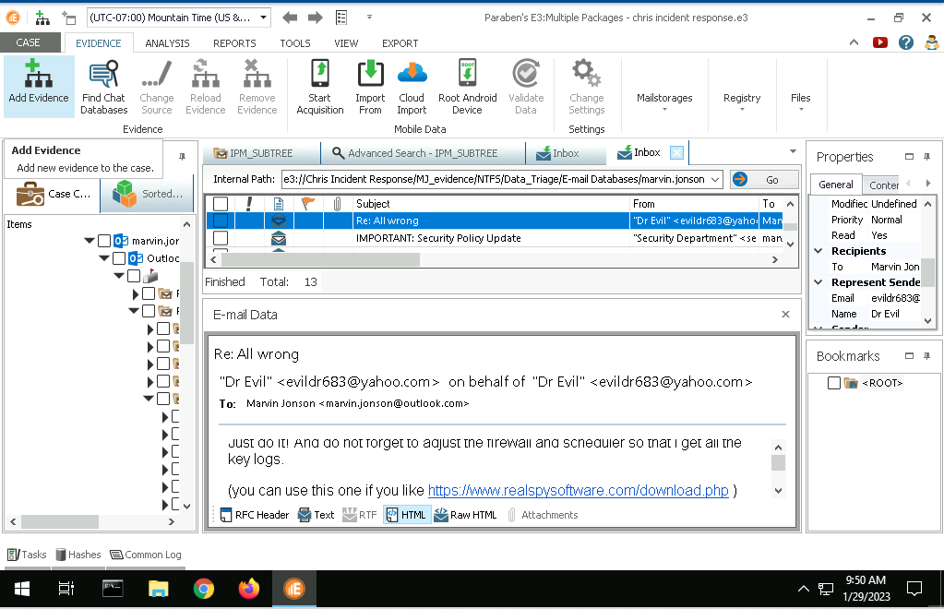
- Scheduled Tasks Advance Search
  - Date: 2021-06-30T14:16:23.27O5256
  - Author: DESKTOP-CGRK7LT\Marvin Johnson
- FirewallPolicy Advance Search
  - Port number = 666
  - Name of executable: akl.exe
  - Location: C=:\ProgramData\Security Monitor\{AKC34567-KCQR-WW34-AK47-INUM589023MY}\akl.exe
- 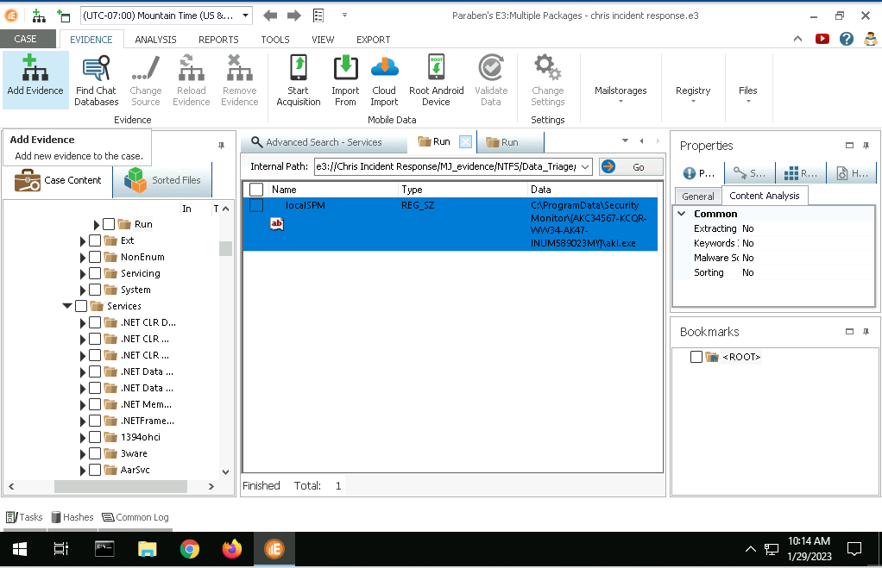
- First and last time keylogger
  - First: June 30, 2021, 9:36:42 PM
  - Last: June 30, 2021, 9:37:22 PM
- Activity type is 6, meaning that Marvin has interacted with the keylogger.

Incident Report
Date: January 9, 2023
Name: Christopher Phan
Incident Priority:
- High, status has been unchanged due to insider threat
Incident Type:
- Compromised System, Malware, Reconnaissance
Incident Timeline:
- The incident occurred on June 30, 2021 for less than a minute, from the start time of 9:36:42 PM and ending at 9:37:22 PM.
- The incident was discovered on July 31, 2021, at 10:30 AM.
Incident Scope:
- There have been no changes in incident scope, as it affects the entire company due to an installed keylogger and firewall policy changes. All users, systems, and third parties are involved.
Systems Affected by the Incident
- The attack source IP address is 157.165.0.25.
- The attack destination is Port 666, IP address destination is 172.31.0.20.
- The operating system affected is Windows 10.
Users Affected by the Incident
- Marvin Jonson, a Giggly Goofo employee.

