Digital Forensics, Spring 2023
Christopher Phan
Dr. Renita Murimi
February 12, 2023
Conducting Forensic Investigations on Email and Chat Logs Lab 07
Section 2
- 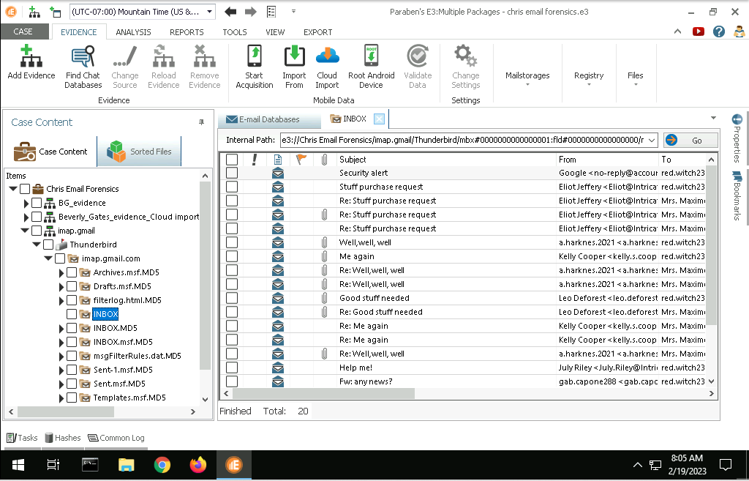
- Documentation
  - Sender’s email address: a.harknes.2021@protonmail.com
  - Mail server name: Protonmail
  - Mail server IP address: 185.70.40.132
- 
 