Instructions:
Given the network security applications and countermeasures in the first column of the table below, explore answers to the following questions:
- Where does the application or countermeasure belong in the seven domains of a typical IT infrastructure? An application or countermeasure may span two or more domains.
- What confidentiality, integrity, and availability (CIA) function(s) does the countermeasure provide?
Provide your answers in the table below.

Network Security Applications and Countermeasures | Domain(s) | CIA Function(s)
Intrusion detection system/intrusion prevention system (IDS/IPS)
Cryptography
Logon rights
Firewall
Proxy
Antivirus scanner
Virtual private network
MAC address filtering

As a reminder, the seven domains of a typical IT infrastructure include the following domains:

- User Domain: Actual users
- Workstation Domain: Workstations, laptops, and end-point devices, such as smartphones and printers
- LAN Domain: Physical and logical LAN technologies—100 Mbps/1000 Mbps switched Ethernet, 802.11-family of wireless LAN technologies—used to support workstation connectivity to the organization’s network infrastructure
- LAN-to-WAN Domain: Routers, firewalls, demilitarized zones (DMZs), and IDSs/IPSs
- WAN Domain: Routers, circuits, switches, firewalls, gateways, and equivalent gear at remote locations, sometimes under a managed service offering by the service provider
- Remote Access Domain: Virtual private networks (VPNs), laptops with VPN software, and secured VPN tunnels
- System/Application Domain: Hardware, operating system software, database software, client/server applications, and data typically housed in a data center or computer room

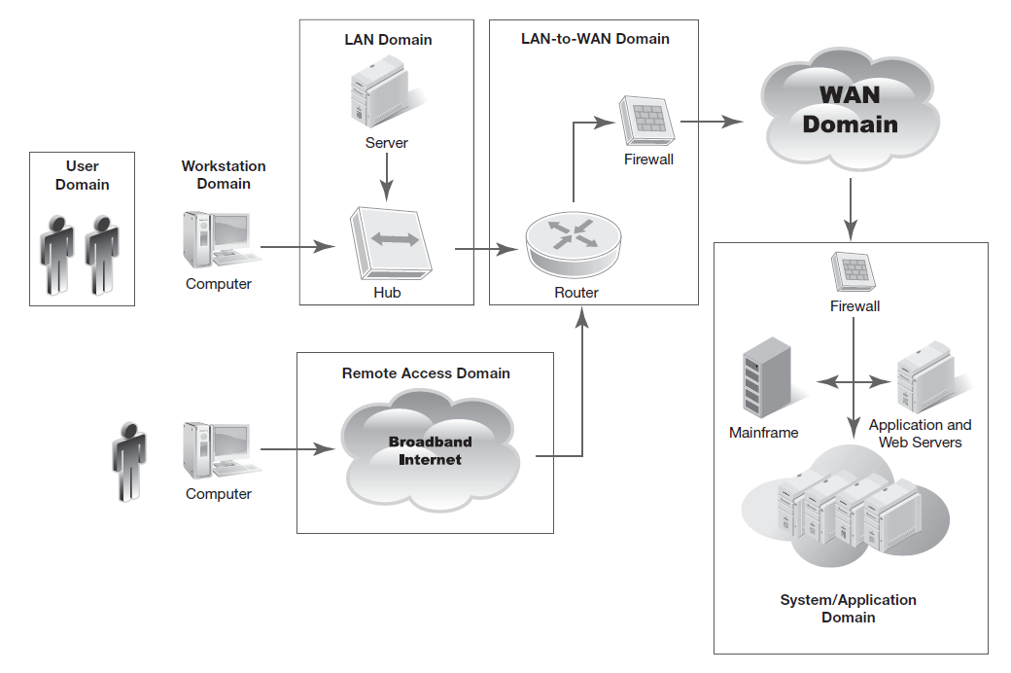
The Seven Domains of a Typical IT Infrastructure

