Remote Access Security Plan and Documentation

Christopher Phan
University of Dallas
CYBS 7357: Network Security
Dr. Malik Dulaney
July 27, 2022

This report will discuss the network security plan that will be implemented for the remote office of Corporation Tech’s four major groups, including: (1) a defense-in-depth approach for the digital assets of Corporation Tech from the VPN remote access, (2) a network topology that will be made for the remote access in connection to the main office, and (3) how to protect corporate digital assets from the new vulnerabilities that are introduced in using host-to-gateway VPN. Creating a security plan is necessary due to the new set of challenges that are presented in a remote office environment, which will necessitate preparation to create a secure network infrastructure.
A defense-in-depth approach entails layer-by-layer security levels that have the digital assets at the center. Having multiple security layers stacked onto each other is vital in deterring malicious actors and intruders from accessing sensitive and confidential information. The defense-in-depth approach includes 7 layers of defenses: (1) physical building defenses, (2) access to physical systems, (3) intrusion detection systems/intrusion prevention systems, (4) firewalls, (5) software firewalls, (6) anti-malware/antivirus, and lastly (7) encryption. These 7 layers are the main defenses against stealing the data that's at the center of it all. Due to the main office containing the VPN gateway that would allow for the remote access workers to connect to the LAN, it is imperative that even the physical security aspects be deployed. For the physical building defenses of the main office building, it is important that all faculty and staff have ID cards that they must use to enter the building, as each part of the building needs a security clearance. For the physical systems, there will be enforcement of multi-factor authentication, where employees have a username and password, a soft time variable token, and a fingerprint reader. This access to physical systems will also include remote workers, who will have to go through the same MFA. With the next generation firewall, Cisco Firepower 9300, that will be included in Corporation Tech’s network infrastructure, it can accomplish the goal of having an intrusion detection system in the network and also serve as the hardware firewall for layers 3 and 4. For the chosen software firewall that will be implemented on all host systems, it shall be pfSense, as it can be particularly adjusted to best support the network as well as be highly specific on the rules for each part of the network. The anti-malware/anti-virus software that will be required for all systems on the network is Kaspersky Endpoint Security for Business, which can detect and stop viruses before they do damage to the internal network. Another benefit of Kaspersky Endpoint Security for Business allows for enterprises to encrypt data for users. A CASB (cloud access security broker) will oversee security too, to help ensure all security policies are enforced, that none of the certificates/licenses are expired and that all security points are up-to-date. All 7 of these factors working together will create the highest security possible for the digital assets of Corporation Tech, circumventing any intrusion attempts that wish to do harm.
The network topology example made below will give a visual representation of how the VPN tunnel will work. The four departments that will be based out of remote work will connect to the main office through the internet. Corporation Tech will utilize the IPSec host-to-gateway VPN technology, so the remote workers are capable of accessing the main office from the internet, creating a direct line of communication and allowing for node-on-the-network services. Also with IPSec, it can be fine-tuned to have the address assignment, traffic classification, and routing necessary for the remote office to connect to the internal network.
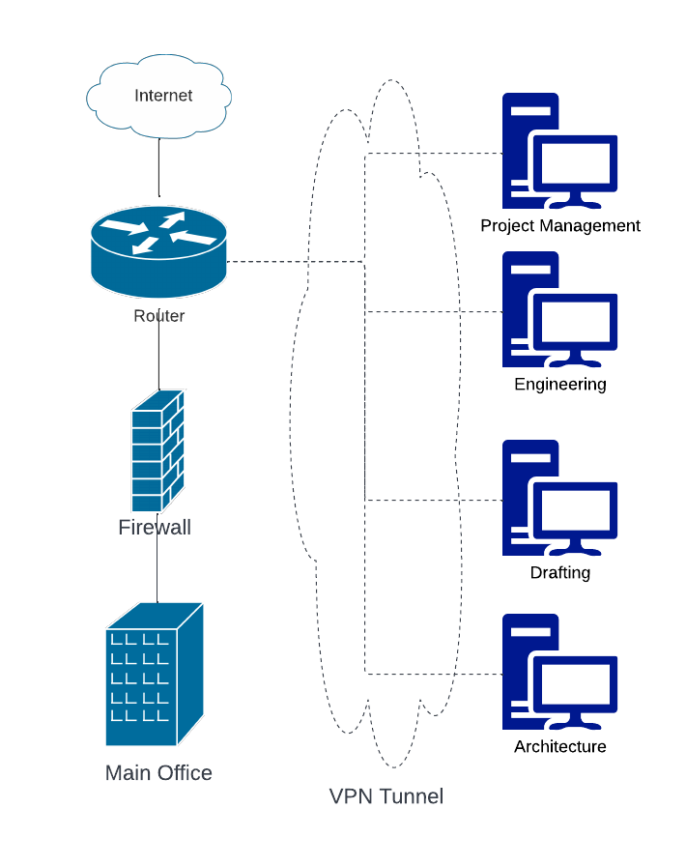
Due to Corporation Tech using IPSec as its host-to-gateway VPN services, there are a few vulnerabilities that can be introduced: weak passwords being used to sign into the VPN, man-in-the-middle attacks, and buffer overflow. All three of these are easy to avoid, based on the implementation of the VPN and if it has been configured correctly for the benefit of the internal network. For the weak password vulnerability, implement a password policy that all workers, remote or not, to follow, having rules using NIST’s framework: passwords should be more than 8 characters long but less than 64 characters, screened against dictionary or context passwords, and passwords do not expire. Both man-in-the-middle attacks and buffer overflows can be fixed through the same solution in making sure that VPN has the most up-to-date patch applied to it, and that Corporation Tech is monitoring its internal network as much as possible. Both those issues are a result of poor implementation, and the vendor is the best point of contact to get those fixed to create a secure work environment. The CASB system can also help ensure that the necessary systems are patched and that security is as fortified as it can be.
Work Cited
Cisco Firepower 9300 series. Cisco. (n.d.). Retrieved July 9, 2022, from https://www.cisco.com/site/us/en/products/security/firewalls/firepower-9300-series/index.html
Kaspersky Endpoint Security for business. Kaspersky. (n.d.). Retrieved August 1, 2022, from https://usa.kaspersky.com/enterprise-security/endpoint
Looking ahead: A brief guide to VPN security & vulnerabilities. SecureLayer7. (2020, May 28). Retrieved July 29, 2022, from https://blog.securelayer7.net/guide-to-vpn-security-vulnerabilities/
NIST. (2020, March 2). NIST Special Publication 800-63B. NIST. Retrieved July 29, 2022, from https://pages.nist.gov/800-63-3/sp800-63b.html
pfSense. pfSense® - World's Most Trusted Open Source Firewall. (n.d.). Retrieved July 9, 2022, from https://www.pfsense.org/
Stewart, J. M., & Kinsey, D. (2021). Network Security, Firewalls, and VPNs (Third Edition, Ser. Information System Security & Assurance). Jones et Bartlett Learning.

