Christopher Phan
Network Security
Dr. Malik Dulaney
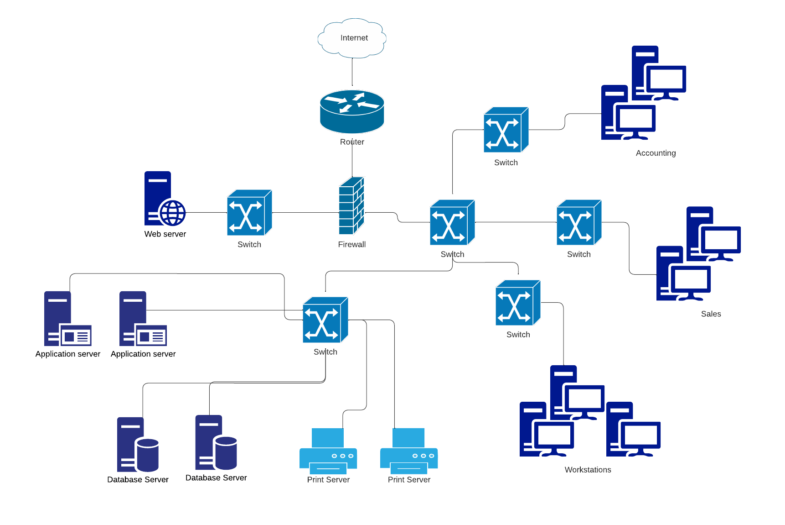
June 7, 2022
Report Network Design
Above is the network topology diagram that is described by the parameters set by Corporation Tech, creating the network with the required components: 1 web server that is accessible to the public, 2 application servers, 2 database servers, 2 file and print servers, and 50 workstations. As well as the other objectives where there is a single border firewall, no gateway due to no connection to other separate networks, and the accounting and sales departments being separated from each other.
There are multiple reasons why the network is configured as seen, to ensure security and efficiency for the work environment. The router is what connects the network to the internet, giving direct access to both the public and employees to reach the network. Employees will have to access this network through remote access, as Corporation Tech is being prepared to work from home for the next 6 months, so the network has to be accessible to employees as well through the internet and not just the public. To create a more secure network, there is an immediate firewall that all traffic has to come through, where this firewall is capable of filtering legitimate and malicious traffic, feeding either clients or employees through a series of switches. This firewall will help direct this traffic into the correct corresponding switches shown on the diagram, allowing the network to be accessed to the public for legitimate clients and for employees who are signing into work. As detailed by Corporation Tech, the entire network is connected through a series of switches, which can be seen especially through the employees side of the network. Each department is separated through a series of switches, meaning that they cannot be interfered by each other nor altered by another department, so there is no overlap or employees that have too many privileges within the network. Also, all three types of the server (application servers, database servers, and file and print servers) are also connected through another series of switches, which means that these servers are also separated from the other departments as well. Due to three different server systems being used within the network, these three server systems are also separated into their own sections. Since Linux/Apache being used for the web server, Microsoft Windows Server for the application, database, file and print servers, and the workstations running on Microsoft Windows, they are run in their own sections. Lastly, this network achieves security of internal access and retaining public website availability, as clients can connect to the web server easily through the internet, but the web server is disconnected from the employee side of the network due to the switch only leading to the web server. Meaning that the client can only access the web server, without interfering with the security of the business as well as the firewall stopping any malicious traffic coming into the network.
How this network can ensure redundant and constant communication that is available 24/7 is through 5 key points: (1) router configuration, (2) encrypted protocol, (3) physical access management, (4) filtering, and (5) emphasizing redundancy. For the router configuration, it is important due to it being the main point of access for the network, as such allowing the correct type of traffic and stopping malicious actors is significant. First to physically isolate the router, only allowing administrators direct access to the network, ensuring secure and trustworthy routes to the network. Router anti-spoofing techniques need to be installed, like source-address validation. Also, creating router access control lists, limiting network access and traffic, and increasing network performance, thus creating more efficient communication. Encrypted protocols are vital as it can stop content eavesdropping, ensuring integrity and accurate information being communicated to others within the network. Physical access management is simple, as prevention of physical access to communication cables and wireless signals can also develop integrity and accurate information. Filtering the movement of data among departments, subnets, WAN-connected LANs, and the Internet is important as authentic communication is what online businesses depend on. Lastly, redundancy is the most important point for communication, as ensuring if one point of contact is to fail, there are multiple avenues reaching this point of contact. Having sufficient backups that can ease the problems of drive failure during peak productivity, along with uninterruptible power supplies preventing any loss of data. Redundant firewall, proxies, routers, switches, servers, and databases guarantee security and that one failure will not take down the entire network. With all these key points establishes communication that is accessible 24/7.
For the final point, it is recommended that Corporation Tech integrates IPv6, replacing IPv4. The reason why is that IPv6 has multiple benefits for any network as it allows: increased IP address space, has enhanced routing capabilities for more efficient routing functionality, reduced management requirement as IPv6 requires less supervision than IPv4 due to IPv4 having numerous changes since its inception, greater quality of service in IPv6 since it can support a myriad of applications, IPv6 is much easier to install and integrate into the network due to no need of dynamic host configuration protocol, and security is automatically accompanied with IPv6. To further inform about the security that comes with IPv6, it has a internet protocol suite that calls IPSec, which helps monitor both data and control packets that come into the network, fortifying confidentiality, data origin authentication, and data integrity within the network, which could not have been possible through IPv4.
Work Cited
Stewart, J. M., & Kinsey, D. (2021). Network Security, Firewalls, and VPNs (Third Edition, Ser. Information System Security & Assurance). Jones et Bartlett Learning.

