Final Network Design

Christopher Phan
University of Dallas
CYBS 7357: Network Security
Dr. Malik Dulaney
July 20, 2022

Table of Contents
Executive Summary 3
Network Topology 5
Firewall Selection 7
Remote Access and VPN 10
Conclusion 12
References 13

Executive Summary
Before explaining what the final network design is, it is important to demonstrate why Corporation Tech needs it. This final network design will revolve around the network topology plan, which is an overview of the computer network of the company. Having a network topology plan is one of the most crucial actions a company can take to secure its internal network. There are two reasons why having a network topology plan is crucial: (1) it illustrates the different elements that are operating in the network and where they connect, and (2) it shows how those different elements interact with each other and develop expectations on how they will perform (Netreo, 2021). Without these two factors, Corporation Tech would not be able to perform at the highest level of efficiency possible as there would be no control that Corporation Tech could use as a measure. This network plan is what determines how smooth communication and operations will go in the network, productive utilization of network resources, lowers network costs due to emphasizing efficiency, and creates a concise roadmap for diagnostics.
This report will detail all the necessary revisions to create the final network design for Corporation Tech and enhance their security. The plans made for this design are based on the past report findings and how each one had solved their network dispute. These recommendations will include documenting the new network topology implemented for Corporation Tech, the firewall selections for both software and hardware, and how remote access VPNs will operate within the internal network. All these factors are vital for the internal network and the success of the network design. It is significant that Corporation Tech implements these designs to create a secure and efficient work environment in the network.

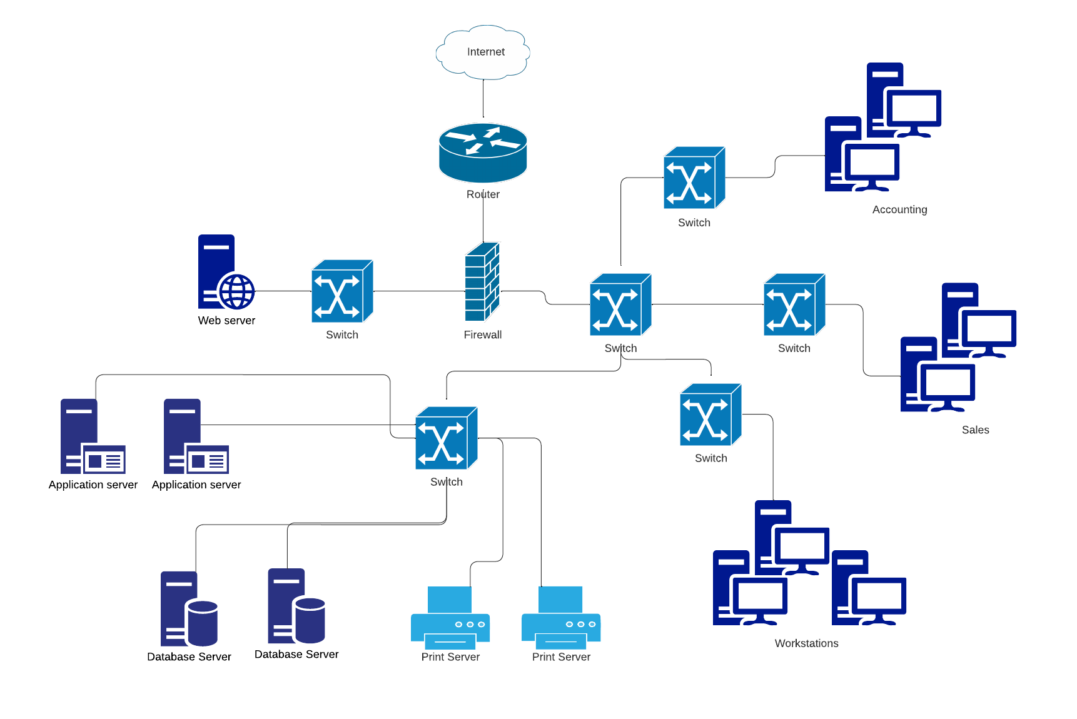
Network Topology
This network topology is based on all the requirements that Corporation Tech needed for the network based on the first architect necessities: 50 workstations, 2 application servers, 2 database servers, 2 file and print servers, and a web server that is accessible to the public. Also, the requirement that sales and accounting departments are separated from the other workstations and logically placed in the topology. The firewall requirement for Corporation Tech will be discussed later in this report, though there is a border firewall that will act as the first line of defense for the internal network. The figure illustrates the final network topology, and there are multiple reasons why this is the selected design for Corporation Tech.
The reason for the separation of all servers and workstations is due to the different operation systems, like the web server running Linux/Apache, the database, application, and file and print servers running Microsoft Windows Server, and the workstations based on Microsoft Windows. Also the web server is completely segmented from the internal network so that malicious actors are cut off from the internal network, while not hindering public accessibility. This network configuration also supports redundant and constant communication due to: router configuration, encrypted protocol, physical access management, and filtering. The router is the main point of contact for both the public and private sectors. Configuring it properly will protect from malicious attacks that are trying to slow down communication and will improve efficiency between the internal and external network as it can rule who can access what systems. Encryption is vital for communication as it can hide the content for eavesdropping, ensuring integrity and accurate information is being transmitted. Physical access management prevents from physical tampering of communication beyond the technical environment. Filters will screen the movement of information within the internal network, and will determine what is legitimate traffic and what is malicious. Redundancy in these processes is significant due to ensuring that if one point of integrity fails, there are other mechanisms that will uphold it. Meaning that sufficient backups can avoid single point failure, sustaining the business and avoiding unnecessary downtime.
Lastly, Corporation Tech will need IPv6, due to the increased IP address, routing capabilities increasing routing functionality, reduced management requirement, quality of service, and the IPSec capability, which will discussed further in this report for remote access.

Firewall Selection
This section will include three network components: firewall selections, the DMZ for the network, and network authentication. These three factors will be part of the final network design as a complement to the last section about the network topology.
The firewalls that will be selected will consist of a hybrid solution, where it will include vendor solutions that are hardware firewalls and software firewalls. The hardware firewall will be first line of defense for the network, filtering and analyzing all traffic that comes into contact within the network, while the software firewall will filter traffic on the host’s system. This means that the hardware firewall will filter traffic before it comes into contact with the network, while the software firewall will filter traffic once it is in the network.
The selected hardware firewall solution will be the Cisco Firepower 9300, a next-gen firewall, being the border for all incoming and outgoing traffic from the router, and directing traffic into the DMZ or the internal network. A next-gen firewall is an improvement beyond a traditional firewall in which it includes additional features, like: integrated intrusion prevention system, high control and visibility of applications, and easy implementation into the system. This next-gen firewall will add a great layer of security along with the many layers of security which will be discussed in the remote access defense-in-depth approach. The software firewall solution wil be pfSense, which is a extremely customizable firewall that is implemented on all stations, making it at a host-level security system. Also with pfSense, it can easily support VPN services which will also be discussed in the remote access section. A important benefit of pfSense is that it has fault tolerance meaning that if one point of the software firewall fails, the entire system can still run. With both Cisco Firepower 9300 and pfSense working together, they can ensure that all traffic is legitimate, fulfilling the need of both a server and workstation firewall, covering all vulnerabilities of either a software or hardware firewall.
A DMZ, or a demilitarized zone, plays the role as the boundary network that is solely for the public, where untrusted systems can be housed and monitored without harm to the internal system and easily accessible. This DMZ is vital for the securing the network and segmenting the internal network, creating a closed subnet for the public and preventing bad actors from entering. What the network topology shows is a three-homed firewall formation, where the private LAN is segmented from the DMZ. The next-gen border firewall will feed the public traffic into the DMZ while monitoring them for any illegitimate activities. The hybrid firewalls can maintain and deploy the DMZ, though Cisco Firepower 9300 will be the main manager as it will be the first one to contact all incoming and outgoing traffic of the DMZ. This DMZ is vital for business as it the contact for clients and how they will interact with Corporation Tech, though this DMZ is what protects digital assets from being compromised.
Lastly is how individuals will authenticate themselves into the internal network, this is one of the most important steps for network security. What will be needed to create the highest level of authentication is multi-factor authentication. What multi-factor authentication requires three parts: something you know, something you have, and something you are. The “something you know” factor will be fulfilled through providing username and password. The “something you have” factor will be fulfilled through users be required to have a software time-variable token, requiring users to download an app that will give a a changing PIN code for every sign-in. For the “something you are” factor, users will need to provide a fingerprint scan lastly. With all these factors working together, it can create a highly secure internal network that can be close to impossible to access from malicious actors without extreme extensive effort.

Remote Access and VPN
For the last factor that will be necessary for the final network design of Corporation Tech is establishing how remote access will work and how it will be implemented through VPN technology. The reason why this is necessary is due to many of the employees at Corporation Tech working remotely, meaning that they need a way to securely access the internal network through the internet. This will be done through IPSec (Internet Protocol Security) VPN technology, which can proficiently be the medium for remote access to the network while also promoting security.
IPSec is one of the best VPN technologies for the network for reasons such as: functions best as the VPN for remote users in connecting to the a private network compared to other VPNs, supports authentication protocols, ease of implementation, and can protect against malicious actors against the network. IPSec specific purpose is to connect remote host or networks to private protected networks. Supporting all OS platforms, which is perfect due to all the different OS systems that are working together in Corporation Tech’s network. IPSec operates on the 3rd layer of the OSI model, which means it operates on the network layer. IPSec secures IP communications and IP-based applications, shown to be highly secure with a small attack window and risk exposure. For IPSec to be implemented, the client simply needs to download the VPN client software, and with the software being downloaded, Corporation Tech can personally ensure that the remote host is aligned with security policies, making sure that the remote host is as strong as the base network. IPSec has built-in authentication functions, through its internet Key Exchange (IKE). IKE can authenticate users through two methods: digital certificates or preshared keys. Also beyond just authenticating users, IPSec can authenticate data origins, verifying that the sender is truly the one sending packets rather than a spoof, and that the receiver can safely receive that data. This process can be recognized as IPSec’s Authentication Header, which is one its integrated integrity mechanisms. Also, IPSec can detect and reject packets that have been tampered with, can stop replay attacks through anti-replay protocols, and can be a factor against denial-of-service attacks.
Lastly, the culmination of all these protocols create a thoroughly secure internal network and protecting all necessary digital assets. This can be recognized through the defense-in-depth approach, which consists of 7 layers of security: physical building defenses, access to physical systems, intrusion detection systems, firewalls, software firewalls, anti-malware/antivirus, and encryption. If all 7 of these layers are implemented, all Corporation Techs’ digital assets would be as protected as it can be. The main office can implemented the physical building defenses such as locked doors, security guards, assets that would impede bad actors from entering the building. Access to physical systems is solved through the multi-factor authentication that was mentioned earlier, such as the username and password, soft time-variable tokens, and fingerprint scanners. The intrusion detection system and the firewall is solved through the Cisco Firepower 9300. The software firewall is fulfilled through pfSense. The anti-malware software and encryption can be solved through Kaspersky Endpoint Security for Business which will allow encryption for any data that Corporation tech wants and protecting it from viruses and malware that attack the business.

Conclusion
With this report and the recommendations made, Corporation Tech will have a highly efficient and redundant network that can operate in the best interest for the business. The network topology, firewall selection, and remote access VPN are all technologies that are vital for Corporation Tech need to implement to have a secure network that protects their digital assets, creates redundant communications, and allows public and private entities to interact with the network.
Corporation Tech needs to reflect their network topology to the design created, segment the DMZ from the internal network for the public, integrate IPv6 into the network, purchase the necessary firewall vendor solutions, create authentication procedures for all employees, and involve IPSec VPN remote access technology. All these factors are important for the network security and the management of sensitive information.

References
Cisco Firepower 9300 series. Cisco. (n.d.). Retrieved August 6, 2022, from https://www.cisco.com/site/us/en/products/security/firewalls/firepower-9300-series/index.html
Kaspersky Endpoint Security for business. Kaspersky. (n.d.). Retrieved August 6, 2022, from https://usa.kaspersky.com/enterprise-security/endpoint
Network topology: Why is it important for your business. Netreo. (2021, February 5). Retrieved August 6, 2022, from https://www.netreo.com/blog/why-is-network-topology-important-for-your-business/#:~:text=Simply%20put%2C%20network%20topology%20helps,can%20expect%20from%20their%20performance.
pfSense. pfSense® - World's Most Trusted Open Source Firewall. (n.d.). Retrieved August 6, 2022, from https://www.pfsense.org/
Stewart, J. M., & Kinsey, D. (2021). Network Security, Firewalls, and VPNs (Third Edition, Ser. Information System Security & Assurance). Jones et Bartlett Learning.

