Christopher Phan
Operational Cybersecurity Management
Dr. Brendan Williams
July 7, 2022
Cloud Access Microsoft Azure Lab Report
This is my first time experiencing and administering Microsoft Azure (albeit it being simply a simulation of doing so). I have noticed that Microsoft Azure is quite simple and easy to administrate, and has quite the straight-forward system, such as creation of groups and users, which streamlines the process as a cloud-as-a-service. Each step was quite simple to follow: (1) creating three groups, one being a dynamic group, (2) creating 5 user personas, assigning their corresponding administrative roles, (3) creating a password policy, and lastly (4) signing in as one of the created user personas to see if the permissions I set up was official. Let’s explain the process for each requirement that was made for this simulation.
For the first step was the creation of the three groups: Finance, Marketing, and Security Ops. Only one of these, the Security Ops group, will be dynamic, meaning that members will not be directly added to it, but filtered to Security Ops. When creating each group, it is important to add license assignments, as without having any license assignment for the group will affect the users in the next step. To be a dynamic group, there must be a dynamic rule expression, which dictates a type of filtering that dictates the groups and the users within it. As shown with the screenshot below, the dynamic rule expression shows that only users who are in the department IT or Audit can be in the group. This dynamic rule then filters all users within the system and automatically populates Security Ops with those users who fill in the criteria.
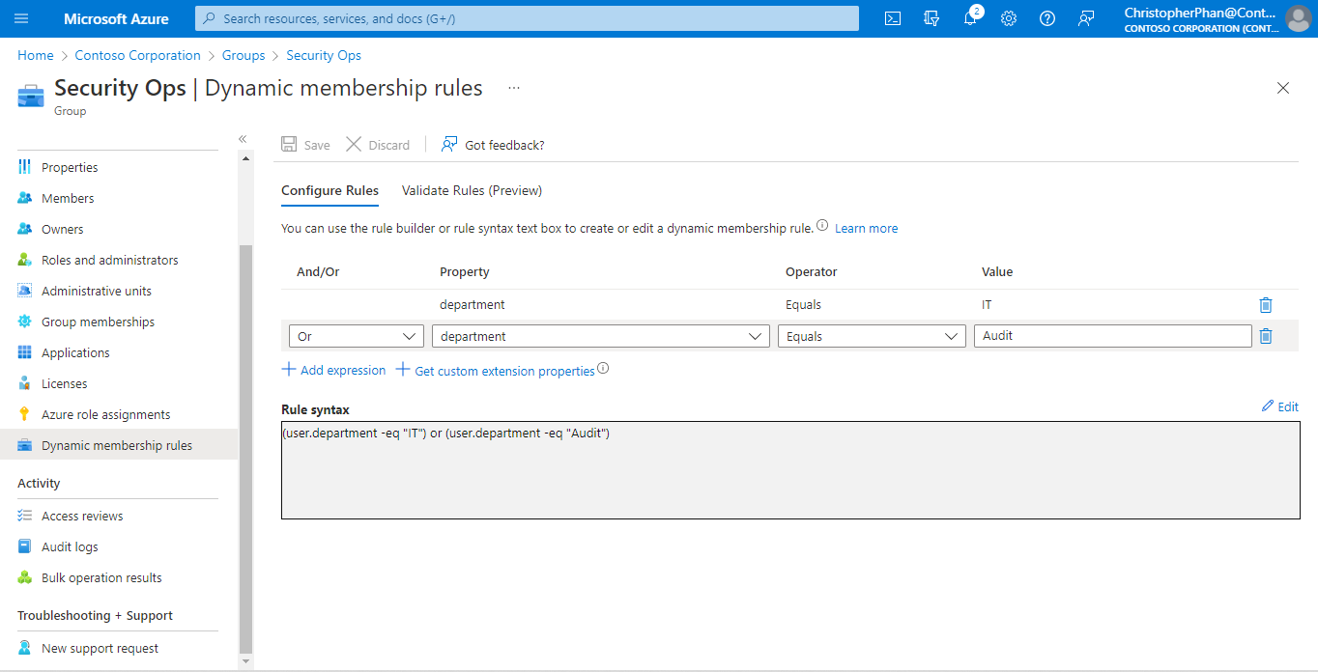
The next step is creating users, who in-turn will populate the groups that were just created. Creating users is an easy process and everything can be reversed and changed even after creation. This is the point where users can be assigned groups, roles, assignments, departments, and more, defining the users’ position in the organization within Azure. This information is what will be filtered by the dynamic rule expression mentioned earlier. Assigning roles for a user is significant as it gives permission to what a user can do within the system, and without any role assigned, will be able to do absolutely nothing in the organization. This step can only be achieved if a group is given license assignment, as it allows for assigned roles to be given for each user in their particular group.
The next step is creation of password policy. This step is done through Microsoft admin center, done through the security and privacy settings. This is one of the easier tasks, as once this password policy is created, it is automatically set for all users that were created in Microsoft Azure. Though, as stated by NIST and Microsoft themself, it is highly recommended to not enforce password expirations as it decreases overall security. In the lab requirements, there was to be a notification requirement for the users about their password expiring, but within the admin center, there was no option for that.
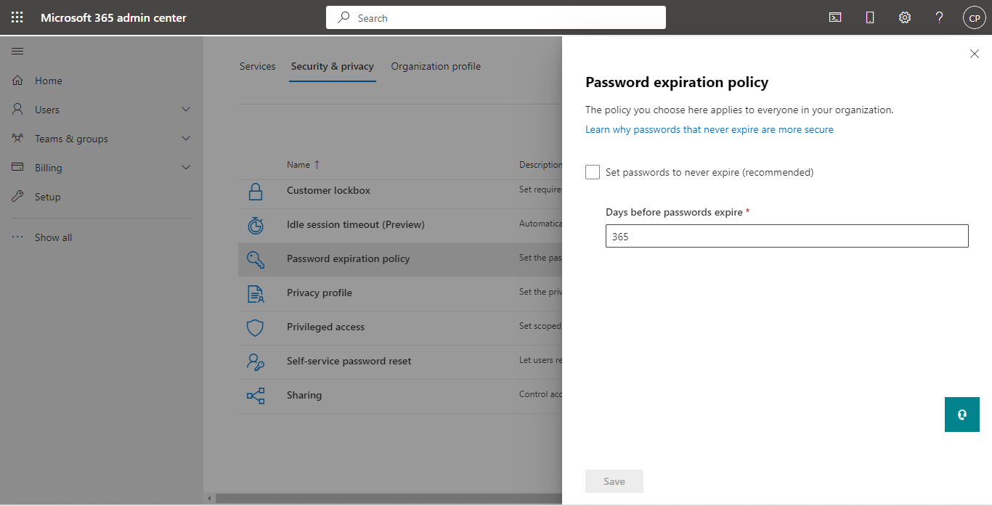
Lastly, where I signed in as one of the users I created, Fatimah Sule. I created a simple password for all the users that I could remember for each one. Signing into Sule’s account, I could find all the information and roles I created for them easily, and it was quite interesting from shift of administrator to user, and seeing all the differences in what one could do in different position within Microsoft Azure.
