Christopher Phan
Penetration Testing and Vulnerability
Dr. Renita Murimi
October 23, 2022
Section 2 Lab 10 Screenshots
- 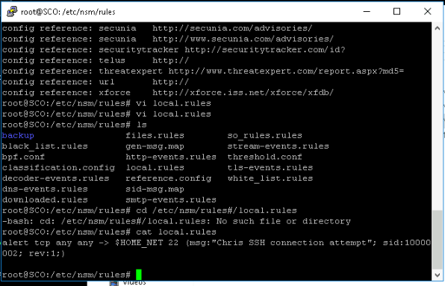
- 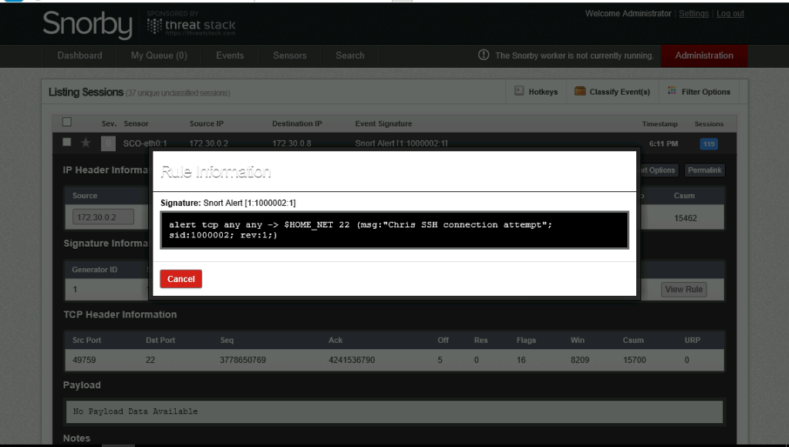
- 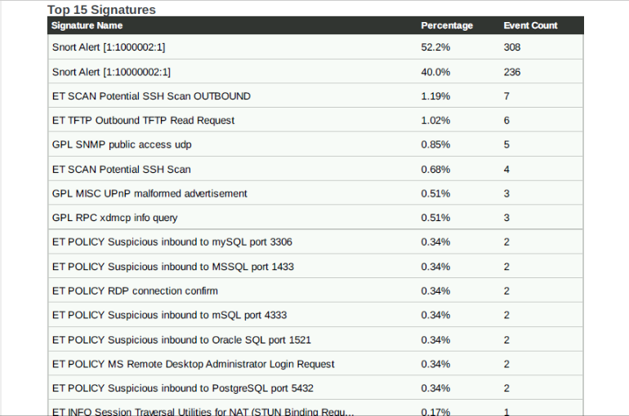
- Describe and research three signature alerts
  - ET SCAN Potential SSH Scan OUTBOUND describes how the vmachine may be connecting to an outside network without any protection. Usually a unknown IP address is connecting to the network and trying to breach the system through SSH.
  - GPL SNMP public access udp is a signature alert where an endpoint is connecting to the network through the SNMP port.
  - GPL MISC UPnP malformed advertisement describes buffer overflow attacp that happens through Windows products, where malicious actors execute code connected to a location URL.

