Christopher Phan
Penetration Testing and Vulnerability
Dr. Renita Murimi
October 17, 2022
Section 2 Lab 9 Screenshots
- 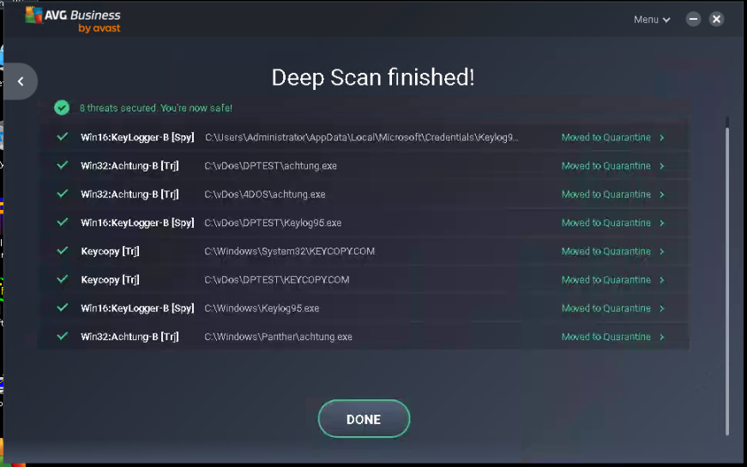
- 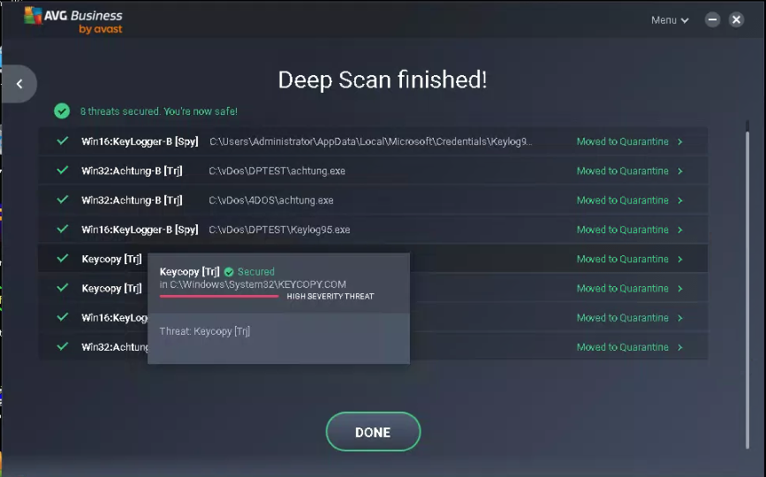
- How to remove the KEYCOPY.COM threat:
  - Scan the computer for viruses through a manual deep scan with AVG antivirus.
  - Quarantine malicious files, and delete them, including KEYCOPY.COM file.
- 