Christopher Phan
Penetration Testing and Vulnerability
Dr. Renita Murimi
August 24, 2022
Section 2 Lab 1 Screenshots
- 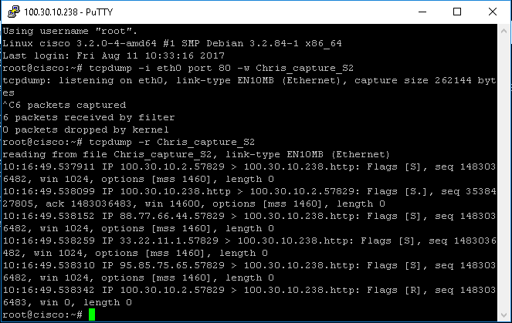
- 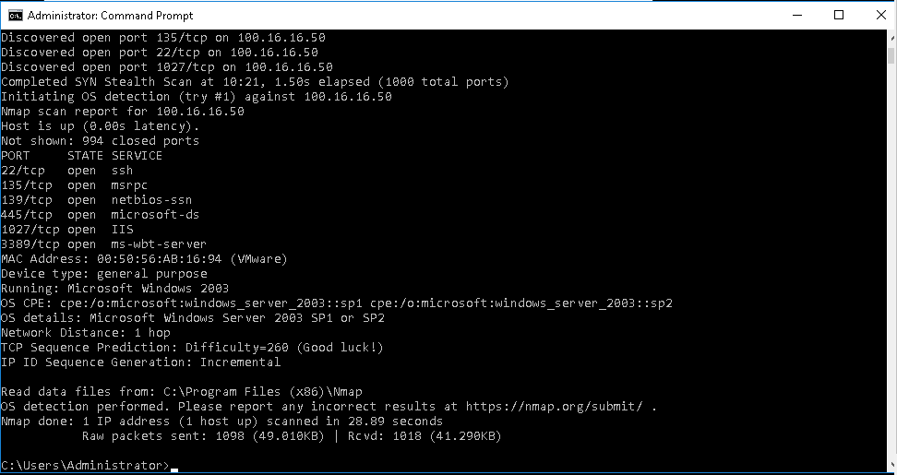
- 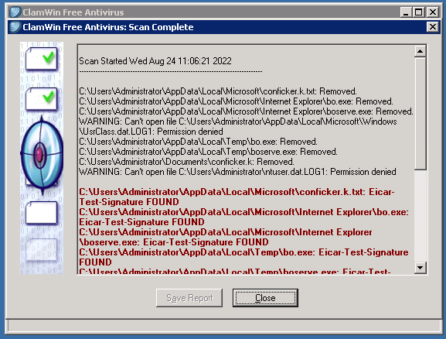
- 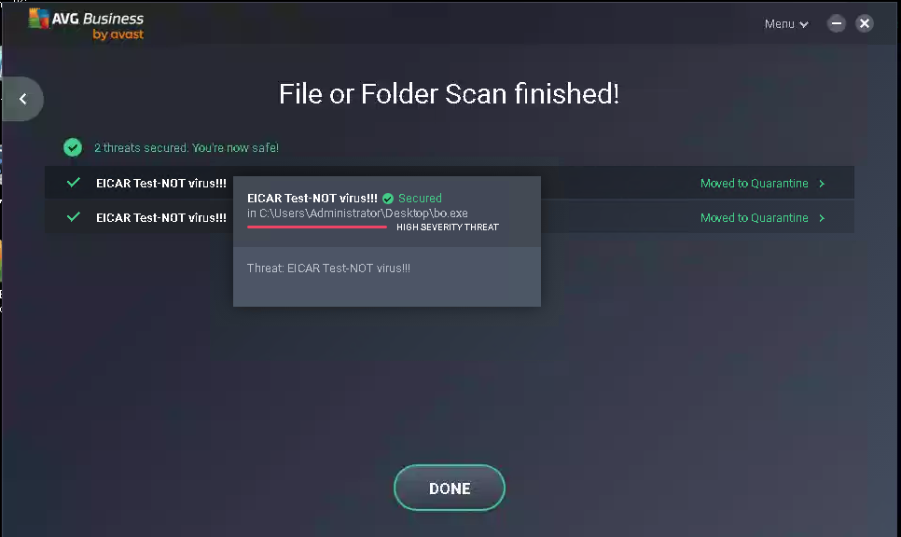
  - 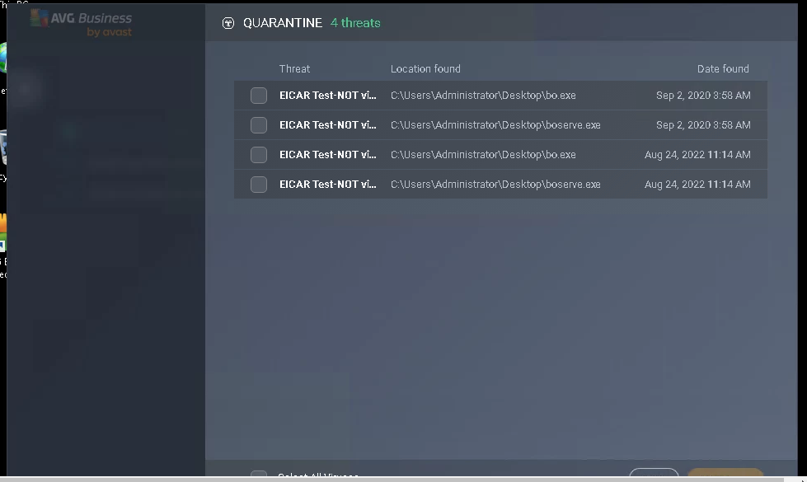
    - Here are the details shown viruses that were captured from the AVG antivirus scan.
- 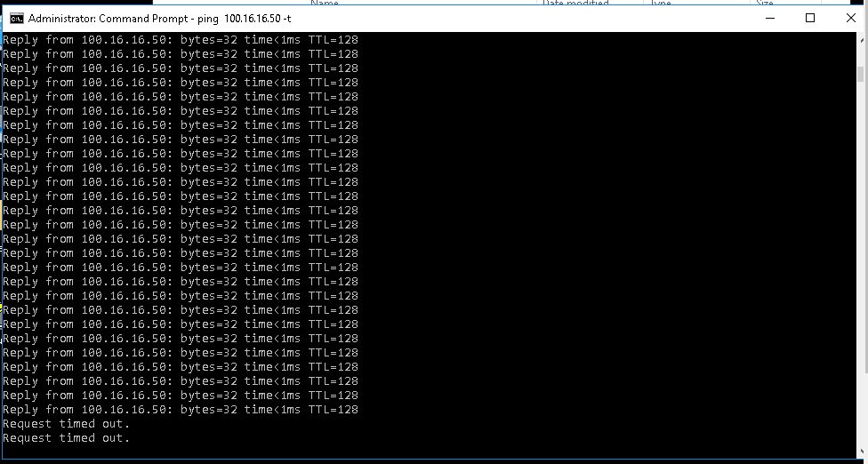
- 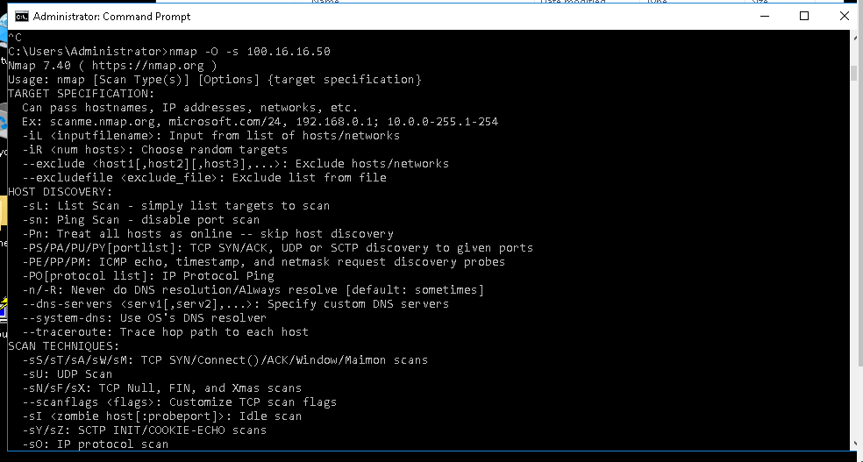
  - 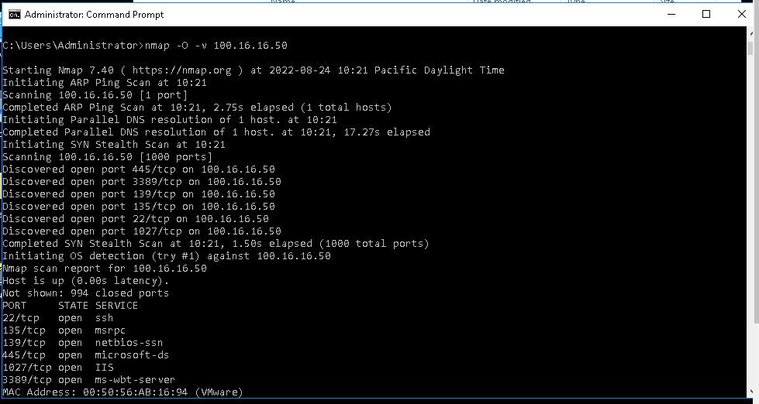
    - The original screenshot above shows that with TargetVulnerable01, the changes made show that the attack surface was immediately minimized and that now an outside system could not scan TargetVulnerable 01.
- 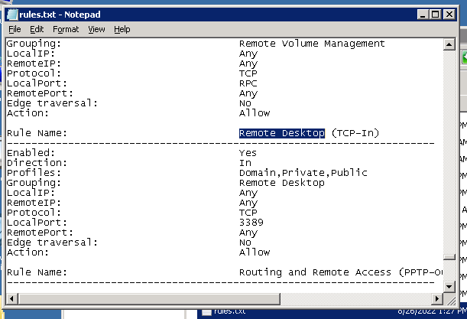
- 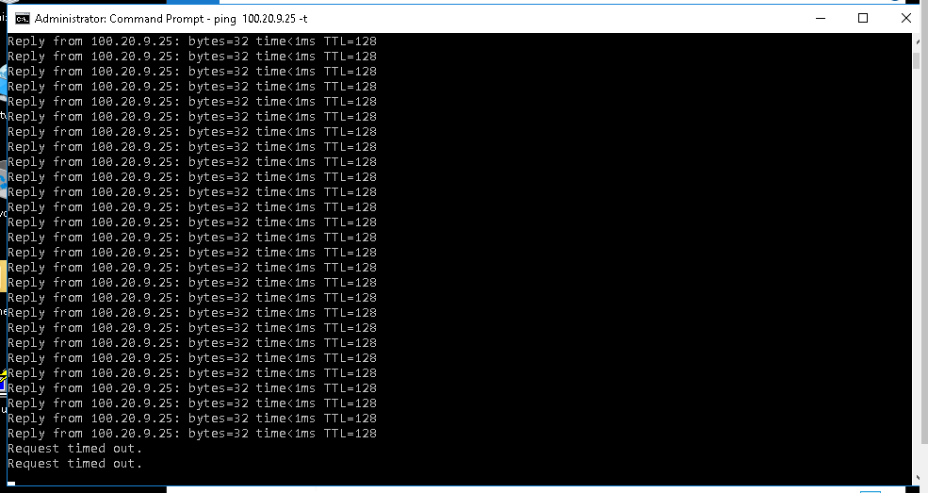
- 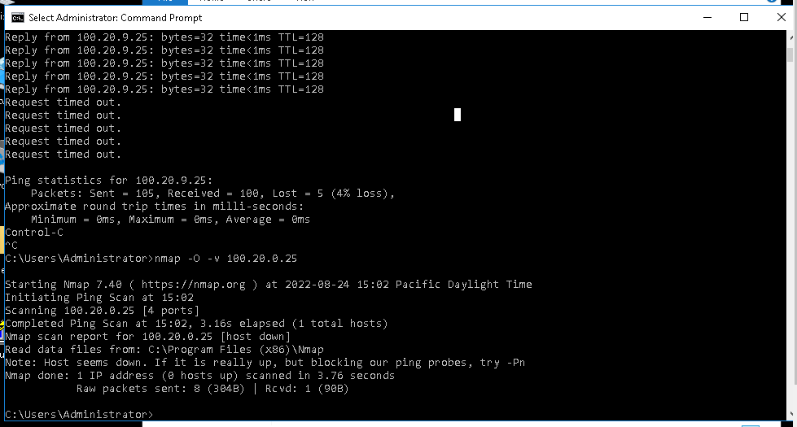
  - 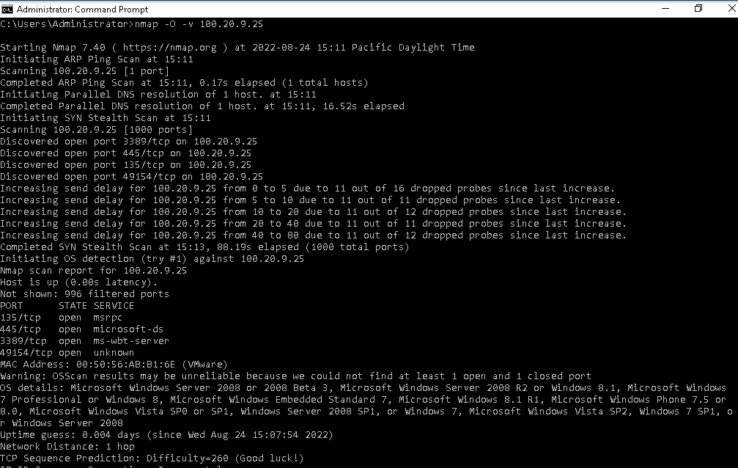
    - Same as the TargetVulnerable01, TargetWindows04’s attack surface was minimized, in that a foreign system could not scan what ports are open or the OS that TargetWindows04 had.

