Christopher Phan
Penetration Testing and Vulnerability
Dr. Renita Murimi
September 11, 2022
Section 2 Lab 4 Screenshots
- 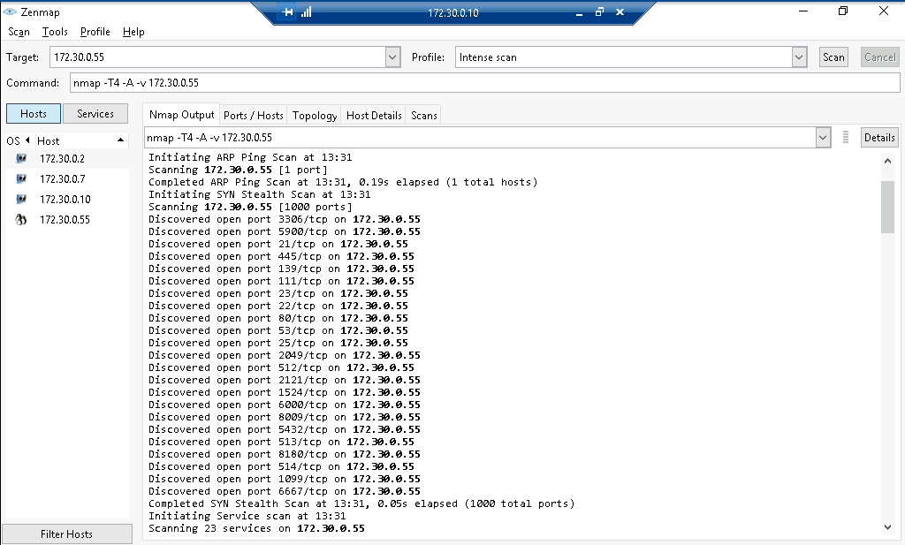
  - Ports/Hosts tab was not displaying the open ports even when I waited for the “Nmap done” message, so I depended on the Nmap Output tab.
  - 
 