Christopher Phan
Penetration Testing and Vulnerability
Dr. Renita Murimi
September 19, 2022
Section 2 Lab 5 Screenshots
- 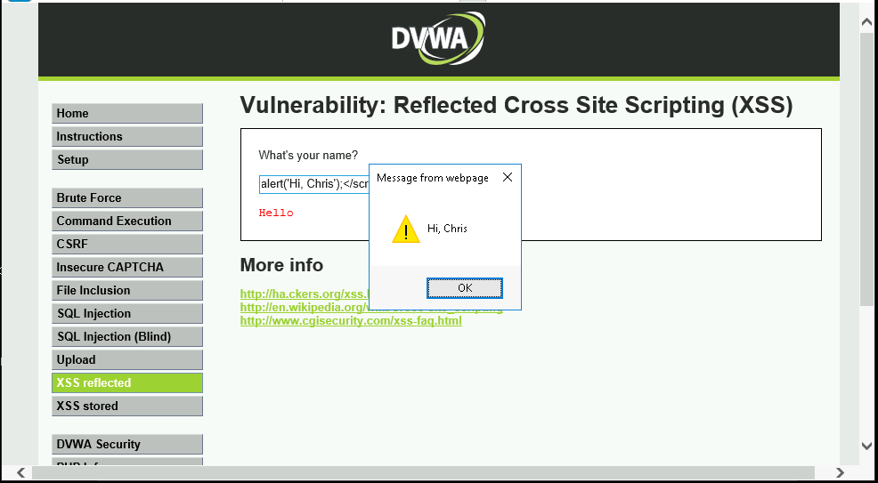
- 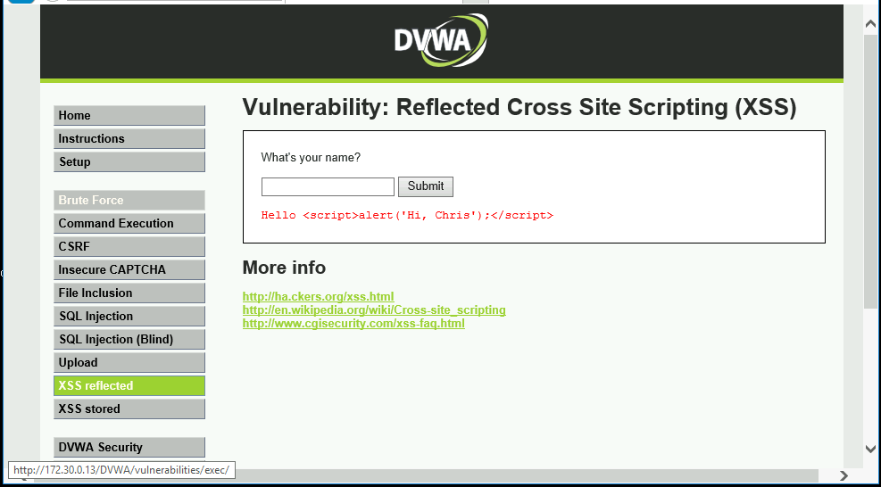
  - With a high-security level, it shows the scripting behind alerts rather than executing the script. With a low-security level, it executes the script immediately, making it seem like an official dispatch.
- Based on the results from steps 4-6 (Section 2, Part 3: Conduct a SQL Injection Attack). We now know that there are two columns, though there is not a third column. So with these, we know the structure of the database, and where there is a lack of errors for vulnerabilities.
- 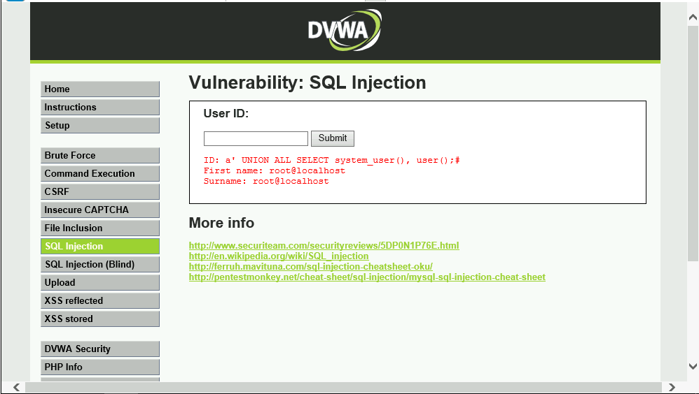
- 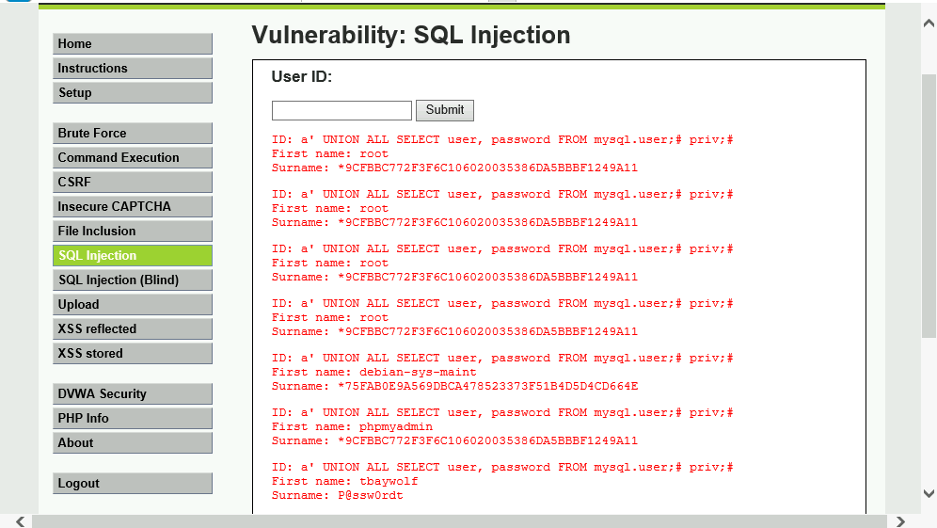
- The point of hashing in a database is to find specific files without the need for an index.
- 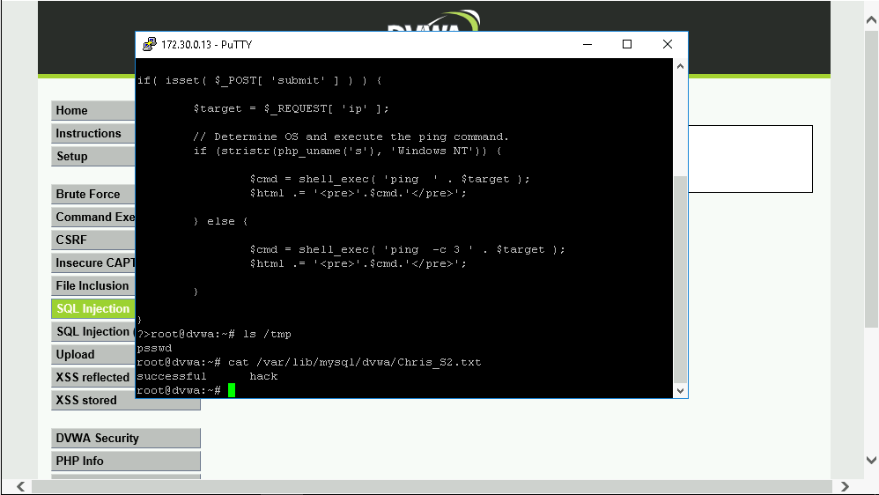
- There are multiple countermeasures to SQL injection attacks: least privilege enforcement, using prepared statements with parameterized queries, stored procedures, allow-list input validation, and possibly escaping all user-supplied input.

