Dear Sir/Madam,

In response to the reviewers’ comments for our submission TC-2016-10-0714, we have revised the manuscript as suggested. This revision includes more experiments and analyses for comparing our methods with the existing SA checking method. For reviewer’s convenience, we reply to the comments for the previous version in the attachment of this letter.

Thanks a lot!

Yours Sincerely,

Yi Wu

Department of Computer Science

Sun Yat-sen University, Guangzhou, China

Email: wu.yi.621@gmail.com

24 April 2017

**Response to Review Comments**

**Comments:**

**Reviewer #2:** Besides, a more complete experimental evaluation is now performed, also including a comparison with existing solutions for building the suffix and LCP arrays. Regarding to this, and just as a minor note, I'd really encourage the authors to better motivate the aim of this last comparison, as they propose two checking methods but the programs they use to compare with are both builder solutions. Finally, as recommended, authors have also identified and discussed further improvements that could be applied to their proposals, with supportive references and explanations.

**Response:**

On page 6, we explain the reason for comparing our solutions with the two builders as follows:

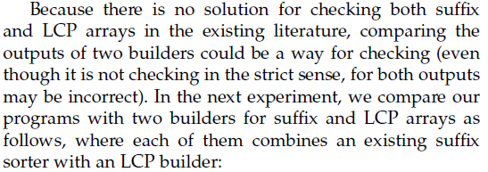

In this revision, we also compare our solutions (for checking a pair of suffix and LCP arrays) with the only existing SA checking method in the literature. The results are shown in Fig. 2 and 3, and the reason for this comparison is explained on page 7 as follows:

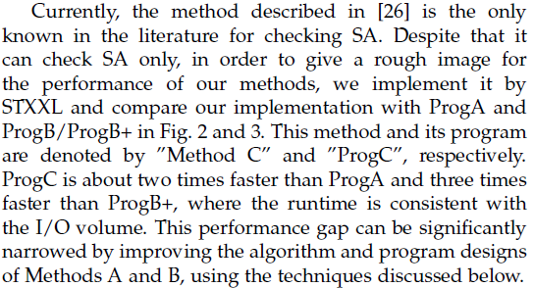

In Section 4.3, we give a discussion about the pros and cons of these methods in our experiments, as well as the optimization techniques for improving the performance of our methods. Finally, we update the conclusion with the last paragraph as follows:

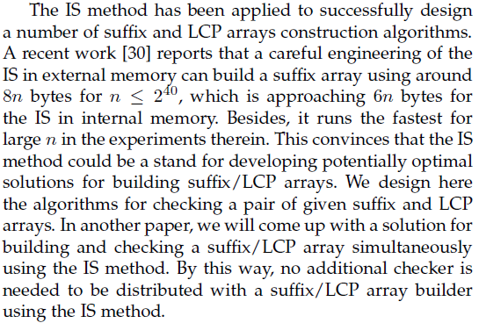

Thanks a lot!