Visayas State University: Campus Safety and Resilience Survey
Respondents: Student

- Sociodemographic

Variables | N = 25
Age | 18.00 (18.00, 19.00)
Sex
Female | 16 (64%)
Male | 9 (36%)
Year
BCAED-3 | 3 (12%)
BSA- 3 | 1 (4.0%)
BSA-2 | 1 (4.0%)
BSABE-2 | 1 (4.0%)
BSBIO-1 | 3 (12%)
BSBT-1 | 5 (20%)
BSCS-2 | 1 (4.0%)
BSDC-2 | 2 (8.0%)
BSED MATH | 1 (4.0%)
BSMET-1 | 3 (12%)
BSS-1 | 1 (4.0%)
BSTM-2 | 3 (12%)
Location
In-campus | 3 (13%)
Off-campus | 20 (87%)
Missing observation(s) | 2
1 Median (Q1, Q3); n (%)

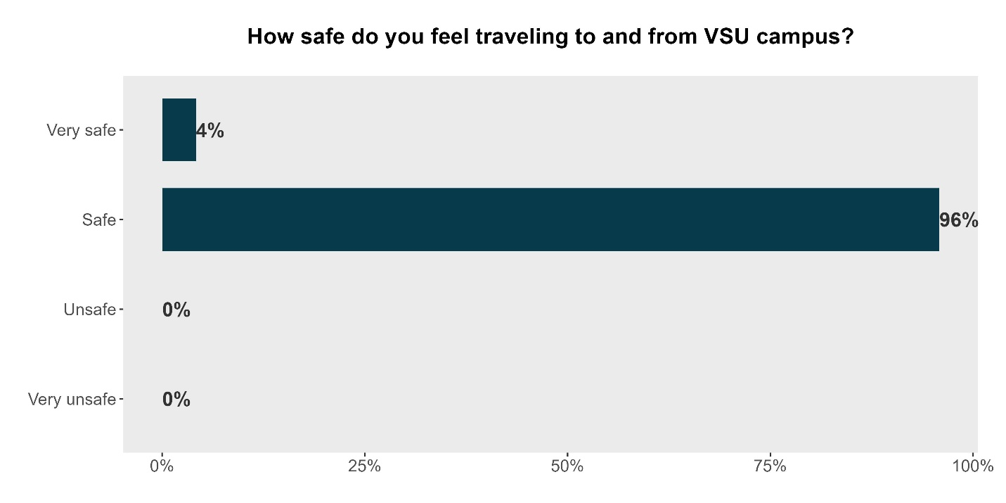

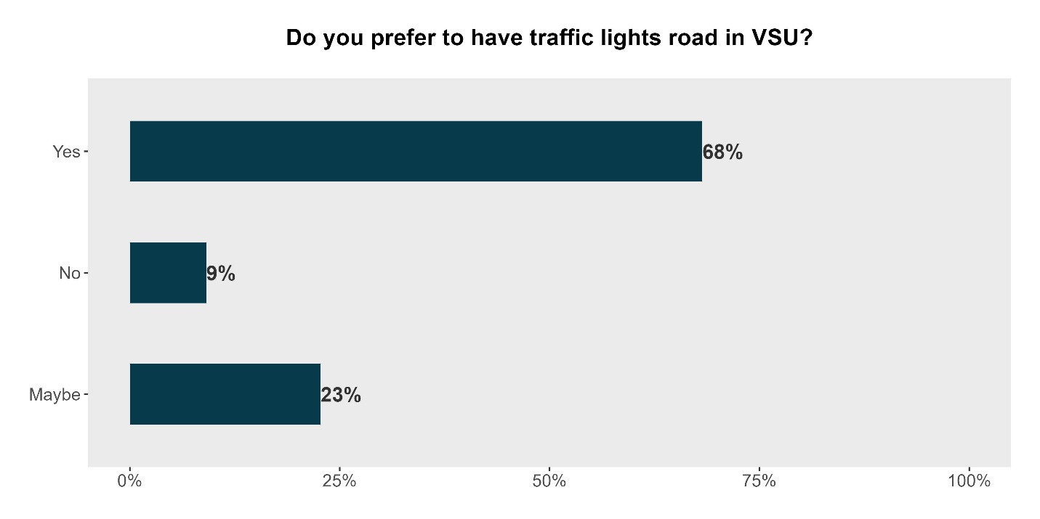

- Physical safety and security

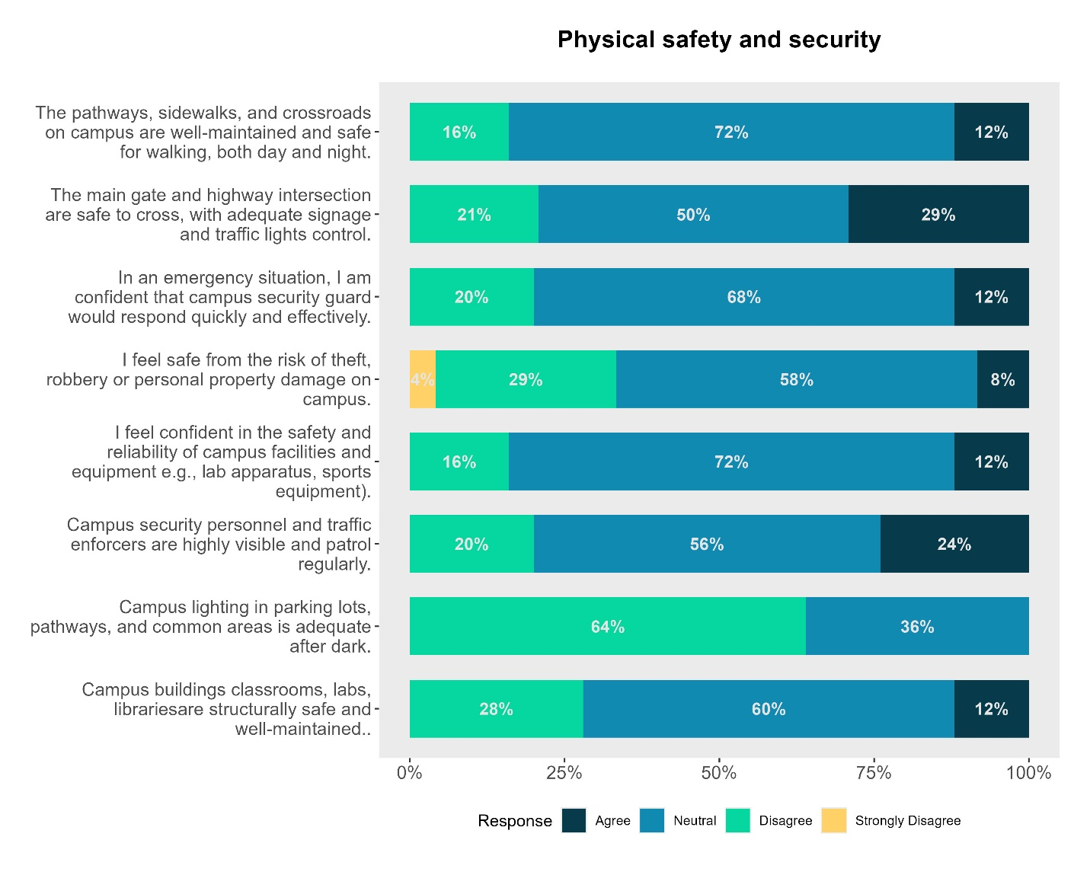
Key findings:
- Pathways and Crossroads
  - 72% neutral, only 16% agree that walkways are safe day and night.
  - Students are uncertain about pedestrian safety. This may reflect poor lighting, uneven surfaces, or lack of signage.
- Main Gate and Highway Intersection
  - 50% neutral, 29% disagree, only 21% agree.
  - The intersection is a concern. Students may feel unsafe crossing due to traffic volume or inadequate controls. This is a priority area for infrastructure and coordination with local traffic authorities.
- Emergency Response Confidence
  - 68% neutral, only 20% agree.
  - Students are unsure whether campus security can respond effectively in emergencies. This suggests a need for visibility, drills, and communication of protocols.
- Protection from Theft or Property Damage
  - 58% neutral, 29% agree, 12% disagree, 4% strongly disagree.
  - While outright fear is low, most students are uncertain. This may reflect inconsistent enforcement or lack of awareness of reporting mechanisms.
- Safety of Campus Facilities and Equipment
  - 72% neutral, only 16% agree.
  - Students are unsure about the reliability of labs, sports gear, and other equipment. This could be due to outdated or poorly maintained resources.
- Visibility of Security Personnel
  - 56% neutral, 24% disagree, only 20% agree.
  - Security presence is not strongly felt. Increasing patrol visibility and engagement could improve perceptions.
- Campus Lighting After Dark
  - 64% neutral, 36% disagree, 0% agree.
  - This is a critical gap. No student agreed that lighting is adequate. Immediate action is needed to improve illumination in key areas.
- Structural Safety of Buildings
  - 60% neutral, 28% agree, 12% disagree.
  - Students are moderately confident in building safety, but the high neutrality suggests limited awareness or inconsistent maintenance.

- Emotional and psychological safety
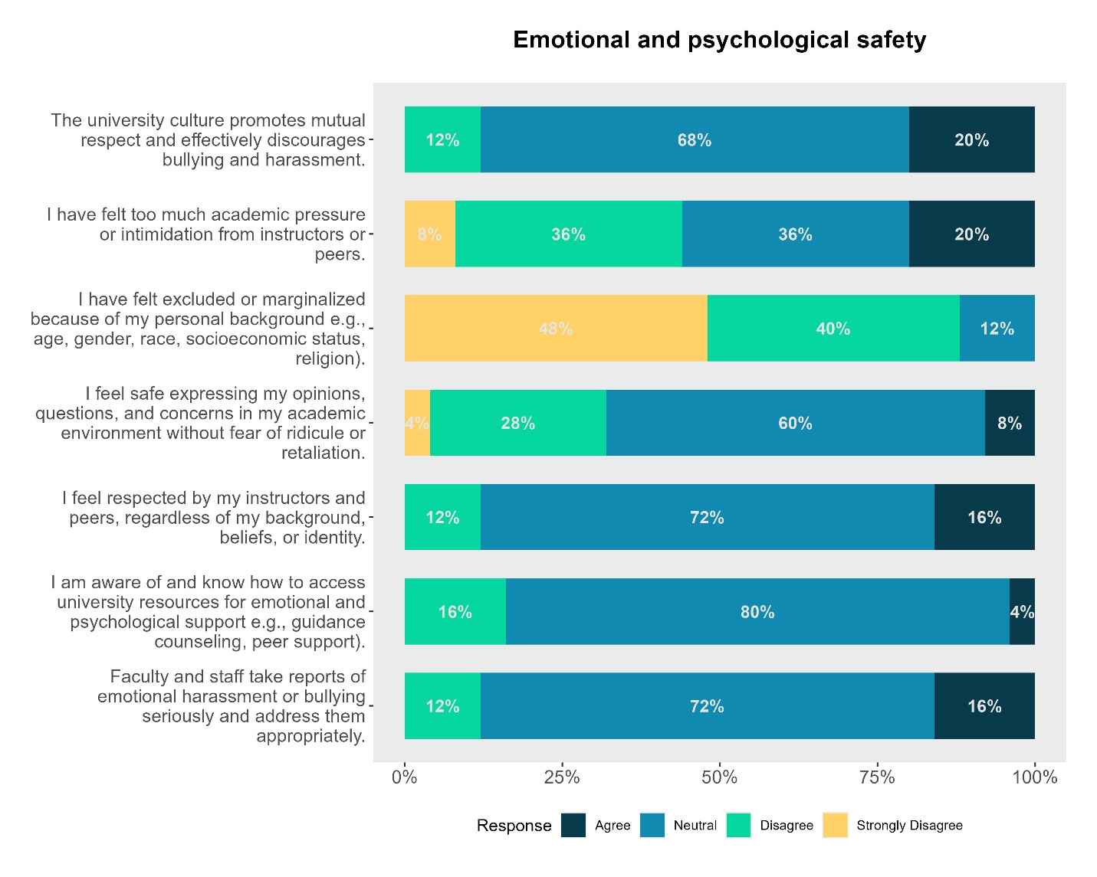
Key findings:
- Emotional and Psychological Safety on Campus
- Data: 72% neutral, 16% agree, 12% disagree.
- A vast majority of students do not have a definitive sense of emotional security. The high neutrality suggests that while there isn't an active "culture of fear," there is a lack of proactive mental health support or a visible "safe space" culture. Students may feel like "just a number" rather than emotionally supported members of the community.
- Personal Safety from Harassment or Bullying
- Data: 64% neutral, 24% agree, 12% disagree.
- While nearly a quarter of the students feel safe, the 64% neutrality indicates uncertainty regarding the university's ability to handle interpersonal conflicts. Students may be unsure of the specific protocols for reporting bullying or may doubt the confidentiality and effectiveness of the resolution process.
- Sense of Belonging and Support
- Data: 56% neutral, 24% agree, 20% disagree.
- This is a notable area of concern, as 1 in 5 students explicitly feels they do not belong or lack support. The mixed results suggest that "community building" is inconsistent across different departments or colleges within VSU. A lack of belonging is a significant precursor to psychological distress and academic burnout.
- Confidence in Reporting Concerns without Retaliation
- Data: 68% neutral, 20% disagree, 12% agree.
- There is a significant "trust gap." With 20% explicitly disagreeing and 68% remaining neutral, only a small fraction of students feel safe speaking up. This suggests a perceived power imbalance where students fear that reporting grievances or safety issues might negatively impact their grades or reputation.
- Overall Perceived Resilience (Psychological Readiness)
- Data: 76% neutral, 16% agree, 8% disagree.
- Students are highly uncertain about their own or the university’s psychological resilience in the face of a crisis. This mirrors the "Emergency Response Confidence" findings in the physical safety section—students don't just doubt the physical tools (drills/equipment), they also doubt the psychological preparedness of the campus to handle trauma or high-stress events.

- Social and community safety

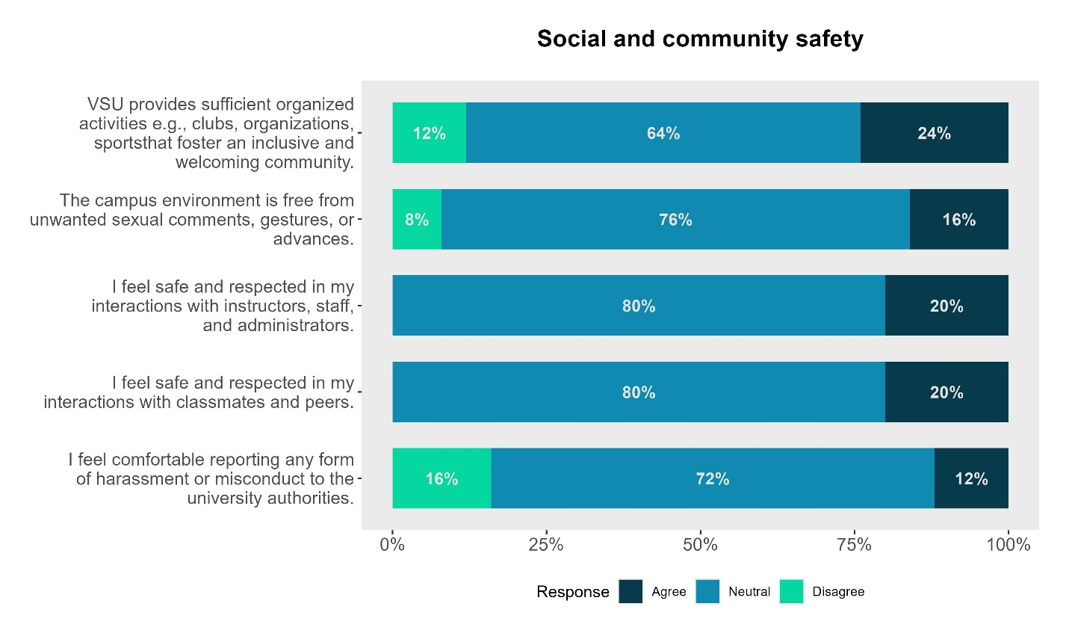
Key Findings
- Inclusivity through Organized Activities
  - Data: 64% neutral, 24% agree, 12% disagree.
  - While nearly a quarter of students find campus organizations effective for fostering community, the high neutral response suggests these activities may not reach the broader student body. The social impact of clubs and sports is present but not universally felt as a core pillar of inclusivity.
- Campus Environment regarding Sexual Misconduct
  - Data: 76% neutral, 16% agree, 8% disagree.
  - There is widespread uncertainty regarding the prevalence of unwanted sexual comments or gestures. While the "disagree" rate is low, the 76% neutrality may indicate that students are either unaware of the existing climate or hesitant to categorize the environment as definitively safe, highlighting a need for clearer boundaries and awareness campaigns.
- Interactions with Instructors, Staff, and Administrators
  - Data: 80% neutral, 20% agree, 0% disagree.
  - Students report a baseline of professional respect, as evidenced by the 0% disagreement. However, the overwhelming 80% neutrality suggests these relationships are largely transactional rather than supportive. There is significant room to move from "neutral coexistence" to a more actively encouraging administrative culture.
- Interactions with Classmates and Peers
  - Data: 80% neutral, 20% agree, 0% disagree.
  - Peer dynamics mirror administrative ones; students do not feel actively disrespected, but the sense of "community" is not deeply felt by the majority. This suggests a campus social life that is functional but lacks strong emotional or social cohesion.
- Comfort in Reporting Harassment or Misconduct
  - Data: 72% neutral, 16% disagree, 12% agree.
  - This is a critical area for improvement. More students feel uncomfortable reporting (16%) than feel comfortable (12%). The high neutrality (72%) indicates a significant lack of trust or knowledge regarding the university's reporting mechanisms and how safe they are for the whistle-blower.

- Digital safety and emergency preparedness
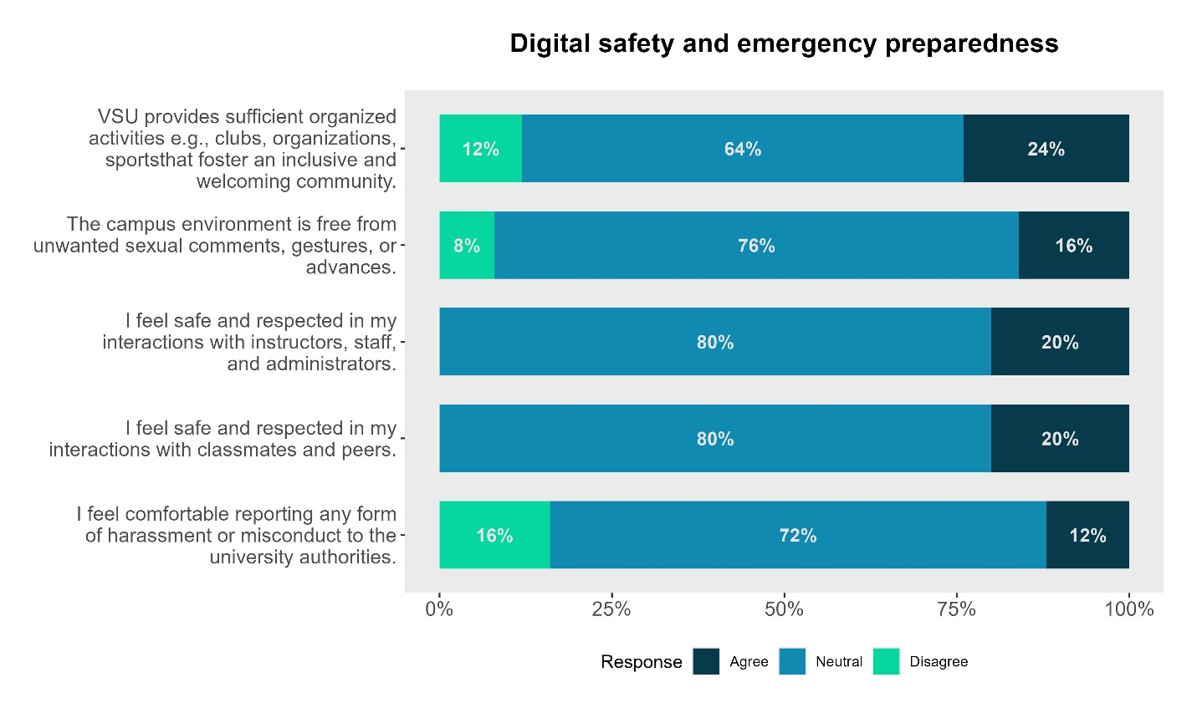
Key Findings: Digital Safety and Emergency Preparedness
- Awareness of Cyber Threats (Phishing, Scams, etc.)
  - Data: 60% neutral, 28% agree, 12% disagree.
  - While nearly a third of the students feel aware of digital risks, the high neutrality indicates a "passive awareness." Students may recognize the terms but likely lack the practical training to identify sophisticated modern threats. This suggests a need for active cybersecurity literacy campaigns beyond basic warnings.
- Privacy Settings and Data Protection Habits
  - Data: 68% neutral, 20% agree, 12% disagree.
  - A significant majority of students are non-committal about their data protection habits. This often reflects "security fatigue" or a lack of specific knowledge on how to navigate complex privacy menus. The low "agree" rate shows that proactive data management is not currently a standard habit among the student body.
- Knowledge of Emergency Procedures (Natural Disasters/Fire)
  - Data: 72% neutral, 16% agree, 12% disagree.
  - This is a critical safety gap. With only 16% of students agreeing they know what to do, the vast majority are unprepared for an actual crisis. High neutrality here usually means students assume they might know what to do but have never actually participated in a drill or read the official protocols.
- Effectiveness of Campus Emergency Notifications
  - Data: 64% neutral, 24% disagree, 12% agree.
  - Students have more "disagreement" (24%) than "agreement" (12%) regarding the effectiveness of campus alerts. This indicates that the current notification systems (SMS, email, or sirens) may be perceived as unreliable, slow, or poorly communicated, leaving the majority of the population in a state of uncertainty.
- Preparedness for Campus Lockdowns or Security Threats
  - Data: 80% neutral, 12% agree, 8% disagree.
  - The extreme level of neutrality (80%) suggests that a lockdown scenario is a "black box" for most students. They have likely not been briefed on the specific procedures for man-made security threats, leading to a dangerous lack of readiness should a real-world incident occur.

