Visayas State University: Campus Safety and Resilience Survey
Respondents: Faculty and Staff

- Sociodemographic
Variable | faculty  n = 20 | staff  n = 20
Age | 32 (24, 37) | 31 (29, 38)
Missing observation(s) | 2 | 0
Sex
Male | 8 (44%) | 8 (42%)
Female | 10 (56%) | 11 (58%)
Missing observation(s) | 2 | 1
Residence
In-campus | 7 (39%) | 3 (16%)
Off-campus | 11 (61%) | 16 (84%)
Missing observation(s) | 2 | 1
Participation
No | 15 (75%) | 9 (60%)
Yes | 5 (25%) | 6 (40%)
Missing observation(s) | 0 | 5
Traffic light
Maybe | 1 (5.6%) | 5 (28%)
No | 12 (67%) | 1 (5.6%)
Yes | 5 (28%) | 12 (67%)
Missing observation(s) | 2 | 2
Median (Q1, Q3); n (%)

- Staff are slightly older on average, with a narrower age range.
- Gender distribution is balanced across both groups.
- Staff are more likely to live off-campus, which may affect perceptions of safety and access.
- Staff show higher participation rates, though missing data may obscure full comparison.
- Staff are more optimistic (higher “Yes”), while faculty lean toward “No” responses.

- Physical safety and security

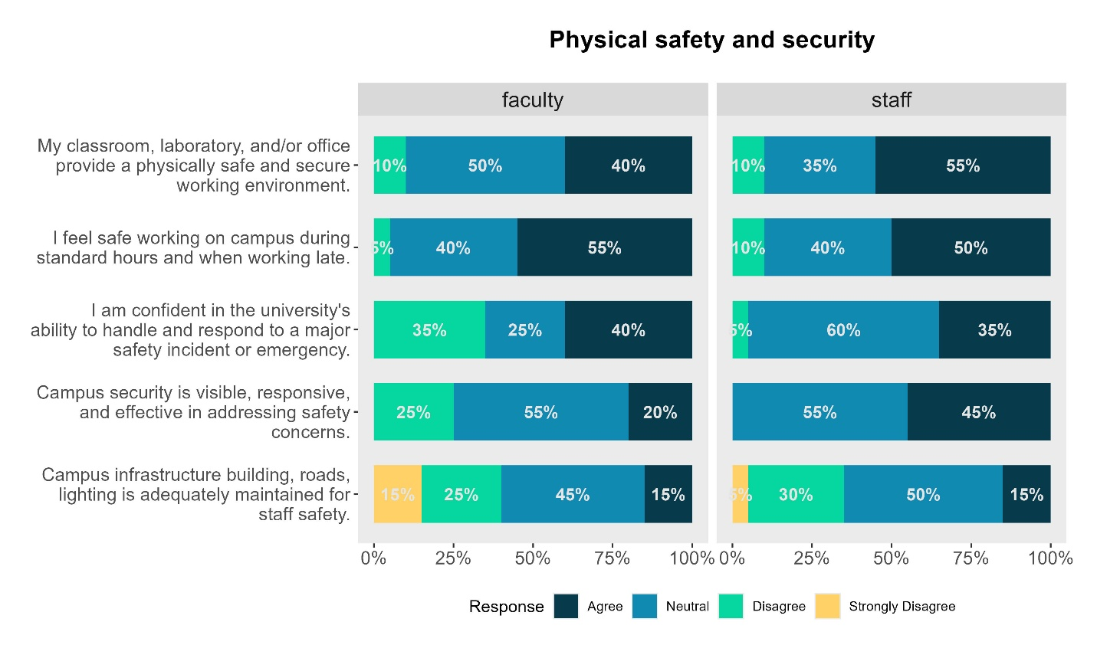
- Key findings:
  - General sense of safety in workplaces
    - Faculty: 40% agree, 50% neutral
    - Staff: 55% agree, 35% neutral
    - Both faculty and staff largely agree that their classrooms, labs, and offices are physically safe.
    - Staff feel slightly more secure than faculty. However, the high neutral responses suggest room for improvement in communicating or reinforcing safety measures.
  - Safety During Standard and Late Hours:
    - Faculty: 55% agree, 40% neutral
    - Staff: 50% agree, 40% neutral
    - Both groups feel relatively safe during working hours, including late shifts. Yet, the consistent 40% neutrality may indicate uncertainty or lack of visibility of nighttime safety protocols.
  - Confidence in Emergency Response
    - Faculty: 35% disagree, only 40% agree
    - Staff: 60% neutral, 35% agree
    - Faculty express more skepticism, while staff are unsure. This points to a need for clearer communication, drills, or training on emergency preparedness.
  - Campus Security Visibility and Responsiveness
    - Faculty: 25% disagree, 45% neutral
    - Staff: 55% neutral, 45% agree
    - Faculty are less confident in campus security than staff. The dominant neutral responses suggest that visibility and responsiveness of security personnel may not be consistent or well-publicized.
  - Infrastructure Maintenance for Safety
    - Faculty: 40% negative (15% strongly disagree, 25% disagree), only 15% agree
    - Staff: 35% negative, 15% agree
    - Both groups express dissatisfaction with the maintenance of buildings, roads, and lighting. This could be a tangible risk factor and should be prioritized in campus planning.

- Emotional and professional safety
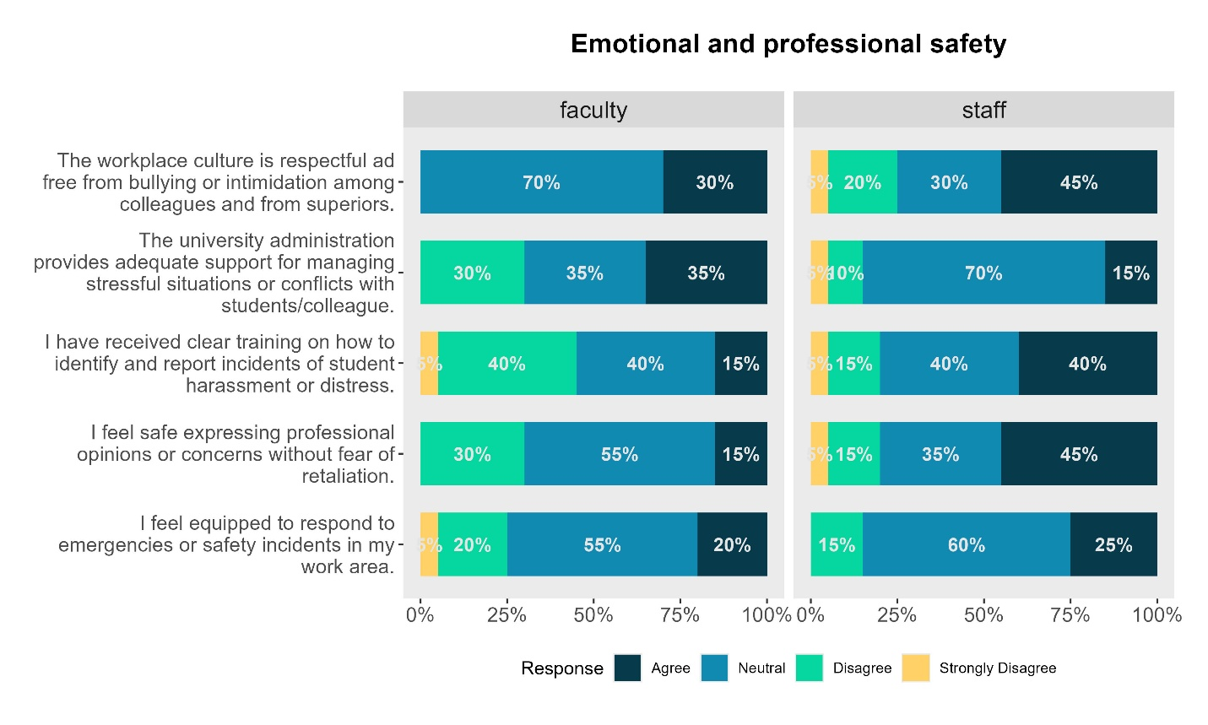
- Key findings
- Workplace Culture and Respect
  - Faculty: 30% agree the culture is respectful and free from bullying.
  - Staff: Only 45% agree; 25% express disagreement.
  - Staff perceive a healthier culture than faculty.
- Support for Stress and Conflict
  - Faculty: Split views — 35% agree, 30% disagree.
  - Staff: 70% neutral, only 15% agree.
  - Staff are uncertain about administrative support, while faculty are divided. This signals a need for clearer support systems, counseling access, and conflict resolution protocols.
- Training on Harassment and Distress
  - Faculty: 45% negative (5% strongly disagree, 40% disagree), only 15% agree.
  - Staff: 40% agree, 20% negative.
  - Faculty lack training and awareness on handling student distress. Staff are better trained but still show gaps. This is a critical area for capacity building.
- Freedom to Express Professional Opinions
  - Faculty: 30% disagree, 55% neutral — only 15% feel safe expressing concerns.
  - Staff: 45% agree, 20% negative.
  - Faculty feel constrained in voicing concerns, possibly due to fear of retaliation. Staff are more confident, but the neutrality suggests hesitation. This affects transparency and innovation.
- Preparedness for Emergencies
  - Faculty: 25% negative, 55% neutral, only 20% agree.
  - Staff: 15% disagree, 60% neutral, 25% agree.
  - Both groups feel underprepared for emergencies. This aligns with earlier findings on physical safety and reinforces the need for drills, protocols, and visible resources.

- Social and community safety
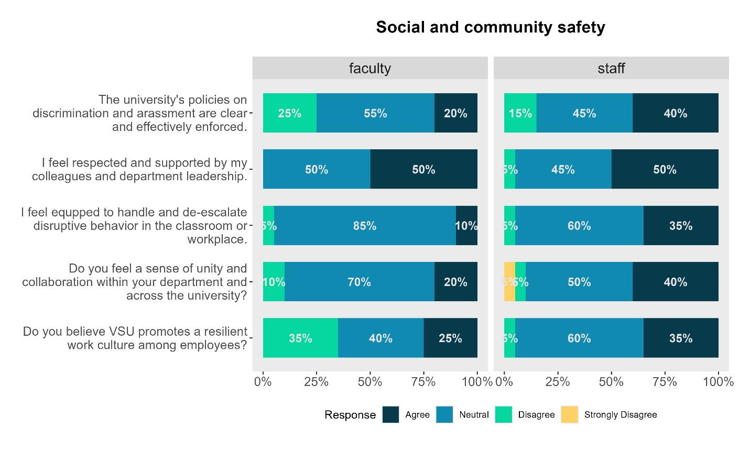

- Key Insights on Social and Community Safety
  - Clarity and Enforcement of Anti-Discrimination Policies
    - Faculty: 25% disagree, 55% neutral, only 20% agree.
    - Staff: 15% disagree, 45% neutral, 40% agree.
    - Faculty are less confident than staff in the clarity and enforcement of policies. The high neutrality suggests that both groups may lack awareness or trust in how these policies are implemented.
  - Respect and Support from Colleagues and Leadership
    - Faculty: 50% agree, 50% neutral.
    - Staff: 50% agree, only 5% disagree.
    - This is a relative strength. Staff feel slightly more affirmed, while faculty show no disagreement but remain cautious. This may reflect variability in departmental leadership styles.
  - Preparedness to Handle Disruptive Behavior
    - Faculty: 85% neutral, only 10% agree.
    - Staff: 60% neutral, 35% agree.
    - Faculty feel significantly underprepared. Staff fare better but still show uncertainty. This points to a need for training in de-escalation techniques and behavioral management.
  - Sense of Unity and Collaboration
    - Faculty: 70% neutral, 20% agree.
    - Staff: 50% neutral, 40% agree.
    - Staff perceive more collaboration than faculty. The dominant neutrality across both groups suggests that interdepartmental cohesion is weak or inconsistent.
  - Promotion of a Resilient Work Culture
    - Faculty: 35% disagree, only 25% agree.
    - Staff: 60% neutral, 35% agree.
    - Faculty are notably more skeptical. Staff are unsure. This reflects a gap in institutional messaging or tangible efforts to build resilience.

