Instruction
- Review EEG
- Open MATLAB program then type revieweeg. After then you can see the following the interface. On the left there are channels from 1 to 8; on the right there are channels from 9 to 16. There is menu ‘file’ and ‘filter’.

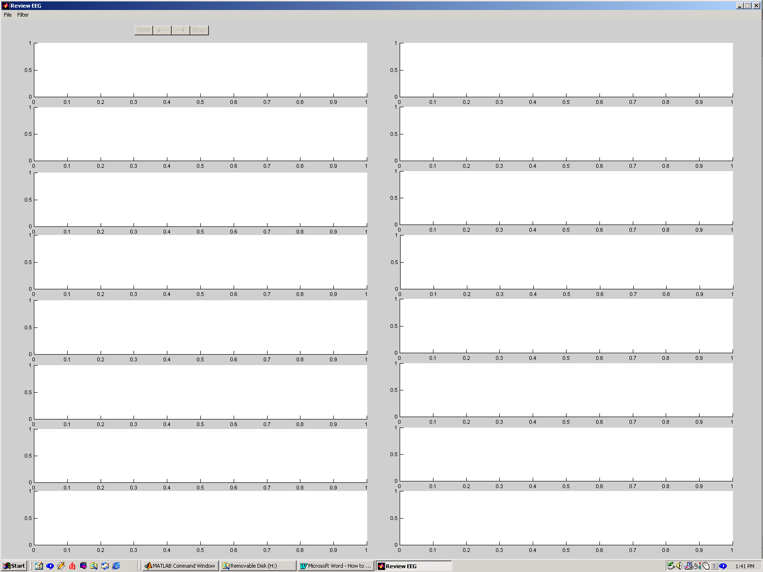

- Click ‘File’ menu then click ‘Convert’, it will convert experimental data files to MATLAB data files that are named as ‘*_A.dat’. This program will use these file to review EEG and process EEG through a low pass filter or a band pass filter.
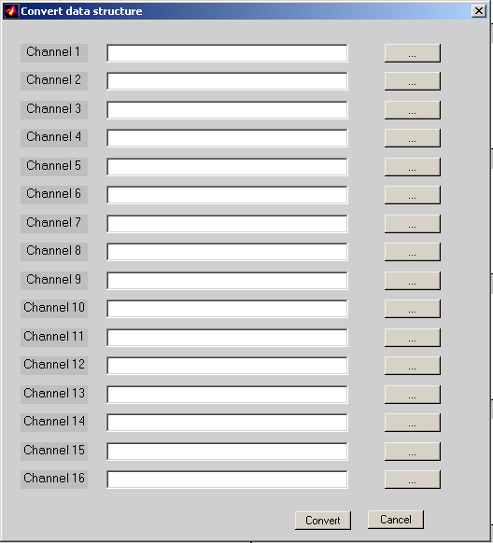
- Click ‘Open’ on the ‘File’ menu. You can open sixteen channels or less than sixteen channels. This program requires you to open files in order, although maybe it is different from your real channels.
- Push ‘Start’ button. You can see the original data on the screen. You also can go back or forward 1second. When you do not want to see, click ‘Stop’ button. After then you can open other files again.
- Click ‘Convert’ on ‘Filter button’. Choose type of filters and write down cutoff frequency and names of files. Click ‘Convert’ . For a low pass filter, filename is ‘_A_Low.dat’ . For a band pass filter, filename is ‘_A_Band.dat’. It will take long time especially for large files. For a 16-sec file, it takes about one minute.
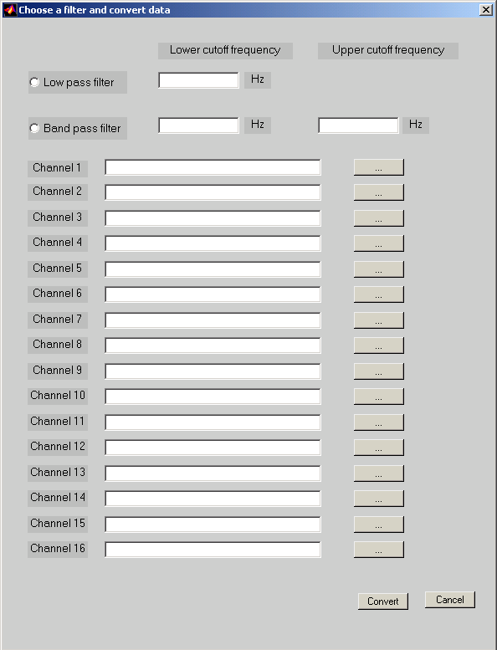

- Click ‘Open data through a low pass filter’ on ‘Filter’ menu. Then you can use ‘Start’ , ‘→’ ,’←’ or ‘Stop’ buttons to review data on the screen.

- Correlation Interface
- Open MATLAB program then type eegcorr. You will see the following interface
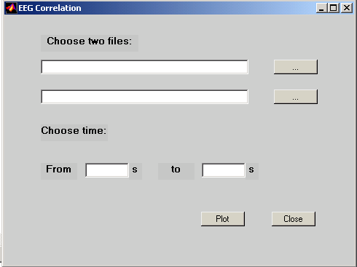

- Choose the files and fill out time that you want to see. After then you can click ‘Plot’ button and see the result. You can only choose files ‘_A.dat’ or ‘_A_Low.dat’ or ‘_A_Band.dat’.

