CSC 821 - Group 1

Group Members
# | Name | Registration No.
1 | Nyabuto Pharminous | ST62/56180/2025
2 | Obed Munyao | ST62/61043/2025
3 | Thomas Kibet Yebei | ST62/59650/2025
4 | Ferdinand Atila Luvembe | ST62/60337/2025
5 | Samson Wangila Wanyonyi | ST62/60771/2025
6 | Thomas Kimani Miringu | ST62/61244/2025
7 | Samuel Abuko Abuti | ST62/59655/2025
8 | Githinji Lucy Njeri | ST62/60682/2025
9 | Haron Samoei | ST62/60356/2025
10 | Simon Mwangi Maina | ST62/61647/2025
11 | Brian Cheruiyot | ST62/61027/2025
12 | Susan Wambui | ST62/60422/2025
13 | Awello Kanyandong Kevins | ST62/61033/2025
14 | Patrick Mwangi Wanjiru | ST62/59698/2025
15 | Stephen Mwangi Mumbi | ST62/59653/2025
16 | Abisagy Nafula Wanyonyi | ST62/56881/2025

Module 9: FFT and Pattern Matching
CSC 821 - Group 1
Author: Enyoni

Objectives
This notebook implements the Fast Fourier Transform (FFT) from scratch and uses it to analyze a test signal. It also implements and compares Naive Search, Knuth-Morris-Pratt (KMP), and Boyer-Moore exact pattern matching. Code, demonstrations, validation, plots,
import cmath
from collections.abc import Sequence
import matplotlib.pyplot as plt
import numpy as np
plt.style.use("seaborn-v0_8-whitegrid")

Part 1: Fast Fourier Transform
Run the cells below to define the recursive radix-2 FFT and analyze the test signal.
def fft(samples: Sequence[complex]) -> list[complex]:
"""Return the DFT of samples using the recursive radix-2 FFT algorithm."""
sample_count = len(samples)
if sample_count == 0 or sample_count & (sample_count - 1):
raise ValueError("FFT input length must be a non-zero power of two")
if sample_count == 1:
return [complex(samples[0])]
even_spectrum = fft(samples[0::2])
odd_spectrum = fft(samples[1::2])
spectrum = [0j] * sample_count
for frequency_index in range(sample_count // 2):
twiddle = cmath.exp(-2j * cmath.pi * frequency_index / sample_count)
odd_component = twiddle * odd_spectrum[frequency_index]
spectrum[frequency_index] = even_spectrum[frequency_index] + odd_component
spectrum[frequency_index + sample_count // 2] = (
even_spectrum[frequency_index] - odd_component
)
return spectrum
sample_rate = 256
duration = 1.0
times = np.arange(0, duration, 1 / sample_rate)
signal = np.sin(2 * np.pi * 20 * times) + 0.5 * np.sin(2 * np.pi * 50 * times)
spectrum = np.asarray(fft(signal))
frequencies = np.arange(len(signal) // 2) * sample_rate / len(signal)
magnitudes = 2 * np.abs(spectrum[: len(signal) // 2]) / len(signal)
figure, (signal_axis, spectrum_axis) = plt.subplots(2, 1, figsize=(10, 7))
signal_axis.plot(times, signal, color="#146c94")
signal_axis.set(title="Test Signal", xlabel="Time (seconds)", ylabel="Amplitude")
signal_axis.grid(alpha=0.25)
spectrum_axis.stem(frequencies, magnitudes, basefmt=" ")
spectrum_axis.set(
title="Frequency Spectrum",
xlabel="Frequency (Hz)",
ylabel="Magnitude",
xlim=(0, sample_rate / 2),
)
spectrum_axis.grid(alpha=0.25)
figure.tight_layout()
figure.savefig("fft_signal_spectrum.png", dpi=150)
plt.show()
dominant_indices = np.argsort(magnitudes)[-2:]
dominant_frequencies = sorted(frequencies[dominant_indices])
print("Dominant frequencies:", ", ".join(f"{value:.0f} Hz" for value in dominant_frequencies))
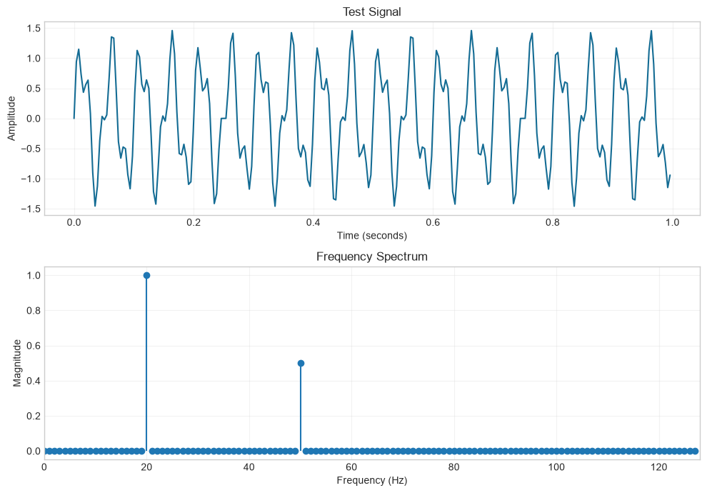
Dominant frequencies: 20 Hz, 50 Hz

Part 2: Pattern Matching
Run the cells below to define and compare Naive Search, KMP, and Boyer-Moore.
def naive_search(text: str, pattern: str) -> list[int]:
"""Return all matches by checking the pattern at every valid index."""
if not pattern:
return list(range(len(text) + 1))
return [
start
for start in range(len(text) - len(pattern) + 1)
if text[start : start + len(pattern)] == pattern
]
def build_lps(pattern: str) -> list[int]:
"""Build KMP's longest proper prefix which is also a suffix table."""
lps = [0] * len(pattern)
prefix_length = 0
pattern_index = 1
while pattern_index < len(pattern):
if pattern[pattern_index] == pattern[prefix_length]:
prefix_length += 1
lps[pattern_index] = prefix_length
pattern_index += 1
elif prefix_length:
prefix_length = lps[prefix_length - 1]
else:
pattern_index += 1
return lps
def kmp_search(text: str, pattern: str) -> list[int]:
"""Return all matches using Knuth-Morris-Pratt prefix information."""
if not pattern:
return list(range(len(text) + 1))
lps = build_lps(pattern)
matches: list[int] = []
text_index = 0
pattern_index = 0
while text_index < len(text):
if text[text_index] == pattern[pattern_index]:
text_index += 1
pattern_index += 1
if pattern_index == len(pattern):
matches.append(text_index - pattern_index)
pattern_index = lps[pattern_index - 1]
elif pattern_index:
pattern_index = lps[pattern_index - 1]
else:
text_index += 1
return matches
def boyer_moore_search(text: str, pattern: str) -> list[int]:
"""Return all matches using Boyer-Moore's bad-character rule."""
if not pattern:
return list(range(len(text) + 1))
last_occurrence = {character: index for index, character in enumerate(pattern)}
matches: list[int] = []
alignment = 0
while alignment <= len(text) - len(pattern):
pattern_index = len(pattern) - 1
while (
pattern_index >= 0
and pattern[pattern_index] == text[alignment + pattern_index]
):
pattern_index -= 1
if pattern_index < 0:
matches.append(alignment)
next_index = alignment + len(pattern)
alignment += (
len(pattern) - last_occurrence.get(text[next_index], -1)
if next_index < len(text)
else 1
)
else:
mismatched_character = text[alignment + pattern_index]
alignment += max(
1,
pattern_index - last_occurrence.get(mismatched_character, -1),
)
return matches
text = "ABAAABCDABCABC"
pattern = "ABC"
algorithms = {
"Naive": naive_search,
"KMP": kmp_search,
"Boyer-Moore": boyer_moore_search,
}
print(f"Text: {text}")
print(f"Pattern: {pattern}")
for name, search in algorithms.items():
print(f"{name} match indices: {search(text, pattern)}")
Text: ABAAABCDABCABC
Pattern: ABC
Naive match indices: [4, 8, 11]
KMP match indices: [4, 8, 11]
Boyer-Moore match indices: [4, 8, 11]
# Validate the custom FFT against NumPy's trusted implementation.
test_values = np.array([0.0, 1.0, 0.0, -1.0, 0.0, 1.0, 0.0, -1.0])
assert np.allclose(fft(test_values), np.fft.fft(test_values))
# Validate every matcher against a simple reference search.
test_cases = [
("ABAAABCDABCABC", "ABC"),
("AAAAA", "AAA"),
("hello", "xyz"),
("", ""),
("abc", ""),
]
for test_text, test_pattern in test_cases:
expected = [
index
for index in range(len(test_text) - len(test_pattern) + 1)
if test_text.startswith(test_pattern, index)
]
for name, search in algorithms.items():
actual = search(test_text, test_pattern)
assert actual == expected, (
f"{name} failed for {test_text=!r}, {test_pattern=!r}: "
f"expected {expected}, got {actual}"
)
assert dominant_frequencies == [20.0, 50.0]
print("All FFT and pattern-matching validation checks passed.")
All FFT and pattern-matching validation checks passed.

Summary and Analysis

The FFT and why it matters (Part 1 summary)
The Discrete Fourier Transform (DFT) rewrites a signal as a sum of sinusoids, showing which frequencies it contains. Computed directly it costs O(n^2). The Fast Fourier Transform gives the exact same result in O(n log n) by recursively splitting the sequence into even- and odd-indexed halves (Cooley-Tukey) and reusing the shared sub-results. That speed-up is what makes real-time signal processing practical - audio/music (equalizers, MP3), image filtering and compression, communications (OFDM in Wi-Fi and LTE), radar/sonar, and seismic analysis all depend on it. In the test signal above, the FFT correctly recovers the frequencies that were put in, matching the peaks in the spectrum plot.

Comparing the three pattern-matching algorithms (Part 2 summary)
Algorithm | Preprocessing | Worst case | Best / typical | When to prefer it
Naive | none | O((n-m+1)·m) | O(n) on random text | tiny inputs, quick one-off searches
KMP | LPS array, O(m) | O(n+m) | O(n+m) | guaranteed linear time; patterns with repeats
Boyer-Moore | bad-character / good-suffix, O(m + alphabet) | O(n·m) | sublinear O(n/m) | long text with a large alphabet - the usual choice in editors and search tools
All three report the same match positions; they differ in how much text they can skip. Naive checks every start position; KMP never re-examines text it already matched (using the LPS array); Boyer-Moore scans the pattern right-to-left and can jump ahead by whole pattern lengths, which makes it the fastest in practice on natural-language text.

