[Happy New Year ondanks de Top 2000](https://medium.com/@m.c.willemsen/happy-new-year-ondanks-de-top-2000-6d9249186d1d)

Enjoy listening to the Top 2000 during the Christmas period, a long run-up to the end of the old year and the start of a (hopefully) "happy" new year. The Top 2000 is full of "golden oldies" and is popular with people of my generation of 40+, but my children also sing happily during the oliebollen baking today. It is mainly evergreens, music that has stood the test of time and that almost everyone can appreciate. According to Leo Blokhuis in Trouw, this music fits “well with sitting at home in the dark with hot chocolate.”

But how cozy is the Top 2000? We can easily see that on the basis of the Spotify Top 2000 playlist. Spotify's Web API, together with the SpotifyR library for R, allows us to further analyze the properties of the songs in the Top 2000.

Spotify describes every song in their database with features such as acousticness, danceability, energy, speechiness and valence. In addition, they also indicate how popular a track is. The question now is: How do the songs differ on those characteristics, given that they are ranked high or low in the Top 2000?

Figure 1 shows the distribution of these properties of all tracks of the Top 2000 on the basis of their ranking (from number 1 to 2000). The blue line indicates the trend and the gray area around it the spread. As you can see, little happens for acousticness and speechiness. What we mainly see is that the danceability and valence of the better noted songs (lower rank) decrease, while their popularity increases. We also see such a drop for the energy (but note: this is only a small part (0.58–0.62) of the 0–1 scale with a lot of spread!). In short, as the new year gets closer, the songs become more popular, but also less danceable and they become more and more sad (lower valence)….! So how much fun is it to keep listening to the Top 2000 like this towards the new year?

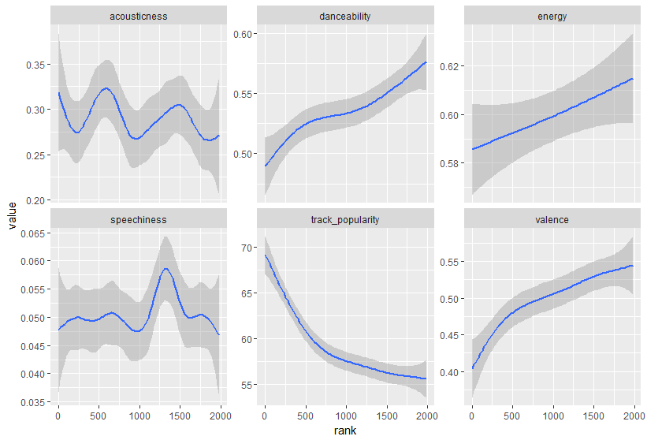

We will close the year and the Top 2000 on December 31, so let's take a closer look at that last day. Figure 2 shows the properties for the last 250 numbers on December 31. Here we see even more strongly that the closer we get to number 1 (and the end of the year), the less danceable, sadder (low valence) and less energetic the music becomes. It will probably be a Happy New Year, but whether the Top 2000 will really contribute to that, that is the question...

