Christopher LaJon Morgan
CS 360 Lab7 Report

ABISS
Introduction

A bishop's interview scheduling system (ABISS) is a simple web based application that provides a scheduling service. This application provides tracking of a bishop's interviews on a daily basis. It was designed to mimic a current excel system.

Therefore the application functions by displaying any set of days that a bishop would like to hold interviews. It then displays every date during the current month that matches the set of days the bishop wishes to hold interviews. The application also allow the bishop to set any set of times he wishes to interview during the set of days. In other words, the application will show any set of days, and any set of times for that set of days during the current month.

Use Cases

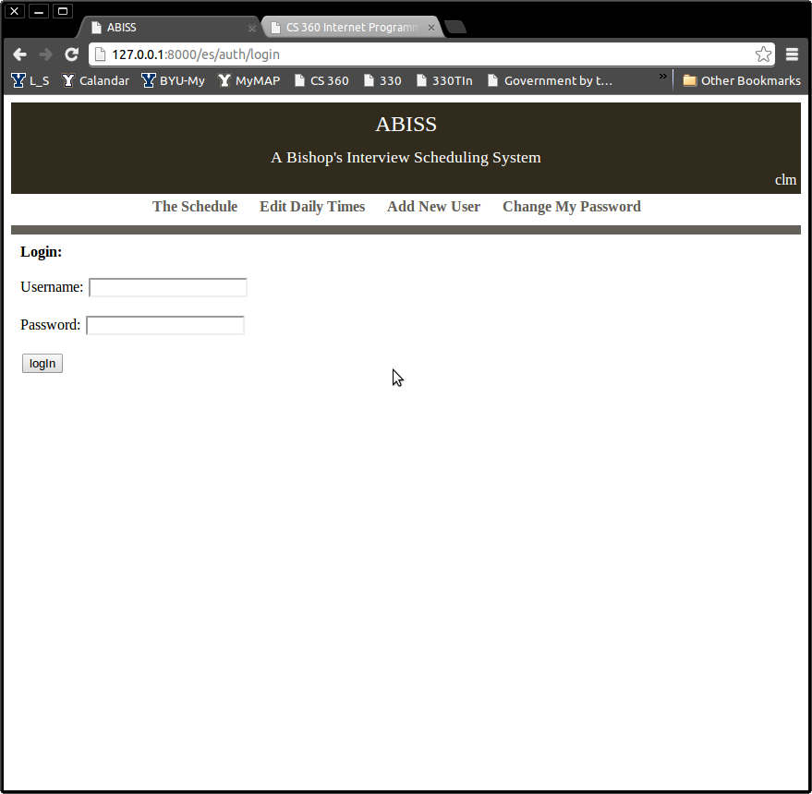 | Login Page:  The first part of this application is to restrict access to the interviews, therefore the application implements user based access. The application keeps track of a set of user's that have access to the application. Each user also has one of two roles, the first being a secretary, and the second being a bishop. Each user also has an associated bishop, if one is a bishop his bishop is simply himself.  User's gain access to the application via a log in screen in which they are prompted for their user name and password. As seen on the left. Upon successful log in the user is taken directly to the main page.  The user's name and password are stored via django's authentication tables, where the user's role and bishop are store in a UserProfile table that is linked to the django tables via username.
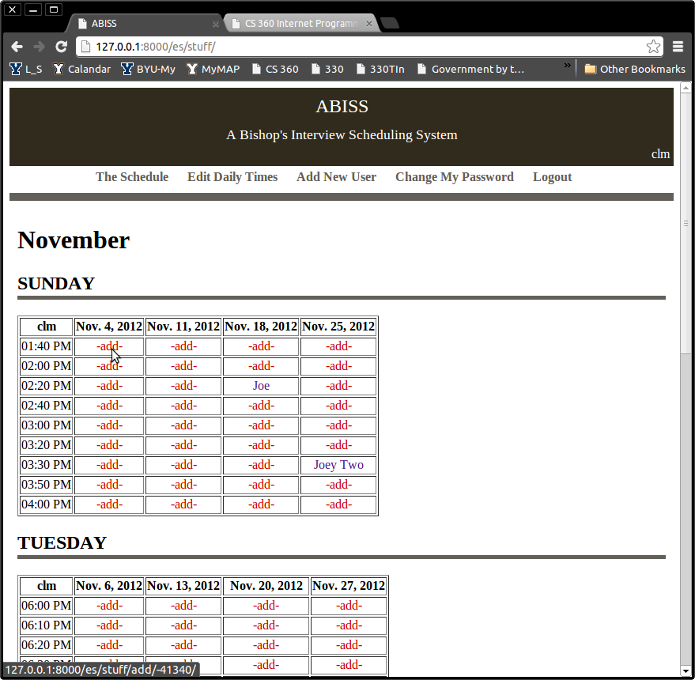 | Main Page:  The heart of the application is the monthly table displayed on the left. This page operates on a monthly basis. Each month it displays a list of days contained in the current month; this list is customizable. The application also displays a list of times for each day, this list a customizable set of times unique to each day.  A column is automatically generated for each date matching the given day in the current month. For example, for the “set to display” day Sunday, the application displays every Sunday in the month of November. The application also displays for Sunday the “set to display” times for Sundays. For example, on the left the desired times 1:40 to 4:00 are shown.  Each of the entries shown in the interview table on the left is a link. The red links will allow the user to add an appointment for the given time. The appointment links will allow the user to modify or remove an appointment, as described later.  The data for this page is always stored directly in three tables: days, times, and appointments. There is an entry in the days table for every day of the week for every bishop. For each day there is a set of times in the times table for every time between 7:00AM and 9:00PM in ten minute intervals. These two tables store the information needed to inform which days and times to display. The appointments table stores the name of the appointment, its bishop, its date, and a corresponding time in the times table. All the information for these tables is kept current during the run time of the application.
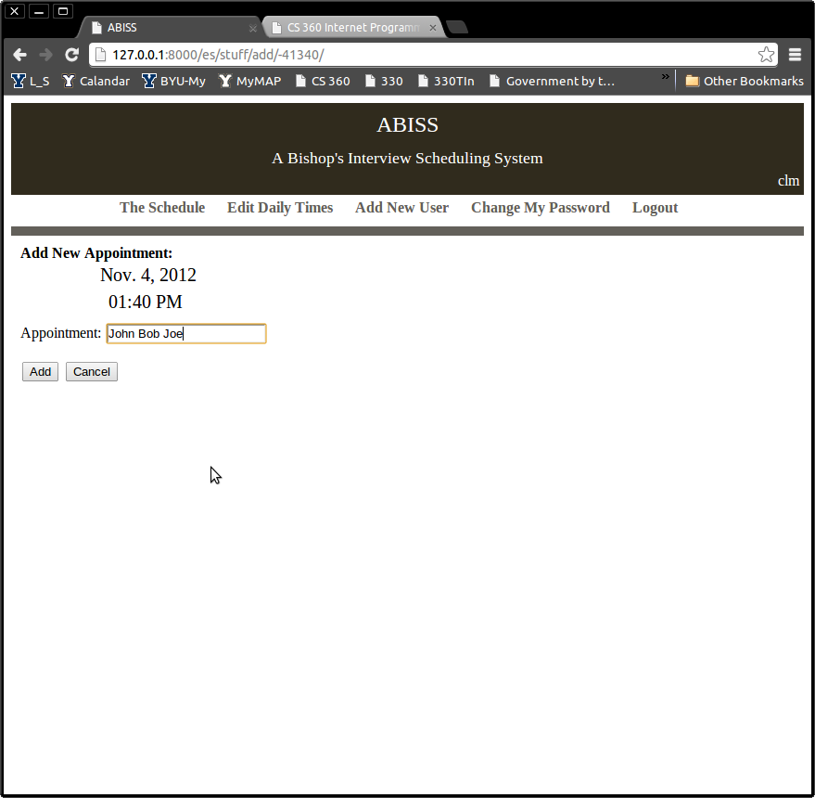 | When a red link is clicked on the main page, as show in the previous screen shot, the user is taken to an add appointment page. This page displays the given date and time for the appointment to be made and provides entry for the appointment's information. The user may then add or forget the appointment as shown to the left. Adding or canceling and appointment addition returns the user to the main page. The change is made immediately in the appointments table in the database and reloaded in the main page.
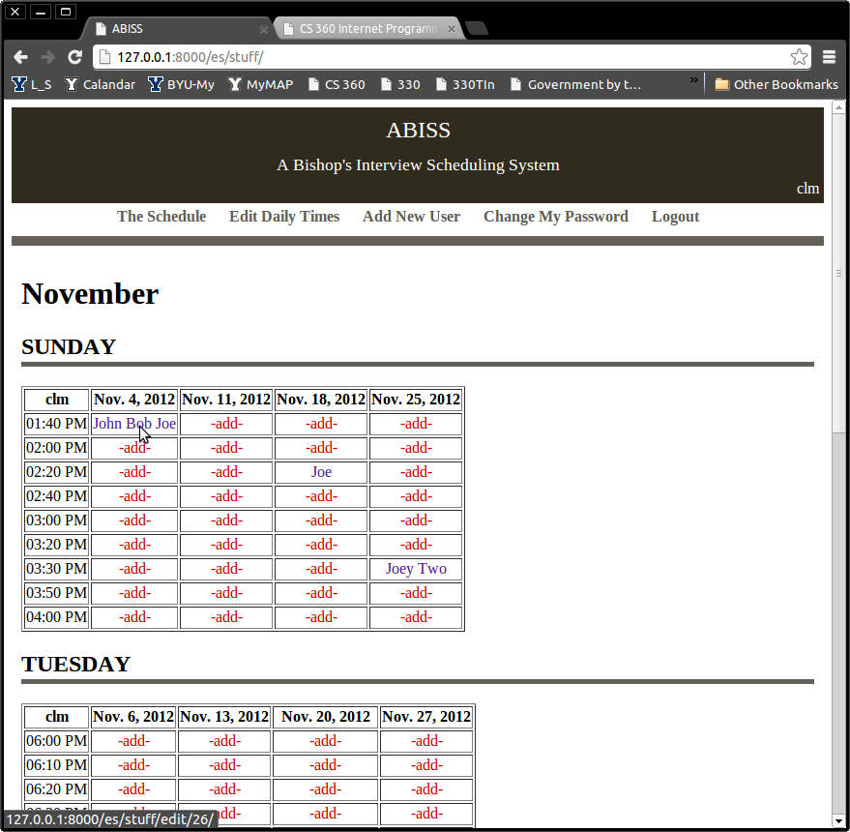 | The user may also modify already made appointments (blue links) from the main page.
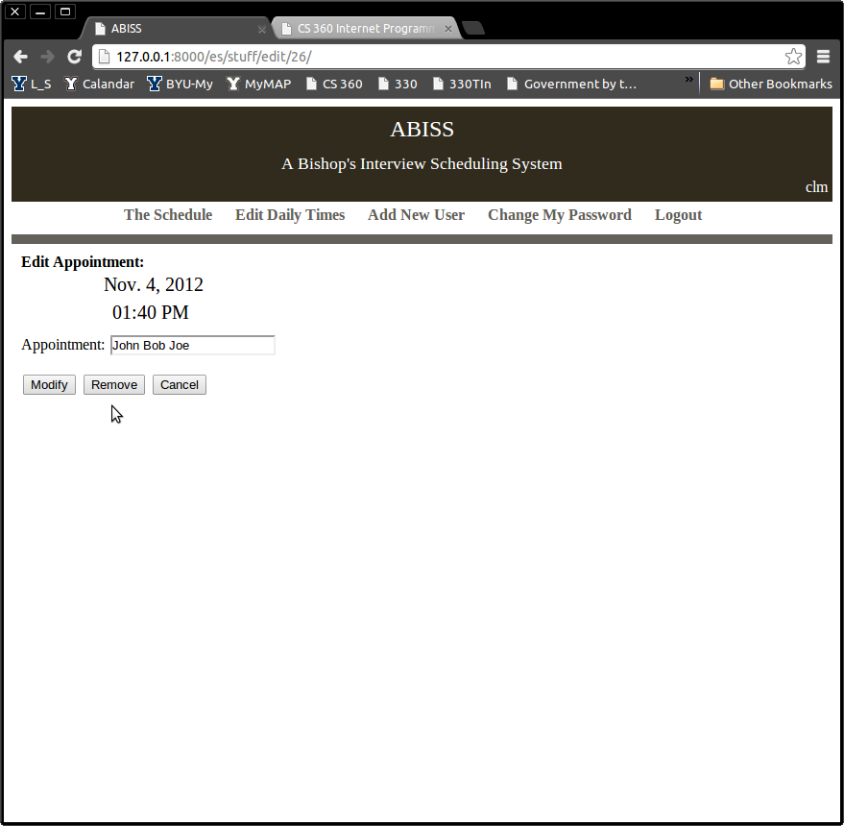 | Upon selection of a blue link on the main page, the user is taken to a modify appointments page. This page allows the user to modify an appointment, remove it, or forget the changes altogether. Upon any of these options the user is taken back to the main page after the change is made in the appointments table in the database.
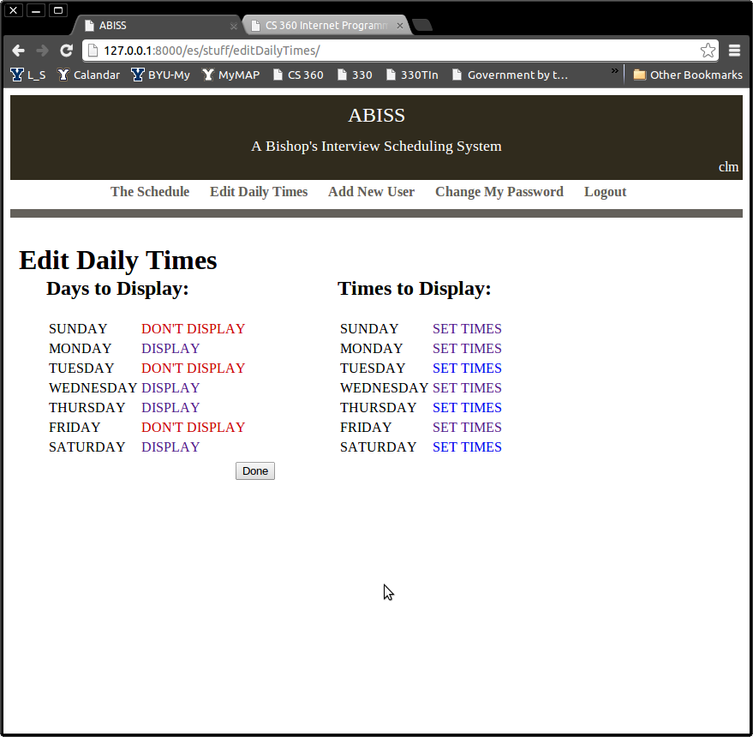 | The next major task for any user is to modify which days and times are displayed for a given user's bishop. The Edit Daily Times page is reached by clicking on the main menu link entitled “Edit Daily Times.” Upon clicking this link the user is taken to the page on the left. This page is populated by looking at the days table.  On the left of the page a list of days appears, with a red link next to each day, that is currently being displayed, allowing the option to not display that day. Also a blue link is displayed allowing the option to display days that are not currently being displayed. For example, on the left Sunday is currently being displayed but one may click the red link “don't display” and have it no longer displayed, or Saturday is not currently being displayed, therefore, one my click the “display” link and have it displayed.  On the right is a list of links that will allow a user to set the times that are displayed for each of the days of the week.  When the user makes a change the change is immediately made in the days table in the database and the page reloaded.
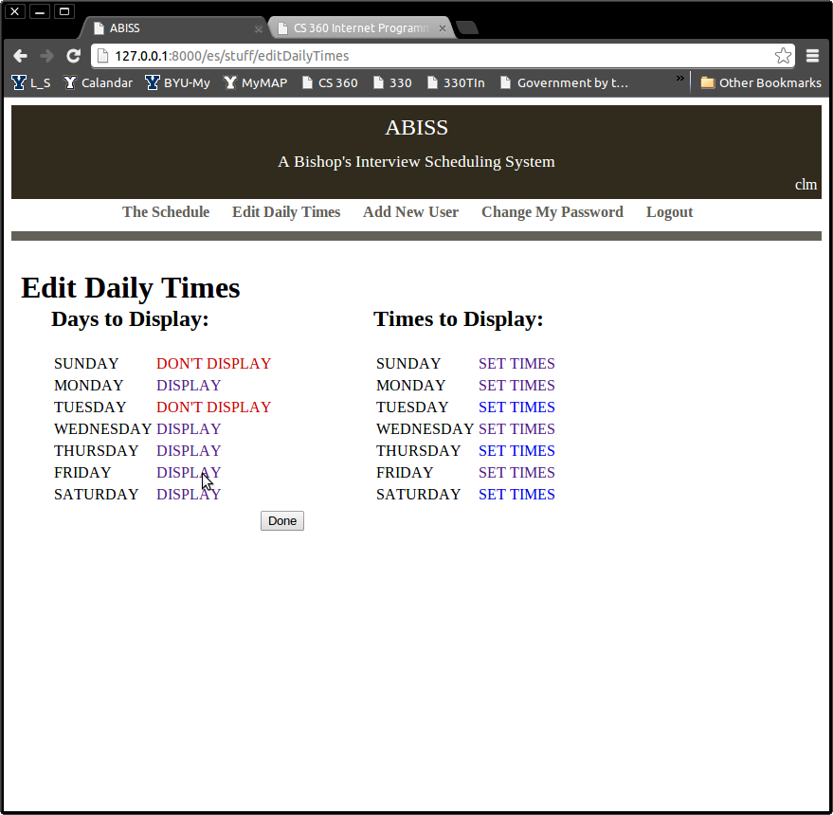 | This screen show the change that is made when a user clicks on the “don't display” link in the previous screen shot, indicating the user would no longer like to display Friday.  When the done button is pressed the user is taken back to the main page.
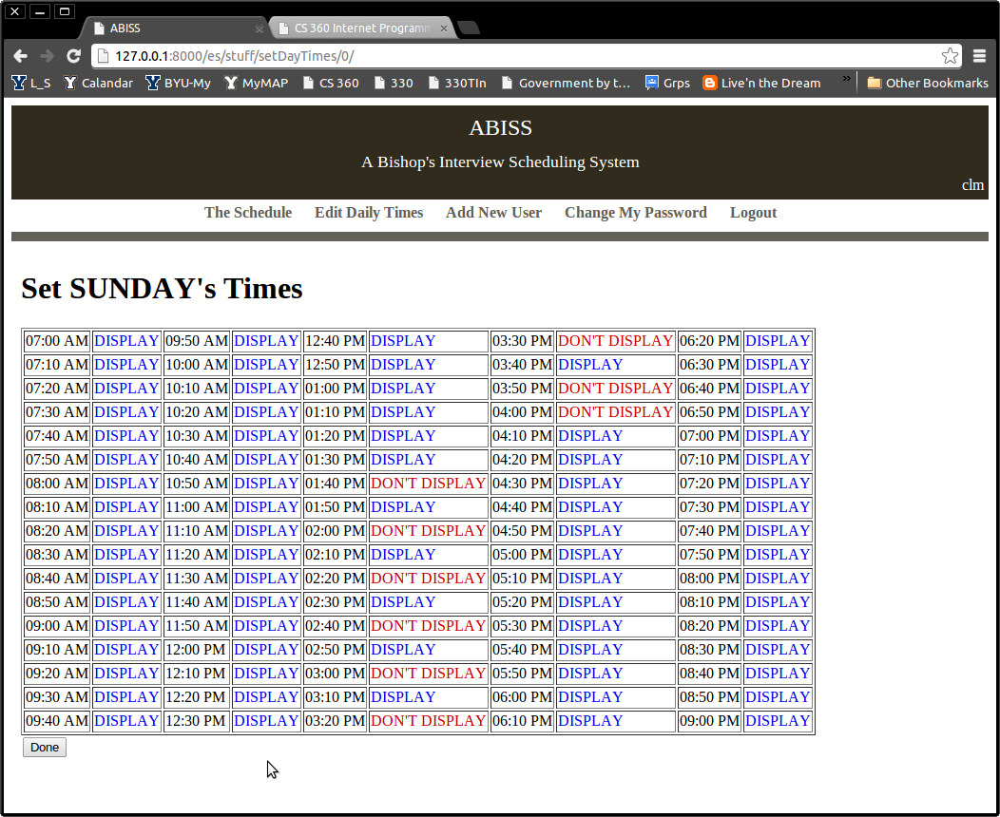 | This page is displayed when the user clicks on any of the “set times” links on the “edit daily times” page. This page displays the day it is editing times for and lists all the time options. Each option has a similar functionality as the “edit daily times” page. In that the user may turn on or off a time being displayed by clicking its corresponding link. The change is immediately made in the data base and the page reloaded.  When the done button is pressed the user is taken back to the “edit daily times” page.
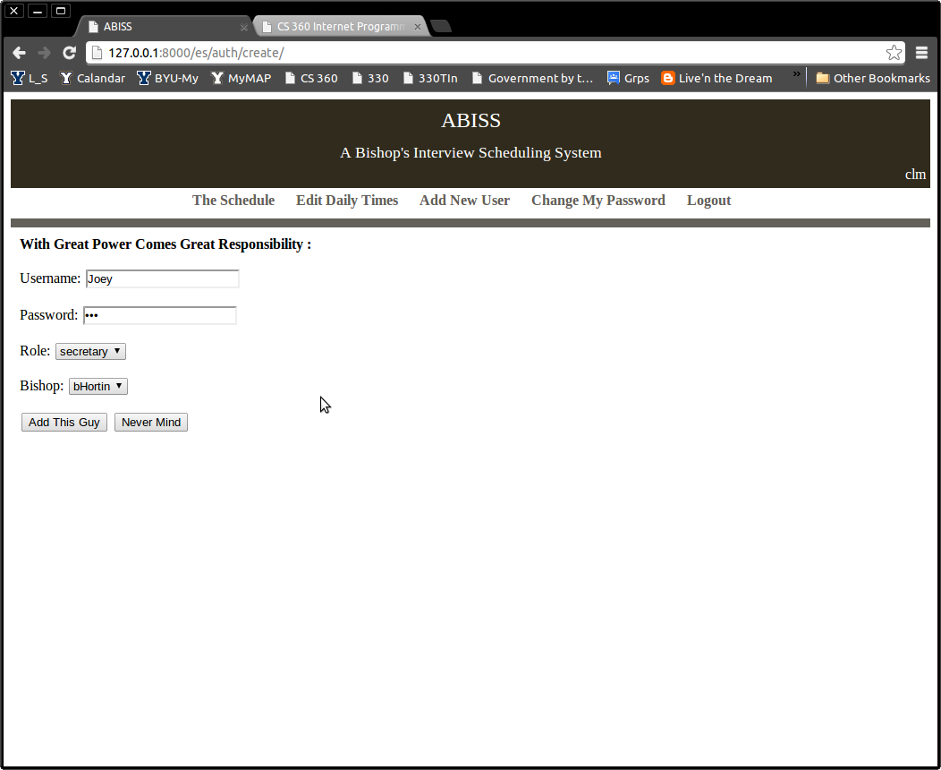 | New user's of the system will only be able to enter the system via an existing user. Therefor the add new user page is provided, as seen on the left. This page is accessible from the main menu link called “Add New User.” This page allows the entry of a user's username, password, role, and bishop. The user may either fill the role of a bishop or a secretary. The user may also only select from existing bishops that are already in the system, however, this rule is ignored if adding a new bishop.  The user's username and password are stored in Django tables, while the user's role and bishop are stored in a UserProfile table. If a new bishop is created the appropriate day and time entries are add to the days and times tables. This information is added upon submission into the mentioned tables and the user is returned to the main page.
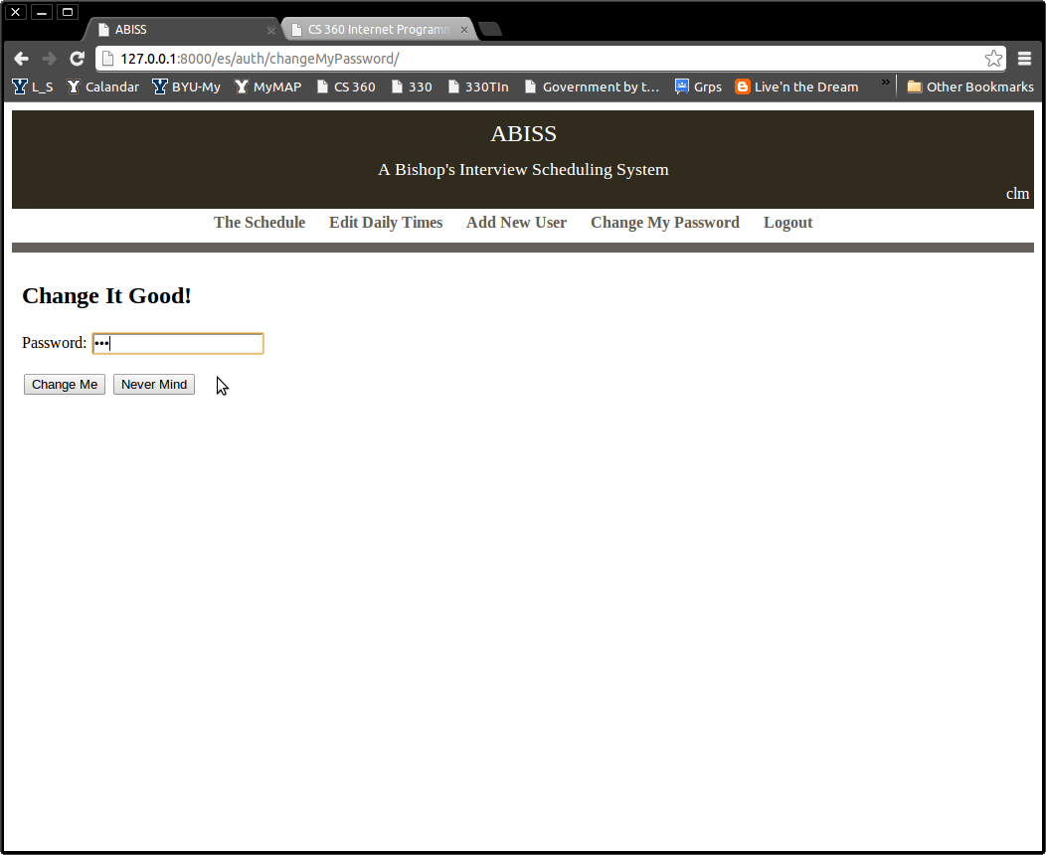 | Because of the nature of adding a new user to the system, there is also a way for each user to change their password. The page on the right, which is used to change a user's password, is reachable from the “Change My Password” link in the main menu.  When a user indicates to change their passwords the Django user's table is immediately updated and the user is return to the main page. The never mind button also returns a user to the main page, but without any modification to the user password.

Database Schema

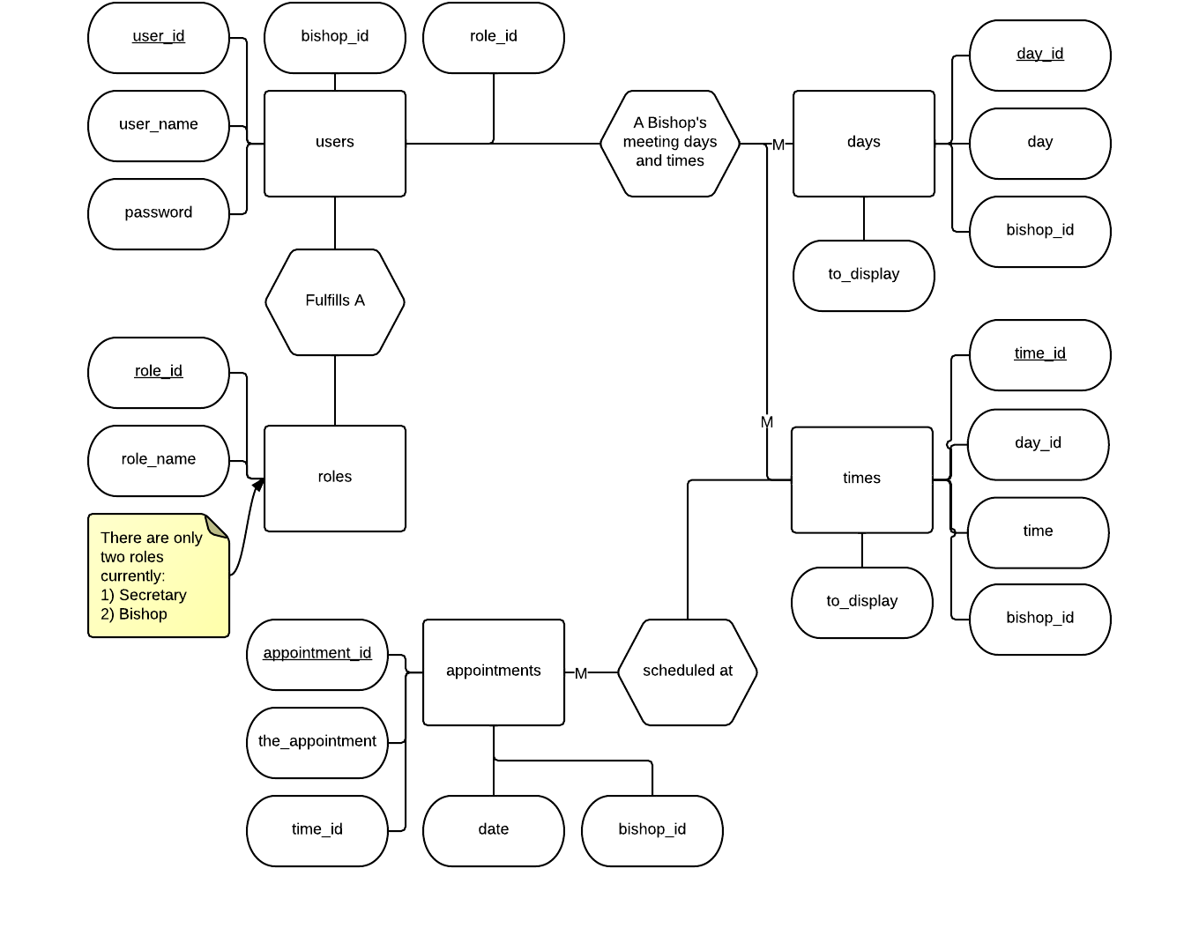
Users | This table is used to store information about the user's able to access the application. It stores each user's role and each user's bishop.
Days | This table is a list of days, which bishop the day belongs to, and wither or not the day should be displayed. This table is used to store wither or not a day for a particular bishop should be displayed.
Times | This table is a list of times from 7:00 AM to 9:00 PM in ten minute intervals. This table stores these times, a set for each bishop, and wither or not the time should be displayed.
Appointments | This table is used to store all of the appointments that are made for a bishop. It stores the appointment, the date of the appointment, the appointments time, and its associated bishop.
Roles | The roles table stores the different roles a user can fill. Currently there are only two, a user is either a bishop or a secretary. If a user is a bishop then appropriate times and days exist in the days and times tables.

Conclusion

- Describe what you learned from this project.
The project in a term was “learning curve.” I was completely new to every aspect of this assignment save a few algorithms. In other words, Python, Django, SQL, HTML, and CSS were all completely new. It was like a semester worth of study crammed into one project, the worst part was that most of it was self taught. To make it explicit I learned about Python, Django, SQL, HTML, and CSS. WOW!

- If you deviated from your initial design, explain how and why. For example, you may have added additional functionality if the specification wasn't clear or you realized something was missing. You may also have fallen short of your expectations; explain why.
There were two major changes from my original design. The first was a change in the bishop's view. This change was neglected because of lack of time. I was going to have the initial page for a bishop be different, be a today's appointments page. However, to do the vertical learning curve, I didn't have time. However, the change would only be slight.

The second major change was in the add page, remove page, and edit day's times page. I originally wanted these pages just to be pop ups from their originating pages, however, do to their technicality, this wasn't possible. In essence, after cramming Python, Django, SQL, HTML, and CSS down my throat there wasn't room, time, nor ambition left to take on Jquery, however, I spent several hours studying the subject.

- Describe what else you would add to the application to make it better, if you had more time.
I would love to spend a ton more time making the site more aesthetically appealing. I would add graphics, animation, pop ups, color, and much more. This is one area I greatly wish I would have more time to work in.

I would also very much like to add the bishop's view page and a notification system. The bishop's page would works as described in the prototype. The notifications would be sent every interview day and notify the bishop of all the appointments for the current day.

I would also spend some more time fine tuning the days and times tables, it currently feels like there is a lot of wasted space.

Additional Documents

- lab 7 protoypte.pdf
- lab 7-Use Cases.pdf

