Christopher LaJon Morgan

CS 470, Brother Goodrich

Homework #1

1. **Create a graph of two functions of your choice by starting MATLAB.   Label the x-axis and y-axis, and give the plots a title.  Print out both the plots to turn in for your homework.**

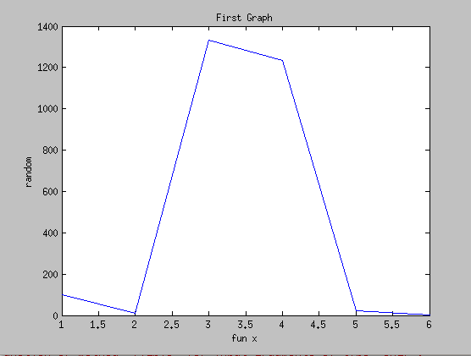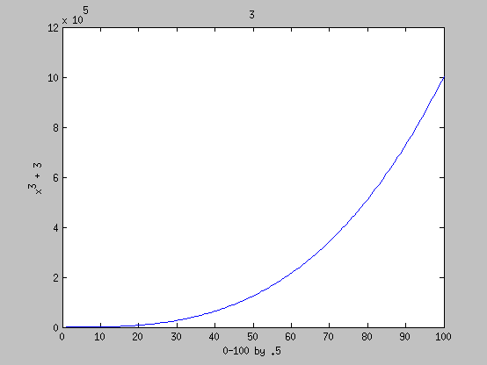

1. **Create histograms of the following vector "x=a*randn(1,1000)-b" for values of (a,b) from the set{(1,0),(10,0), (1,-4),(10,30)}.   Explain the changes in the four figures. Print out both plots to turn in for your homework.**

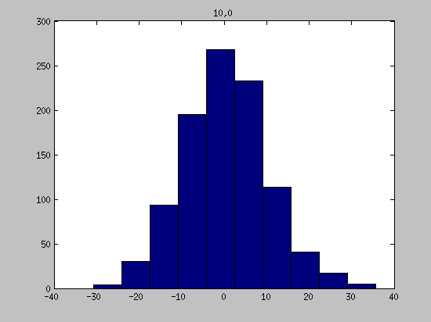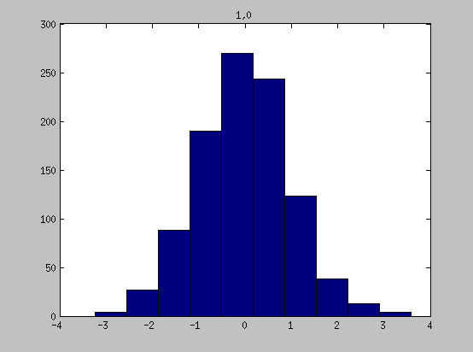

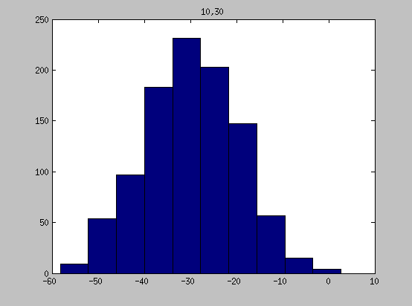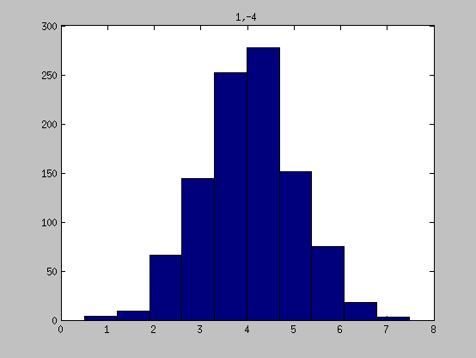

Randn produces random numbers that conform to a normal distribution about zero. Therefore, changes to “a” caused the spread of the distribution to increase, where changes to “b” caused the entire distribution to shit.

1. **Repeat problem 3, but use "hist(x,100);". Print out both plots to turn in for your homework.**

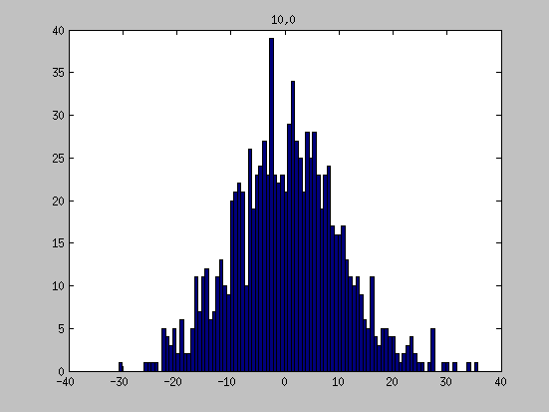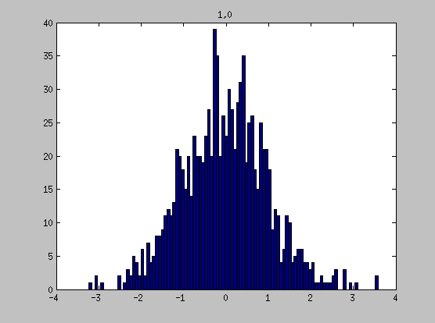

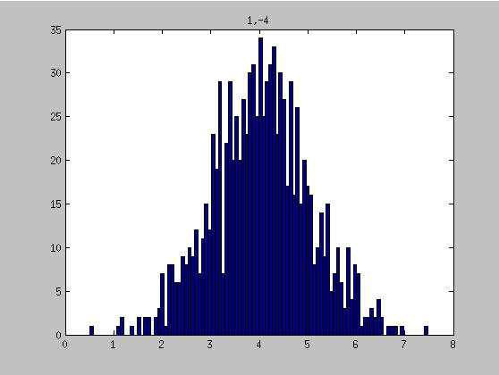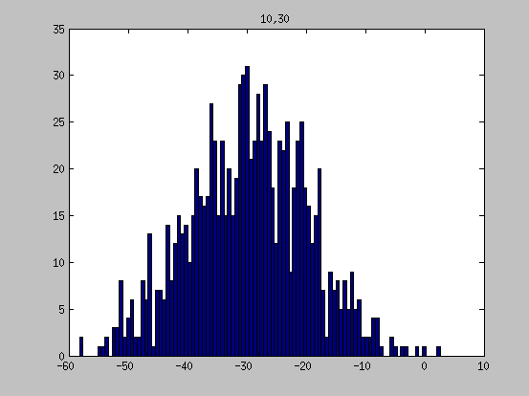

1. **Compare the results of the figures in problems 3 and 4. Discuss why are they different?**

The results in problems 3 and 4 are similar in sifts and spread changes caused by changes to “a” and “b”. However, they appear different only in the appearance of bars. This is because the data is grouped into fewer bins in problem 3 which appears to smooth the distribution.