Christopher LaJon Morgan

Brother Christophe

Project 2: NN / CS 478

Oct 22, 2013

* **Discuss the effect of different learning rates on the algorithm's performance.**

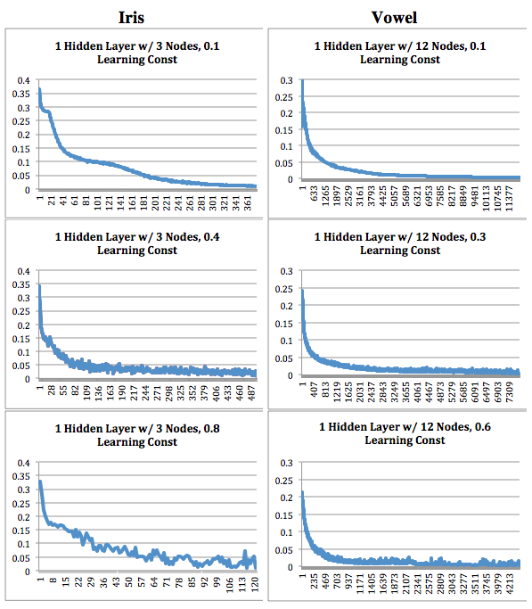

* **Discuss the effect of different numbers of hidden units on the algorithm's performance (1-hidden layer case).**

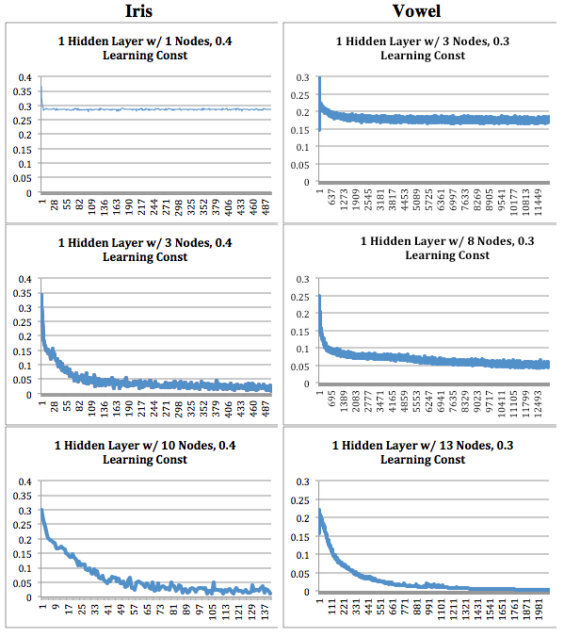

* **Compare your recorded best numbers of hidden nodes for each problem with the following heuristic value: *H*=*N*/(10(*I*+*O*)), where *N* is the size of the (training) data set, *I* is the number of network inputs and *O* is the number of outputs.**
* **How did the momentum term affect the learner's behavior (number of epochs to convergence, final accuracy, etc.)?**

|  |  |
| --- | --- |
|  |  |