

Functional Safety Concept Lane Assistance

**Document Version: 1.0**



# Document history

|  |  |  |  |
| --- | --- | --- | --- |
| Date | Version | Editor | Description |
| 11/24/17 | 1.0 | Chris Ferone | First draft of document |
|  |  |  |  |
|  |  |  |  |
|  |  |  |  |
|  |  |  |  |

# 

# Table of Contents

Document history

Table of Contents

Purpose of the Functional Safety Concept

Inputs to the Functional Safety Analysis

Safety goals from the Hazard Analysis and Risk Assessment

Preliminary Architecture

Description of architecture elements

Functional Safety Concept

Functional Safety Analysis

Functional Safety Requirements

Refinement of the System Architecture

Allocation of Functional Safety Requirements to Architecture Elements

Warning and Degradation Concept

# Purpose of the Functional Safety Concept

The purpose of the functional safety concept is to refine the safety goals into functional requirements.

# Inputs to the Functional Safety Concept

## Safety goals from the Hazard Analysis and Risk Assessment

|  |  |
| --- | --- |
| **ID** | **Safety Goal** |
| Safety_Goal_01 | the oscillating steering torque from the lane departure warning function shall be limited |
| Safety_Goal_02 | the lane keeping assistance function shall be time limited and the additional steering torque shall end after a given time interval so that the driver cannot misuse the system for autonomous driving. |

## Preliminary Architecture

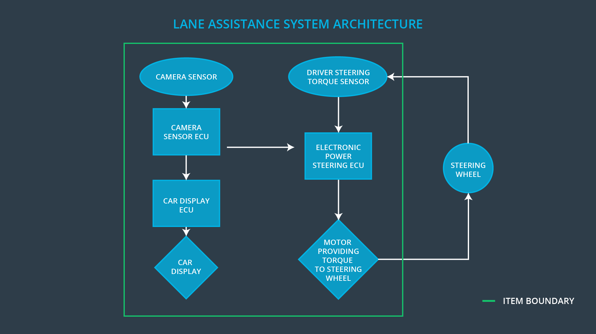

### Description of architecture elements

|  |  |
| --- | --- |
| **Element** | **Description** |
| Camera Sensor | Captures raw image of lane |
| Camera Sensor ECU | Processes camera data to determine vehicle’s position in lane and if a lane departure warning should be issued or if a torque command should be sent to the EPS to keep lane |
| Car Display | Notifies driver if LDW and LKA are enabled and when they become active |
| Car Display ECU | Processes information from Camera Sensor ECU and updates Car Display accordingly |
| Driver Steering Torque Sensor | Measures torque applied to steering wheel by driver |
| Electronic Power Steering ECU | Controls EPS torque. Listens for torque commands from Camera sensor ECU |
| Motor | Applies torque to steering column |

# Functional Safety Concept

The functional safety concept consists of:

* Functional safety analysis
* Functional safety requirements
* Functional safety architecture
* Warning and degradation concept

## Functional Safety Analysis

|  |  |  |  |
| --- | --- | --- | --- |
| **Malfunction ID** | **Main Function of the Item Related to Safety Goal Violations** | **Guidewords (NO, WRONG, EARLY, LATE, MORE, LESS)** | **Resulting Malfunction** |
| Malfunction_01 | Lane Departure Warning (LDW) function shall apply an oscillating steering torque to provide the driver a haptic feedback | MORE | The lane departure warning function applies an oscillating torque with very high torque amplitude (above limit) |
| Malfunction_02 | Lane Departure Warning (LDW) function shall apply an oscillating steering torque to provide the driver a haptic feedback | MORE | The lane departure warning function applies an oscillating torque with very high torque frequency (above limit) |
| Malfunction_03 | Lane Keeping Assistance (LKA) function shall apply the steering torque when active in order to stay in ego lane | NO | The lane keeping assistance function is not limited in time duration which leads to misuse as an autonomous driving function. |

## Functional Safety Requirements

Lane Departure Warning (LDW) Requirements:

|  |  |  |  |  |
| --- | --- | --- | --- | --- |
| **ID** | **Functional Safety Requirement** | **ASIL** | **Fault Tolerant Time Interval** | **Safe State** |
| Functional  Safety  Requirement  01-01 | The lane keeping item shall ensure that the lane departure oscillating torque amplitude is below Max_Torque_Available. | C | 50ms | turn off the functionality |
| Functional  Safety  Requirement  01-02 | The lane keeping item shall ensure that the lane departure oscillating torque frequency is below Max_Torque_Frequency. | C | 50ms | turn off the functionality |

Lane Departure Warning (LDW) Verification and Validation Acceptance Criteria:

|  |  |  |
| --- | --- | --- |
| **ID** | **Validation Acceptance**  **Criteria and Method** | **Verification Acceptance**  **Criteria and Method** |
| Functional  Safety  Requirement  01-01 | validate that a reasonable max torque value was chosen. We would need to test how drivers react to different torque amplitudes to prove that we chose an appropriate value. | verify that when the torque amplitude crosses the limit, the lane assistance output is set to zero within the 50 ms fault tolerant time interval. |
| Functional  Safety  Requirement  01-02 | validate that a reasonable max frequency value was chosen. We would need to test how drivers react to different frequencies to prove that we chose an appropriate value. | verify that when the torque frequency crosses the limit, the lane assistance output is set to zero within the 50 ms fault tolerant time interval. |

Lane Keeping Assistance (LKA) Requirements:

|  |  |  |  |  |
| --- | --- | --- | --- | --- |
| **ID** | **Functional Safety Requirement** | **ASIL** | **Fault Tolerant Time Interval** | **Safe State** |
| Functional  Safety  Requirement  02-01 | the electronic power steering ECU shall ensure that the lane keeping assistance torque is applied for only Max_Duration | B | 500ms | turn off the functionality |

Lane Keeping Assistance (LKA) Verification and Validation Acceptance Criteria:

|  |  |  |
| --- | --- | --- |
| **ID** | **Validation Acceptance**  **Criteria and Method** | **Verification Acceptance**  **Criteria and Method** |
| Functional  Safety  Requirement  02-01 | validate that the max_duration chosen really did dissuade drivers from taking their hands off the wheel | verify that the system really does turn off if the lane keeping assistance every exceeded max_duration |

## Refinement of the System Architecture

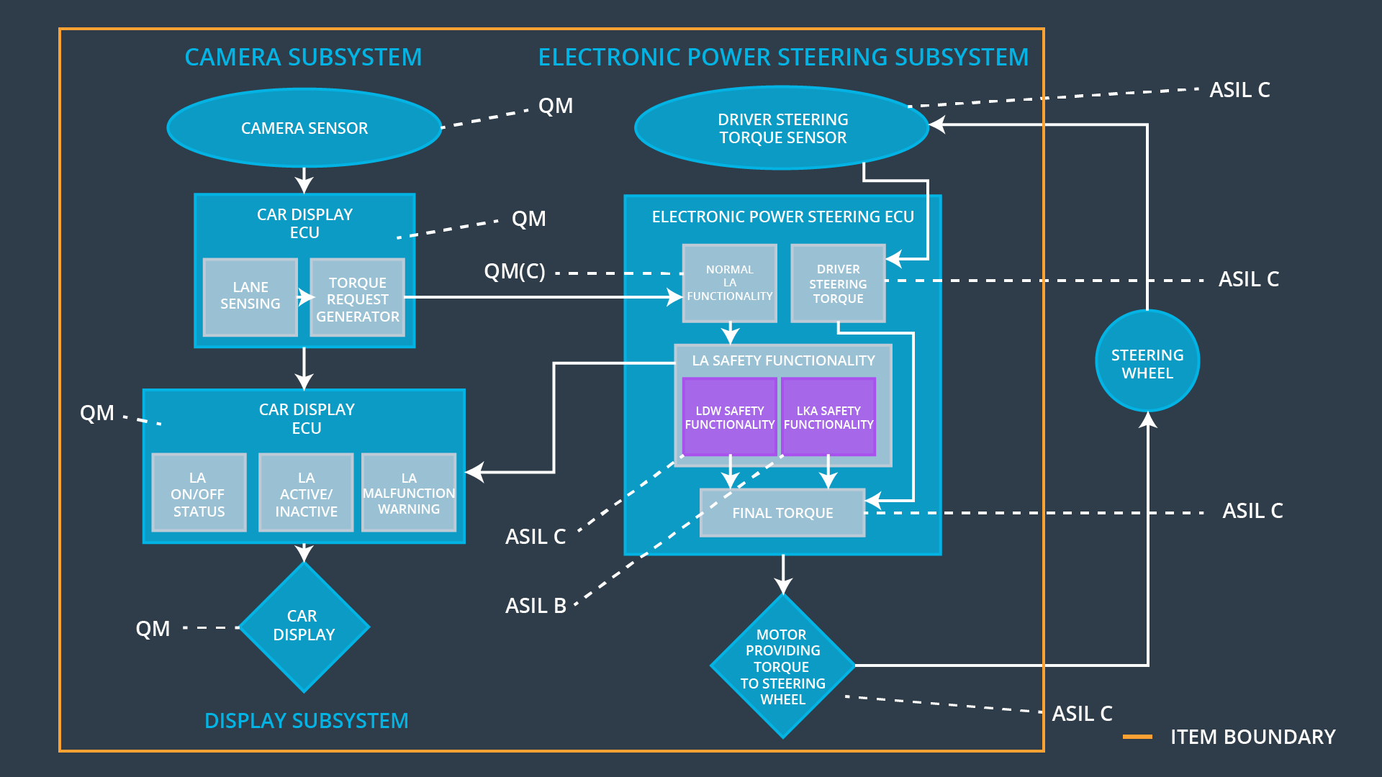

## Allocation of Functional Safety Requirements to Architecture Elements

|  |  |  |  |  |
| --- | --- | --- | --- | --- |
| **ID** | **Functional Safety Requirement** | **Electronic Power Steering ECU** | **Camera ECU** | **Car Display ECU** |
| Functional  Safety  Requirement  01-01 | The electronic power steering ECU shall ensure that the lane departure warning oscillating torque amplitude is below Max_Torque_Amplitude | **x** |  |  |
| Functional  Safety  Requirement  01-02 | The electronic power steering ECU shall ensure that the lane departure warning oscillating torque amplitude is below Max_Torque_Frequency | **x** |  |  |
| Functional  Safety  Requirement  02-01 | the electronic power steering ECU shall ensure that the lane keeping assistance torque is applied for only Max_Duration | **x** |  |  |

## Warning and Degradation Concept

|  |  |  |  |  |
| --- | --- | --- | --- | --- |
| **ID** | **Degradation Mode** | **Trigger for Degradation Mode** | **Safe State invoked?** | **Driver Warning** |
| WDC-01 | turn off the functionality | Malfunction_01, Malfunction_02 | Yes | warning light on the dashboard |
| WDC-02 | turn off the functionality | Malfunction_03 | Yes | warning light on the dashboard |