

Technical Safety Concept Lane Assistance

**Document Version 1.0**



# Document history

|  |  |  |  |
| --- | --- | --- | --- |
| Date | Version | Editor | Description |
| 11/24/17 | 1.0 | Chris Ferone | First draft of document. |
|  |  |  |  |
|  |  |  |  |
|  |  |  |  |
|  |  |  |  |

# 

# Table of Contents

Document history

Table of Contents

Purpose of the Technical Safety Concept

Inputs to the Technical Safety Concept

Functional Safety Requirements

Refined System Architecture from Functional Safety Concept

Functional overview of architecture elements

Technical Safety Concept

Technical Safety Requirements

Refinement of the System Architecture

Allocation of Technical Safety Requirements to Architecture Elements

Warning and Degradation Concept

# Purpose of the Technical Safety Concept

The purpose of the technical safety concept is look in greater detail at functional safety requirements. These requirements oftentimes define signal flow and look at the system elements and components.

# Inputs to the Technical Safety Concept

## Functional Safety Requirements

|  |  |  |  |  |
| --- | --- | --- | --- | --- |
| **ID** | **Functional Safety Requirement** | **ASIL** | **Fault Tolerant Time Interval** | **Safe State** |
| Functional  Safety  Requirement  01-01 | The lane keeping item shall ensure that the lane departure oscillating torque amplitude is below Max_Torque_Available. | C | 50ms | turn off the functionality |
| Functional  Safety  Requirement  01-02 | The lane keeping item shall ensure that the lane departure oscillating torque frequency is below Max_Torque_Frequency. | C | 50ms | turn off the functionality |
| Functional  Safety  Requirement  02-01 | the electronic power steering ECU shall ensure that the lane keeping assistance torque is applied for only Max_Duration | B | 500ms | turn off the functionality |

## Refined System Architecture from Functional Safety Concept

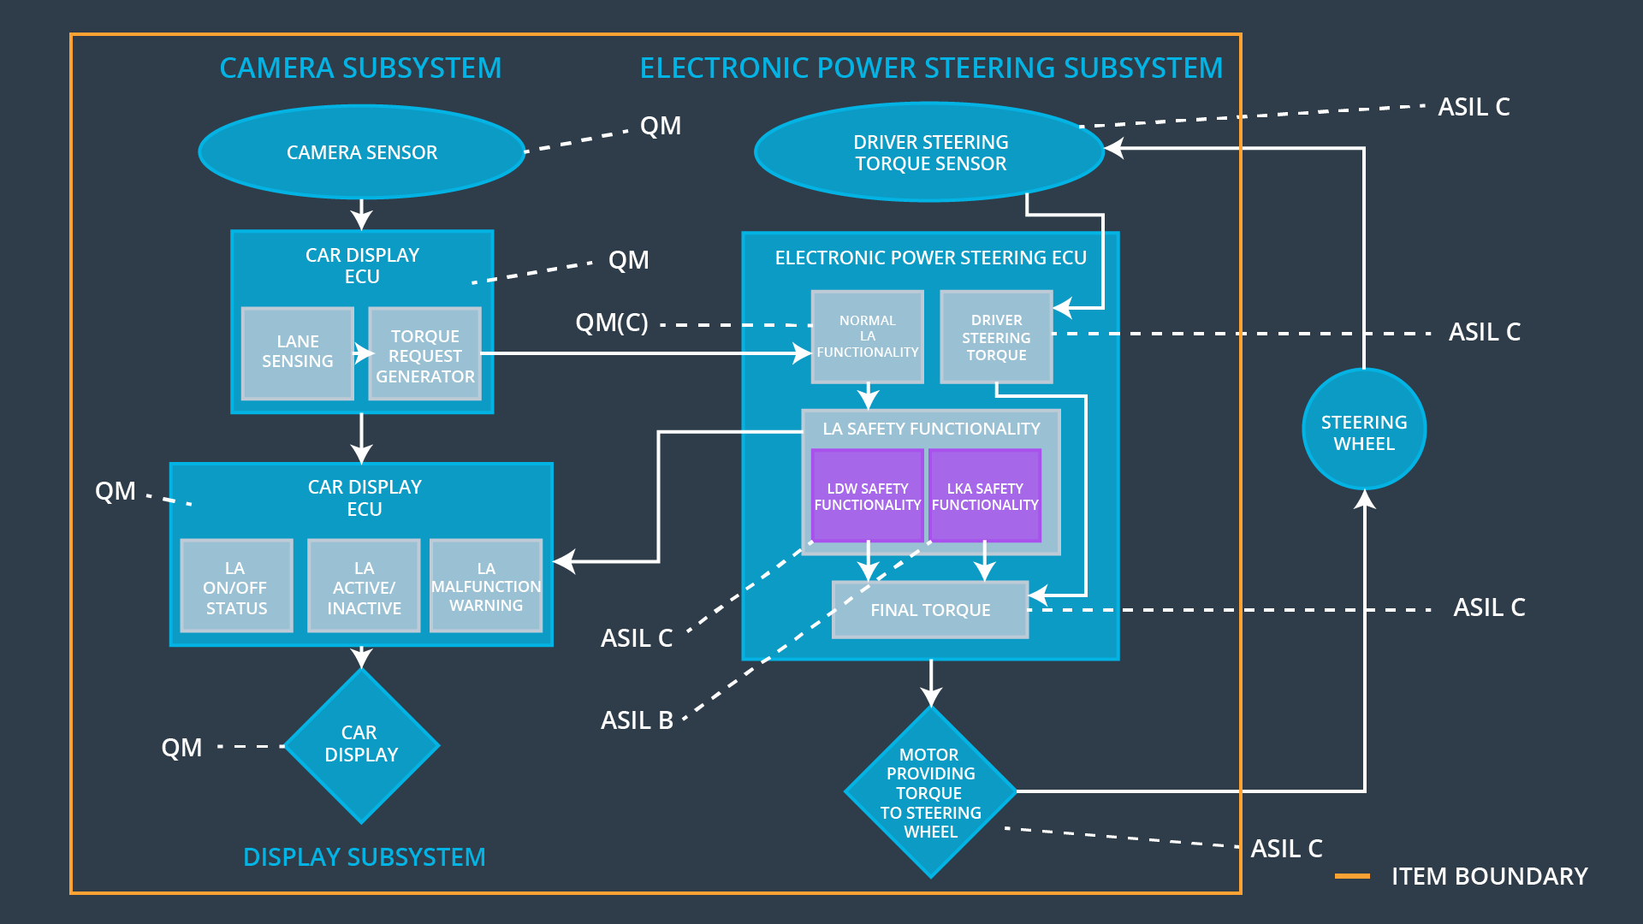

### 

### Functional overview of architecture elements

|  |  |
| --- | --- |
| **Element** | **Description** |
| Camera Sensor | Captures raw image of lane |
| Camera Sensor ECU - Lane Sensing | Detect lane lines within image |
| Camera Sensor ECU - Torque request generator | Determine torque needed to move vehicle back into lane |
| Car Display | Notifies driver if LDW and LKA are enabled and when they become active |
| Car Display ECU - Lane Assistance On/Off Status | Notify driver LKA is on/off |
| Car Display ECU - Lane Assistant Active/Inactive | Notify driver LKA is active/inactive |
| Car Display ECU - Lane Assistance malfunction warning | Notify driver LKA system has malfunctioned |
| Driver Steering Torque Sensor | Measures torque applied to steering wheel by driver |
| Electronic Power Steering (EPS) ECU - Driver Steering Torque | Adjust final torque request based on driver steering torque input |
| EPS ECU - Normal Lane Assistance Functionality | Passes torque requests from Camera Sensor ECU to Safety Functionality module |
| EPS ECU - Lane Departure Warning Safety Functionality | Passes LDW torque request to final torque module if memory and data integrity checks pass |
| EPS ECU - Lane Keeping Assistant Safety Functionality | Passes LKA torque request to final torque module if memory and data integrity checks pass |
| EPS ECU - Final Torque | Final Motor Torque request, after limits are applied, commanded by EPS |
| Motor | Applies torque to steering column |

# Technical Safety Concept

## Technical Safety Requirements

**Lane Departure Warning (LDW) Requirements:**

Functional Safety Requirement 01-01 with its associated system elements

(derived in the functional safety concept)

|  |  |  |  |  |
| --- | --- | --- | --- | --- |
| **ID** | **Functional Safety Requirement** | **Electronic Power Steering ECU** | **Camera ECU** | **Car Display ECU** |
| Functional  Safety  Requirement  01-01 | The lane keeping item shall ensure that the lane departure oscillating torque amplitude is below Max_Torque_Amplitude | X |  |  |

Technical Safety Requirements related to Functional Safety Requirement 01-01 are:

|  |  |  |  |  |  |
| --- | --- | --- | --- | --- | --- |
| **ID** | **Technical Safety Requirement** | **ASIL** | **Fault Tolerant Time Interval** | **Architecture Allocation** | **Safe State** |
| Technical  Safety  Requirement  01 | The LDW safety component shall ensure that the amplitude of the ‘LDW_Torque_Request’ sent to the ‘Final electronic power steering Torque’ component is below ‘Max_Torque_Amplitude’ | C | 50ms | LDW safety software component | The LDW torque request amplitude shall be set to zero |
| Technical  Safety  Requirement  02 | The validity and integrity of the data transmission for ‘LDW_Torque_Request’ signal shall be ensured | C | 50ms | Data Transmission Integrity Check | N/A |
| Technical  Safety  Requirement  03 | As soon as a failure is detected by the LDW function, it shall deactivate the LDW feature and the ‘LDW_Torque_Request’ shall be set to zero. | C | 50ms | LDW safety software component | The LDW torque request amplitude shall be set to zero |
| Technical  Safety  Requirement  04 | As soon at the LDW function deactivates the LDW feature, the ‘LDW Safety’ software block shall send a signal to the car display ECU to turn on a warning light. | C | 50ms | LDW safety software component | The LDW torque request amplitude shall be set to zero |
| Technical  Safety  Requirement  05 | Memory test shall be conducted at startup of the EPS ECU to check for any faults in memory. | A | Length of vehicle ignition cycle | Safety Startup – Memory Test | The LDW torque request amplitude shall be set to zero |

Functional Safety Requirement 01-2 with its associated system elements

(derived in the functional safety concept)

|  |  |  |  |  |
| --- | --- | --- | --- | --- |
| **ID** | **Functional Safety Requirement** | **Electronic Power Steering ECU** | **Camera ECU** | **Car Display ECU** |
| Functional  Safety  Requirement  01-02 | The lane keeping item shall ensure that the lane departure oscillating torque frequency is below Max_Torque_Frequency | X |  |  |

Technical Safety Requirements related to Functional Safety Requirement 01-02 are:

|  |  |  |  |  |  |
| --- | --- | --- | --- | --- | --- |
| **ID** | **Technical Safety Requirement** | **ASIL** | **Fault Tolerant Time Interval** | **Architecture Allocation** | **Safe State** |
| Technical  Safety  Requirement  01 | The LDW safety component shall ensure that the frequency of the ‘LDW_Torque_Request’ sent to the ‘Final electronic power steering Torque’ component is below ‘Max_Torque_Frequency’ | C | 50ms | LDW safety software component | The LDW torque request frequency shall be set to zero |
| Technical  Safety  Requirement  02 | The validity and integrity of the data transmission for ‘LDW_Torque_Request’ signal shall be ensured | C | 50ms | Data Transmission Integrity Check | N/A |
| Technical  Safety  Requirement  03 | As soon as a failure is detected by the LDW function, it shall deactivate the LDW feature and the ‘LDW_Torque_Request’ shall be set to zero. | C | 50ms | LDW safety software component | The LDW torque request frequency shall be set to zero |
| Technical  Safety  Requirement  04 | As soon at the LDW function deactivates the LDW feature, the ‘LDW Safety’ software block shall send a signal to the car display ECU to turn on a warning light. | C | 50ms | LDW safety software component | The LDW torque request frequency shall be set to zero |
| Technical  Safety  Requirement  05 | Memory test shall be conducted at startup of the EPS ECU to check for any faults in memory. | A | Length of vehicle ignition cycle | Safety Startup – Memory Test | The LDW torque request frequency shall be set to zero |

**Lane Departure Warning (LDW) Verification and Validation Acceptance Criteria:**

**Lane Keeping Assistance (LKA) Requirements:**

Functional Safety Requirement 02-1 with its associated system elements

(derived in the functional safety concept)

|  |  |  |  |  |
| --- | --- | --- | --- | --- |
| **ID** | **Functional Safety Requirement** | **Electronic Power Steering ECU** | **Camera ECU** | **Car Display ECU** |
| Functional  Safety  Requirement  02-01 | The lane keeping item shall ensure that the lane keeping assistance torque is applied for only Max_Duration | X |  |  |

Technical Safety Requirements related to Functional Safety Requirement 02-01 are:

|  |  |  |  |  |  |
| --- | --- | --- | --- | --- | --- |
| **ID** | **Technical Safety Requirement** | **ASIL** | **Fault Tolerant Time Interval** | **Allocation to Architecture** | **Safe State** |
| Technical  Safety  Requirement  01 | The LKA safety component shall ensure that that ‘LKA_Torque_Request’ sent to the ‘Final electronic power steering Torque’ component is applied for only Max_Duration | B | 500ms | LKA safety software component | The LKA torque request shall be set to zero |
| Technical  Safety  Requirement  02 | The validity and integrity of the data transmission for ‘LKA_Torque_Request’ signal shall be ensured | B | 500ms | Data Transmission Integrity Check | N/A |
| Technical  Safety  Requirement  03 | As soon as a failure is detected by the LKA function, it shall deactivate the LKA feature and the ‘LKA_Torque_Request’ shall be set to zero. | B | 500ms | LKA safety software component | The LKA torque request shall be set to zero |
| Technical  Safety  Requirement  04 | As soon at the LKA function deactivates the LKA feature, the ‘LKA Safety’ software block shall send a signal to the car display ECU to turn on a warning light. | B | 500ms | LKA safety software component | The LKA torque request shall be set to zero |
| Technical  Safety  Requirement  05 | Memory test shall be conducted at startup of the EPS ECU to check for any faults in memory. | A | Length of vehicle ignition cycle | Safety Startup – Memory Test | The LKA torque request shall be set to zero |

**Lane Keeping Assistance (LKA) Verification and Validation Acceptance Criteria:**

## Refinement of the System Architecture

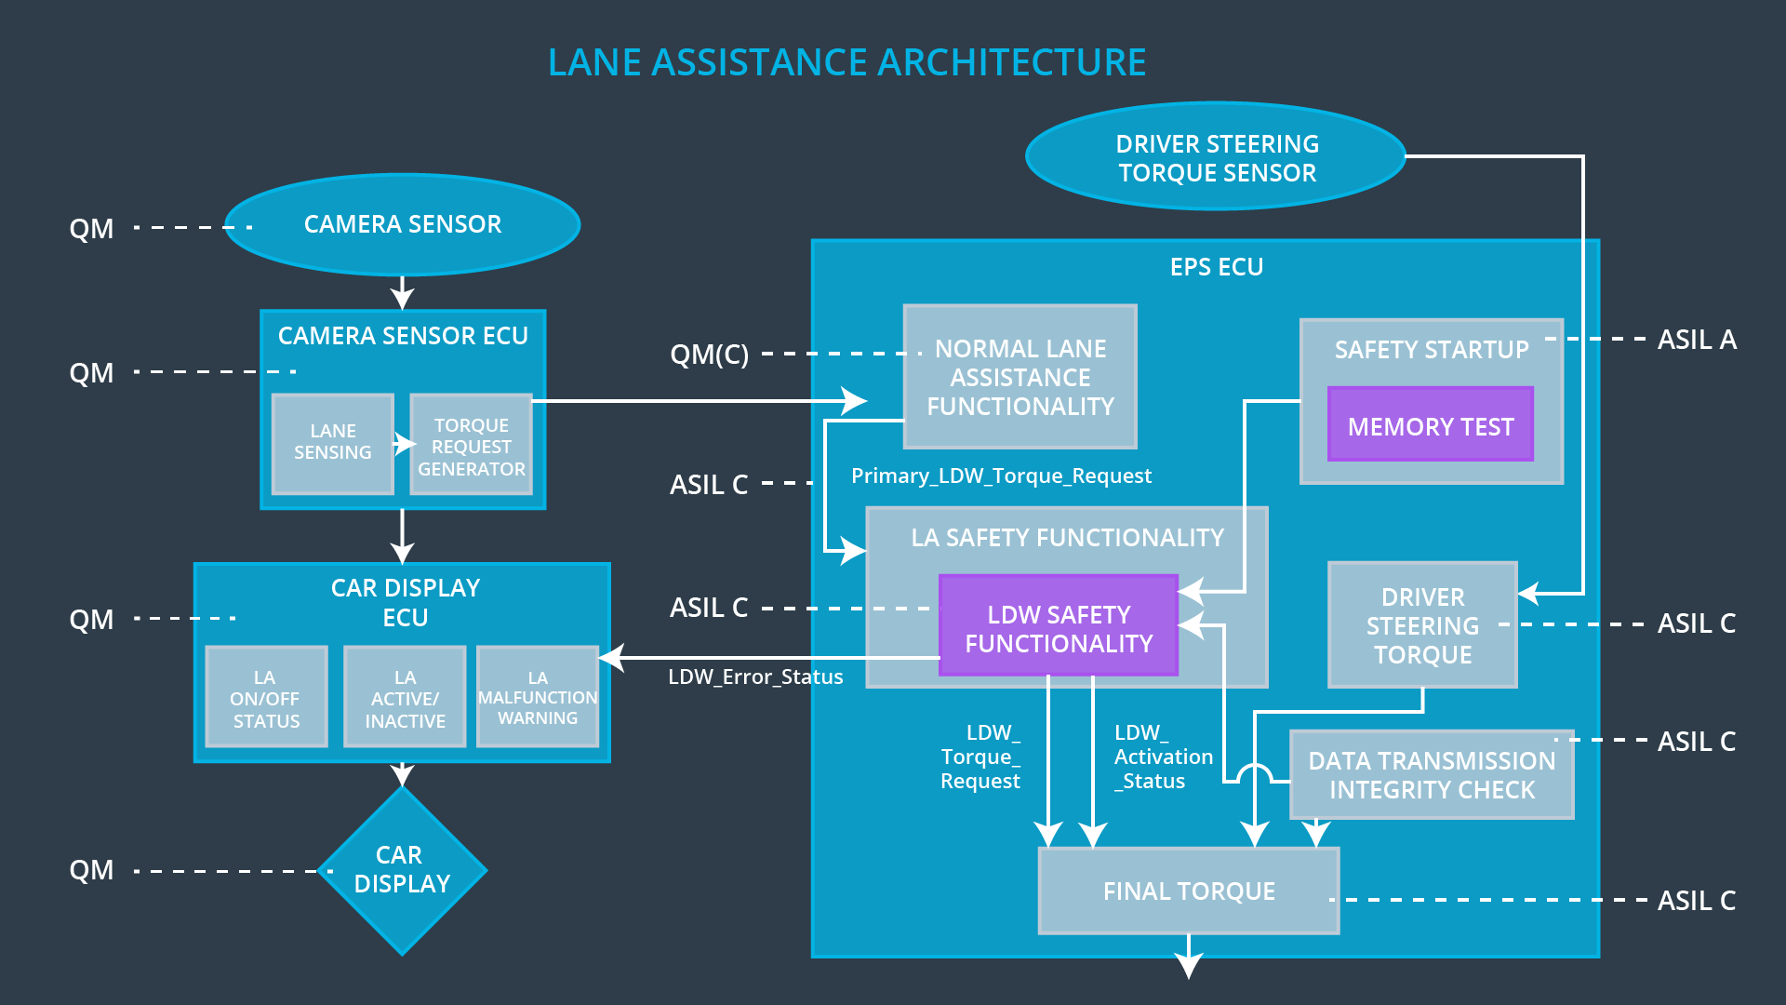

## Allocation of Technical Safety Requirements to Architecture Elements

All technical safety requirements are allocated to the Electronic Power Steering ECU.

## Warning and Degradation Concept

|  |  |  |  |  |
| --- | --- | --- | --- | --- |
| **ID** | **Degradation Mode** | **Trigger for Degradation Mode** | **Safe State invoked?** | **Driver Warning** |
| WDC-01 | turn off the functionality | Malfunction_01, Malfunction_02 | Yes | warning light on the dashboard |
| WDC-02 | turn off the functionality | Malfunction_03 | Yes | warning light on the dashboard |