A)

from pandas import read_excel

from random import sample

from sklearn.model_selection import train_test_split

from sklearn.tree import DecisionTreeClassifier, export_graphviz

from sklearn.metrics import classification_report, confusion_matrix

import matplotlib.pyplot as plt

import graphviz

def read_data():

table = read_excel("P4Data.xlsx")

data_sets = []

classes = []

for x, y, c in zip(table['X'], table['Y'], table['Class']):

data_sets.append([x, y])

classes.append([c])

return (data_sets, classes)

def get_testing_indicies(training_indices, data_size):

testing_indicies = []

for index in range(data_size):

if index not in training_indices:

testing_indicies.append(index)

return testing_indicies

def build_50_by_50():

lst = []

for i in range(1, 51):

for j in range(1, 51):

lst.append([i, j])

return lst

def sort_pred(coords, pred):

pred0x = []

pred0y = []

pred1x = []

pred1y = []

for i in range(len(pred)):

if pred[i] == 0:

pred0x.append(coords[i][0])

pred0y.append(coords[i][1])

else:

pred1x.append(coords[i][0])

pred1y.append(coords[i][1])

return (pred0x, pred0y, pred1x, pred1y)

def create_graph(coords, pred):

pred0x, pred0y, pred1x, pred1y = sort_pred(coords, pred)

plt.plot(pred0x, pred0y, 'ks', pred1x, pred1y, 'rs')

plt.xlabel('x')

plt.ylabel('y')

plt.title('Decision Tree Predictions')

plt.axis([0, 50, 0, 50])

plt.show()

def main():

(data_sets, classes) = read_data()

x_train, x_test, y_train, y_test = train_test_split(

data_sets, classes, test_size=.30)

classifier = DecisionTreeClassifier()

classifier.fit(x_train, y_train)

y_pred = classifier.predict(x_test)

print(confusion_matrix(y_test, y_pred))

print(classification_report(y_test, y_pred))

dot_data = export_graphviz(classifier, out_file=None, feature_names=[

'X', 'Y'], class_names=['0', '1'])

graph = graphviz.Source(dot_data)

graph.render("iris")

n_test = build_50_by_50()

n_pred = classifier.predict(n_test)

m_test = data_sets

m_pred = classifier.predict(m_test)

create_graph(n_test, n_pred)

create_graph(m_test, m_pred)

if __name__ == "__main__":

main()



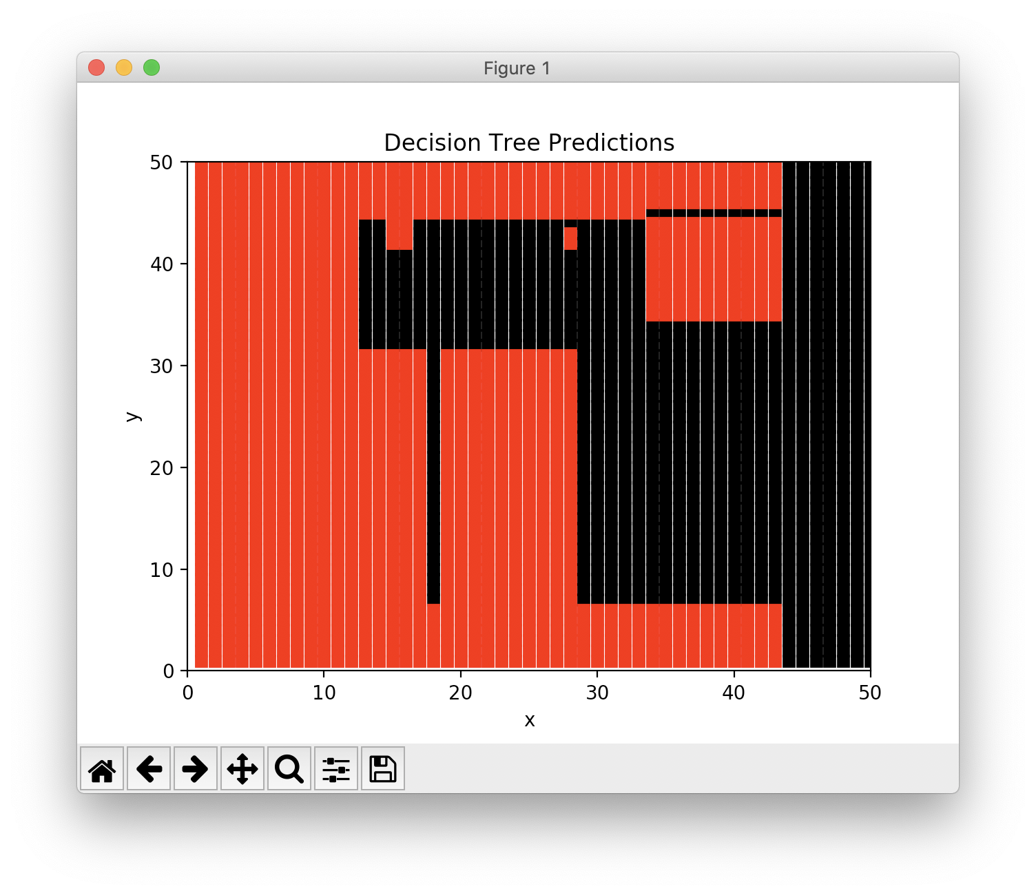

50x50 data points plotted with the classifier

Plotted excel document values for reference

In the graphs above, the black points represent coordinate points that the classifier predicted to be in class 0 and the red points are those predicted to be in class 1. Looking at the 50x50 graph, the class 1 points seem to trend towards the left (generally x < 30) and at the top and bottom (y > 45 and y < 7). The class 0 categorized points tended to be in the x < 44 area and in a couple of boxes in the middle area.

The black line at about x = 18 seems out of place, looking at the scatter plot of the excel values. There doesn’t appear to be any indication that that would be a class 0 area, so I would just have made that area red from y = 31 down to y=0 at x = 18. Otherwise, given the small amount of data the classifier has to work with, the areas appear to be fairly correct.

B) Perceptron

Final: 4, -1, 10, 3