等式优化问题的求解
本题分别为用有可行初始点的标准牛顿方法，不可行初始点的牛顿方法和对偶牛顿方法求解等式优化问题。
根据第四章的等式优化问题的求解方法，编写代码，运行结果如下（代码见最后）:
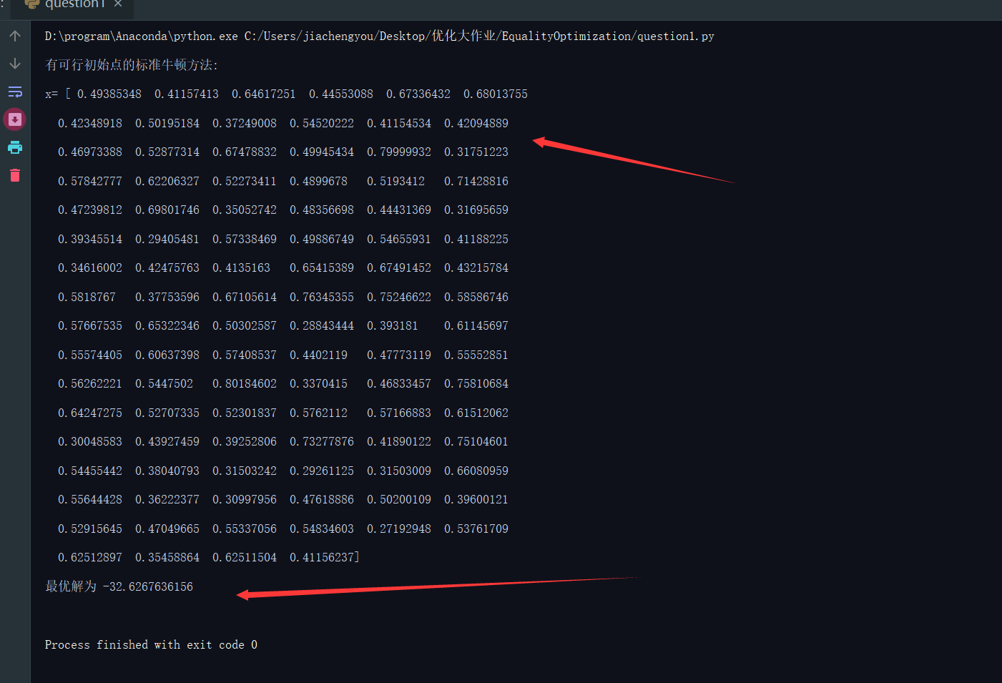
有可行初始点的标准牛顿方法
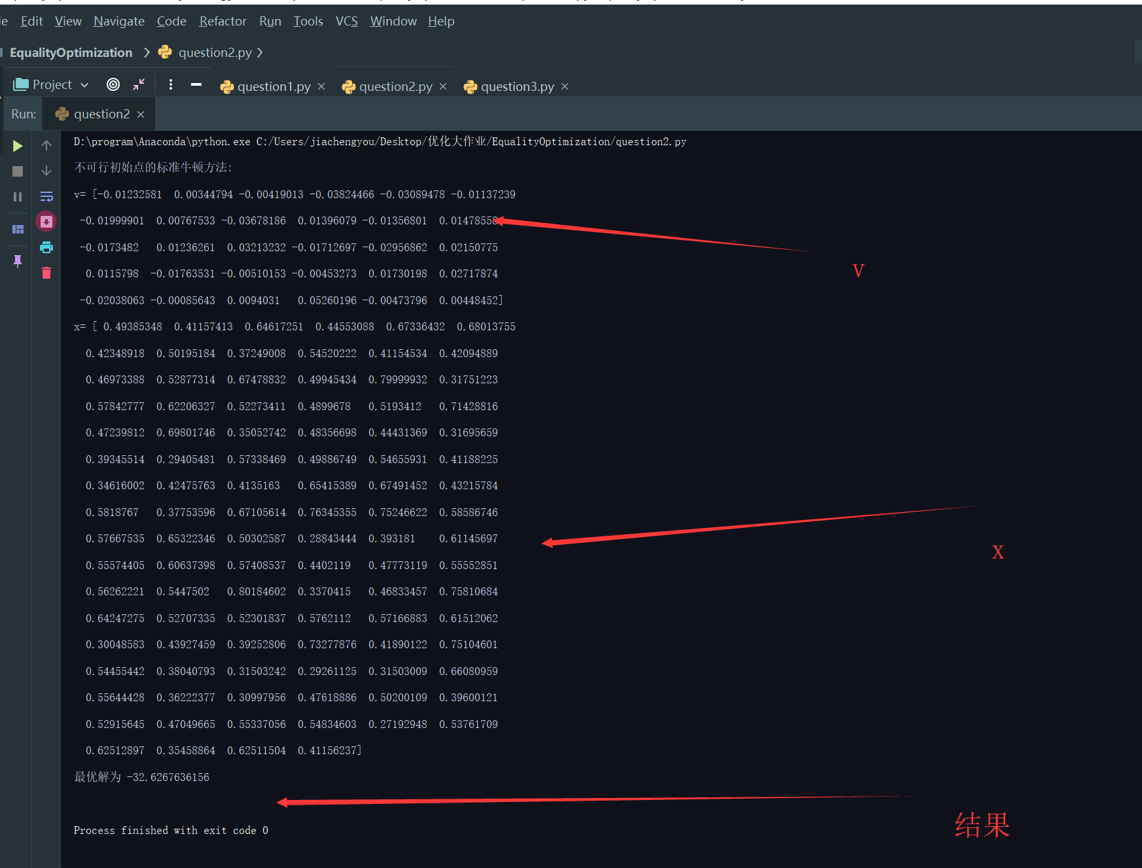

不可行初始点的牛顿方法
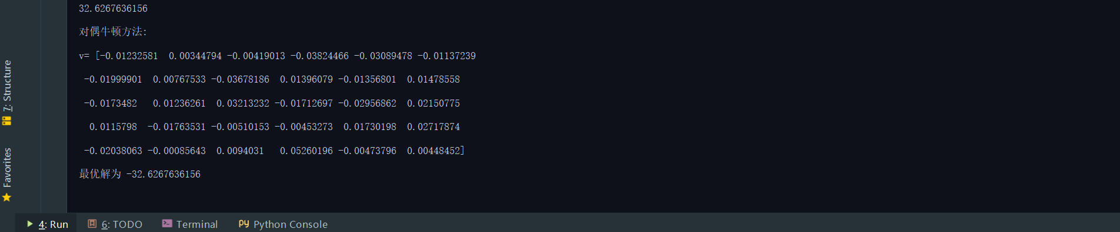
对偶牛顿方法
由上面用三种方法求出来的结果可以看出，三者方法具有相同的最优解（从23可以看出拉格朗日因子也相同），同时也具有相同的最优解。

代码：
问题一：
#!/usr/bin/env python
# -*- coding:utf-8 _*-

"""
@author:Jiachengyou(贾成铕)
@license: Apache Licence
@file: question1.py
@time: 2019/06/08
@contact: 1284975112@qq.com
@site:
@software: PyCharm

"""
import numpy as np

# 有可行初始解

# 产生0,10之间的随机数
def generateA(p, n):
return np.random.rand(p, n)*10

# 产生0,1的x_hat
def generate_x_hat(n):
return np.random.rand(n, 1)

def fun(x):
result = 0
for i in x:
result = i*np.log(i) + result
return result

def calc_grad(x):
return np.log(x) + 1

def calc_hessian(x):
len = x.size
result = np.zeros((len, len))
for i in range(len):
result[i][i] = 1/x[i]
return result

def calc_dk(hessian, A, grad, p):
len = grad.size
zero1 = np.zeros((p, p))
zero2 = np.zeros(p)
neg_grad = -grad

# 进行拼接组合
A_col1 = np.concatenate((hessian, A), axis=0)
A_t = A.T
A_col2 = np.concatenate((A_t, zero1), axis=0)
A_new = np.concatenate((A_col1, A_col2), axis=1)
b_new = np.concatenate((neg_grad, zero2), axis=0)

# 计算
x_new = np.linalg.solve(A_new, b_new)
dk = x_new[:len]
w = x_new[len:]
return dk, w

def calc_lambda_k2(dk, hessian):
dk_t = dk.T
lambda_k2 = np.dot(np.dot(dk, hessian), dk_t)
return lambda_k2

if __name__ == '__main__':
p = 30
n = 100
# 已保存
# A = generateA(p, n)
# x_hat = generate_x_hat(n)
# np.savetxt('matrix_A.txt', A)
# np.savetxt('matrix_x_hat.txt', x_hat)

# 读取 设初值
A = np.loadtxt('matrix_A.txt')
x_hat = np.loadtxt('matrix_x_hat.txt')
b = np.dot(A, x_hat)

# 1.给定x_hat为初始点

x = x_hat
error_value = 1e-25

# 2.确定牛顿方向和牛顿减少量
# 进行矩阵拼接

hessian = calc_hessian(x)
grad = calc_grad(x)

dk,w = calc_dk(hessian, A, grad, p)
lambda_k2 = calc_lambda_k2(dk, hessian)

# 3.停止准则
while lambda_k2/2 > error_value :
# 给定α,β,tk
alpha = 0.2
beta = 0.5
tk = 1
# 4.回溯直线搜索
while( fun(x+tk*dk) > fun(x)-alpha*tk*lambda_k2) :
tk = beta*tk

# 5. 新的数据
x = x + tk*dk
hessian = calc_hessian(x)
grad = calc_grad(x)
dk, w = calc_dk(hessian, A, grad, p)
lambda_k2 = calc_lambda_k2(dk, hessian)

print('有可行初始点的标准牛顿方法:')
print('x=', x)
print('最优解为', fun(x))

问题二：
#!/usr/bin/env python
# -*- coding:utf-8 _*-

"""
@author:Jiachengyou(贾成铕)
@license: Apache Licence
@file: question2.py
@time: 2019/06/08
@contact: 1284975112@qq.com
@site:
@software: PyCharm

"""
import numpy as np

# 不可行初始解

# 产生0,10之间的随机数
def generateA(p, n):
return np.random.rand(p, n)*10

# 产生0,1的x_hat
def generate_x_hat(n):
return np.random.rand(n, 1)

def fun(x):
result = 0
for i in x:
result = i*np.log(i) + result
return result

def calc_grad(x):
return np.log(x) + 1

def calc_hessian(x):
len = x.size
result = np.zeros((len, len))
for i in range(len):
result[i][i] = 1/x[i]
return result

def calc_dk(hessian, A, grad, b, v, p):
len = grad.size
zero1 = np.zeros((p, p))

# 进行拼接组合
A_col1 = np.concatenate((hessian, A), axis=0)
A_t = A.T
A_col2 = np.concatenate((A_t, zero1), axis=0)
A_new = np.concatenate((A_col1, A_col2), axis=1)

new_b_rol1 = grad + np.dot(A_t, v)
new_b_rol2 = np.dot(A, x) - b
b_new = -np.concatenate((new_b_rol1, new_b_rol2), axis=0)

# 计算
x_new = np.linalg.solve(A_new, b_new)
dk = x_new[:len]
dv = x_new[len:]
return dk, dv

def calc_lambda_k2(dk, hessian):
dk_t = dk.T
lambda_k2 = np.dot(np.dot(dk, hessian), dk_t)
return lambda_k2

def calc_r_matrix(x, v, A, b):
A_t = A.T
rol1 = calc_grad(x) + np.dot(A_t, v)
rol2 = np.dot(A, x) - b
r_matrix = np.concatenate((rol1, rol2), axis=0)
return r_matrix

def calc_norm2(mat):
return np.sqrt(np.sum(mat**2))

if __name__ == '__main__':
p = 30
n = 100
# 已保存
# A = generateA(p, n)
# x_hat = generate_x_hat(n)
# np.savetxt('matrix_A.txt', A)
# np.savetxt('matrix_x_hat.txt', x_hat)

# 读取 设初值
A = np.loadtxt('matrix_A.txt')
x_hat = np.loadtxt('matrix_x_hat.txt')
b = np.dot(A, x_hat)

# 1.给定x_hat为初始点

x = x_hat
v = np.ones(p)
error_value = 1e-10

# 2.确定dk,dv
# 进行矩阵拼接

hessian = calc_hessian(x)
grad = calc_grad(x)

dk,dv = calc_dk(hessian, A, grad, b, v, p)

# 3.停止准则 等式条件怎么搞
while calc_norm2(calc_r_matrix(x, v, A, b)) > error_value :
# 给定α,β,tk
alpha = 0.2
beta = 0.5
tk = 1
# 4.回溯直线搜索
while calc_norm2(calc_r_matrix(x+tk*dk, v+tk*dv, A, b)) > (1-alpha*tk)*calc_norm2(calc_r_matrix(x, v, A, b)) :
tk = beta*tk
# 5. 新的数据
x = x + tk*dk
v = v + tk*dv
hessian = calc_hessian(x)
grad = calc_grad(x)
dk, dv = calc_dk(hessian, A, grad, b, v, p)

print('不可行初始点的标准牛顿方法:')
print('v=', v)
print('x=',x)
print('最优解为',fun(x))

问题三：
#!/usr/bin/env python
# -*- coding:utf-8 _*-

"""
@author:Jiachengyou(贾成铕)
@license: Apache Licence
@file: question3.py
@time: 2019/06/08
@contact: 1284975112@qq.com
@site:
@software: PyCharm

"""
import numpy as np

# 求解对偶问题

# 产生0,10之间的随机数
def generateA(p, n):
return np.random.rand(p, n)*10

# 产生0,1的x_hat
def generate_x_hat(n):
return np.random.rand(n, 1)

def fun(x, b, A):
result = -np.dot(b,x)
n = x.size
for i in range(100):
result = result - np.exp(-np.dot(x,A[:,i])-1)
return -result

def calc_grad(x, b, A):
n = x.size
result = np.zeros(n)
for i in range(n):
sum = 0
for k in range(100):
sum = sum + A[i][k]*np.exp(-np.dot(x,A[:,k])-1)
result[i] = -b[i] + sum
return -result

def calc_hessian(x, A):
n = x.size
result = np.zeros((n,n))
for i in range(n):
for j in range(n):
num = 0
for k in range(100):
num = num + A[i][k]*A[j][k]*np.exp(-np.dot(x,A[:,k])-1)
result[i][j] = -num
return -result

def calc_dk(hessian, grad):
dk = -np.dot(np.linalg.inv(hessian), grad)
return dk

def calc_lambda_k2(dk, hessian):
dk_t = dk.T
lambda_k2 = np.dot(np.dot(dk, hessian), dk_t)
return lambda_k2

if __name__ == '__main__':
p = 30
n = 100
# 已保存
# A = generateA(p, n)
# x_hat = generate_x_hat(n)
# np.savetxt('matrix_A.txt', A)
# np.savetxt('matrix_x_hat.txt', x_hat)

# 读取 设初值
A = np.loadtxt('matrix_A.txt')
x_hat = np.loadtxt('matrix_x_hat.txt')
b = np.dot(A, x_hat)

# 1.给定x_hat为初始点

x = x_hat
error_value = 1e-25

# 2.确定牛顿方向和牛顿减少量
# 进行矩阵拼接
x = np.ones(p)*0.1
hessian = calc_hessian(x, A)
grad = calc_grad(x, b, A)

dk = calc_dk(hessian, grad)
lambda_k2 = calc_lambda_k2(dk, hessian)
#
while lambda_k2/2 > error_value :
# 给定α,β,tk
alpha = 0.2
beta = 0.5
tk = 1
# 4.回溯直线搜索
while( fun(x+tk*dk,b,A) > fun(x,b,A)-alpha*tk*lambda_k2) :
tk = beta*tk
# 5. 新的数据
x = x + tk*dk
hessian = calc_hessian(x,A)
grad = calc_grad(x,b,A)
dk = calc_dk(hessian, grad)
lambda_k2 = calc_lambda_k2(dk, hessian)
print(fun(x, b, A))

print('对偶牛顿方法:')# 这里的x为v('v=',x)
print('最优解为',-fun(x,b,A))

