Study cohort
A total of xxx male patients who underwent prospective matched tumor and normal genomic profiling using either one of the MSK-IMPACT 341, 410, 468 or 505 gene panel (citation) were included in this study (Figure 1A). Myeloid and lymphoid tumors were excluded (http://www.cbioportal.org/oncotree/). We chose one sample per patient, and further excluded samples with chromosome Y aneuploidies in the matched normal samples. Mosaic loss of chromosome Y (mLOY) is the most common somatic genetic aberration and is associated with increased risk for all-cause mortality, Alzheimer’s disease, cancer, and other common human malignancies (citations). mLOY was studied on peripheral blood tissue from xxx male samples (Figure) with no history of hematological malignancies before or at the timepoint of sampling. The 99% confidence interval around the expected chromosome Y ploidies were calculated and samples with a ploidy < 0.76 were considered as mLOY (Figure 1C). Overall, we observed xxx normal samples (2%) with mLOY. Furthermore, a significant negative correlation (ANOVA, p < 0.001) was found between age and mLOY, indicating that mLOY increases with age (Figure 1D, citation). Conversely, we applied the same hypothesis to the X-chromosome and observed that a chromosome X decay is not associated with age (ANOVA, p = 0.43, supplementary figure). The remaining xxx samples were subject to FacetsY, a modification of the existing functionality of the Facets algorithm (citation). Finally, xxx samples were discarded due to not meeting individual copy-number fit quality metrics (Methods). Among the retained cancer types, COAD (…%), LUAD (…%) and PRAD are among the most prominent cancer-types analysed (Figure 1, B).
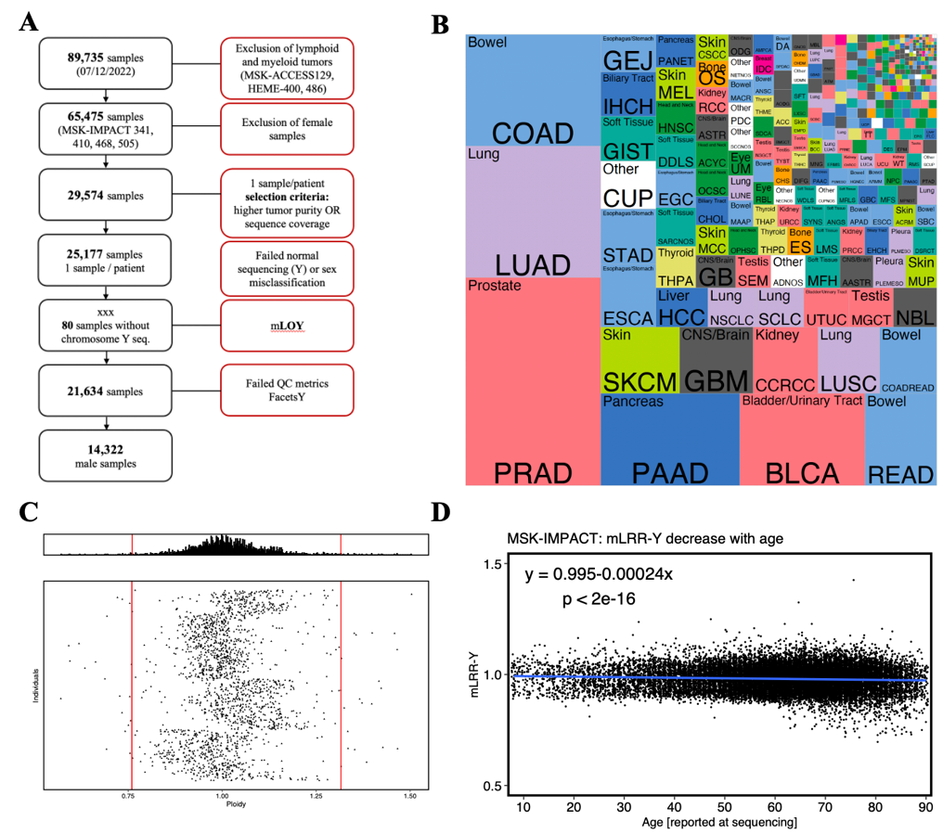
Figure 1: Cohort overview and assessment of somatic mosaicism of the Y-chromosome (mLOY). A) Flow diagram showing the selection criteria for the final analysis cohort. B) Treeplot showing the relative contribution of individual cancer types considered for subsequent analysis. C) The upper histogram shows the distribution whereas the lower jitter-plot highlight estimated chromosome Y ploidies (black triangles) in xxx men. The red lines indicate the lower and upper 99% confidence interval. D) Age (x-axis) was plotted again individual chromosome Y ploidies. The blue curve with corresponding intercept and slope was determined via linear regression. Abbreviations in B) are found in supplementary table 1

MSK-IMPACT is suitable for chromosome Y loss determination
Accurate sequence read-depth distribution is of uttermost importance for copy number estimation (Krumm et al., 2012; Shen & Seshan, 2016). Thus, we started to investigate tumor/normal sequencing files, speculating about biased coverage data given the repetitive nature of the Y-chromosome (Skaletsky et al., 2003). Although MSK-IMPACT sequencing assays include only 13 baits on the Y-chromosome (supplementary table), we found that 63 transcriptional and non-transcriptional active elements (63/429, 14.7%) were covered with >20 sequence reads. Out of these, only 17 elements (of which 13 are protein coding genes, Figure 2A) were covered in more than 75% of tumor samples analyzed, indicating that most genetic elements are covered by off-target reads. Of note, while persistent sequence coverage was seen for 15 genes, CCNQP2 and PARP4P1 were not captured using either on of gene panel IM3 or IM5 (supplementary figure). Next, we assessed the average mapping qualities of aligned sequencing reads at retained genetic loci to ensure proper read-depth distributions. Three genes, namely FAM197Y1, CHEK2P1 and PCDH11Y showed an average mapping quality (BWA-MAPQ) < 22 indicating ambiguous alignments and hence biased read-depth distribution. (Figure 2B). For PCDH11Y it makes sense, considering the close nucleotide similarity with its X-homolog, PCDH11X (citation). Equally, CHEK2P1 is part of the centromere which is known to contain a lot of tandem repeats (citation). With the exclusion of those regions, an aggregate length of 20.4 Mb [total range: 2,654 – 27,800 kbp] which corresponds to roughly 34% of the Y-chromosome was accessible for copy-number determination.
We further assessed the breadth and depth of sequence coverage of retained elements (Figure 2C). 10 genes showed coverage at only < 20% of its coding sequence with sequencing depth ranging from 45- 187X indicating that subsequent gene copy number calls are impeded. For example, the protein coding gene ubiquitin specific peptidase 9 Y-Linked, USP9Y consist of 44 coding exons and an aggregate length of 10,036 bps, however we only saw coverage at exon 22 (0.14% of coding sequence covered) indicating a rather specific snapshot of this given gene. On the contrary, 88.5% of KDM5D coding sequence is covered by sequencing reads with an average of 81.2 reads meaning that this gene is represented by almost its entirety (Figure 2C).
FacetsY, a modified version of an existing state-of-the-art algorithm (citation) was deployed for copy-number and chromosome Y loss determination. Before applying this method to our pancancer cohort (Figure 1A), we gathered intuition about the validity of our approach using a whole exome sequencing (WES) validation cohort. Specifically, a cohort of n=950 WES samples where we have corresponding MSK-IMPACT samples were analyzed, knowing that WES samples showed significantly more per-base coverage at the Y-chromosome (wilcoxon-test, p-value < 2.2e-16; supplementary figure). FacetsY was run on both the matched MSK-IMPACT and WES-recaptured samples respectively, and we used the median copy-number log ratio (CnLR [median]) of the Y-chromosome to compare the calls across the two datasets. We found a good correlation (pearson’s r: 97.5; p-value < 2.2-e16) between the two datasets, suggesting that MSK-IMPACT, even with reduced genomic representation provide enough information to estimate the same chromosome Y calls (Figure 2C). A small number of samples deviates from the expectations (i.e., y = x) and those are discussed in the supplementary figure (). Finally, we used purity estimates to assess the overall agreement between the copy-number fits and found a reasonable correlation (pearson’s r: 90.0; p-value < 2.2-e16) suggesting that the overall fits are okay as well. Taken together, MSK-IMPACT panel sequencing provides enough information to assess chromosome Y loss.
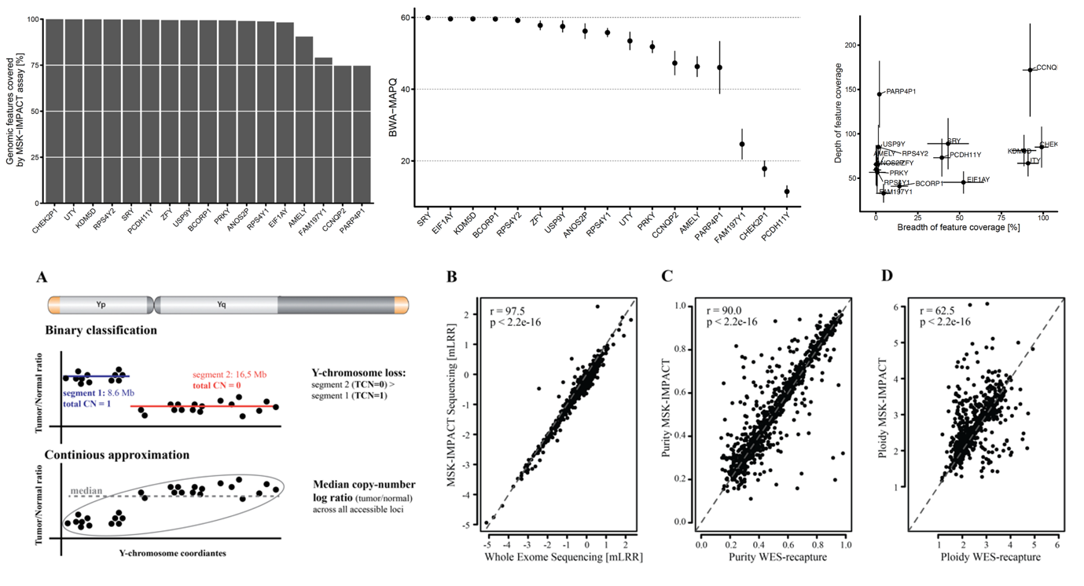
Figure 2: MSK-IMPACT depicts a reliable tool to assess chromosome Y loss in tumor samples. A) 17 (x-axis) loci where sequencing read coverage was observed in >75% of tumor samples analyzed. B) Average mapping qualities (BWA-MAPQ) of selected loci. C) Breadth (x-axis) expressed as percentage of coding sequence covered by sequencing reads is plotted again the average depth (y-axis) of retained elements. D) Cartoon showing i) the accessible genomic region for copy-number calling (light grey in the top plot), ii) the logic of the binary classification approach which was chosen for all samples analyzed and iii) the continuous approximation which was used to compare copy-number estimates from the Y-chromosome between MSK-IMPACT and WES-recaptured cancer samples. Note that, all individual tumor/normal ratios (black dots) are randomly placed and not scaled with the outline of the Y-chromosome on the top. E) The median log-ratio (tumor/normal) between whole exome sequenced (x-axis) and MSK-IMPACT sequenced (y-axis) are plotted. The grey dashed line indicates the expectation of y = x. Plots F, G, show the estimates for purity and ploidy respectively.

mLOY
Age-related somatic loss of chromosome Y (mLOY) is frequent in normal hematopoietic cell (citation), and association with risk of all-cause mortality was validated in an independent cohort (citation; Forsberg). We determined the mLOY status of individual samples due to the necessity for subsequent analysis. Specifically, since tumor copy-number analysis with Facets depend on matched normal samples, we wanted to rule out the possibility of false positives. MSK-IMPACT has proven as solid basis to estimate mLOY from targeted gene panel sequencing experiments. Our method was confirmed by applying the same logic to chromosome 22 (supplementary figure). We chose a binary approach, meaning that we didn’t quantify the fraction of cells suffering from mLOY, however, we assume that true mLOY samples are excluded. We found a clear link with age and further confirmed that this trend was not seen for chromosome X (supplementary figure). Lastly, our conservative estimation of xxx% mLOY is in great accordance with previous literature (8.2% in Forsberg 2014, 1.34% 76-80 years Guttenbach et al 1995; doi:10.1007/s00439-020-02114-w).

MSK-IMPACT is suitable for chromosome Y loss determination
MSK-IMPACT gene panels were not designed to include any specific targets from the Y-chromosome. However, apart from 13 baits that are included we saw a variable number of off-targets reads covering 13 genetic elements at reasonable qualities. The reduced representation of the Y-chromosome leads us to compare Y chromosome calls in a validation cohort of n=950 WES sequenced samples with a significantly higher per-base coverage. We found a significant correlation between two methods, reinsuring that even with reduced sequence representation that the chromosome Y calls are the same. We admit that the average coverage on the Y-chromosome is much lower than the average coverage of the autosomes (600X : 100 X), however, since copy-number analysis tools rely on T/N ratios, we see that both Normal / Tumor are within the same range.

Detection of chromosome Y mosaicism (mLOY)
We used peripheral blood tissue to detect chromosome Y aneuploidies (i.e., mLOY)(citation). Matched blood samples are collected at the timepoint of tumor sample acquisition and sequenced using MSK-IMPACT panel testing if consent was given to protocol IRB #12-245 (citation). We deployed the MADSEQ R-package to determine the sequencing read-depth and GC information for each targeted region (http://ykong2.github.io/MADSEQ/). Targeted regions were dependent on the gene panel deployed, ranging from 6623 tiling intervals for MSK-IMPACT 341, to 9488 for MSK-IMPACT 505. Of these, 13 baits were designed to enrich genomic DNA from chromosome Y (Supplementary table 1). Sequence coverage was corrected by GC content using a loess regression.
The estimation of mLOY was performed by comparing the median read depth on chromosome Y in relation to the full genome (i.e., mLRR-Y; citation). Expected ploidies were obtained by multiplying individual mLRR-Y estimates by two with the subsequent correction for batch effects using the local regression median from a kernel density estimation (Danielsson et al., 2020, Forsberg et al., 2014, citation). Next, we determined the 99% confidence interval (CI) of expected chromosome Y ploidies and defined that samples that show chromosome Y ploidies < 0.76 (supplementary figure) are deemed as mLOY. Samples designates as mLOY were discarded and not included in chromosome Y loss studies.

Determination of sequence coverage
Gene annotations (Ensembl, GRCh38.p3) of chromosome Y were obtained via the R/Bioconductor package biomaRt (Durinck et al., 2009, accession data 07/01/2022). We used the liftover-tool (https://genome.ucsc.edu/cgi-bin/hgLiftOver) to transfer given annotations to the GRCh37/hg19 coordinates. DNA elements with no distinct descriptions (HGNC) were excluded. This approach yielded annotations for 429 transcriptional and non-transcriptional active elements. We used Rsamtools (Morgan et al., 2022) to assess sequence coverage and mapping qualities at given genetic loci (n=429). For this purpose, we deployed the scanBam and countBam modules with flags: isUnmappedQuery = FALSE, isNotPassingQualityControls = FALSE, isSecondaryAlignment = FALSE, isDuplicate = FALSE. Subsequent read-depth data (i.e., count-matrices) from tumor/normal pairs were obtained using the snp-pileup function using default parameters (https://github.com/mskcc/htstools). SNP locations were retrieved from the single nucleotide polymorphism database (dbSNP) build 137 for humans.

Supplementary table 1: Baits (tiling intervals) deployed for chromosome Y DNA enrichment for MSK-IMPACT gene panels 341, 410, 468 and 505.
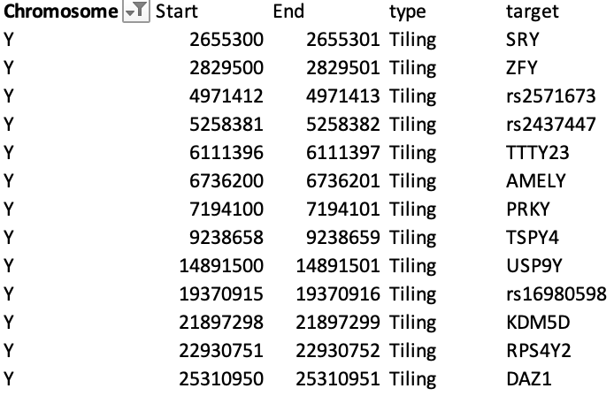

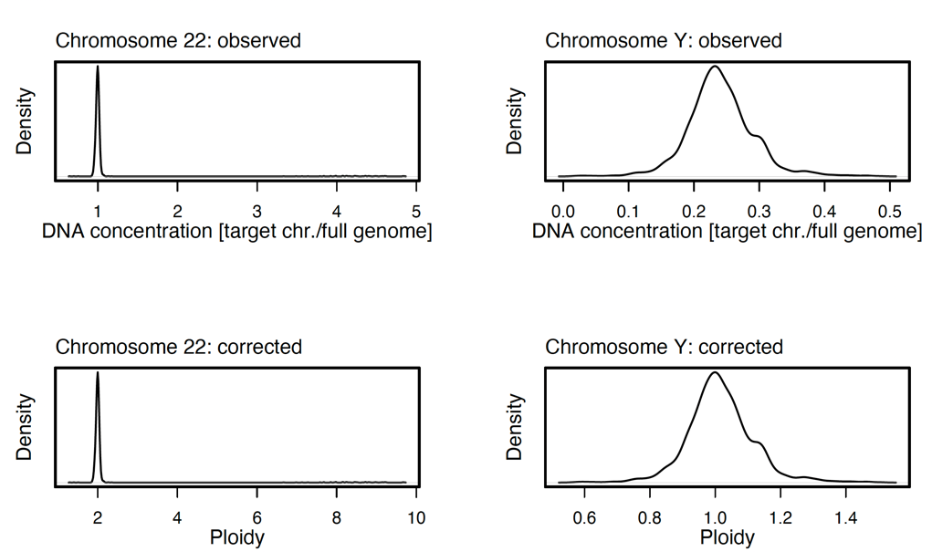
Supplementary figure 1: mLOY estimation after accounting for experimental variation. Validation that chosen approach is correct. As an approximation chromosome 22 was chosen.

Supplementary figure 2: Somatic chromosome X decay is not associated with age. Plotted are age against individual mLRR-X values. The blue curve was determined with a linear regression model showing no evidence of a negative trend.
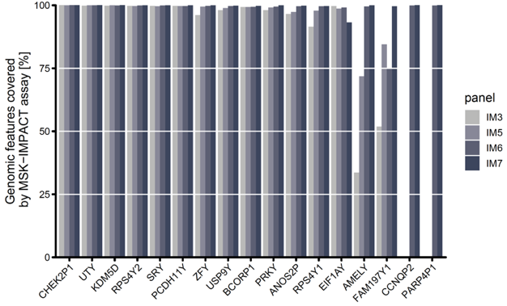
Supplementary figure 3: Sequence coverage of chromosome Y elements depending on sequencing gene-panel deployed. Gene panel IM3 depicts the initial release targeting 341 genes, whereas IM7 targets 505 genes.
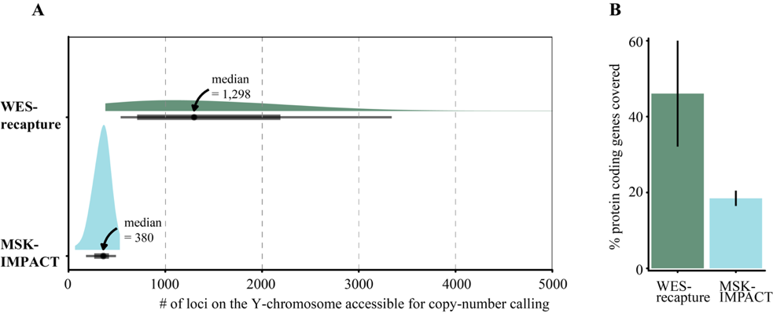
Supplementary figure 4: WES-recapture samples show higher per-base coverage MSK-IMPACT samples. A) Grouped bar- and density charts showing the distribution of genomic loci on the Y-chromosome that are accessible for copy-number estimation stratified by sequencing strategy. B) Bar-chart showing the percentage of protein coding genes (total of 78 protein coding genes) that are covered by either of the sequencing strategies deployed for the validation approach. The black line indicates the 95% CI. Note that, although theoretically 100% of protein coding genes should be covered within WES-recaptured samples, this was never realized to due difficulties in short-read sequence alignments to the Y-chromosome (see section 1 and Figure 1 for details).
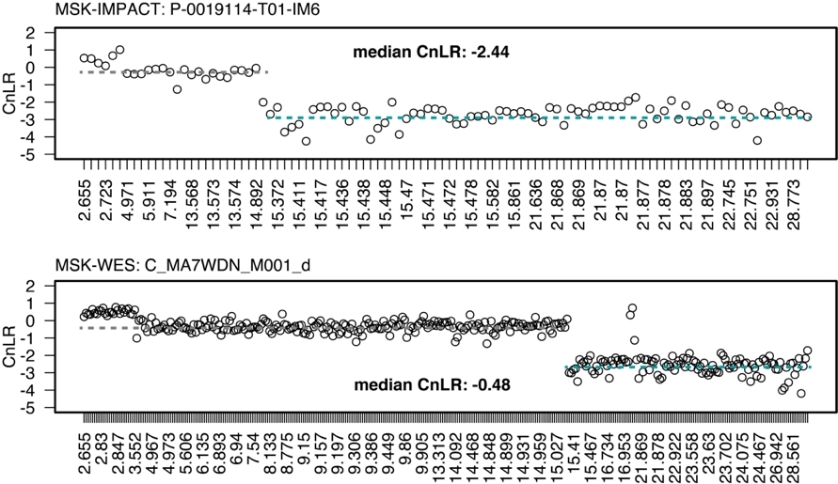
Supplementary figure 5: Exemplary tumor sample (P-0019114-T01-IM6) showing the reason for the disagreement between the CnLR estimates form either MSK-IMPACT or WES-recapture sequencing experiments. A) Individual CnLR estimates (y-axis) across the Y-chromosome (x-axis). B) Matched WES-recaptured sample showing likewise the CnLR estimates on the y-axis whereas respective Y-chromosome coordinates are depicted on the x-axis. Grey as well as turquoise lines in both plots depicts local averages. Importantly, since we used the median across the whole Y-chromosome to approximate the copy-number, this metric is highly dependent on number of individual observations. As this example clearly shows, we see two regions with two different copy-number states. The grey line indicates a region of length 12.65 Mb [range: 2.655 – 15.372 Mb] with a median CnLR of -0.238 for the MSK-IMPACT sequenced sample. Likewise, for the WES-recaptured sample a region of 12.76 [range: 2.655-15.41 Mb] with a median CnLR of -0.36 was obtained. The second segment clearly indicates a loss in both sequencing strategies. However, since the genomic loci content for WES-recaptured samples is much higher and the central tendency was assessed with the median, we see why we observed different central estimates although we made the same observations. This mitigates the problem with outliers in Figure 2B.

