1. Default webpage should look something like this. Good if you carry the same header across all pages.

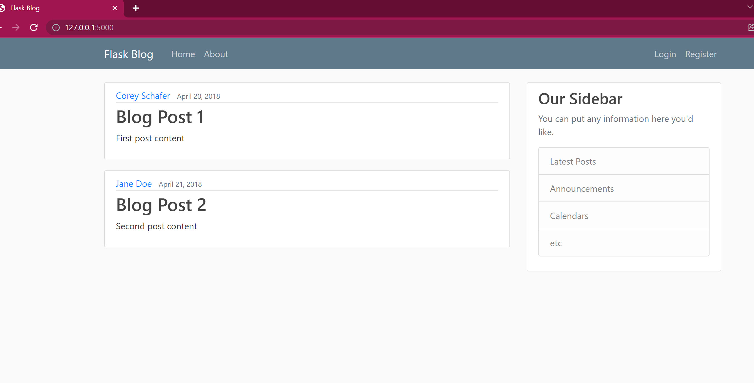

2.home page should point to default page.



1. About link should navigate to the following about page.

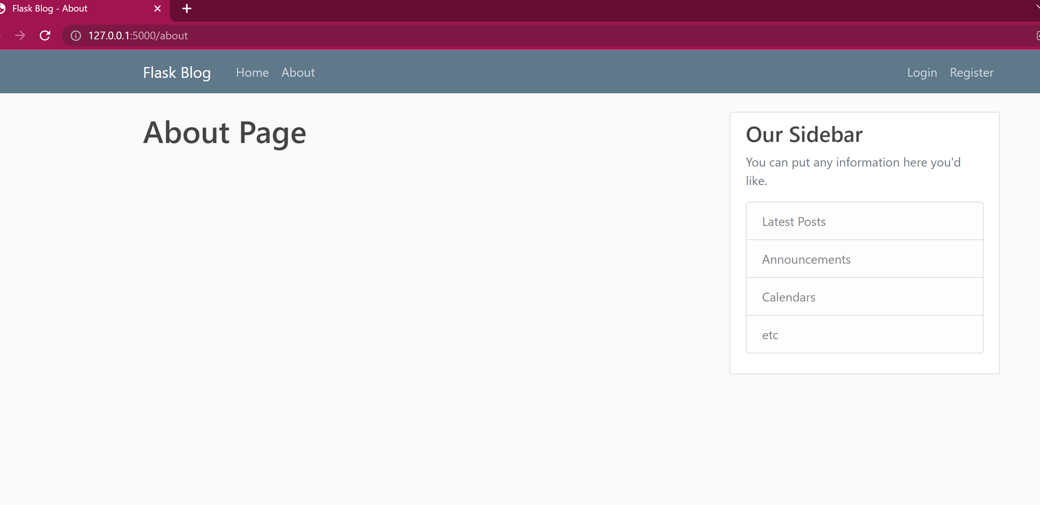

Login page, all fields should do the needed validation

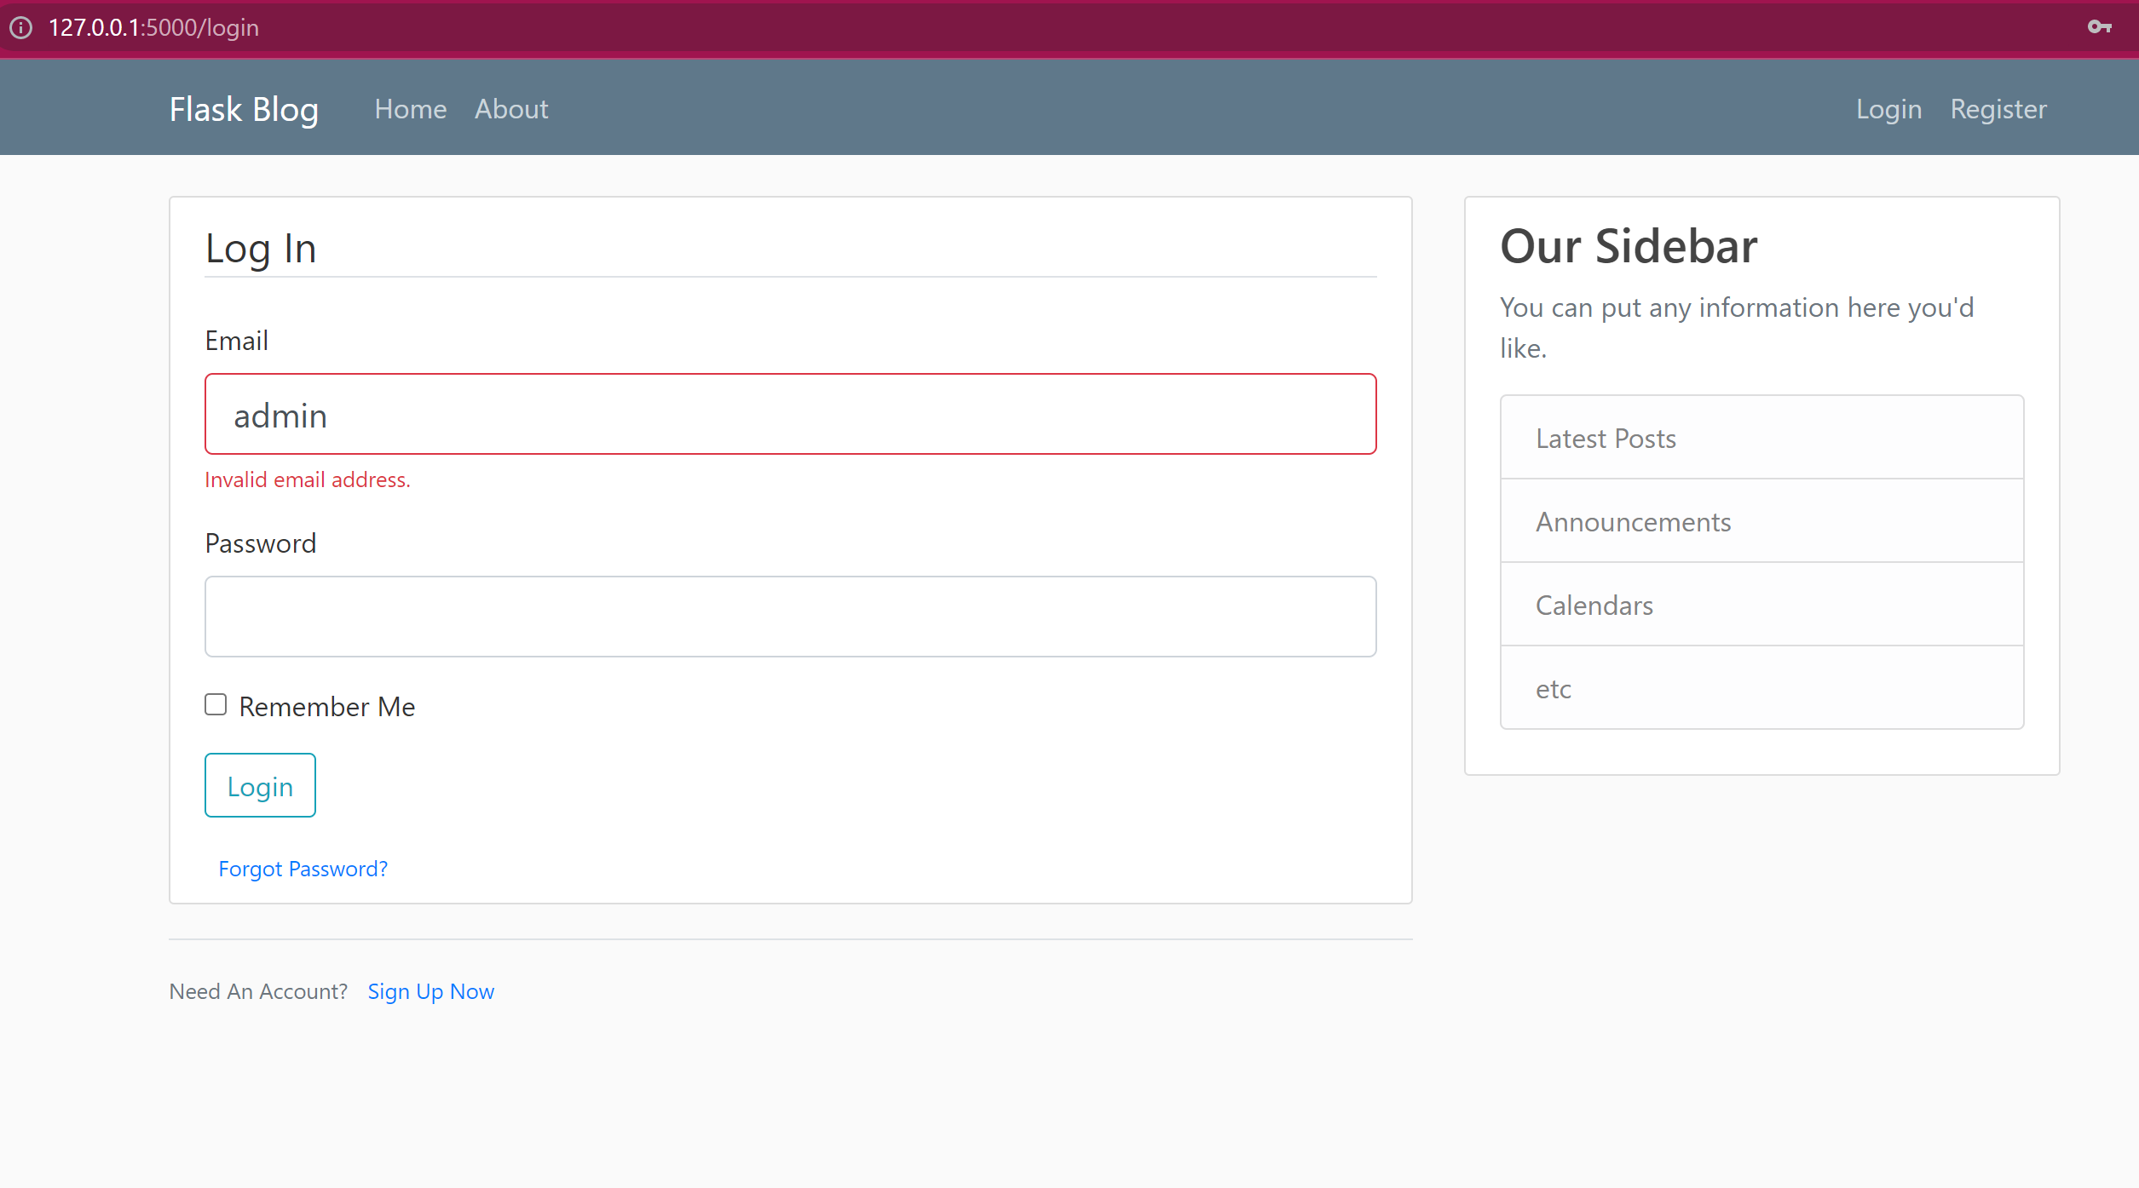

All users should be able to register If they click the Register link and fill the appropriate fields.You can use a local db file or external database for it using sqllachemy (or)sqllite packages.

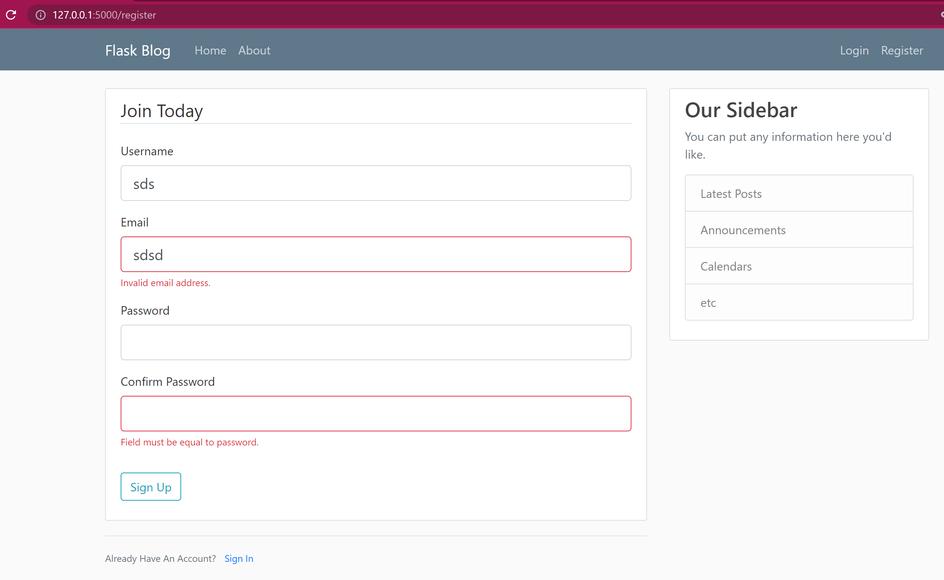

Once a normal user logs in it should take me to the login page. If admin user logs in it should show html table of list of all the users and their email ids.

