Cascadia Oceanic
  - Brand Kit
Fonts
Headings: Metro Nova Pro Black
Text: Metro Nova Pro
Signaturte Eaglefeather P22
Alt for online printing: Kabel

Logos
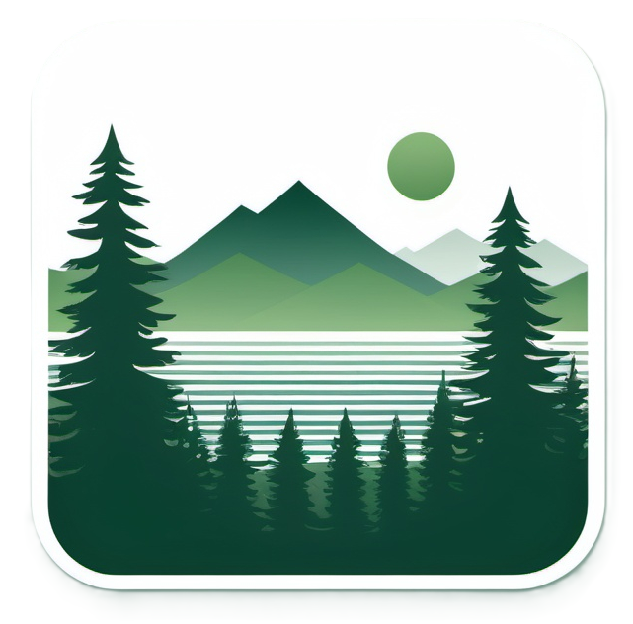

Specials

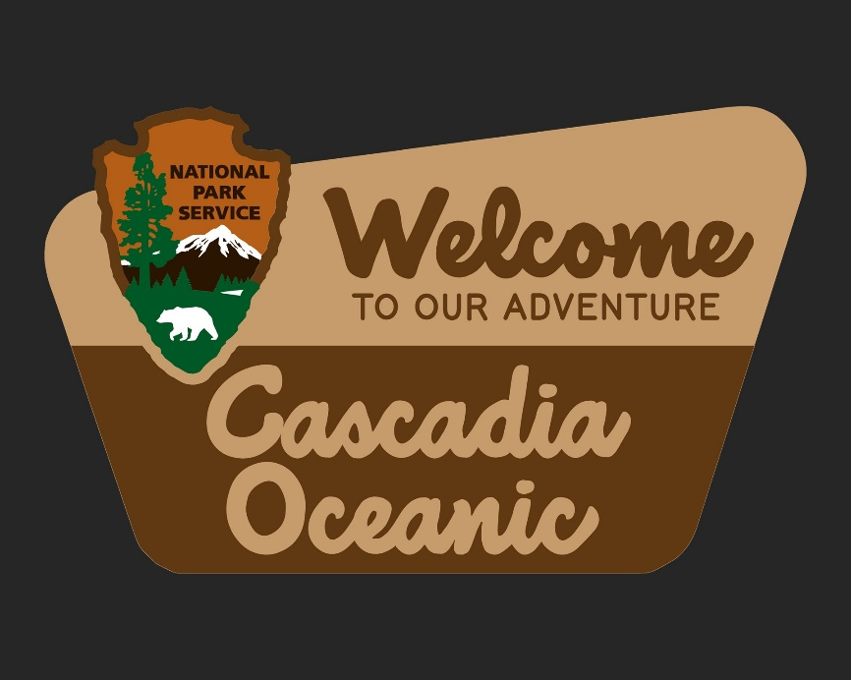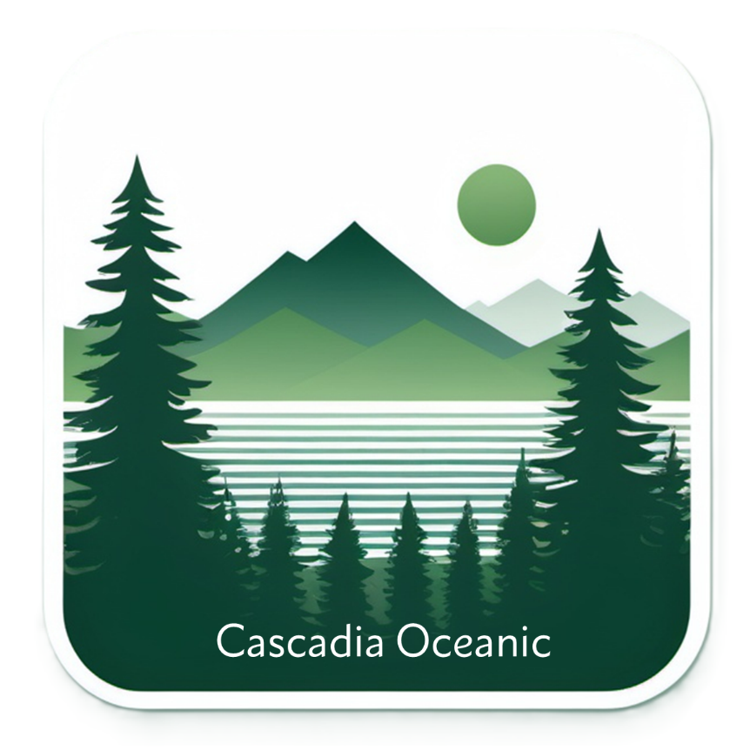
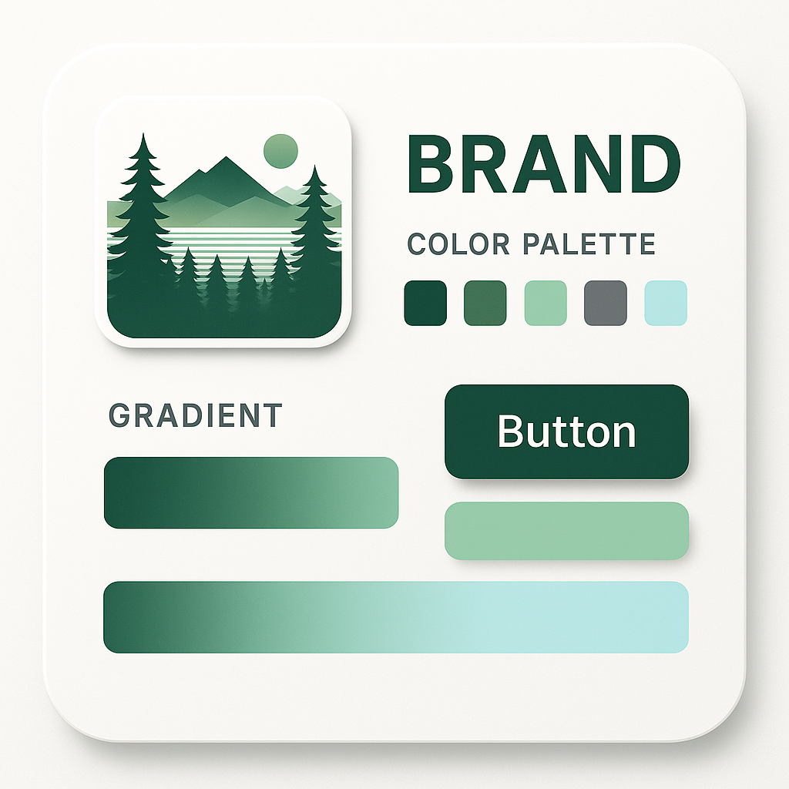

🌲 Proposed 5-Color Brand Kit (excluding white)
Role | Color | Hex | Description
1. Evergreen Core | #174A2E | Deep forest green anchoring brand visuals; ideal for logos, typography, or key accents.
2. Mountain Midtone | #3F8F5A | Balanced natural green bridging dark and light; good for secondary fills or gradients.
3. Mist Light | #92D1A9 (from palette) | Gentle, airy green that echoes Cascadia fog and alpine meadows; supports backgrounds and light gradients.
4. Granite Neutral | #717478 (from palette) | A soft charcoal gray for text, UI outlines, and grounding contrast.
5. Sky Highlight | #A8EBD8 | Cool, mint-sky accent—adds freshness in gradients, callouts, or digital interfaces.

🎨 Usage Hierarchy
- Primary Brand Color: #174A2E (logo base, headers)
- Secondary Accent: #3F8F5A (buttons, submarks)
- Support / Background: #92D1A9 and #A8EBD8 (gradients, cards, soft fills)
- Neutral Anchor: #717478 (text, icons, shadow balance)

✳️ Brand Tone
- Mood: Fresh, grounded, eco-modern
- Visual Signature: Pacific Northwest inspired — deep forest meets open sky
- Balance: Natural palette that stays vivid but sophisticated on both light and dark backgrounds

