Navigating the End-to-End Microsoft Partner Journey: From Idea to Go-to-Market Success
Microsoft’s partner ecosystem offers a rich toolkit of programs, platforms, and guidance to help Independent Software Vendors (ISVs) and services/consulting partners build, launch, and scale their offerings. This page provides practical, stage-by-stage guidance on key resources and actions to take at each step—from initial idea and validation through technical build, marketplace publishing, co-selling with Microsoft, and beyond.
To make it easy, we’ve broken the partner journey into stages, each with recommended Microsoft tools, programs, and best practices. Whether you’re an ISV developing a cloud solution or a services partner creating a new offering, this roadmap will help you leverage Microsoft’s resources to accelerate time-to-market and reach more customers.
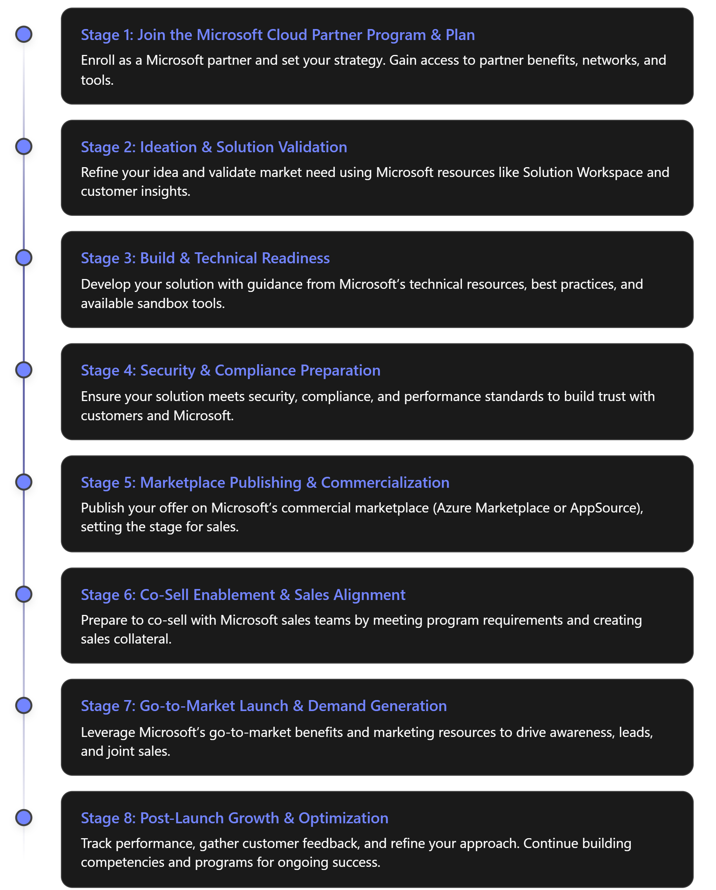
The table below summarizes each stage with its focus and key Microsoft resources to leverage:
Partner Journey Stages and Key Microsoft Resources
Stage | Focus & Key Actions | Microsoft Resources & Programs
Join & Plan | Enroll in Microsoft partner program; understand partner program structure and benefits; define your offering’s strategy and alignment with Microsoft solution areas (e.g. Azure, Business Apps, Modern Work). | 🔹 [Microsoft AI Cloud Partner Program (formerly MPN) – free enrollment, community, training, and support](https://partner.microsoft.com/) 🔹 Partner Center – centralized portal to manage membership, benefits, customer accounts, and offerings. 🔹 Solutions Partner designations – credentials in solution areas (Azure, Data & AI, Biz Apps, Modern Work, etc.) demonstrating competencies and unlocking benefits.
Ideation & Validation | Refine solution idea and validate market need. Align with Microsoft cloud strategy and customer demand; gather feedback on concept viability and target use-case. | 🔹 Solution Workspace – guided steps to take your idea from concept to market, with curated resources and checklists. 🔹 Microsoft Learn & Docs – technical learning paths & reference architectures to explore solution feasibility.
Build & Technical Readiness | Develop and architect your solution. Leverage best practices and technical support to build a robust, scalable, and secure solution on the Microsoft cloud. | 🔹 Cloud sandbox & credits – e.g. in ISV Success program: Azure credits, dev/test sandboxes, and dev tools (GitHub, Visual Studio) to accelerate development. 🔹 Azure Well-Architected Framework – prescriptive guidance to ensure reliability, security, performance efficiency, and cost optimization in your design (especially for Azure solutions). 🔹 Architecture design sessions & technical consults – available via partner benefits (e.g. architecture reviews offered in ISV Success program).
Security & Compliance | Meet security, compliance, and performance standards. Prepare any required certifications or attestations to build customer trust and meet Microsoft co-sell criteria. | 🔹 Microsoft 365 Publisher Verification & App Compliance – for M365 integrated apps, complete publisher attestation and app certification to demonstrate security (required for certain marketplace listings). 🔹 Azure technical validation – ensure Azure-based solutions follow Microsoft’s technical guidelines (Microsoft may conduct an Azure solution architecture review for co-sell eligible status). 🔹 Microsoft Marketplace Policies – review offer certification policies to guarantee your solution meets all requirements.
Marketplace Publishing | List your offer on Microsoft’s commercial marketplace (Azure Marketplace for IT/pro developers, or AppSource for business users) to reach Microsoft’s global customer base. Configure pricing, trials, and transactability. | 🔹 Partner Center Marketplace portal – create and publish your offer via Partner Center’s step-by-step process. 🔹 Offer Publishing Guides – official how-to guides for preparing and submitting each offer type (e.g. SaaS, Azure app, services listing). 🔹 Transactable listings – consider enabling direct sales through Azure Marketplace to allow customers to buy and have usage count toward their Azure consumption commitments (MACC).
Co-Sell Preparation | Become co-sell ready and collaborate with Microsoft sales. Fulfill program requirements (e.g. proven customer success, published offers) to unlock co-selling benefits and incentives. Prepare sales materials for joint selling. | 🔹 Co-sell programs – Achieve Co-sell Ready status by meeting requirements (live marketplace offer with profile, sales contacts, etc.). Attain Azure IP Co-sell Eligible for additional benefits (contributes to customers’ Azure commitments). 🔹 Sales collateral templates – Partner Center’s Co-sell > Solutions page requires uploading a one-page overview and pitch deck; Microsoft provides templates to guide your content. 🔹 Partner Center Referrals – Use the Referrals workspace to share leads with Microsoft or other partners and manage co-sell opportunities .
Launch & Demand Generation | Go-to-market launch – announce and promote your solution with help from Microsoft’s marketing programs. Drive demand and leads via co-marketing, marketplace promotions, and field engagement. | 🔹 Marketplace Rewards – program offering marketing and sales benefits (e.g. PR support, webinars, account planning) based on your Marketplace success. 🔹 Go-To-Market Toolbox – partner marketing portal with co-branded asset templates (whitepapers, brochures, etc.), campaign assets, and marketing plan guidance. 🔹 Solution partner incentives – if eligible (esp. services partners), leverage partner incentives funds for driving customer usage and co-op marketing (Microsoft offers performance-based incentives to partners in many categories).
Post-Launch & Optimization | Measure, optimize, and grow. Track marketplace performance and customer feedback; iterate your solution and marketing. Pursue advanced designations to unlock further benefits. | 🔹 Partner Center Insights – monitor your offer’s performance (leads, usage, ratings) in the marketplace and review analytics to guide improvements. 🔹 Advanced Specializations & Expert Programs – after initial success, consider attaining advanced credentials (e.g. an Advanced Specialization or Microsoft “Preferred Solution” badge) to stand out and gain additional Microsoft field support. 🔹 Field & Customer Engagement – continue engaging Microsoft field teams and customers via events, case studies, and solution updates to maintain momentum.

1. Join the Microsoft AI Cloud Partner Program & Plan Your Journey
The first step is to enroll in the Microsoft partner program – now known as the Microsoft AI Cloud Partner Program (MAICPP) – which is free and open to all. Enrolling provides access to a global community of 500,000+ partners and exclusive training, support, and go-to-market resources . Through the Partner Center portal, you can manage your membership, update your company profile, and explore available programs and benefits.
Key actions at this stage:
- Enroll via Partner Center: Create a Partner Center account for your organization. This involves providing company details and undergoing business verification . Once verified, you’ll have a PartnerID (formerly MPN ID) and can start using partner resources.
- Understand program structure: Familiarize yourself with the Microsoft Cloud Partner Program structure. Microsoft retired the legacy Gold/Silver competencies and introduced “Solutions Partner” designations aligned to six solution areas (e.g. Data & AI (Azure), Infrastructure (Azure), Digital & App Innovation (Azure), Business Applications, Modern Work, Security). Achieving a Solutions Partner designation in a relevant area can enhance your visibility and benefits.
- Review partner benefits and incentives: As a new partner, you can access benefits like development software and cloud credits (via Action Pack or ISV Success), technical support, and training . Also review partner incentives programs—for example, Microsoft offers rebates or co-op funds to partners who drive cloud consumption or meet sales targets, especially after you attain solution designations (for services partners) or publish transactable offers (for ISVs).
Outcome of Stage 1: You are now a registered Microsoft partner with access to Partner Center and baseline benefits. You have a clear understanding of program levels and have mapped out which solution area(s) your offering will target and what resources (credits, training, support) you can leverage.

2. Ideation & Solution Validation
With your partner membership in place, shift focus to refining your solution idea and ensuring it addresses a real customer need and fits into Microsoft’s technology ecosystem or priority solution areas. Microsoft provides resources to help partners validate and shape their solution concepts.
Key actions at this stage:
- Leverage Solution Workspace for idea development: Solution Workspace is a partner resource hub that guides you from initial idea to a viable solution plan. It provides curated resources, checklists, and self-service guidance to help you at each step—whether you’re just starting with an idea or already prototyping. Use it to outline your solution’s value proposition, target market, and technical requirements, and identify any support you might need from Microsoft.
- Validate market demand: Use Microsoft’s market insights and your own research to validate that there is a customer need for your solution. If possible, engage early with potential customers or Microsoft field teams to get feedback on your idea. If you are a services partner developing a new offering or practice, ensure it aligns with Microsoft’s solution areas and industry focus (e.g., an analytics solution under Data & AI). If you’re building software, research existing Azure Marketplace or AppSource listings to identify differentiation opportunities in your product category.
- Align with Microsoft strategy: Microsoft often publishes industry trend reports, product roadmaps, and priority scenarios (e.g., AI transformation, security and compliance, cloud migrations). Aligning your solution with these priorities can improve support. For example, if Microsoft is emphasizing Power Platform solutions or Azure AI services, consider how your offering complements those areas.
Outcome of Stage 2: You have sharpened your solution concept with validated customer needs and use cases. You’ve defined how your offering will leverage Microsoft technology (Azure, Microsoft 365, Dynamics 365, etc.) and fit into Microsoft’s solution areas. You have an initial roadmap or project plan, possibly using Solution Workspace as a guide.

3. Build & Technical Readiness
With a solid plan, the next step is to build your solution or service offering. Microsoft provides extensive technical resources and programs to help partners accelerate development and ensure their solution is cloud-ready, secure, and scalable.
Key actions at this stage:
- Use Microsoft’s technical guidance: Explore reference architectures and best practices on Microsoft Learn and the Azure Well-Architected Framework to guide your design. Microsoft’s Azure Well-Architected Framework covers five pillars (security, reliability, performance, cost, and operational excellence) to help you design high-quality cloud solutions, which is especially vital if you plan to publish on Azure.
- Leverage training and skilling: Encourage your team to take advantage of Microsoft Learn modules, certification paths, and partner Skilling programs related to your solution area. For example, if building a Teams app or Azure service, complete relevant Microsoft certifications or advanced workshops. Partners have access to role-based trainings in the Partner Training Center.
- Join the ISV Success program (for software solutions): If you are an ISV building a software product, consider enrolling in ISV Success, a program designed to help software partners develop, test, and go-to-market faster. Benefits include Azure credits, cloud sandbox environments for development and demo, GitHub Enterprise licenses, and technical consultations with Microsoft architects. For instance, the core ISV Success package provides $5,000 in Azure credits and access to developer tools like GitHub Enterprise Cloud and Visual Studio, enabling you to build and test without upfront cloud costs. Participants also get 1:1 architecture design or app review sessions to ensure the solution meets Microsoft’s standards.
- Utilize partner technical support: Through your partner benefits or programs like ISV Success, you may schedule technical advisory sessions (for architecture, app design, integration) or use the Partner Center’s new AI Assistant to get answers within the portal. Additionally, consider reaching out to Microsoft Cloud Solution Architects or the FastTrack program if available for guidance on complex architectures.
Outcome of Stage 3: Your solution is developed or well underway, built on a strong architectural foundation consistent with Microsoft’s best practices. You’ve taken advantage of available Microsoft technical resources—cloud credits, tools, training, and guidance—to reduce development friction. The result is a near market-ready offering that aligns with Azure or Microsoft 365 architecture guidelines and is ready for validation.

4. Security, Compliance & Readiness Checkpoints
Before launching, it’s critical to ensure your offering meets key security, compliance, and performance benchmarks. Not only is this important for gaining customer trust, it’s often required for participation in certain Microsoft programs (like co-sell). Microsoft offers frameworks and processes to validate that partners’ solutions are enterprise-ready.
Key actions at this stage:
- Review Microsoft’s certification and compliance requirements: If your solution integrates with Microsoft products, you may need to complete specific compliance steps. For example, for Microsoft 365 or Teams applications, you should undertake the Microsoft 365 Publisher Verification and App Compliance processes. Publisher Verification confirms your app comes from a verified partner, and App Compliance / Certification involves meeting Microsoft’s security and data handling standards for apps on Microsoft AppSource.
- Perform security testing and attestation: For solutions hosted on Azure, follow the Azure Well-Architected security recommendations and test for vulnerabilities. Document your security measures and compliance with industry standards (like GDPR, HIPAA if applicable). Microsoft’s General Marketplace Policies provide guidance on requirements such as data security, privacy, and support that your offer must comply with.
- Prepare for Microsoft technical validation (for co-sell): If you intend to pursue Azure IP Co-sell eligibility (discussed in Stage 6), be aware that Microsoft requires a technical architecture validation for Azure-based solutions as part of the co-sell vetting. This typically includes presenting your architecture diagram and demonstrating that your solution is primarily Azure-based and follows best practices. Passing this Azure platform review is needed for the highest co-sell status.
- Ensure performance and scalability: Conduct load testing or pilot deployments to ensure your solution can scale to meet user demand. Microsoft’s guidelines emphasize designing for scalability and operational excellence (for instance, using Azure Monitor for performance telemetry).
Outcome of Stage 4: Your solution has cleared internal security and compliance checklists. You have either completed or are in the process of completing Microsoft’s publisher verification or app certification if relevant. You are confident your offering meets Microsoft’s Marketplace policies and technical standards, reducing the risk of delays in publication or issues in customer adoption.

5. Publishing on Microsoft’s Commercial Marketplace
Now it’s time to make your solution publicly available through Microsoft’s marketplace channels—Microsoft AppSource (for business and industry solutions, often targeting business users) or Azure Marketplace (for IT and developer-focused solutions). Publishing in the commercial marketplace exposes your offer to Microsoft’s global customer base and enables transactions or lead referrals through Microsoft systems.
Key actions at this stage:
- Choose the right offer type and marketplace: Microsoft’s commercial marketplace supports various offer types, such as SaaS applications, Azure VM images, Azure Managed Applications, Dynamics 365 apps, Power BI visuals, and consulting services. Decide how you want to list your offering. For example, an ISV with a cloud-based software product might publish a SaaS offer on Azure Marketplace, whereas a services partner may list a Consulting Service offer (e.g., an assessment or workshop) on AppSource. Note: Consulting service listings generate lead referrals (not direct sales) but can increase your visibility.
- Follow Partner Center submission steps: In Partner Center, use the Marketplace workspace to create a new offer. Provide all required details including offer metadata, descriptions, categories, pricing, and any Azure Active Directory integration. Microsoft provides a https://learn.microsoft.com/en-us/partner-center/marketplace/checklist-prepare-manage-publishing for each offer type. Also ensure you have completed tax and payout profile setup in Partner Center so you can transact and receive revenue.
- Meet validation criteria: After submission, Microsoft will run automated validation and certification tests on your offer (for example checking security, metadata, and functional tests). Address any issues identified by the certification team promptly. Once approved, your offer status changes to “Live”, meaning it’s published on Microsoft’s marketplaces for customers to find and deploy/buy. At this point, your solution is considered “In market” as a Microsoft partner offering.
- Enable transacting and trials (if applicable): If your goal is to allow customers to directly purchase or provision your software via Microsoft (which can streamline procurement), ensure your offer is transactable. This typically involves integrating with Azure marketplace billing (for SaaS or Azure VM offers) and possibly providing a free trial or test drive option to attract customers. Transactable offers that run on Azure can also qualify for additional benefits, like contributing to customers’ Azure Consumption Commitments (MACC), which can make your solution more attractive to Azure customers.
Outcome of Stage 5: Your solution offering is successfully published on Microsoft’s commercial marketplace (AppSource or Azure Marketplace). Customers and Microsoft field sellers can discover your offer, request information, or purchase/try it directly (depending on your offer’s configuration). You have effectively “opened up shop” in Microsoft’s ecosystem.

6. Co-Sell Enablement & Microsoft Sales Alignment
Once your solution is live, unlocking co-sell opportunities can significantly amplify your reach. Co-selling with Microsoft means collaborating with Microsoft’s own sales teams (and other partners) on deals involving your solution. To do this, you’ll need to achieve co-sell program status and prepare necessary sales materials.
Key actions at this stage:
- Achieve Co-Sell Ready status: In Partner Center, navigate to the Referrals / Co-sell section. For “Co-sell Ready” status, you must meet core requirements: a live marketplace offer, a complete business profile, sales contacts for defined regions, and have uploaded required solution collateral (e.g., one-pager, pitch deck). Make sure to fill out the Co-sell Solution page in Partner Center fully – Microsoft provides templates for the one-page solution overview and a pitch presentation. Services partners also need at least one Solutions Partner designation in a relevant category to be co-sell ready. Once these are satisfied, your solution will be tagged as Co-sell Ready in Microsoft systems.
- Aim for Azure IP Co-Sell (if you have an IP-based solution): Azure IP Co-sell Eligible is a higher status for Azure-based ISV solutions that unlocks additional benefits. On top of being co-sell ready, you’ll need to meet a few additional criteria: e.g. $100K in trailing 12-month Azure consumption or marketplace revenue, and passing a technical validation of your solution’s Azure architecture. Achieving this status grants your offer a “Microsoft Preferred Solution” badge on the marketplace, and it allows Microsoft account teams to count deals towards customers’ Azure commitment targets (making your product easier to sell to Azure customers).
- Engage Microsoft field sellers: With co-sell status, Microsoft’s sales teams can view and filter for co-sell ready solutions. Build relationships with Microsoft’s partner management or field team relevant to your solution area (often through a Partner Development Manager or via networking at MS events). When you have a qualified lead or opportunity, you can share it as a co-sell opportunity in Partner Center; this alerts Microsoft sellers and attaches your solution to that customer deal pipeline.
- Utilize Partner-to-Partner (P2P) co-sell: Co-sell isn’t only with Microsoft corporate sellers. You can also collaborate with other Microsoft partners. The Partner-to-Partner Co-sell motion allows you to find other partners (e.g., an SI that could implement your software) via the referrals tool and engage in joint selling. Microsoft’s ecosystem is huge; leveraging it can bring specialist skills to your deals or open new markets.
Outcome of Stage 6: Your solution is now co-sell enabled: Microsoft’s sales organization recognizes your offer as ready to sell together. You have the required sales collateral (1-page datasheet, decks) prepared and shared in Partner Center. You can actively collaborate on deals with Microsoft or other partners and benefit from any co-sell incentives (e.g., Microsoft sellers may have incentives to co-sell Business Applications solutions, or deals with your Azure IP co-sell solution count towards Azure quotas).

7. Go-to-Market Launch & Demand Generation
With your offer live and co-sell ready, focus on marketing and demand generation. Microsoft offers robust go-to-market (GTM) resources to help partners create buzz and generate leads for their solutions. These range from marketplace promotion benefits to marketing content and campaigns you can co-brand.
Key actions at this stage:
- Leverage Go-to-Market benefits and “Marketplace Rewards”: Microsoft’s Marketplace Rewards program provides a tiered set of marketing and sales benefits automatically as you reach certain marketplace milestones (like publishing a solution, achieving Azure IP co-sell, or attaining usage targets). These benefits may include press release support, newsletter features, solution showcase webinars, case study development, and lead gen campaigns. Review your eligibility in Partner Center and utilize these complimentary benefits to amplify your launch.
- Use the Partner GTM toolbox: Tap into the Partner Co-branded Marketing assets available. The Partner Go-To-Market Toolbox is an online portal where you can generate custom marketing materials (e.g., pitch decks, brochures, social media content, email templates) pre-populated with Microsoft branding and messaging alongside your own. This saves time and ensures your materials align with Microsoft’s style. You can also request an editorial review of your marketing copy through Microsoft to ensure it resonates with customers.
- Engage in joint marketing and events: Work with Microsoft’s marketing and field teams to co-market your solution. For example, you might join Microsoft-led events or roadshows in your industry, be featured in relevant Microsoft blogs or partner showcases, or co-sponsor webinars. Many partners also participate in lead-sharing programs via the marketplace: customers who show interest in your solution (via the “Contact Me” button on your listing) become sales leads visible in your Partner Center, so respond quickly to these marketplace-generated leads to maximize conversions.
- Drive your own digital marketing: Augment Microsoft’s programs with your own campaigns. Highlight your Microsoft partnership in press releases and on your website (e.g., mention your Solutions Partner designation or showcase the Microsoft Preferred Solution badge if you’ve earned it). Use social media and content marketing to announce your solution’s availability on Microsoft Marketplace and how it benefits customers, possibly linking to your listing.
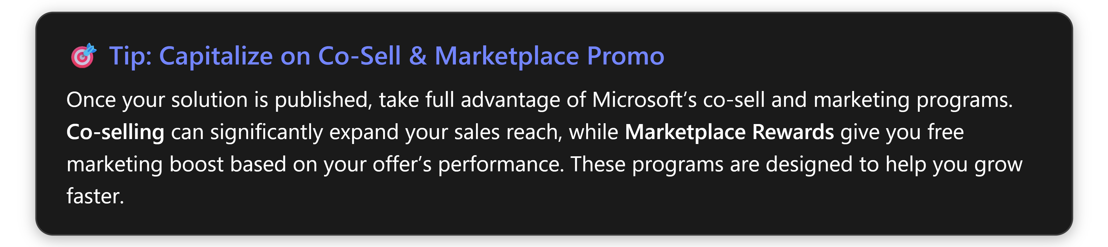
Outcome of Stage 7: Your offering is launched with a marketing splash. Through a combination of Microsoft’s GTM offers and your own efforts, you’re reaching a wide audience. Customers can discover your solution via Microsoft’s site and you have inbound leads flowing from the marketplace and co-sell motions. You also have the collateral and sales strategy to engage those leads effectively with Microsoft’s backing.

8. Post-Launch: Growth, Optimization & Next Steps
Launching your solution is a huge milestone, but the partner journey doesn’t end there. Continuous improvement and engagement are key to long-term success in the Microsoft ecosystem.
Key actions at this stage:
- Monitor marketplace performance: Use Partner Center Insights and reports to track how your offer is performing. Key metrics include listing page views, lead volume, conversions (trials or purchases), usage (for SaaS), and customer reviews. Identify trends or drop-off points (e.g., many trials but few conversions could imply a need to refine your free trial or pricing).
- Gather and leverage customer feedback: Encourage early customers to leave reviews on your marketplace listing and pay attention to their feedback. Success stories and ratings will improve your marketplace ranking and credibility. Address any negative feedback by improving your product or service and updating your listing content.
- Expand product capabilities and integrations: As you learn from customers, iterate on your solution. Consider adding deeper integrations with Microsoft services (for instance, integrating Teams, Azure AI services, or Power BI) to increase your solution’s value and stickiness in the Microsoft ecosystem. Align future feature development with Microsoft’s evolving product roadmap (e.g., incorporate new Azure AI features as Microsoft releases them).
- Pursue advanced recognitions: As your solution gains traction, look into achieving Advanced Specializations or additional designations that correspond to your area. For example, an ISV might aim for the “Azure Specialized” status in a certain domain (like AI or analytics), or a consulting partner might pursue an Azure Expert MSP certification. These achievements can unlock more benefits and further differentiate your offering to customers.
- Stay engaged with Microsoft: Keep building your relationship with Microsoft’s teams. Participate in partner communities and events, keep your Partner Center business profile updated (so Microsoft field teams understand your latest offerings), and share your success metrics with Microsoft. The goal is to become a go-to partner in your solution niche—the one Microsoft sellers think of first for customer opportunities.
Outcome of Stage 8: Your offering and go-to-market approach continue to evolve. Through active engagement, you maintain momentum, fine-tune your solution, and potentially access new opportunities (like being invited into private previews, special Microsoft programs, or regional campaigns). By measuring performance and continually investing in your Microsoft partnership, you position your business for sustained growth within Microsoft’s ecosystem.

About Synozur
As a dedicated guide and partner – not just a consultant – we bring deep Microsoft ecosystem fluency and an empathetic, tailored (no one-size-fits-all) approach to help you navigate your entire go-to-market journey. Through our proven Messaging & Positioning Framework (MPF), we help define your North Star vision, align your strategy with Microsoft’s priorities, and translate it into clear messaging and executable GTM motions. We orchestrate co-sell readiness and partner development along the way, always focusing on delivering tangible outcomes and sustained adoption.
In summary, by following this end-to-end journey and tapping into Microsoft’s partner resources at every stage, you can significantly streamline the development of your solution and maximize your go-to-market impact. Success as a Microsoft partner is not just about building a great product or service—it’s also about using the right programs, tools, and partnerships to amplify that product in the market. Microsoft’s partner network and commercial marketplace provide an unparalleled platform for growth, enabling you to reach customers worldwide, collaborate with Microsoft’s sales force, and benefit from marketing and financial incentives . By carefully planning your journey from idea to GTM and beyond, you ensure that your offering is not only well-built, but also well-positioned to succeed in the marketplace.

Ultimately, the Microsoft partner journey is a continuous cycle of innovation, go-to-market execution, and refinement. Embrace the resources available, build strong alignment with Microsoft’s strategy, and engage proactively with both the tools and the people in the ecosystem. With diligence and the support from these programs, ISVs and service partners can accelerate time-to-market, reach new customers, and scale their solution into a thriving business on the Microsoft platform. Good luck on your journey to a successful go-to-market launch!

https://partner.microsoft.com/en-us/partnership
https://www.alifconsulting.com/post/microsoft-partner-center
https://www.alifconsulting.com/post/microsoft-partner-center
https://www.linkedin.com/posts/microsoft-cloud-partner-program_use-solution-workspace-to-bring-your-idea-activity-6808406266403180544-EPGd
https://www.microsoft.com/en-us/isv/program-benefits
https://www.microsoft.com/en-us/isv/program-benefits
https://learn.microsoft.com/en-us/partner-center/referrals/co-sell-requirements
https://learn.microsoft.com/en-us/partner-center/marketplace-offers/transacting-commercial-marketplace
https://learn.microsoft.com/en-us/partner-center/referrals/co-sell-overview
https://learn.microsoft.com/en-us/partner-center/referrals/co-sell-requirements
https://learn.microsoft.com/en-us/partner-center/referrals/co-sell-overview
https://learn.microsoft.com/en-us/partner-center/referrals/co-sell-requirements
https://www.alifconsulting.com/post/microsoft-partner-center
https://learn.microsoft.com/en-us/partner-center/referrals/co-sell-overview
https://www.microsoft.com/en-us/isv/program-benefits
https://partner.microsoft.com/partnership/sell-with-microsoft
https://www.alifconsulting.com/post/microsoft-partner-center
https://learn.microsoft.com/en-us/partner-center/referrals/co-sell-overview
https://partner.microsoft.com/en-us/partnership
https://www.microsoft.com/en-us/isv/program-benefits
https://www.alifconsulting.com/post/microsoft-partner-center
https://partner.microsoft.com/en-us/partnership
https://learn.microsoft.com/en-us/partner-center/marketplace-offers/transacting-commercial-marketplace
https://learn.microsoft.com/en-us/partner-center/referrals/co-sell-requirements
https://www.alifconsulting.com/post/microsoft-partner-center
https://www.microsoft.com/en-us/isv/program-benefits
https://www.alifconsulting.com/post/microsoft-partner-center
https://learn.microsoft.com/en-us/partner-center/referrals/co-sell-overview
https://www.govevents.com/details/33165/solution-workspace-take-your-solution-from-idea-to-market-with-curated-resources-advice-and-steps/
https://learn.microsoft.com/en-us/partner-center/referrals/co-sell-requirements
https://www.linkedin.com/posts/microsoft-cloud-partner-program_use-solution-workspace-to-bring-your-idea-activity-6808406266403180544-EPGd
https://partner.microsoft.com/en-us/partnership
https://partner.microsoft.com/partnership/sell-with-microsoft
https://www.microsoft.com/en-us/isv/program-benefits
https://www.microsoft.com/en-us/isv/program-benefits
https://www.microsoft.com/en-us/isv/program-benefits
https://learn.microsoft.com/en-us/partner-center/marketplace-offers/transacting-commercial-marketplace
https://learn.microsoft.com/en-us/partner-center/referrals/co-sell-requirements
https://learn.microsoft.com/en-us/partner-center/referrals/co-sell-requirements
https://learn.microsoft.com/en-us/partner-center/marketplace-offers/transacting-commercial-marketplace
https://learn.microsoft.com/en-us/partner-center/marketplace-offers/transacting-commercial-marketplace
https://learn.microsoft.com/en-us/partner-center/referrals/co-sell-requirements
https://learn.microsoft.com/en-us/partner-center/referrals/co-sell-overview
https://learn.microsoft.com/en-us/partner-center/referrals/co-sell-overview
https://learn.microsoft.com/en-us/partner-center/referrals/co-sell-requirements
https://learn.microsoft.com/en-us/partner-center/referrals/co-sell-requirements
https://learn.microsoft.com/en-us/partner-center/referrals/co-sell-requirements
https://learn.microsoft.com/en-us/partner-center/referrals/co-sell-overview
https://learn.microsoft.com/en-us/partner-center/referrals/co-sell-requirements
https://learn.microsoft.com/en-us/partner-center/referrals/co-sell-overview
https://learn.microsoft.com/en-us/partner-center/referrals/co-sell-overview
https://learn.microsoft.com/en-us/partner-center/referrals/co-sell-overview
https://learn.microsoft.com/en-us/partner-center/referrals/co-sell-requirements
https://learn.microsoft.com/en-us/partner-center/referrals/co-sell-overview
https://www.microsoft.com/en-us/isv/program-benefits
https://partner.microsoft.com/partnership/sell-with-microsoft
https://www.microsoft.com/en-us/isv/program-benefits
https://learn.microsoft.com/en-us/partner-center/referrals/co-sell-overview
https://www.alifconsulting.com/post/microsoft-partner-center
https://partner.microsoft.com/en-us/partnership
https://partner.microsoft.com/en-us/partnership
https://learn.microsoft.com/en-us/partner-center/referrals/co-sell-overview
https://www.microsoft.com/en-us/isv/program-benefits

