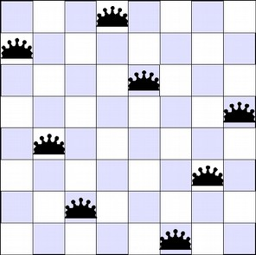

Report 1 (N-Queen)
Artificial Intelligence Module 2
Marco Roetta (876884) in collaboration with Christian Bernabe Cabrera (843382)

Project structure
The assignment is written in Python language and is provided in multiple files.
The main script to run is called main.py and output all relevant information in the terminal.
The code has been written together with Christian while the report is individual.

Project goals
The goal of the assignment is create solvers for the n-queen problem for any N.
It will provide solvers using three different methods:
- Constraint Propagation and Backtracking (depth first search)
- Local optimization (hill climbing with and without restart)
- Global optimization (genetic algorithm)
The next chapters will describe the problem and the used approaches, the representation/modeling choices made, and a comparison of the behavior, ending with pro/cons of the various approaches.

The N-Queen problem
The n-queens problem consist in placing N queens on a chess board, randomly in each row with only one queen in each column. The goal is to move the queens into positions where no queen is attacking any other queen.
All solutions to the problem can be identified using a depth-first search algorithm. With this search strategy, a queen is placed in any square in the first column. For each of these states, a queen is then placed in any rows in the second column for which the two queens will not be attacking each other. Queens are sequentially added to each column in this manner to generate all possible states.

Project background
Backtracking is the first method used in this project and consist of a recursive function that will try every possible solution, starting from the first column in the matrix of the problem space, up to the last one. The first solution found is shown in the console.
To improve the running time, some constraint have been placed:
- For every column, first check if a queen is present on the current row, if yes, skip to next solution;
- Then check only the upper left diagonal, then the lower left since there are no queens yet on the right part of the matrix;
The algorithm will place the first queen always on the first available cell.
It’s possible to obtain different solutions by randomly placing queens in the columns instead of picking always the first one starting form the top and a speed up if using an optimized class for constraint checks. This has been implemented in the optimized Backtracking code section.
The second algorithm implemented is Hill Climbing. This is implemented in two versions since there are more strategies available.
The first one is the min conflicts hill climbing where all current state successors are compared and the closest to the solution is chosen. The action chosen at each iteration is the one that most decreases the number of attacking queens, so the name min conflicts. It terminates at a minima, when no single move from the present state can reduce the number of attacking queens.
Both algorithms fail if there is no closer node, which may happen if there are local minima in the search space. This is why we use the next Hill Climbing technique.
The second version is random-restart hill climbing. It will simply iteratively compute the previous hill-climbing, each time with a random initial condition (the initial column where to start). The best run is kept: if a new run of hill climbing produces a better result than the stored one, it replaces the stored result.
The last algorithm implemented is Genetic from the global optimization family.
This strategy is to create a population and run on every one a fitness function that will determine the best mother and father individual to be used for the next generation run.
Those two individuals are combined with a crossover value and with a probability of random mutation before being used to generate a new population.

Problem data set decisions
Backtracking uses an empty board as starting state.
For the other search strategies, a starting state is generated by placing one queen randomly in each column. Random restart hill climbing will use the same board but will start from a different position in the search state and try to find a better solution.
The board is implemented as a matrix object with nodes representing a queen [cell=1] or an empty space [cell=0]. In some algorithm it is converted into a list[N] where the position in the list is the column and the integer value inside the row position. This way I can improve performance during the search phase and print the solution in a compact manner.

Results analysis
A simple brute force solution, as stated in the textbook, will have a complexity from N^N to N! and will be completely impractical in a real scenario.
If I use backtracking without a specific optimization pattern, I achieve a solution with complexity from N^3 to N^2. By applying the techniques described above I can improve the execution time and approach the lower complexity limit.
Using our first proposed solution I achieved the positioning of 27 queens in 14 seconds. Optimized version does even better with 256 queens in less than 10 seconds.
Using Hill Climbing instead, provides an even better improvement in the execution time per number of queen placed correctly.
The estimated code complexity is in the range N^2 to N^1.5. The randomness of the local search starting point allows to find a solution faster and in case of random restart it also increases the probability to find a lower number of steps required for the solution.
The algorithm count the steps to reach the solution from the provided problem, a lower number of steps is considered an improvement for this minimize problem.
Using the hill climbing algorithm we can position 400 queens in around 15 seconds. Rounded average on 50 runs. This is a 14x improvement over standard backtracking and 2x the optimized.
The number of steps required to reach the solution is 332 on average of 50 runs as visible in the graph above. Note that each run calculate the solution for a new problem.
Can I improve also the quality of the solution using an arbitrary number of random restarts for the same problem?
Yes, with a drawback. In the test I used 10 random restarts per run (again, to position 400 queens) and the average steps for the best run dropped from 332 to 292. An improvement of 14% with more consistent results.
The time required instead increased from 15 to 167 seconds per run on average, 10% more than expected. Probably due to object handling by python.

Basic Genetic Algorithm Tests
As last solver, we have implemented a standard genetic algorithm as available on the textbooks.
I used the recommended settings for a generic GA algorithms for the first run: 60% crossover with 10% probability of mutation and N*2 population size.
With those settings I run the program 50 times asking to position 20 queens.
The results was very variable and ranged from 340 steps to our arbitrary upper limit of 10000 steps.
The average of 50 runs is 3100 generations to find a solution as shown in the graph. The results have been ordered descending for simplicity. It is possible to see that results distribution favor the smaller values.
Generations is the number of generations before a complete solution is found.
Only one run did not terminate before the generation limit.
By tuning some parameters and choices of the genetic algorithm I can probably achieve better results.

Extended Genetic Algorithm Tests
One of the first things I tried is to plot how much of an impact have the crossover and mutation probabilities on the generation before solution value.
Fixing the number of queens to position at 8, and population size at N*2 = 16 boards, the results are as following, after around 7 hours of computation time.
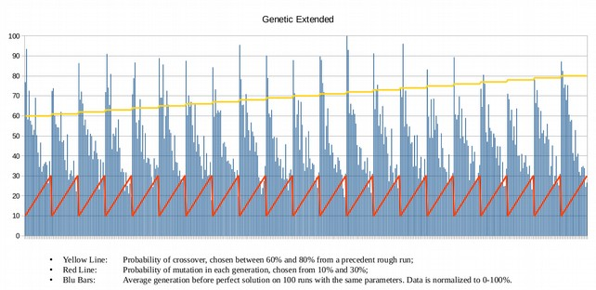
Yellow Line: probability of crossover, chosen between 60% and 80% from a precedent rough run;
Red Line: probability of mutation in each generation, chosen from 10% and 30%;
Blu Bars: average generation before solution on 100 runs with the same parameters. Data is normalized to 0-100%. 100% equals to 3150 generations.

I can see that an increase of mutation probability impacts a lot the number of iteration needed for a solution. This could mean that the population size is too low to handle correctly the crossover between individuals or an error on father/mother choice.
Also, crossover variance do not show particularly interesting changes in the results.
To try to improve the situation I have rewritten the code as following:
- Each generation is composed by (N^2)*2 individuals. More population will help picking different kinds of solutions in the first generations;
- For each generation, divide the population in N*2 groups of N individuals. This way I will pick the best of each group without leaving out someone.
- Run the fitness selection on all of those groups and select N*2 leaders.
- For each child of the new generation I randomly pick mother and father from the leader pool and apply crossover and mutation functions;
- Each time the father and mother solutions are equal (usually near convergence to solution) I increase the probability mutation of this generation only, by 5% per equal couple found up to 100% max. This way I will explore much faster the space around the solution.
Despite the increased population per generation, the speed up is good, from 7 hours it dropped to around 3 hours with a lower generations number before solution. This allowed me to do the following tests in a reasonable amount of time.
The search space for best parameters has been set to 60-90% crossover and 5-25% of global mutation probability as this should be a good range to minimize the global mutation probability for this specific algorithm.
Results for 8 queens (100 runs average)
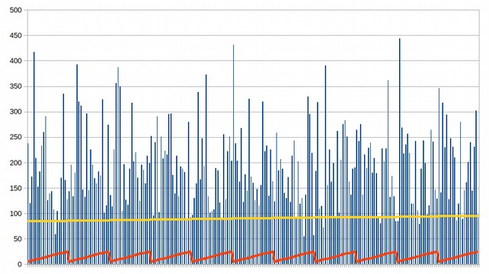
Yellow Line: probability of crossover, chosen between 60% and 90%;
Red Line: probability of mutation in each generation, chosen from 5% and 25%;
Blu Bars: average generation before complete solution on 100 runs with the same parameters.
The graph shows a high speed up, required generations dropped from 3100 to XXX on average.
The average on 100 runs allow a good consistency between runs, I will keep this parameter for all the next tests.
The crossover variance show that the best range is around 80% while mutation variance shows that a higher mutation probability helps the finding of a solution in the first stages. This is expected, since it’s required to minimize it.
Let’s run it again in a focused range and see which are the best parameters of cross and mutation probabilities.
Results for 8 queens focused region (100 runs average)
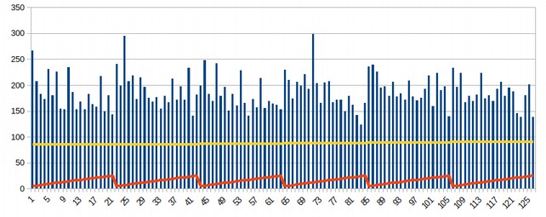
Yellow Line: probability of crossover, chosen between XX% and XX%;
Red Line: probability of mutation in each generation, chosen from XX% and XX%;
Blu Bars: average generation before complete solution on 100 runs with the same parameters.
The average number of generations required for a solution is now XXX.
The pest parameters for this solution are then: mutation p. at XX% and crossover p. at XX%.
From this test I learned that using a progressively increasing mutation, where the same solution is randomly picked to breed the next generation, leads to a faster search.
So, what happens if I just set the mutation at 100% probability the first time I pick mother and father equals?
Since they are randomly chosen from the mating pool, the probability of them being equals will increase only when approaching the complete solution (fitness function will select two equal solution from two different sections of the current generation).
As soon as this happens, generating an almost whole new generation that differ by only a single queen position from the best solution so far, will greatly increase the probability of finding the complete solution or one with increased fitness.
Results for 8 queens + steep mutation (100 runs average)
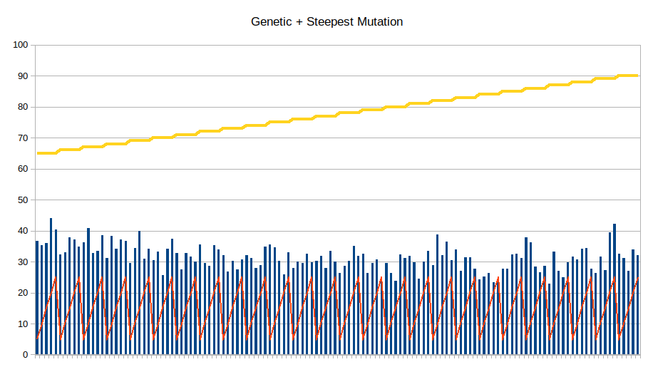
Yellow Line: probability of crossover, chosen between 60% and 90%;
Red Line: probability of mutation in each generation, chosen from 5% and 25%;
Blu Bars: average generation before complete solution on 100 runs with the same parameters.
This version simply set mutation probability to 100% when the first mother==father occurs, during the new generation creation. The mutation is then set to the default value when starting the next generation.
It yields the best results overall, from XXX it now finds a solution in just 31 generations.
The mutation probability is irrelevant since we are going to always mutate every child each time the mother and father are equal in a generation. I set it to XX% in the final code since it’s a good value for the progressive mutation version of the algorithm (the default one provided).
The option to mutate every child used above is activated by placing the variable “nuke = True” in the genetic_lib.py file, inside the new_generation function.
The crossover probability shows that the best value is 84%. Set rounded to 85% in the final code.
As last test I run the whole code with a variable number of queens and see as the execution time changes at increasing values of N.
Results for various algorithms at increasing N
N 4 6 8 16 24 32
Backtracking 0.0 0.0 0.001 0.152 10.452
Opt. Back. 0.0 0.0 0.0 0.033 1.764
Hill Climb 0.0 0.0 0.001 0.01 0.019
Rand. Res. H. C. 0.001 0.023 0.001 0.081 0.2
Genetic Prog. Muta. 0.002 0.039 0.352
Genetic Ste. Muta.

Conclusions
- Backtracking (optimized):
PRO: easy to implement, small on memory
CON: higher complexity, run slower with increasing number of queens
- Hill Climb:
PRO: very fast with low variations, small on memory
CON: easily stop on local minima solutions
- Hill Climb w/ restarts:
PRO: fast, consistent, small on memory
CON: require at least 10x time for a good consistency
- Genetic:
PRO: sometimes is faster than hill climbing
CON: complex to implement and slow, heavy on memory, requires good parameters
- Genetic + Steepest Mutation:
PRO: a bit faster, independent from mutation parameter by design
CON: still slow due to generation management, heavy on memory

