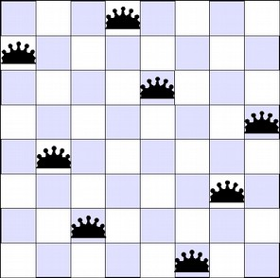

Report 1 (N-Queen)
Artificial Intelligence Module 2
Marco Roetta and Christian Bernabe cabrera

Project structure
The assignment is written in Python language and is provided in multiple files. The main script to run is called <programname.py> and output all relevant information in the terminal.

Project goals
The goal of the assignment is create solvers for the n-queen problem for any n.
It will provide solvers using three different methods:
- Constraint Propagation and Backtracking
- Local optimization (hill climbing)
- Global optimization (simulated annealing)
The next chapters will describe the problem and the used approaches, the representation/modeling choices made, and a comparison of the behavior, pros and cons of the various approaches.

The N-Queen problem
[TODO]

Project background
CSP with Backtracking is the first method used in this project and consist of a recursive function that will try every possible solution, starting from the first column in the matrix of the problem space, up to the last one.
The second algorithm implemented is Hill Climbing. This is implemented in different versions since there are a lot of variations available.
The first one used is the simple hill climbing, where the first closer node is chosen.
The second one is the steepest ascent hill climbing where all successors are compared and the closest to the solution is chosen.
Both algorithms fail if there is no closer node, which may happen if there are local maxima in the search space which are not solutions.
The third and last version is random-restart hill climbing. It will simply iteratively compute hill-climbing, each time with a random initial condition. The best run is kept: if a new run of hill climbing produces a better result than the stored one, it replaces the stored result.
The third algorithm implemented is simulated annealing from the global optimization family.
This algorithm is a probabilistic technique for approximating the global optimum of a given function in a large search space for an optimization problem.
It’s possible to use when the search space is discrete. It is suitable for problems where finding an approximate global optimum is more important than finding a local optimum in a fixed amount of time.

Problem data set decisions
The problem is the same for all algorithms so we created a common problem set object to be used from all the functions as a parameter.
This implement a matrix object with nodes
[TODO]

Results analysis
[TODO]

