Final Project通訊所 王紹丞 103064517
Implement the Reduced Typical Urban (TU) Model with modification
(Doppler Spectrum: CLASS, GAUS1 and GAUS2; M = 16)
Use the power delay profile of reduced typical urban(TU) as follow:
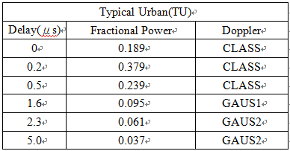
Tap1~Tap3 are for CLASS, Tap4 is for GAUS1 and Tap5~Tap6 are for GAUS2.

- CLASS
Power Spectral Density-CLASS
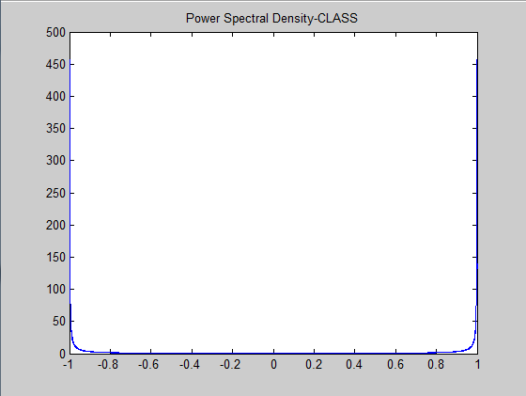

Time-Domain Fading Gain-CLASS
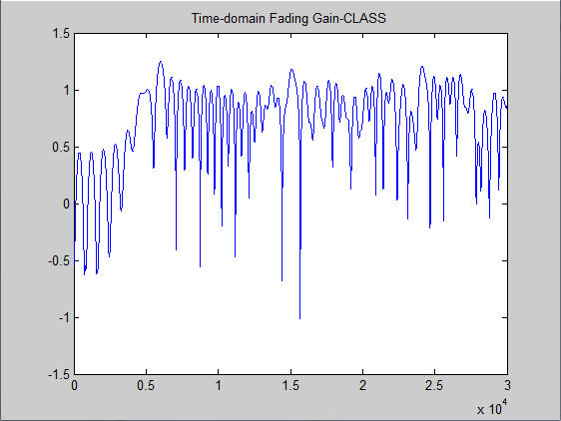
Autocorrelation-CLASS
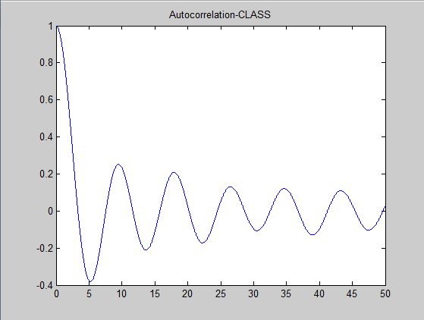
- GAUS1
Tap4 is for GAUS1. Use power spectral density of GAUS1 whose normalized Doppler frequency f/fm range is -1~1, and divide it into 16 parts. Next, use mean and variance of both side Gaussian distribution to derive 16 parts power allocation. (GAUS1 is improved and rewritten from CLASS).
Power Spectral Density-GAUS1
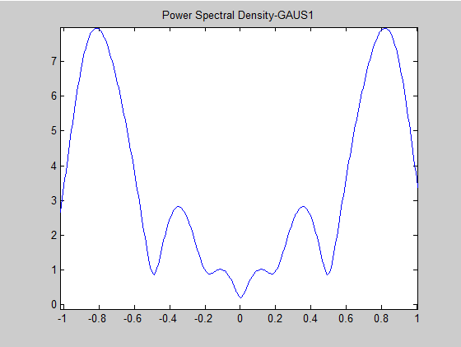
Time-Domain Fading Gain-GAUS1
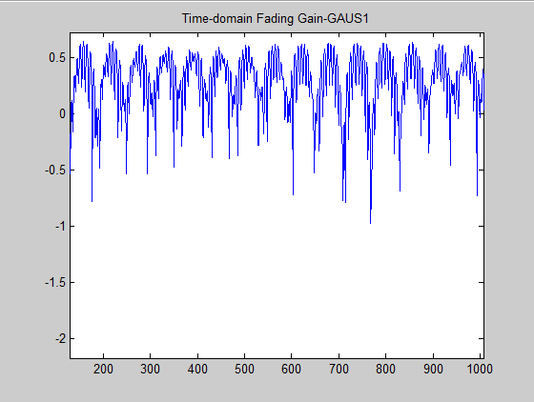
Autocorrelation-GAUS1
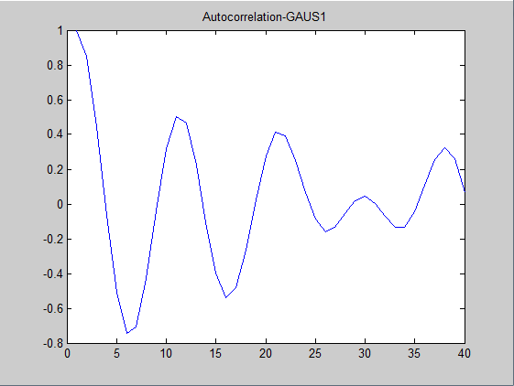
- GAUS2
Tap5~Tap6 are for GAUS2. Most power of GAUS1 are at left side. Respectively, most power of GAUS2 are at right side. If we want to find GAUS2, we can put both sides of GAUS2 mean and variance into power allocation of GAUS1. And we can get the GAUS2.
Power Spectral Density-GAUS2
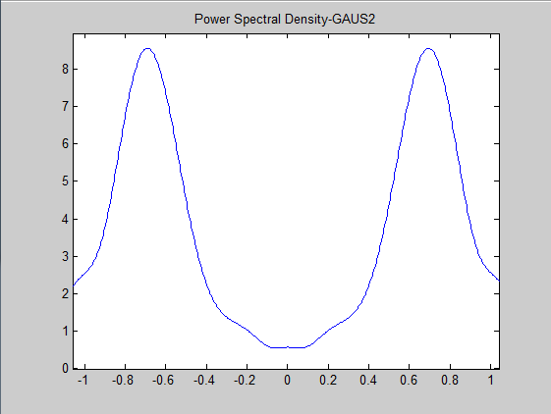
Time-Domain Fading Gain-GAUS2
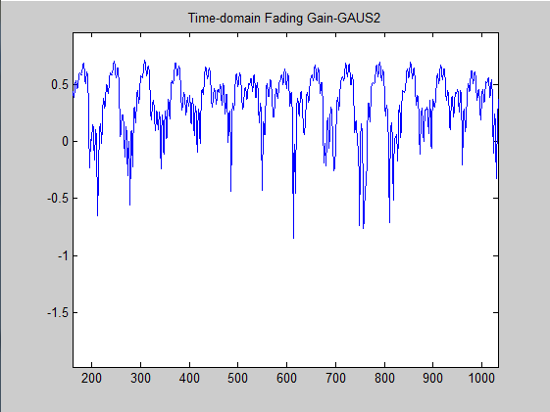
Autocorrelation-GAUS2
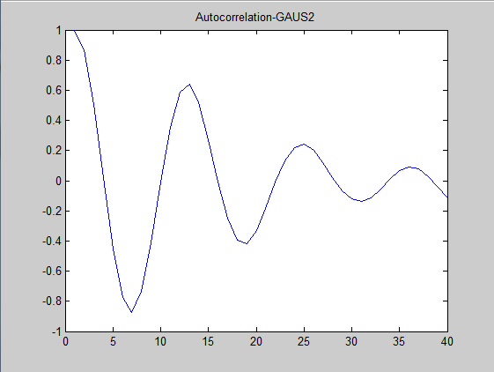

Power Delay Profile
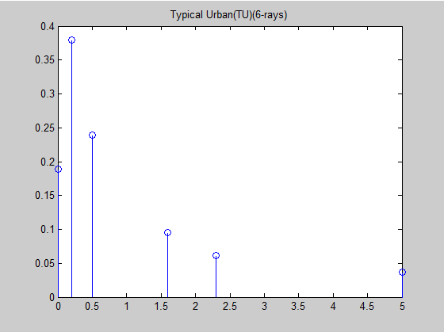

IV. Discussion
在GAUS1部份，先將它的功率頻譜密度(PSD)的Normalized Doppler Frequency f/fm的範圍-1~1分成16個等份，再按照兩個Gaussian distribution的mean值及variance值來計算出16根當中每一根的power，因為分的等份不夠多，所以跑出來的圖形有點不一樣，但還是可看得出GAUS1的PSD在-0.8附近有一個很高的最大值還有在0.4附近也有一個比較小起伏的值，它們就是各自以-0.8fm還有以0.4fm為mean的兩個Gaussian distribution，所以GAUS1的功率主要是集中在左邊。
在GAUS2方面，跟GAUS1相似的做法，把它的兩個Gaussian distribution的mean值及variance值重新代換一下即可，從它的PSD圖也可以看出在-0.4附近有一個小起伏的值，以及在0.7附近有一個很高的最大值，它們就是各自以-0.4fm還有0.7fm為mean值的Gaussian distribution，所以GAUS2的功率主要是集中在右邊。

