1. Suppose we’re in the middle of round 5 of an AES encryption, right before “Mixed Columns” shown as below: [20pts]

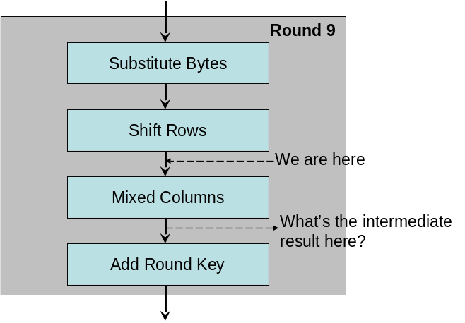
What is the state after “Mixed Columns”?
Below are some related data and tables. The state is as follows.

00 | 00 | 31 | 00
00 | 00 | 2A | 00
00 | 00 | 0F | 01
00 | 00 | 97 | 00
00 | 02 | 00 | 00
0A | 00 | 01 | 00
01 | 00 | 00 | A9
00 | 00 | 00 | 02

and the round key is
S= w[16,19]=

The auxiliary matrix is shown below on the left.
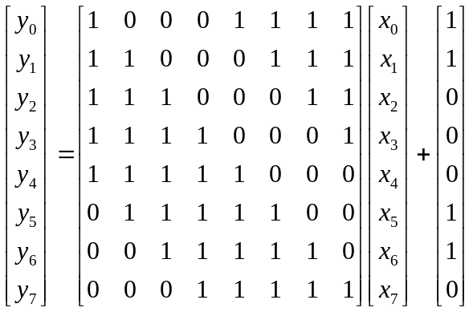
02 | 03 | 01 | 01
01 | 02 | 03 | 01
01 | 01 | 02 | 03
03 | 01 | 01 | 02

m(x) = x⁸+x⁴+x³+x+1, and the affine transformation formula is shown as above on the right.

2. Alice and Bob have each generated a public and private key pair. However, they do not know each other's keys yet. Now they are trying to exchange a message M over a public network with RSA infrastructure. Explain the procedure of applying RSA key exchange while preventing the man-in-the-middle attack. [12pts]

Both Alice and Bob need two public-private key pairs. One for signature. The other for Key exchange.
Alice (Ua1, Ra1) (Ua2, Ra2)
Bob (Ub1,Rb1) (Ub2, Rb2)
Steps are as follows:
Alice generates a session key Ks and a nonce N. Alice encrypts Ks||N with Bob's public key Ub2.
Alice then sends the encrypted message to Bob along with a signature (signed with Ra1).
Bob verifies Alice's signature and decrypts Ks and N.
Bob encrypts N with Ua1 and sends to Alice.
Finally Alice decrypts the message with Ra1 and verifies N.

類似protocol即可，重點是要用兩組 public-private keys

3. What is the difference between a block cipher and a stream cipher? When would it be more appropriate to use them? [12pts]

Block ciphers processes messages in blocks. Stream ciphers encrypts the message bit by bit. For applications with very little tolerance on delays (like streaming video), stream ciphers are more appropriate. For general-purpose applications block ciphers are better.

4. Suppose we are calculating the quadratic residue (square root) of 37 mod 251. Since 251=3 mod 4, according to the formula, one square root must be 37^{(251+1)/4}=37⁶³=163. We can easily verify this result by calculating its square as follows: 163² mod 251, but surprisingly 163² = 214 mod 251, which is NOT equal to 37. Something must have gone wrong! Explain what went wrong in the above calculation. [12pts]

We should check whether or not the Legendre symbol is equal to 1.

5. Rabin’s public key system is based on finding quadratic residues. However, quadratic residues do not always exist, and they are not unique. Sometimes there are no quadratic residues, and sometimes there are many quadratic residues. Explain how to deal with this situation particularly on the case where there are more than one quadratic residues. How to determine which one is the plaintext? [12pts]

Apply a coding scheme. For example, before encryption, we can repeat some bits at the end.

- Explain the homomorphic property of the RSA. [10pts]

Let E(x) denote the RSA encryption of plaintext x. Suppose we are given two plaintexts x1 and x2. We have E(x1*x2)=E(x1)E(x2), which is the homomorphic property.

- Explain the Interactive Prove problem "Ali Baba's Cave" as shown in the following diagram. How does B prove to A that she can pass the gate between C and D? [10pts]
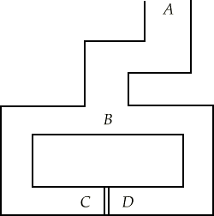

- Bob goes to A, waits there while Alice goes to C or D.
- Bob then asks Alice to appear from either the right side or the left side of the tunnel.
- If Alice does not know the secret words there is only a 50 percent chance that she will come out from the right tunnel.
- Bob will repeat this round as many times as he desires until he is certain that Alice knows the secret words.
- No matter how many times that the proof repeats, Bob does not learn the secret words.

- Is attacking RSA or Rabin public-key encryption algorithm is equivalent to solving the FACTORIZATION problem? Explain why. [12pts]

Rabin encryption algorithm is equivalent to solving FACTORIZATION. Since FACTORIZATION => RABIN is trivial, We prove RABIN=> FACTORIZATION.

Suppose A is an algorithm that solves RABIN
Then we generate x randomly and compute a = x2 mod N
Apply A to find sqrt y
If y=x or –x, try another x and repeat
If not, we obtain both rdp and scq. We can apply Euclid's algorithm to rdp and N to factorize N.

RSA does not have similar properties.

