National Tsing Hua University
COM 5335 Network Security
Midterm Exam
(Total 7 pages)

Time: 2018/11/21 (Wed) 3:30-6:20

Name _____________________________

Student ID # _____________________

Grade ____________

1. Suppose we’re in the middle of round 5 of an AES encryption, right before “Mixed Columns” shown as below: [20pts]

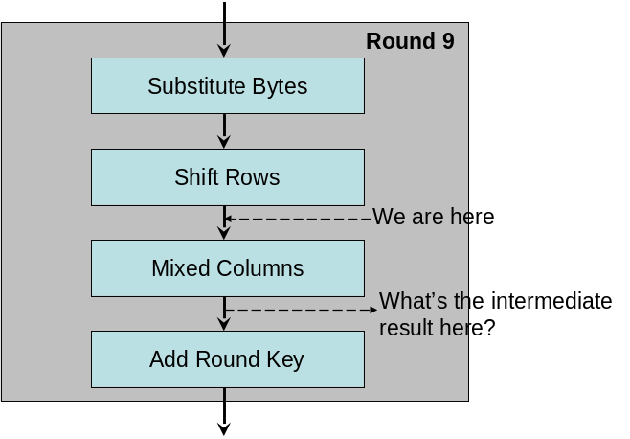
What is the state after “Mixed Columns”?
Below are some related data and tables. The state is as follows.

00 | 00 | 31 | 00
00 | 00 | 2A | 00
00 | 00 | 0F | 01
00 | 00 | 97 | 00
00 | 02 | 00 | 00
0A | 00 | 01 | 00
01 | 00 | 00 | A9
00 | 00 | 00 | 02

and the round key is
S= w[16,19]=

The auxiliary matrix is shown below on the left.
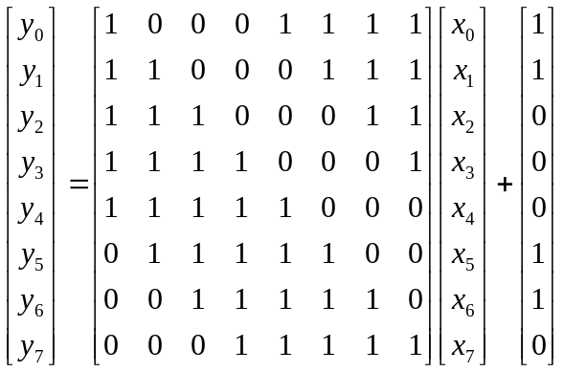
02 | 03 | 01 | 01
01 | 02 | 03 | 01
01 | 01 | 02 | 03
03 | 01 | 01 | 02

m(x) = x⁸+x⁴+x³+x+1, and the affine transformation formula is shown as above on the right.

2. Alice and Bob have each generated a public and private key pair. However, they do not know each other's keys yet. Now they are trying to exchange a message M over a public network with RSA infrastructure. Explain the procedure of applying RSA key exchange while preventing the man-in-the-middle attack. [12pts]

3. What is the difference between a block cipher and a stream cipher? When would it be more appropriate to use them? [12pts]

4. Suppose we are calculating the quadratic residue (square root) of 37 mod 251. Since 251=3 mod 4, according to the formula, one square root must be 37^{(251+1)/4}=37⁶³=163. We can easily verify this result by calculating its square as follows: 163² mod 251, but surprisingly 163² = 214 mod 251, which is NOT equal to 37. Something must have gone wrong! Explain what went wrong in the above calculation. [12pts]

5. Rabin’s public key system is based on finding quadratic residues. However, quadratic residues do not always exist, and they are not unique. Sometimes there are no quadratic residues, and sometimes there are many quadratic residues. Explain how to deal with this situation particularly on the case where there are more than one quadratic residues. How to determine which one is the ciphertext? [12pts]

- Explain the homomorphic property of the RSA. [10pts]

- Explain the Interactive Prove problem "Ali Baba's Cave" as shown in the following diagram. How does B prove to A that she can pass the gate between C and D? [10pts]
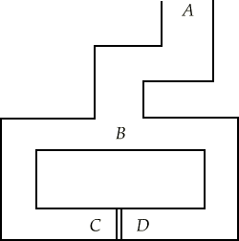

- Is attacking RSA or Rabin public-key encryption algorithm is equivalent to solving the FACTORIZATION problem? Explain why. [12pts]

