Final project for Wireless Communications 100064505 朱育萱
COST 207 Channel Emulator
- Input parameters:
- 6 taps power delay profiles:
Reduced typical urban (TU):
typical urban (TU)
Delay (μs) | Fractional Power | Doppler
0.0 | 0.189 | CLASS
0.2 | 0.379 | CLASS
0.5 | 0.239 | CLASS
1.6 | 0.095 | GAUS1
2.3 | 0.061 | GAUS2
5.0 | 0.037 | GAUS2

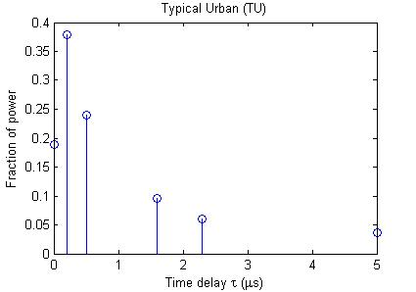

(2) MS velocity: 66.67(m/s), 1000(m/s)
➔ f_{m}=200Hz, 3000Hz
(3) Number of oscillators: M=16
(4) Doppler spectrum parameters:

 | a1 | v11 | v21 | a2 | v12 | v22
GAUS1 | 10 | -0.8 f_{m} | 0.05 f_{m} | 1 | 0.4 f_{m} | 0.1 f_{m}
GAUS2 | 1 | 0.7 f_{m} | 0.1 f_{m} | 31.6 | -0.4 f_{m} | 0.15 f_{m}

- Implementations and output results:
- Three kinds of Doppler channel
CLASS:
We use modified sum of sinusoids method (Multiple faded envelopes) to generate the first three taps.
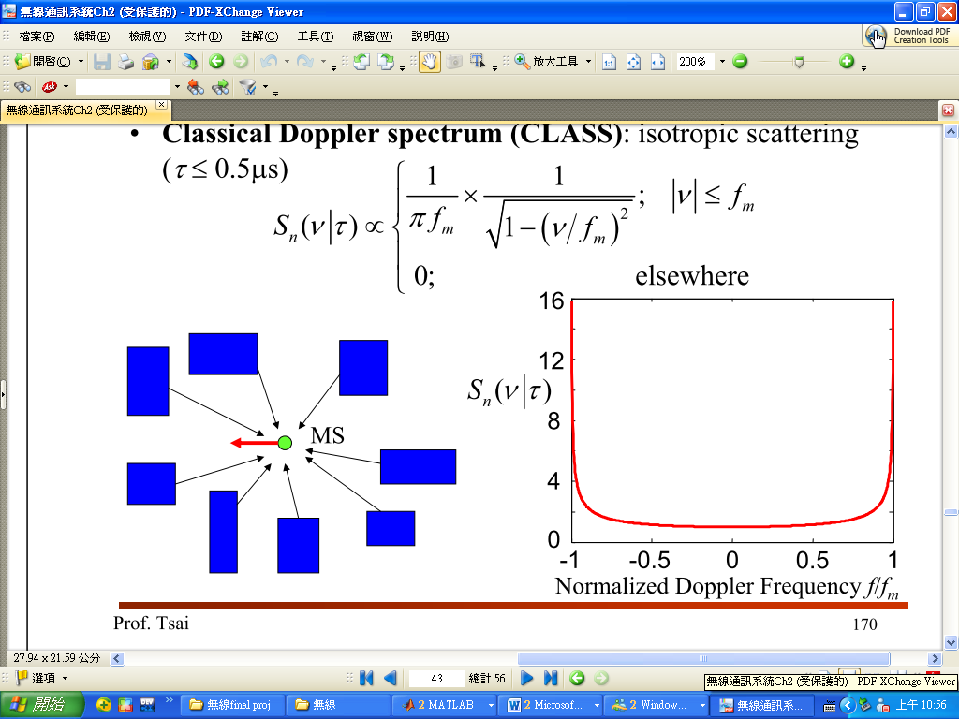
GAUS1:
In GAUS1, we still use M oscillators with uniform distribution of incident angles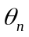. Different from sum of sinusoids (equal strength of multipath components), we choose the magnitude of spectrum below as the strength of multipath components.
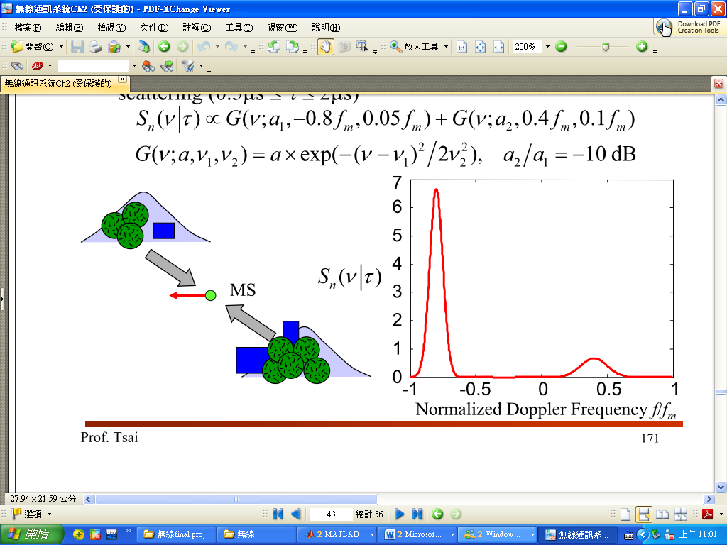
GAUS2:
The implementation is the same as in GAUS1.
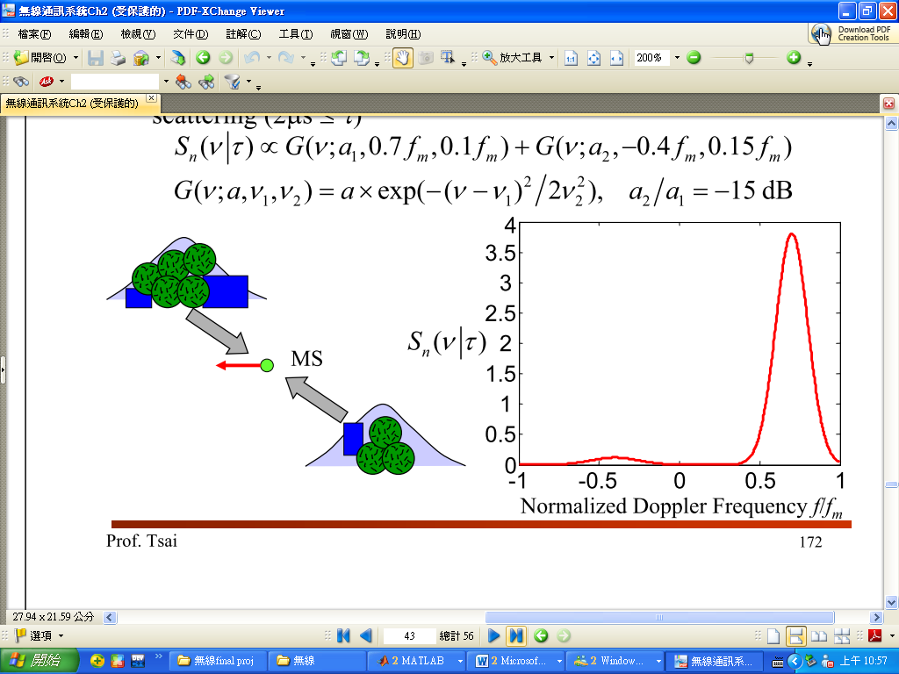
Simulation results:
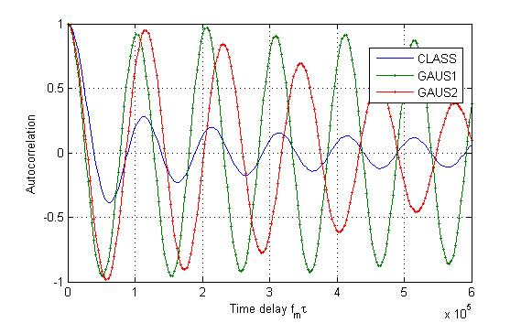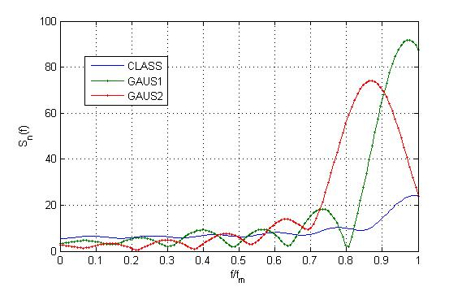
First we see the autocorrelation of the three fading channels (left-hand side), CLASS drops very fast and the second one is GAUS2 and GAUS1 drops very slow. Then see the right-hand side figure, the peak of spectrum of CLASS is at 1* f_{m}, GAUS1 is at about 0.95* f_{m}, and GAUS2 is at about 0.87* f_{m}.
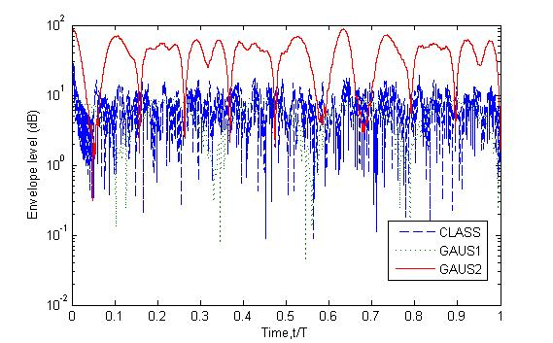

(2) Fading gain distribution
The figures below are the fading gain distribution with two different MS velocities.
a. velocity=66.67m/s. b. velocity=1000m/s.
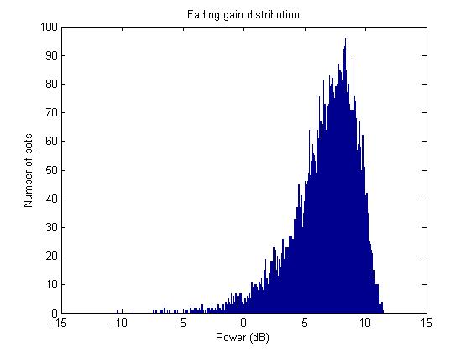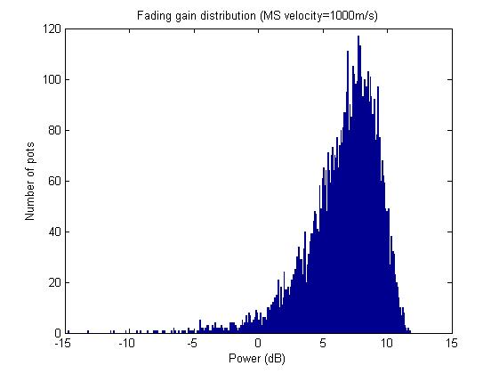
For larger MS velocity, the distribution spread larger, i.e. figure (a) the power spreads to -10dB and figure (b) spreads to -15dB. Therefore, higher speed has lager delay spread.

(3) Strength profile (Time-domain)

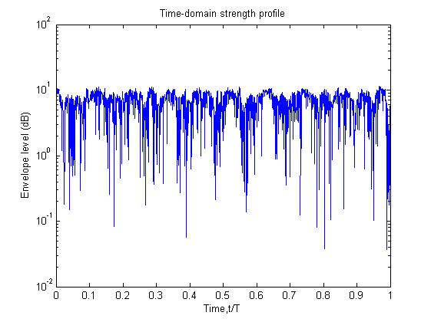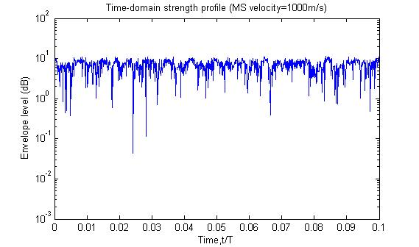
We can observe that when MS velocity becomes higher, the channel changes very fast for MS. This means shorter coherence time, and we will see later in (7).

(4) Autocorrelation (Time-domain)
a. velocity=66.67m/s. b. velocity=1000m/s.
(f_{m} =200Hz) (f_{m} =3000Hz)
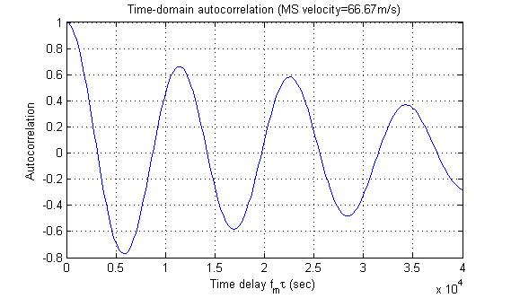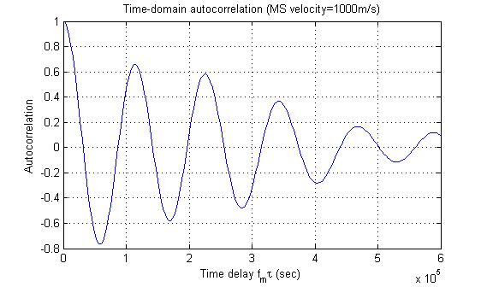
We can see that two figure drop almost equal, so the coherent bandwidth of different MS velocity are almost the same (also shown later in (9),(10)).

(5) Level crossing rate (Time-domain)
a. velocity=66.67m/s. b. velocity=1000m/s.
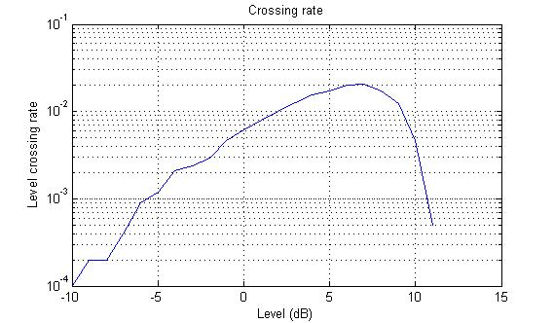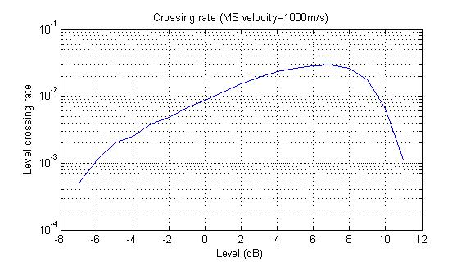
We can observe that the larger the level, the lager the crossing rate. Also, the maximum level crossing rate is at about 7dB. When level becomes larger than 7dB, most of the fading gain are less than it, therefore results the decrease of crossing rate.

(6) Average fade duration (Time-domain)
a. velocity=66.67m/s. b. velocity=1000m/s.
(with total simulation time 1 sec) (with total simulation time 0.1 sec)
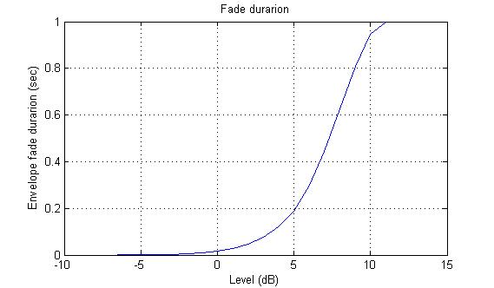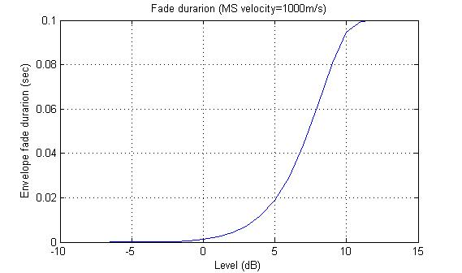
From the figure, we see that fade duration increases with the level and finally goes to total running time. This is reasonable. The larger the level, the more fading gains below it. Finally as the level is very large, all the fading gains are below it.

(7) Coherence time and Doppler spread
Level check: autocorrelation = 0.9
Coherence time = the time between autocorrelation 1~0.9
MS velocity (m/s) | Coherence time (s) | Doppler spread (kHz)
66.67 | 500 | 2
1000 | 100 | 10

The table shows that the larger the MS velocity, the smaller the coherence time and the Doppler spread is larger. This results match to part(3).

(8) Strength profile (Frequency-domain)

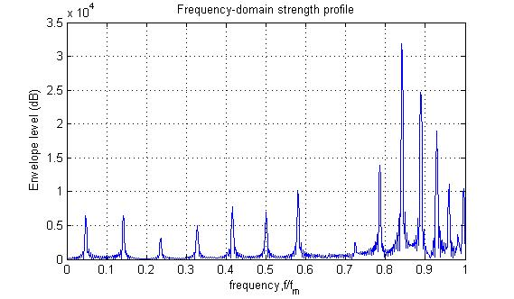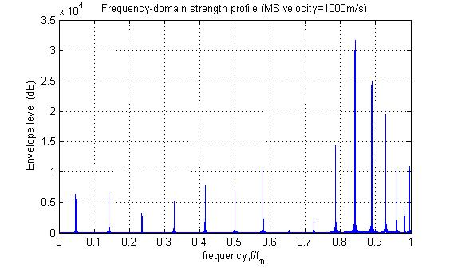
The figures above show that the power concentrates between 0.78*f_{m} and 1*f_{m}. this is reasonable because the main components in CLASS, GAUSE1, and GAUS2 lie in this region. Since GAUS1 and GAUS2 has small components at lower frequency, there are some power lies in the lower frequency region.

(9) Autocorrelation (Frequency-domain)

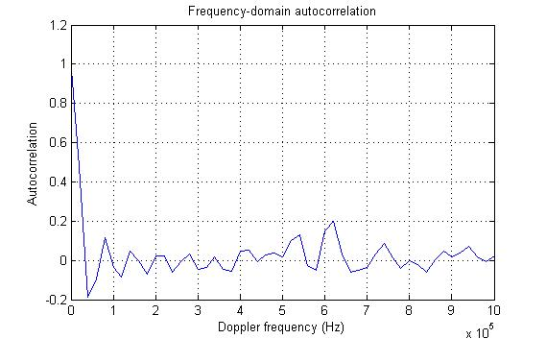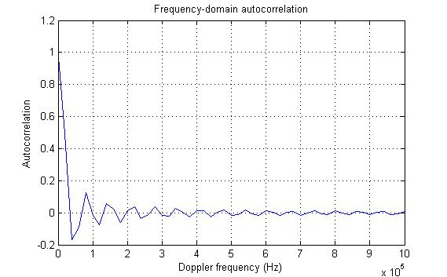
We can observe that both the MS velocities give small coherence bandwidth. The impact of different velocities to the coherence bandwidth is small.

(10) Coherence bandwidth
Level check: autocorrelation = 0.5
Coherence time = the time between autocorrelation 1~0.5
MS velocity (m/s) | Delay spread (s) | Coherence bandwidth (kHz)
66.67 | 50 | 20
1000 | 50 | 20
Because the coherence bandwidths of different velocities are almost the same and the sampling rate is not enough, we get the same coherence bandwidth here.

(11) Doppler spectrum
Doppler spectrum is done by doing FFT with autocorrelation in time domain channel.
a. velocity=66.67m/s. b. velocity=1000m/s.
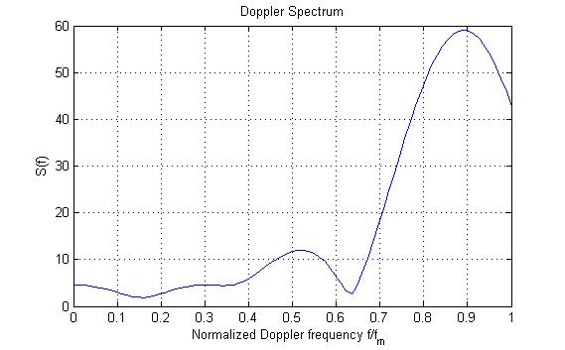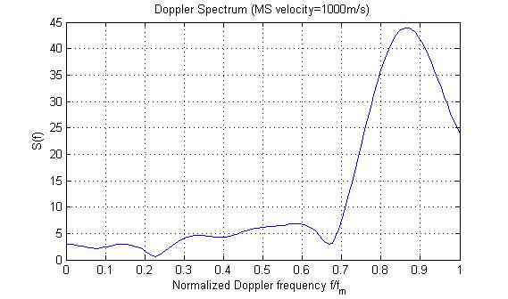
The figure shows that the main peak is at about 0.88*f_{m} and the second peak is at about 0.4~0.5*f_{m}. That is the combination of three fading channel: CLASS, GAUS1, and GAUS2.

(12) Cross correlation between different taps
a. velocity=66.67m/s. b. velocity=1000m/s.
(f_{m} =200Hz) (f_{m} =3000Hz)
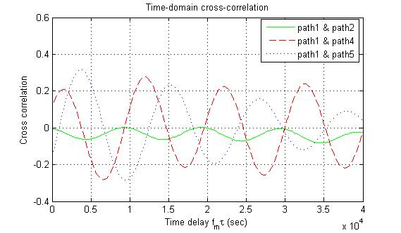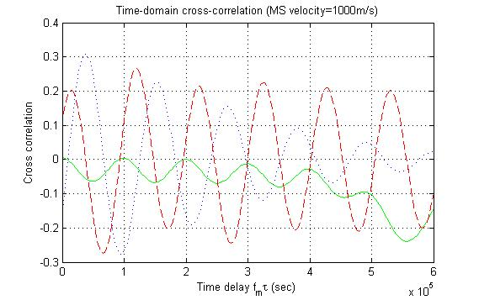
We can see that the correlation between tap1& tap2 is smaller because we use Hadamard matrix to decorrelate the fading envelope when generating the CLASS channels. The tap1 is more correlated with tap4 and tap5.

3. Conclusion
This project gives the opportunities for us to construct the multipath fading channel by simulations. By doing so, I use acknowledge learned in class and therefore learn the model more precisely. Also, I learn how to derive the information (ex: autocorrelation, Doppler spectrum, level crossing rate,…)from the channel we have generated.

