Network Security Assignment#1

108064535 陳文遠(Wen-Yuan Chen)

* **ENVIRONMENT**

|  |  |
| --- | --- |
| **Operation System** | Ubuntu 18.04 |
| **Compiler** | GNU C/C++ |
| **Extra Library** | GMP |

* **INSTALL GMP ON LINUX DEBIAN SYSTEM**

Please enter the following command to install gmp library in your linux computer terminal.

|  |
| --- |
| $ sudo apt-get install m4  $ wget <https://gmplib.org/download/gmp/gmp-6.1.2.tar.bz2>  $ tar –jvxf gmp-6.1.2.tar.bz2  $ cd gmp-6.1.2  $ ./configure –enable-cxx  $ make  $ make check  $ make install |

* **COMPILE AND RUN MY PROGRAM**

|  |
| --- |
| $ g++ assignment1.cpp –o output –lgmp –lgmpxx  $ ./output |

After compiling ,executing and typing input, the result will show on your terminal as following figure.

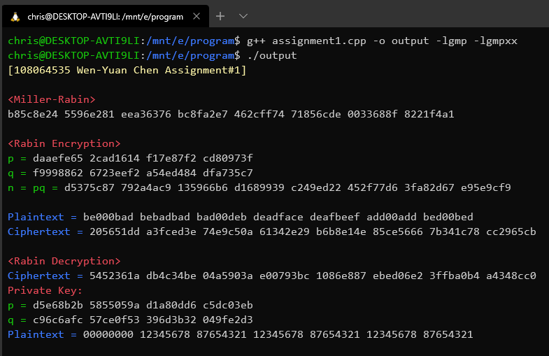

If you don’t understand my instructions or cannot execute, please let me know, I will try my best to figure out the problem.