**COM 5335 : NETWORK SECURITY ASSIGNMENT#3**

**108064535 陳文遠 WEN-YUAN CHEN (Chris)**

1. Show my assign IP address and other information list in the following table.

* The device information under each VLAN

|  |  |  |  |  |
| --- | --- | --- | --- | --- |
| **Devices** | **Interface** | **IP / Mask** | **Getway** | **VLAN** |
| **PC0 (Ireland)** | NIC | 192.168.10.2/24 | 192.168.10.1 | 10 |
| **PC1 (Ireland)** | 192.168.20.2/24 | 192.168.20.1 | 20 |
| **PC2 (Ireland)** | 192.168.30.2/24 | 192.168.30.1 | 30 |
| **PC3 (Germany)** | NIC | 192.168.100.2/24 | 192.168.100.1 | 100 |
| **PC4 (Germany)** | 192.168.200.2/24 | 192.168.200.1 | 200 |
| **PC5 (Finland)** | NIC | DHCP | 192.168.100.1 | N/A |
| **PC6 (Finland)** |
| **DHCP Server (Finland)** | NIC | 192.168.100.2/24 | 192.168.100.1 |
| **Web Server (Estonia)** | NIC | 192.168.1.5/24 | 192.168.1.1 | N/A |
| **Mail Server (Estonia)** | 192.168.1.6/24 |
| **DNS Server (Estonia)** | 192.168.1.7/24 |
| **Dublin Router**  **(Ireland)** | G0/0.10 | 192.168.10.1/24 | N/A | N/A |
| G0/0.20 | 192.168.20.1/24 |
| G0/0.30 | 192.168.30.1/24 |
| S0/0/0 | 10.1.1.1/30 |
| **Berlin Router**  **(Germany)** | G0/0.100 | 192.168.100.1/24 | N/A | N/A |
| G0/0.200 | 192.168.200.1/24 |
| S0/0/0 | 10.2.2.1/30 |
| **Tartu Router**  **(Estonia)** | G0/0 | 192.168.1.1/24 | N/A | N/A |
| S0/0/0 | 10.3.3.1/30 |
| **Helsinki Router**  **(Finland)** | G0/0 | 192.168.100.1/24 | N/A | N/A |
| S0/0/0 | 10.4.4.1/30 |
| **Central Router**  **(Our company)** | S0/0/0 | 10.1.1.2/30 | N/A | N/A |
| S0/0/1 | 10.2.2.2/30 |
| S0/1/0 | 10.3.3.2/30 |
| S0/1/1 | 10.4.4.2/30 |

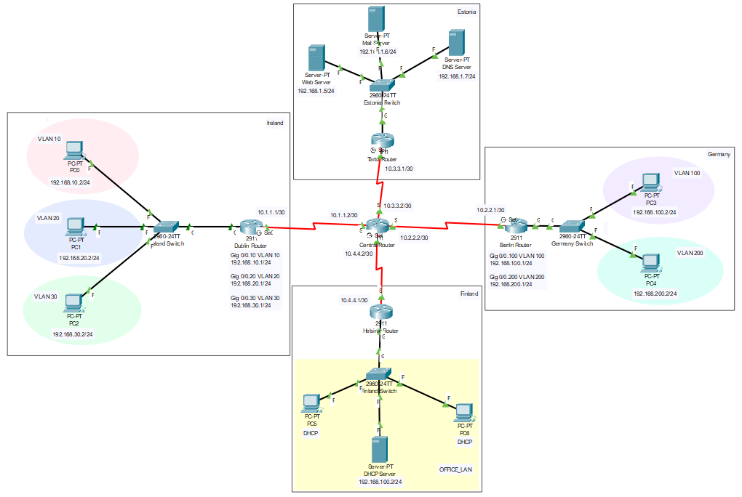

B. What are the purposes of Configure the Standard Access Control List?

ANS : Cisco provides basic traffic filtering capabilities with Access Control List (ACL). Access Control List can be configured for all routed network protocols (such as IP and so on) to filter those protocols’ packets as the packets pass through a router.

C. What are the “RIPv2” and “OSPF”?

1. RIPv2

Routing Information Protocol (RIP) is suitable for small network environments and low reliability network. It can let router dynamically appropriate the variety of network by continuously exchanging information. In this protocol, routers exchange information with neighboring routers every 30 seconds to dynamically build routing tables. RIPv2 is a modified version of RIPv1, it improves the following points on the basis of RIPv1.

* Supports Route Tag. It has flexible routing control according to Tag in routing strategy.
* The packet carries mask information and supports route aggregation and CIDR.
* Only RIPv2 devices can receive protocol messages, which reduces resource consumption.
* Supports verification of protocol messages to enhance security.

2. OSPF

Open shortest Path First (OSPF) is a routing protocol based on IP protocol. Compare to RIP, it’s more suitable for large network environments. It takes Dijkstra’s algorithm to calculate the shortest path tree. Also, OSPF offers the concept of 「Area」, a network can be consisted of a single area or multiple areas. Among them, area 0 is called Backbone Area, this area is the core of the whole OSPF network and directly connected with other areas.

D. What is the VLAN hopping?

E. What is the DHCP spoofing?

F. Describe the security implications of a native VLAN.

G. Describe the one of the network security architecture/framework.

H. List 10 important commands I use in this assignment and describe the reason what is the main purpose to use them

I. List all the commands I use in this assignment.

* Configure within the Ireland Switch

|  |
| --- |
| **>** enable  # configure terminal  (config)# VLAN 10  (config)# VLAN 20  (config)# VLAN 30  (config)# interface fastEthernet 0/1  (config-if)# switchport access vlan 10  (config-if)# switchport mode access  (config)# interface fastEthernet 0/2  (config-if)# switchport access vlan 20  (config-if)# switchport mode access  (config)# interface fastEthernet 0/3  (config-if)# switchport access vlan 30  (config-if)# switchport mode access  (config-if)# end  # show vlan brief  (config)# interface gigabitEthernet 0/1  (config-if)# no shutdown  (config-if)# switchport mode trunk  # show run  # copy running-config startup-config |

* Configure within the Dublin Router

|  |
| --- |
| > enable  # configure terminal  (config)# interface gigabitEthernet 0/0  (config-if)# no shutdown  (config)# interface gigabitEthernet 0/0.10  (config-subif)# encapsulation dot1Q 10  (config-subif)# ip address 192.168.10.1 255.255.255.0  (config)# interface gigabitEthernet 0/0.20  (config-subif)# encapsulation dot1Q 20  (config-subif)# ip address 192.168.20.1 255.255.255.0  (config)# interface gigabitEthernet 0/0.30  (config-subif)# encapsulation dot1Q 30  (config-subif)# ip address 192.168.30.1 255.255.255.0  # show run  # show ip route  (config)# line console 0  (config-line)# password ireland@cisco  (config-line)# login  (config)# enable password ireland@cisco  (config)# line vty 0 4  (config-line)# password ciscocisco  (config-line)# login  (config)# router ospf 1  (config-router)# network 192.168.10.0 0.0.0.255 area 0  (config-router)# network 192.168.20.0 0.0.0.255 area 0  (config-router)# network 192.168.30.0 0.0.0.255 area 0  (config-router)# network 10.1.1.0 0.0.0.3 area 0  # copy running-config startup-config |

* Configure within the Germany Switch

|  |
| --- |
| > enable  # configure terminal  (config)# VLAN 100  (config)# VLAN 200  (config)# interface fastEthernet 0/1  (config-if)# switchport access vlan 100  (config-if)# switchport mode access  (config)# interface fastEthernet 0/2  (config-if)# switchport access vlan 200  (config-if)# switchport mode access  (config-if)# end  # show vlan brief  (config)# interface gigabitEthernet 0/1  (config-if)# no shutdown  (config-if)# switchport mode trunk  # show run  # copy running-config startup-config |

* Configure within the Berlin Router

|  |
| --- |
| > enable  # configure terminal  (config)# interface gigabitEthernet 0/0  (config-if)# no shutdown  (config)# interface gigabitEthernet 0/0.100  (config-subif)# encapsulation dot1Q 100  (config-subif)# ip address 192.168.100.1 255.255.255.0  (config)# interface gigabitEthernet 0/0.200  (config-subif)# encapsulation dot1Q 200  (config-subif)# ip address 192.168.200.1 255.255.255.0  # show run  # show ip route  (config)# line console 0  (config-line)# password germany@cisco  (config-line)# login  (config)# enable password germany@cisco  (config)# line vty 0 4  (config-line)# password ciscocisco  (config-line)# login  (config)# router ospf 1  (config-router)# network 192.168.100.0 0.0.0.255 area 0  (config-router)# network 192.168.200.0 0.0.0.255 area 0  (config-router)# network 10.2.2.0 0.0.0.3 area 0  # copy running-config startup-config |

* Configure within the Tartu Router

|  |
| --- |
| > enable  # configure terminal  (config)# line console 0  (config-line)# password tartu@cisco  (config-line)# login  (config)# enable password tartu@cisco  (config)# line vty 0 4  (config-line)# password ciscocisco  (config-line)# login  (config)# router ospf 1  (config-router)# network 192.168.1.0 0.0.0.255 area 0  (config-router)# network 10.3.3.0 0.0.0.3 area 0  # copy running-config startup-config |

* Configure within the Helsinki Router

|  |
| --- |
| > enable  # configure terminal  (config)# line console 0  (config-line)# password finland@cisco  (config-line)# login  (config)# enable password finland@cisco  (config)# line vty 0 4  (config-line)# password ciscocisco  (config-line)# login  (config)# router ospf 1  (config-router)# network 192.168.100.0 0.0.0.255 area 0  (config-router)# network 10.4.4.0 0.0.0.3 area 0  # copy running-config startup-config |

* Configure within the Central Router

|  |
| --- |
| > enable  # configure terminal  (config)# router ospf 1  (config-router)# network 10.1.1.0 0.0.0.3 area 0  (config-router)# network 10.2.2.0 0.0.0.3 area 0  (config-router)# network 10.3.3.0 0.0.0.3 area 0  (config-router)# network 10.4.4.0 0.0.0.3 area 0  # copy running-config startup-config |