**Wireless Network Lab 6**

**108064535 陳文遠**

* ***Objective***

Implement CMDA scheme.

* ***Requirements***

Generate 8x8 matrix of Walsh codes, and then using it to encode and decode data in a CDMA scheme with at least two senders.

* ***Architecture***

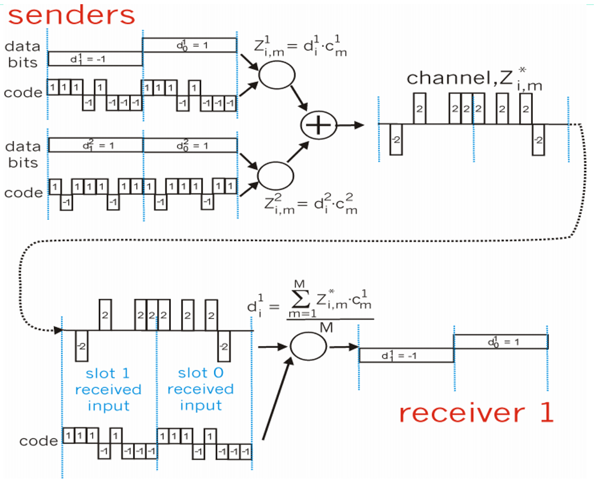

* ***Implementation Step***

1. Generate 8x8 Walsh code matrix, and modify all the element 0 to -1.
$$C=\left[\begin{matrix}-1 & -1 & -1 & -1 & -1 & -1 & -1 & -1 \\ -1 & 1 & -1 & 1 & -1 & 1 & -1 & 1 \\ -1 & -1 & 1 & 1 & -1 & -1 & 1 & 1 \\ -1 & 1 & 1 & -1 & -1 & 1 & 1 & -1 \\ -1 & -1 & -1 & -1 & 1 & 1 & 1 & 1 \\ -1 & 1 & -1 & 1 & 1 & -1 & 1 & -1 \\ -1 & -1 & 1 & 1 & 1 & 1 & -1 & -1 \\ -1 & 1 & 1 & -1 & 1 & -1 & -1 & 1\end{matrix}\right]$$

2. Generate the matrix for two senders, and modify all element 0 to -1 as well. By the way, the first row of D represent the first sender and the second row of D represent the second sender.
$$D=\left[\begin{matrix}1 & 1 & 1 & -1 & 1 & -1 & -1 & -1 & 1 & 1 & 1 & -1 & 1 & -1 & -1 & -1 \\ 1 & -1 & 1 & 1 & 1 & -1 & 1 & 1 & 1 & -1 & 1 & 1 & 1 & -1 & 1 & 1\end{matrix}\right]$$

3. Encode: using the first row of C to times every element in the first row of D as well as using the second row of C to times every element in the second row of D. Finally, summarize the result to a matrix G.
4. Decode: using the same sender matrix to times the encoded matrix G. Summarize all the result and divide by M, then you can restore the data.

* ***CDMA Scheme Program (CDMA.m)***

|  |
| --- |
| clc; clear;    % CDMA Simulation for N Transmitter/Receiver Pairs      % data bit stream for each sender  D = [ 1 1 1 -1 1 -1 -1 -1 1 1 1 -1 1 -1 -1 -1;  1 -1 1 1 1 -1 1 1 1 -1 1 1 1 -1 1 1 ];      % generate a 8x8 matrix of Walsh codes (W)  C = 0;  for i=1:(4-1)  C = [C, C; C, ~C];  end  X = size(C); X = X(1);  Y = size(C); Y = Y(2);  % modify 0 element in walsh code matrix to -1  for i=1:X  for j=1:Y  if C(i, j) == 0  C(i, j) = -1;  end  end  end      % parameters  M = length(C); % length (number of bits) of code  Y = size(D);  N = Y(1); % number of unique senders / bit streams  I = Y(2); % number of bits per stream  T = []; % sum of all transmitted and encoded data on channel  RECON = []; % vector of reconstructed bits at receiver      % show data bits and codes  'Vector of senders to be transmitted:', D  'Vector of walsh codes used for transmission:', C      % encode bits and transmit  G = zeros(I,M);  for n = 1:N  Z = zeros(I,M);  for i = 1:I  for m = 1:M  Z(i,m) = [D(n,i)*C(n,m)];  end  end  G = G + Z;  end  % show channel traffic  for i = 1:I  T = [ T G(i,:) ];  end  'Resulting traffic on the channel:', T      % decode and reconstruct  for n = 1:N  TOT = zeros(1,I);  R = zeros(I,M);  for i = 1:I  for m = 1:M  R(i,m) = G(i,m) * C (n,m);  TOT(i) = TOT(i) + R (i,m);  end  end  RECON = [RECON ; TOT / M];  end  'Reconstructed data at the receiver:', RECON |