**Abstract Reasoning Experiment - Procedure**

**General Preparation**

1. Instructions to participants:
   * Before the day of the expriment:
     1. No hair product
     2. No eye makeup
     3. If corrected-vision, wear contact lenses instead of glasses if possible
   * Try to refrain from moving, clenching their jaw, and blinking as much as possible
   * During breaks, take as long as needed but try to keep head still and not move too much
2. Measure screen to chin-rest distance
3. Check tape marks on location of screen and EyeLink camera
4. Check screen resolution and refresh rate
5. File naming:
   * Pattern: “cp<participant ID><session number>”
   * using two digits (leading zero) for both Participant ID and Session number
   * e.g., participant 1, session 1: “cp0101”

**First Steps**

1. Informed consent form
2. Turn on all three experimenter’s PCs and the participant’s PC
3. Turn on light, decrease brightness to minimum. Make sure the neons are not flickering, otherwise try to increase the brightness a bit until they stop.
4. Plug in the Eye tracker
5. connect the battery to the EEG amplifier and turn it on
6. turn off the speakers
7. **EEG computer:**
   1. Launch ActiView
   2. Check the battery level, swap the battery if needed
   3. Select configuration file:
      1. Click on "About / configure" tab
      2. Click on “Load CFG File”
   4. Select "Michael2.cfg"
   5. Press start on upper left corner
8. **EyeLink computer:**
   1. click on "Tracker"
   2. Load the correct configuration
9. Ask participant to put phone / electronic devices away

**Setting up EEG – Part 1**

1. Measure the head’s circumference and select the right cap size

|  |  |  |
| --- | --- | --- |
| Small / Medium | 52-56 cm | Yellow & Red |
| Medium | 54-58 cm | Red |
| Medium / Large | 56-60 cm | Blue & Red |
| Large | 58-62 cm | Blue |

1. Fit the cap on the head, get ears out if more comfortable for participant
2. Make sure the cap is aligned:

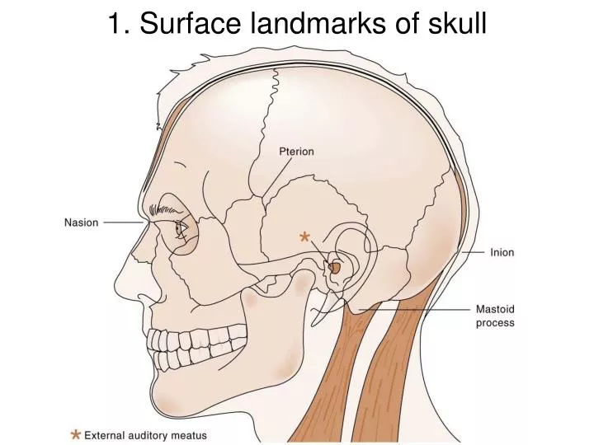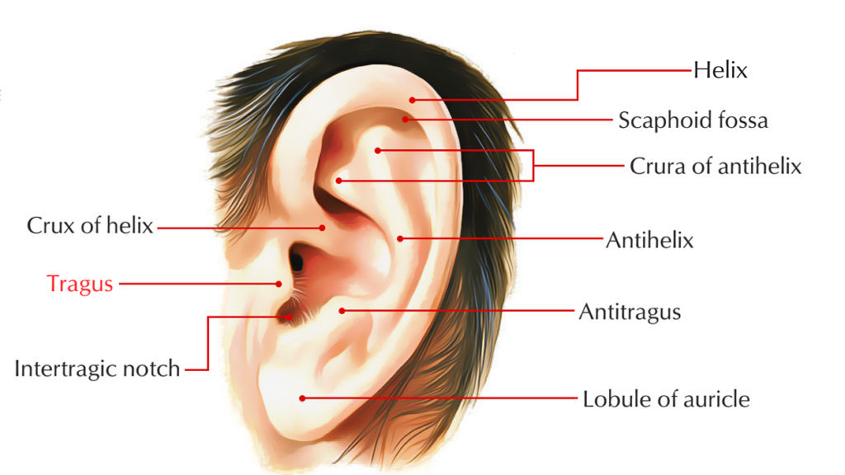

* + Measure the distance between the inion and nasion, Cz should be at the midpoint
  + Measure the distance between the tragi (protrusion on front of the ear), Cz should be at the midpoint

1. Fasten the cap’s strap and ensure it is relatively tight
2. Apply conductive gel to EEG cap
   * Fill a clean syringe with conductive gel
   * Gently part the hair beneath each electrode’s hole by slowly rotating the tip of the syringe on the scalp
   * Slowly inject a small amount of gel while gradually withdrawing the syringe
3. Place the eye electrodes

1. Check the electrodes activity on the monitor and readjust the cap / gel if necessary
   * Note any problematic electrodes or unusual circumstances in a “notes.txt” file in the session’s folder

**Setting up Eye-tracking – Part 1**

1. Launch the experiment’s script:
   1. open the command line and cd to the experiment’s folder: C:\Users\topuser\Documents\ChrisPinier\abstract_reasoning\experiment-Lab
   2. run “poetry run python experiment.py”
2. Perform dominant eye test
3. Fill out the dialogue box:

1. Set up chin-rest
2. Measure eye to screen distance, record it in the dialogue box (in mm)
3. Adjust camera focus
4. Click on the pupil of the dominant eye using the mouse
5. Press A multiple times to use the auto-threshold until you get stable CR value

**Setting up the EEG – Part 2**

1. Click on "Start File".
2. Fill out the fields (copy filename), ignore Error 7003 -> click on “continue”
3. Navigate to the data folder: C:\Data\ChrisPinier\abstract-reasoning
4. Enter the filename using the pattern described in the “General Preparation” section
5. Click on “Paused” to start saving data, the button above will turn green and show “Saving”

**Launching the Experiment**

1. Press C for calibration, move mouse cursor away, press enter to start
2. Press V for validation, move mouse cursor away, press enter to start, press enter to continue once calibration done
3. Press O to start the experiment, move mouse cursor away

**End of experiment**

1. On the “EEG computer:
   * In ActiView:
     1. click on “Pause File” (upper right corner)
     2. click on “Stop” (upper left corner)
   * Copy the EEG (.bdf) file to the USB stick
2. On the “main computer”:
   * Copy the behavioral data files (practice and experiment; .csv) and the eye tracking files (.edf & .asc) to the USB stick
3. Remove the electrodes, put them in the plastic bucket, making sure they are not touching anything metallic
4. Remove the cap
5. Provide a towel and shampoo to the participant, guide them to the bathroom
6. Clean the electrodes, hang them on the wall, electrodes inward, connector outward
7. Clean the cap, hang it with the electrodes

**Lab Information  
Technical specifics**

All PC’s standard installed software:

* **Windows 10 version 19.03 64bit**
* **Psychopy**
* **Eye Link software in Eye Link labs**

**Hardware:**

* **Eye Link 1000 (in Eye Link lab)**
* **144 Hz stimulus monitor (LG 27GL850 27″ resolution 2560 x 1440)**
* **Biosemi Actiview, 64 channel Biosemi Active II EEG amplifier (if available)**
* **High performance stimulus PC to allow real-time data analysis**