

RMSk
RCI Project Authorization Request Process
V.1.9
Prepared By:
Regional Information Security Office

1. Introduction
The Regional Cloud Infrastructure (RCI) is the regional cloud data center of AP region on MS Azure for both internal and external customers. Industrial best practices from ITIL, ISMS and Azure are applied to RCI to ensure the operation environment is secure, stable, and cost effective. To facilitate smooth system provisioning on RCI, the Project Authorization Request (PAR) process is introduced by regional IT (RIT) to collect necessary information for system design and cost estimation.
The PAR process will take some time to complete, in general 1-2 weeks. The actual elapsed time will depend on project complexity, response time of project team and external partners etc. Therefore, we suggest you engage us in early stage of system development (figure 1 refers). Please read following instructions before filling the PAR form. Should you have any question, please contact RIT.

2. Instructions:
- Requestor should complete Section 1 of the PAR form and submit it to RIT.
- RIT staff will contact the requestor to verify the information after receiving the PAR form.
- If necessary, we will request additional information from the requestor. The requestor should gather and revert the information to RIT ASAP, in order not to delay the approval and implementation.
- RIT will document the system design and cost estimation at Section 2.
- The requestor should review the system design and cost estimation, obtain the project sponsor approval; and revert to RIT.
- Then, RIT Infrastructure Manager and Security Manager will endorse the solution
- Finally, the GM RIT will approve the PAR.
- System provisioning will be started in the agreed schedule.

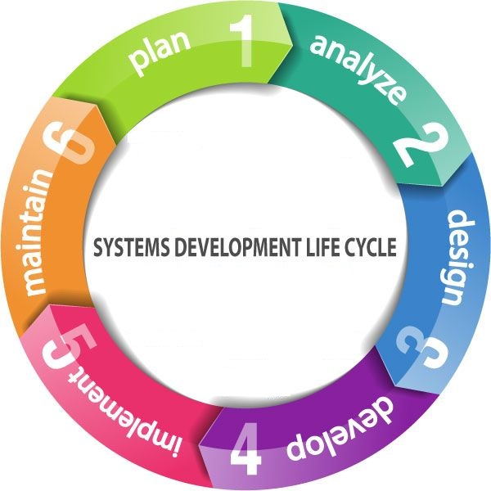
Figure 1 System Development Life Cycle (SDLC)

3. Section 1
Project Information (Filled by Requestor)
Basic Information
Requester: | [Chris Lai] | Opcos: | RAPO - Regional IT (the platform serves all APAC OpCos)
Department: [TO BE COMPLETED BY REQUESTOR] | RAPO IT | Request Date: 9 August 2026 | 10/8/2026
Project Name: | APAC ISMS Governance Platform
Project Sponsor: | [Dewey Lou]
Project Manager: [TO BE COMPLETED BY REQUESTOR] | Dewey Lou | Project technical contact: [TO BE COMPLETED BY REQUESTOR] | Chris Lai
Project Objective: | An internally built ISMS governance platform for the Regional IT office, covering 13 operating companies across 11 jurisdictions under ISO/IEC 27001:2022 and ISO/IEC 27017. It is not a general-purpose GRC suite.  It digitises the group’s existing ISMS forms and procedures — the RCI Risk Management Procedure and Report, the Security Incident template, the APAC ISMS Profile and the supplier management set — rather than imposing a generic model, so ISO 27001 certification continuity is preserved and adoption friction stays low.  The flagship capability is a cross-entity roll-up dashboard giving the Regional ISO a live view of ISMS posture across every OpCo with drill-down, replacing the current quarterly Excel-and-email collection cycle.  Wave 1 delivers the shared backbone — core data model, entity-scoped access enforced by PostgreSQL row-level security, an append-only tamper-evident audit trail, a lean workflow engine and Entra ID based identity/RBAC — proven end to end by two modules: Policy Management, and the Risk and Control registers.  This is an internal system for group staff only. It holds ISMS governance records. It holds no customer data, no payment card data and no special-category personal data.
Project Schedule
Expected Implementation Date: | 8/17/2026
High-level Project Timeline: | Task Date Remarks  - M0 Repository, CI/CD, security scanning, container images Completed 8 Aug 2026 Done. No Azure environment was needed for it.  DEV environment provisioning Target Sep 2026 Blocks every milestone below. Earliest possible date is requested.  - M1–M3 Core data model, entity scoping + row-level security, audit trail Sep – Oct 2026 Runs on dev.  M4–M5 Entra ID identity and RBAC, workflow engine Oct – Nov 2026 Needs the App Registrations and the corporate DNS name.  - STAGING environment provisioning Target Nov 2026 Required for user acceptance testing with the Regional ISO.  M6–M7 Policy, asset inventory, ISMS profile, risk and control registers Nov 2026 – Jan 2027 UAT on staging.  - M8–M9 Roll-up dashboard (flagship), “Entity Zero” self-assessment Jan – Feb 2027 PRODUCTION environment required for go-live, target Feb 2027.  Dates after M0 are targets and will be re-confirmed once the environments exist. The PAR process itself (1–2 weeks) is on the critical path for the dev environment.
Third Party Information (If third party vendor is involved, please fill in the following information)
Company Name: N/A — no third-party vendor. Built and operated internally by Regional IT. | Company Name
Contact Person | N/A
Email: | N/A | Phone: | N/A
Scope of work: | N/A — no third party is involved in the build or the operation of this system. Development is in-house; the Azure resources are provisioned and operated by Regional IT.

System Architecture
System Diagram (Please simply drag and drop the attachment to below area):
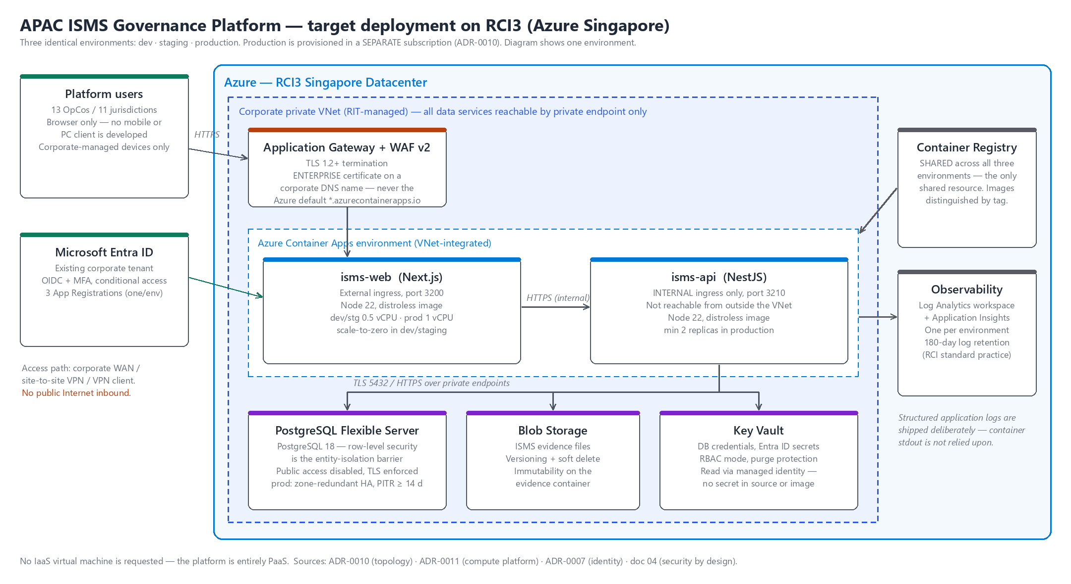
Figure 1 — one environment. Three identical environments are requested (dev / staging / production); production is provisioned in a separate subscription.
System Component Specification
The system will be hosted on:
☐ RCI1 -- Azure Hong Kong Datacenter
☐ RCI2 -- Azure Australia East Datacenter
☒ RCI3 -- Azure Singapore Datacenter

VM Specification:
None. No IaaS virtual machine is requested — see the table below.
The platform is deployed entirely as PaaS: two containerised Node.js services on Azure Container Apps. There is no guest operating system for us to patch, so no VM patching window, no VM backup policy and no VM start/stop schedule applies.
If RCI standards require an IaaS deployment instead, please advise before design sign-off — it materially changes the build.
Hostname | CPU | RAM | Storage | OS | Application  (e.g. SQL, IIS) | System Up Time  (e.g. 5x8, 7x24)
N/A — no VM | — | — | — | None (no guest OS) | Containerised Node.js 22: NestJS API + Next.js web, on Azure Container Apps | production 7x24; dev and staging scale to zero when idle

Other Resources (i.e. AKS, Azure App Services…etc)
Summary below; the resource table that follows carries the same request in the form’s own format.
PER ENVIRONMENT — three environments requested: dev, staging, production. Production is provisioned in a SEPARATE subscription; dev and staging may share one.
1. Azure Container Apps environment (VNet-integrated) running isms-api (INTERNAL ingress only, port 3210) and isms-web (published through the WAF, port 3200).
2. Azure Database for PostgreSQL Flexible Server — PostgreSQL specifically: row-level security is the data-isolation barrier between operating companies and cannot be substituted.
3. Blob Storage for ISMS evidence files · 4. Key Vault · 5. Log Analytics + Application Insights
6. Application Gateway with WAF v2, TLS 1.2+ on an ENTERPRISE certificate and corporate DNS name — never the Azure default hostname (see note 4 under “Addition Requirement”).
7. User-assigned managed identity · 8. VNet subnets and private DNS zones
SHARED across all three environments: 9. one Azure Container Registry, images distinguished by tag.
Resource Name | Specification | Remark(s)
Key Vault | Name: kv-isms-dev, kv-isms-stg | RBAC mode; soft-delete + purge protection. Holds DB credentials and Entra ID client secrets, read through a managed identity. No secret in source or image.
Key Vault | Name: kv-isms-prod | In the SEPARATE production subscription.
Event Grid | Not required | Not used by this system.
ACA/AKS/DevSecOps
Azure Container Apps | cae-isms-dev → ca-isms-web-dev + ca-isms-api-dev  cae-isms-stg → ca-isms-web-stg + ca-isms-api-stg  cae-isms-prod → ca-isms-web-prod + ca-isms-api-prod  (one Container Apps environment per deployment environment) | VNet-integrated. isms-api has INTERNAL ingress only. dev/stg 0.5 vCPU, 1 GiB, min 0 (scale to zero) / max 2 replicas. prod 1 vCPU, 2 GiB, min 2 / max 6.
AKS | Not required | Container Apps is used instead. A Kubernetes cluster would be a second system to secure, patch and prove compliant for two HTTP services.
Azure Container Register | Yes — ONE registry shared by all three environments | Standard SKU minimum; Premium only if a private endpoint is mandated. Images distinguished by tag. The only deliberately shared resource.
Azure DevOps  Pipelines, Boards, Repos, Artifacts. (Test features excluded) | Not required | Basic Plan: US$6/user/mth  Basic + Test Plan:  US$52/user/mth  Source control and CI/CD run on the existing corporate GitHub organisation. No Azure DevOps licences are requested.
Blob Storage | Size(GB): dev 100 / staging 100 / production 500 | ISMS evidence files. Private endpoint, versioning + soft delete, immutability policy on the evidence container.
Azure Database for PostgreSQL — Flexible Server | PostgreSQL 18.  dev / staging: Burstable B2s, 64 GB, 7-day PITR, no HA.  production: General Purpose D2ds_v5 (2 vCPU / 8 GiB), 256 GB,  zone-redundant HA, PITR ≥ 14 days (RPO 15 min / RTO 4 h). | Row-level security is the entity-isolation barrier — the engine cannot be substituted. Public network access disabled; private endpoint only; TLS enforced.
Application Gateway + WAF v2 (or Front Door Premium + WAF) | One per environment. TLS 1.2 minimum termination. | ENTERPRISE certificate on a corporate DNS name. The Azure default hostname (*.azurecontainerapps.io) and default platform certificate must NOT be used.
Log Analytics workspace + Application Insights | One per environment. | Diagnostic settings for Container Apps and the WAF. 180-day retention per RCI standard practice.
User-assigned managed identity | One per environment. | Container registry pull and Key Vault access, so no credential is stored in code or image.
VNet subnets + private DNS zones | Container Apps infrastructure subnet; private-endpoint subnet. | All data services reachable by private endpoint only.
Azure OpenAI Service
ChatGPT | Not required | No Azure OpenAI or other LLM service is in scope for this phase.

Other SaaS/PaaS Subscription:
• Microsoft Entra ID — the EXISTING corporate tenant. Three new App Registrations are required (one per environment) with redirect URIs on the approved corporate DNS names. No new licence.
• GitHub — the existing corporate organisation, for source control and CI/CD. Build output is pushed to the Azure Container Registry above.
• No other new SaaS or PaaS subscription is requested. No third-party AI or LLM service is in scope for this phase.
No other subscription is required.

Start/Stop VMs during off-hours:
Not applicable — no virtual machines are requested.
The equivalent control on Azure Container Apps is the replica floor:
• dev and staging — minimum 0 replicas (scale to zero when idle: the same off-hours saving, with no schedule to maintain and nothing to restart);
• production — minimum 2 replicas, always on. This is a risk and incident system and must be available during an incident, so it is deliberately excluded from any off-hours shutdown.
Hostname | Schedule Start Time (UTC)  (e.g. 1 : Daily at 08:00 UTC)  (e.g. 2 : Every Monday at 08:00 UTC) | Schedule Stop Time (UTC)  (e.g. 1 : Daily at 18:00 UTC)  (e.g. 2 : Every Friday at 18:00 UTC)
isms-web / isms-api (dev, staging) | No schedule — scale-to-zero when idle | No schedule — scale-to-zero when idle
isms-web / isms-api (production) | Always on (minimum 2 replicas) | Must not be stopped
PostgreSQL (dev, staging) | Office hours only, if that is RCI practice | The production database must not be stopped
Note(s):
- The patch maintenance windows are scheduled as follow(s). During these periods, the Scheduled Start/Stop Time could be affected.

Communication protocol between each system components
Source Hostname | Destination Hostname | Protocol | Port Number
User browser (corporate network / VPN client) | Application Gateway + WAF (agw-isms-<env>) | HTTPS, TLS 1.2 minimum | 443
Application Gateway + WAF | isms-web (Container Apps, external ingress) | HTTPS | 443
isms-web | isms-api (Container Apps, INTERNAL ingress only) | HTTPS | 443
isms-api | PostgreSQL Flexible Server (private endpoint) | PostgreSQL over TLS | 5432
isms-api | Key Vault (private endpoint) | HTTPS | 443
isms-api | Blob Storage — evidence files (private endpoint) | HTTPS | 443
Container Apps environment | Azure Container Registry — image pull | HTTPS | 443
isms-web, isms-api | Microsoft Entra ID (login.microsoftonline.com) | HTTPS — OIDC | 443
All components | Log Analytics / Application Insights | HTTPS | 443
All traffic is encrypted. There is no unencrypted protocol anywhere in the design and no public inbound path to the API or the database. isms-api is published on the Container Apps INTERNAL ingress, so the web app is its only client.

Application-level security headers (HSTS, Content-Security-Policy, X-Content-Type-Options, Referrer-Policy, and cookie Secure / HttpOnly / SameSite attributes) are set by the application and are already asserted by automated tests in the CI pipeline.

Integration with existing system?
☐ Yes ☒ No
If yes, please answer:
Internal system | Internal system Name  IP address  Physical location
Integration methods:

User Access/Authentication
☒ Administrator(s)
Number of Administrator: | [TO BE COMPLETED BY REQUESTOR]
User location: | ☒RAPO ☐RHK ☐RTW ☐RVN ☐RNZ ☒RAP  ☐RA ☐RSP ☐RTH ☐RMS ☐RPH  Remark: Opcos out of o365 Tenant should be count as External users  Administrators are Regional IT staff (Platform Admin) and the Regional ISO.
What information the Administrator can access? | Full access across all 13 OpCos: policies, assets, risks, controls, Statements of Applicability, ISMS profiles, audit issues, supplier assessments and security incidents; plus platform configuration and the assignment of roles and entity scopes.  The append-only audit trail is readable but cannot be modified or deleted by any role, administrators included — it is hash-chained and tamper-evident by design, and administrator actions are themselves written to it.  There is no standing privileged access: privileged operations use time-boxed, fully logged elevation.  Data classification: Internal and Restricted ISMS governance records, plus staff name, job title and work e-mail as record owner. No customer data, no payment card data, no special-category personal data.
From where the administrator will access the information: | ☐ Internet  ☒ Internal network  ☐ VPN client  ☐ Site-to-Site VPN  No public Internet exposure is requested — the application sits behind the corporate private VNet.
How to access the system: | ☒ Managed Devices  Please specify : corporate-managed Windows PCs and Intune-managed corporate mobile devices | ☐ Mobile app (Native app/ New developed app)  ☐ PC client (Native client/ New developed client)  ☒Browser
 | ☐ Unmanaged Devices  Please specify : NOT PERMITTED — access from unmanaged devices is not requested and should be blocked | ☐ Mobile app (Native app/ New developed app)  ☐ PC client (Native client/ New developed client)  ☐Browser
Log-in Method: | ☒ Window ID/O365 Account  ☐ WSO (for mobile devices)  ☐ New account  ☐ No need Login  ☐ Other, please specify: Comments
Authentication:  (If login is required) | ☐ Password  ☐ Certification Based Authentication  ☒ MFA, please specify Entra ID MFA via conditional access; phishing-resistant authentication strength (FIDO2 security key or certificate-based) required for the Platform Admin role  ☐ Others, please specify: ___________

☒ Internal User(s)
Number of users: | [50-100]
User location: | ☒RAPO ☒RHK ☒RTW ☒RVN ☒RNZ ☒RAP  ☒RA ☒RSP ☒RTH ☒RMS ☒RPH  Remark: Opcos out of o365 Tenant should be count as External users
What information the user will access? | Entity-scoped by default: a user sees only their own operating company’s records. Isolation is enforced at the database layer by PostgreSQL row-level security, not by application code alone.  Six roles across eleven modules — Platform Admin, Regional ISO, OpCo Admin, Control Owner, OpCo OS and Auditor. Permission is enforced in three places (navigation, route, action) with the entity scope applied on top, server-side, on every query.  Regional roles have a legitimate cross-entity roll-up scope. That is an explicit, authorised and separately audited scope expansion — not a bypass of the filter.  Content: policies and attestations, asset inventory, risk register and RCSA responses, control library and test evidence, ISMS profiles, audit issues, supplier assessments, security incidents. Classification Internal / Restricted. Personal data is limited to staff name, job title and work e-mail.
From where the user will access the system: | ☐ Internet  ☒ Internal network  ☐ VPN client  ☐ Site-to-Site VPN  No public Internet exposure is requested.
How to access the system: | ☒ Managed Devices  Please specify : corporate-managed Windows PCs and Intune-managed corporate mobile devices | ☐ Mobile app (Native app/ New developed app)  ☐ PC client (Native client/ New developed client)  ☒Browser
 | ☐ Unmanaged Devices  Please specify : NOT PERMITTED — access from unmanaged devices is not requested and should be blocked | ☐ Mobile app (Native app/ New developed app)  ☐ PC client (Native client/ New developed client)  ☐Browser
Log-in Method: | ☒ Window ID/O365 Account  ☐ WSO (for mobile devices)  ☐ New account  ☐ No need Login  ☐ Other, please specify: Comments
Authentication:  (If login is required) | ☐ Password  ☐ Certification Based Authentication  ☒ MFA, please specify Entra ID MFA via conditional access (Microsoft Authenticator or FIDO2 security key)  ☐ Others, please specify: ___________

☐ External User(s)
Number of users: | 0 — none. The “External User(s)” box above is deliberately left unticked.
What information the user will access?
From where the user will access the information: | ☐ Internet  ☐Internal network  ☐ VPN client
How to access the system: | ☐ Managed Devices  Please specify : devices | ☐ Mobile app (Native app/ New developed app)  ☐ PC client (Native client/ New developed client)  ☐Browser
 | ☐ Unmanaged Devices  Please specify : devices | ☐ Mobile app (Native app/ New developed app)  ☐ PC client (Native client/ New developed client)  ☐Browser
Log-in Method: | ☐ Window ID/O365 Account  ☐ WSO (for mobile devices)  ☐ New account  ☐ No need Login  ☐ Other, please specify: Comments
Authentication:  (If login is required) | ☐ Password  ☐ Certification Based Authentication  ☐ MFA, please specify: ____________  ☐ Others, please specify: ____________

Addition Requirement (Optional):

4. Section 2
Recommended Solution (Filled by RAPO)
Recommended System Diagram on RCI
System integrated with RCI / RCIT environment

RCI resources cost estimation
Pre-production Environment: server specification

Security Requirements of the proposed solution
☐ High Availability
☐ TLSv1.2
☐ VPN
☐ Data Encryption
☐ Application Gateway
☐ Global Protect EE
☐ Web Application Firewall
☐ Firewall Policy Configuration
☐ Multi-factor Authentication
☐ Endpoint Detection and Response
☐ Security Acceptance Test
☐ Other, please specify: Comments

Proposed Implementation Date
Start Date: | Start date. | End Date: | End date. | Total Man-day | Man-day
Additional Information
Please specify.

5. Section 3:
Approval
Reg. Cloud Infra & Workspace Manager: | [Infra and Ops Manager] | Signature: | Not yet request | Date: | [InfraApprovalDate]
Reg. Information & Security Manager: | [Security Manager] | Signature: | Not yet request | Date: | [SecApprovalDate]
G.M. CISO IT: | [G.M. Regional IT] | Signature: | [G.M. Regional IT Approval] | Date: | [GMApprovalDate]
Project Sponsor: | [Project Sponsor]  Please drag and drop the approval documents here | Checked By RISO: | Nil | Date: | [SponsorReview]
Chief Digital Officer: | [Chief_Digital_Officer] | Signature: | Not yet request | Date: | [CDOApprovalDate]

Appendix
6.1 Azure/RCI/ROC Practice
Backup Management:
- VM:
Default Data backup policy: Daily backup
Backup retention:
  - Daily Incremental (7 days),
  - Weekly full backup (4 weeks),
  - Monthly full backup (12 months)
- Azure SQL service:
Default backup policy: Real time backup
Backup retention:
  - Daily Incremental (7 days),
  - Weekly full backup (4 weeks),
  - Monthly full backup (12 months)

SLA provided by Azure:

Single VM With Premium Disk | Virtual Machine (With Availability Set) | Azure SQL | Application Gateway | Azure Backup | Azure DNS
99.90% | 99.95% | 99.95% | 99.95% | 99.90% | 100%

load balancer | VPN gateway | Web Application firewall | Azure Private Link | Storage (LRS)
99.99% | 99.95% | 99.95% | 99.99% | 99.90%

Log Management:
- VM Event Log: Send collected log to Log Analytics workspace
- Traffic Log:
  - Firewall Log will be collected through Azure sentinel and sent to Log Analytics workspace
  - NSG Log will be sent to Log Analytics workspace
- Azure Service: Log will be sent and store at Log Analytics workspace
- Azure App services: send log to Application Insight, Log collected will be stored at Log Analytics workspace (if needed)
- Other option: Set schedule task to copy the application log file to Blob storage. This action does not provide analysis and reporting.
- Log retention period: 180 days

ROC operation hours (technical support and system monitoring):
Monday to Friday, 8 AM to 12 AM. (5x16)

6.2 Document Release History
Version | Prepared By | Description | Date
V1.0 | Dewey Lou, Zoe Chung | Released | 21/11/2019
V1.1 | Zoe Chung | Added Missing Pages | 2/12/2019
V1.2 | Zoe Chung | Modified Internal Login method:  Window ID ->  Window ID/O365 account | 3/12/2019
V1.3 | Zoe Chung | Added Administrator information part | 17/9/2020
V1.4 | Zoe Chung | Change the contact person in Introduction part. | 28/4/2021
V1.5 | Cruise Siu | Added VM Start/Stop Requirement | 19/5/2022
V1.6 | Dewey Lou  Cruise Siu | Revised the document name  Revised Introduction and Instruction sections.  Added RCI locations  Added ROC operation hours  Updated security requirements | 31/Aug/2022
V1.7 | Cruise Siu | Section name of 6.2  Moved Azure/RCI/ROC Practice to Section 6.1  Added “Other Resources Table” in Section1. | 23/Jun/2023
V1.8 | Cruise Siu | Updated Approver in Section 3 | 05/Apr/2024
V1.9 | Lydia Sin | Updated Approver in Section 3 | 07/Aug/2025

