1. **Enter QT and open the RADAV application** 
   1. **Once QT is loaded in the QT creator application click on the Build menu and click:**
      1. **Clean All**
      2. **Run QMake**
      3. **Run the application to ensure functionality**
   2. **In the lower left corner of the creator is the build settings button**

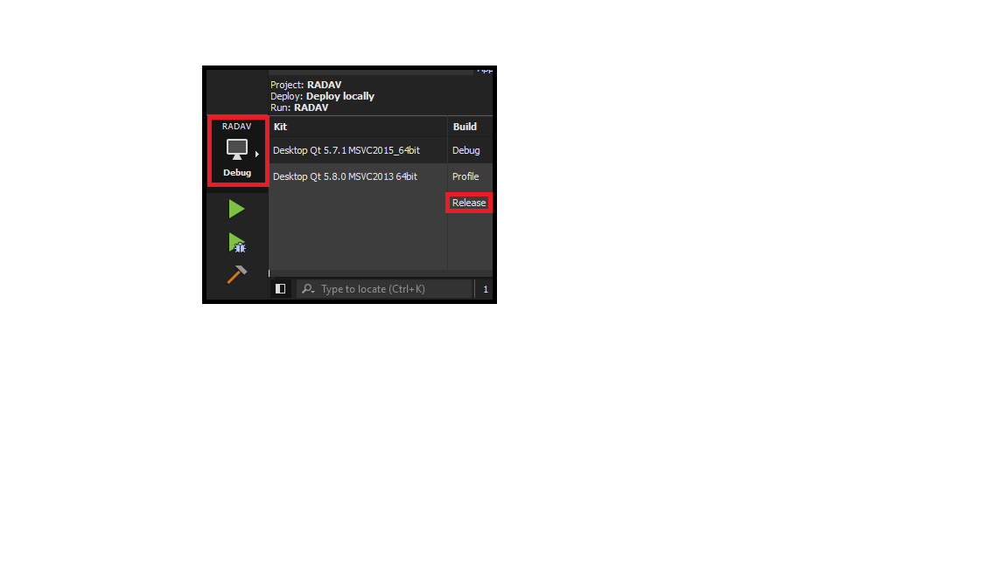

* 1. **Run the application again in release mode to ensure functionality**

1. **First enter the build folder that contains the latest application build (Will have -Releas appended to the end of the build folder name in a command prompt.**
2. **Run the following command line argument to build the dependency list for the application including resource folde.**
   1. <location of QT install>\windeployqt.exe --qmldir "<location of resource folde>" RADAV.exe
      1. **Example “**d:\IDEs\Qt\5.7\msvc2015_64\bin\windeployqt.exe --qmldir "D:\GitHub\ESRA-CS-Team-Post-Expo\RADAV_APPLICATION\Resources” RADAV.exe”
3. Now go to location of the installer package files and create a folder for your version of the installer.
4. Copy the existing “config” and “package” folders into your new folder
5. Copy the contents of the <location of build -Release> all files and folders into <location of your installer package>\package\com.vendor.product\data

Example ““D:\GitHub\ESRA-CS-Team-Post-Expo\build-RADAV-Desktop_Qt_5_7_1_MSVC2015_64bit-Release\release” to “D:\GitHub\ESRA-CS-Team-Post-Expo\RADAVInstaller\radavInstallerV3\package\com.vendor.product\data”

1. Finally run the following command from the root of your new installer folder.
   1. Run command <location of QT installer framework>\2.0\bin\binarycreator.exe <proper flags> name of application installer
      1. Example: from “D:\GitHub\ESRA-CS-Team-Post-Expo\RADAVInstaller\radavInstallerV3” run command “d:\IDEs\Qt\Tools\QtInstallerFramework\2.0\bin\binarycreator.exe --verbose --offline-only -c config\config.xml -p package RADAVInstall.exe”
2. Test your new installer.

Feel free to modify installer as needed. Use the QT documentation reference site at: <http://doc.qt.io/qtinstallerframework/index.html>

**MY PC**

**Command line argument to create a dependency list for install package.**

~~d:\IDEs\Qt\5.7\msvc2015_64\bin\windeployqt.exe TestApplication.exe~~

~~d:\IDEs\Qt\5.7\msvc2015_64\bin\windeployqt.exe RADAV.exe~~

**This line will create all the items need to run the application in the current folder including the sub directory resources.**

d:\IDEs\Qt\5.7\msvc2015_64\bin\windeployqt.exe --qmldir "C:\Users\acwood\Desktop\CS 461\ESRA\ESRA-CS-Team\RADAV_APPLICATION\Resources" TestApplication.exe

d:\IDEs\Qt\5.7\msvc2015_64\bin\windeployqt.exe --qmldir "D:\GitHub\ESRA-CS-Team-Post-Expo\RADAV_APPLICATION\Resources” RADAV.exe

The above line will work for build or release version as long as the windeployqt tool is pointed at the appropriate directory.

Now go to location of the installer package files and creat a folder for your version of the installer.

Copy the existing “config” and “package” folders into your new folder

Copy the contents of the <location of build -Release> all files and folders into <location of your installer package>\package\com.vendor.product\data

“D:\GitHub\ESRA-CS-Team-Post-Expo\build-RADAV-Desktop_Qt_5_7_1_MSVC2015_64bit-Release\release” to “D:\GitHub\ESRA-CS-Team-Post-Expo\RADAVInstaller\radavInstallerV3\package\com.vendor.product\data”

Finally run the following command from the root of your new installer folder.

From here: D:\GitHub\ESRA-CS-Team-Post-Expo\RADAVInstaller\radavInstallerV3

Run d:\IDEs\Qt\Tools\QtInstallerFramework\2.0\bin\binarycreator.exe --verbose --offline-only -c config\config.xml -p package RADAVInstall.exe

<https://wiki.qt.io/Show_library_dependencies>

<http://stackoverflow.com/questions/17736229/do-i-have-to-include-all-these-qt-dlls-with-my-application>

<http://doc.qt.io/qt-5/windows-deployment.html#the-windows-deployment-tool>

<http://www.dependencywalker.com/>

**Location of the working directory for the install**

C:\Users\acwood\Desktop\CS 461\ESRA\ESRA-CS-Team\RADAVInstaller

D:\GitHub\ESRA-CS-Team-Post-Expo\RADAVInstaller\radavInstallerV3

**IT WOOOORRRRRKRKKKSSS!!!**

d:\IDEs\Qt\Tools\QtInstallerFramework\2.0\bin\binarycreator.exe --verbose --offline-only -c config\config.xml -p package RADAVInstall.exe