SELECT name,department
from directors
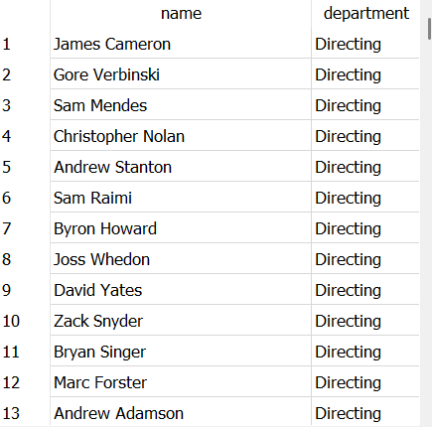

;

select title,popularity
from movies
where popularity>5
order by popularity asc
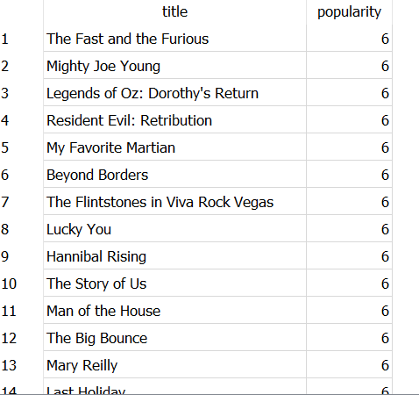

;

select name,id
from directors
where department = "Directing" and gender=2
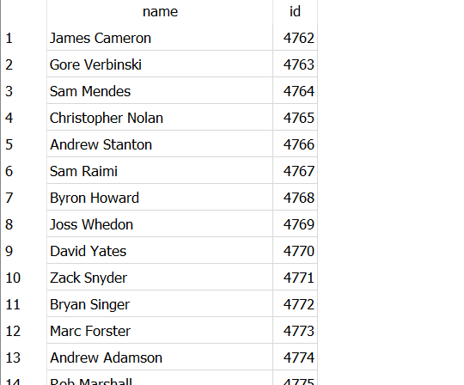

select name
from directors
where name like '%sam%'
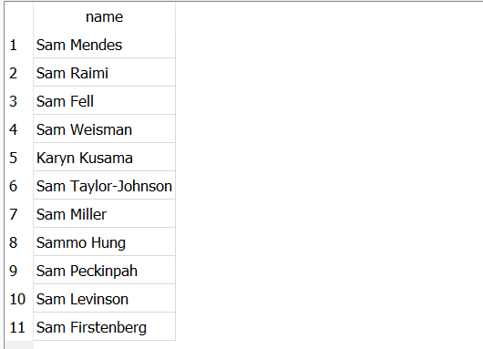

select title,release_date
from movies
order by release_date asc
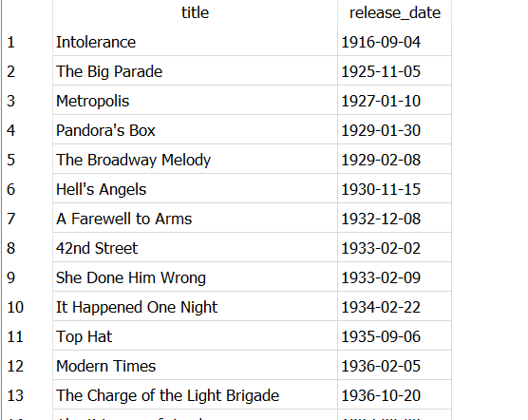

select title
from movies
where (release_date>"1995-1-01" and release_date<"2000-12-31")


;

select title,vote_average
from movies
where title like '%star%' and vote_average>7
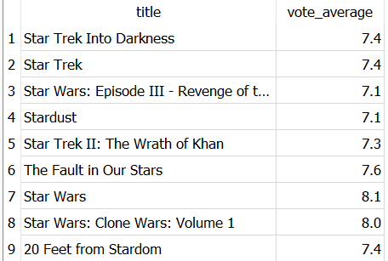

;

select name,uid
from directors
where uid > 7000 or uid < 100
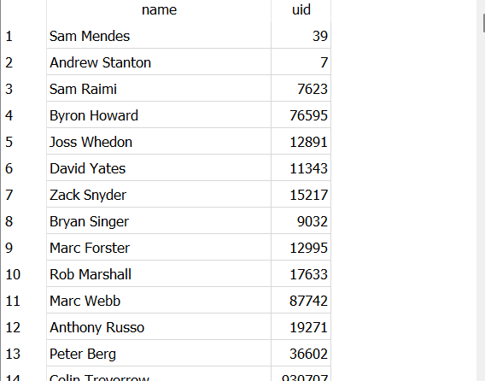

select title,vote_count
from movies
where (vote_count>50 and vote_count <100)
AND
(vote_average = 7)
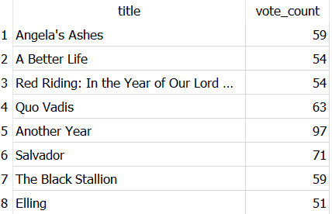
;
select name
from directors
where name like '%John%'
AND
(uid > 5000 and uid<10000)
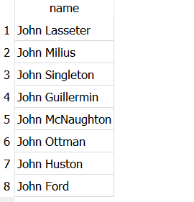

select title
from movies
where (uid % 2 !=0)
and
(vote_count %2 =0 and vote_count>500)


select title
from movies
where (vote_average >6 and vote_average<8 and vote_count = 200)
or
(budget > 100000 and budget < 500000)
