Release Notes Generator - Readme

Release Notes Template Replacement Tags

Anywhere the piece of data in the left column is found in your release notes, replace it with the tag from the column on the right, and the Release Notes Generator will replace the tag with the data collected by the script GUI. When using replacement tags to create a release notes template, it is important that the replacement tag has the same formatting as the text it is replacing.

|  |  |
| --- | --- |
| 2014 | ==YEAR== |
| WEU | ==REGION== |
| September | ==MONTH== |
| Western Europe (WEU) | ==FULL_REGION== |
| 161H0 | ==INITDVN== |
| 161H1 | ==DVN== |
|  |  |

Setup instructions

Decide where you want the Release Notes Generator to reside on your hard drive. The location where the .exe is unzipped will be its default ‘home’ directory. The script will look for a folder in this directory called “templates” where you will store the release notes templates. In addition to the script using the templates folder, it will create a “scratch” folder, and requires a “new_rn” folder. The scratch folder can be ignored as it is just used by the script. The “new_rn” folder is where the generated release notes will appear after running the script.

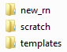

When running the script, a window will pop up where you choose the inputs that will be used as the basis for your release notes. Error messages will pop up if one of the inputs is not selected.

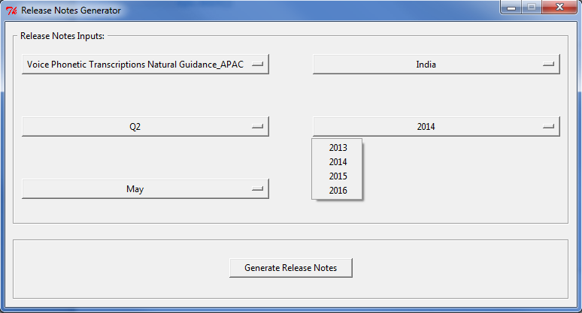

Note: The templates you have in your templates folder will determine the products available to choose from under “Select Product:”

Templates should be named in two ways:

1. Product name only for generic templates. i.e. “3D Landmarks.docx”
2. Product name + underscore + region, for region specific templates. i.e. “3D Landmarks_WEU.docx”.

Note: if you choose a region specific template under “Select Product:”, then the region you choose under “Select Region:” is irrelevant because the script will use the region specific to the template.

Click “Generate Release Notes” when selections have been made. The script will alert you when the release notes have been generated.

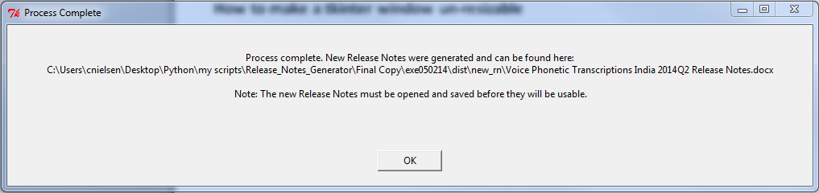

When first opening the newly created release notes, you will have to click through two Word error messages. For example:

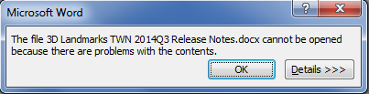

Click OK.

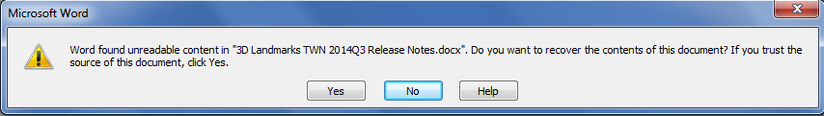

Click Yes.

Once opened, check each page to make sure all template replacements have been completed successfully. Then SAVE the file. Once saved, it can be re-opened without triggering the Word error message shown above.

Use Case: Best Practice

I am using the Release Notes Generator script to generate Q214 release notes for all regions for Voice Phonetic Transcription products. This is the first quarter that the Voice release notes are in the HERE template and are globally standardized .

I started out with two generic templates, one for each product type:

1. Voice Phonetic Transcriptions.docx
2. Voice Phonetic Transcriptions Natural Guidance.docx

As each product delivery date approaches, I usethe generic (non-region specific) templates to quickly create release notes for the current product, quarter, region, year and release month. I then add the relevant stats specific to the region, which can mean expanding or decreasing the size of the stats tables manually based on how many countries there are in the region.

Once the stats tables are added and the release notes are finalized, I create a new region specific template out of the finalized copy, and add this to the templates folder:

1. Voice Phonetic Transcriptions_APAC.docx
2. Voice Phonetic Transcriptions Natural Guidance_APAC.docx

This way, next quarter when I need to create new release notes for this region, I won’t have to copy whole tables or expand/decrease table sizes based on differing numbers of countries in each region. All that is left to do to complete the release notes is update the stats for the current quarter.