Interactive Robot Game
CPSC 3710

By: Eric Mu, Chris Toth, Jayden Stoll, Qi Guo
Introduction
The goal of this project was to create a 3D interactive robot game using OpenGL. There are several different interactions implemented within this project, function keys F1-F3 will turn the robot's head to face forward, right, or left respectively, F4 returns the LookAt view to its default setting, F5-F8 will change the camera to the following positions:
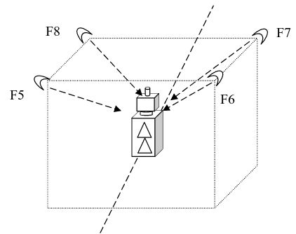
Illustration 1: Camera Binds

Keys F9 to F12 has similar functionality to keys F5-F8 except the camera is further away. The user can push the robot forward using ‘Z’, and turn the robot left using ‘Q’ or right using ‘A’. Pressing ‘P’ will pause the game and pressing ‘R’ returns the robot to the starting position (origin).

Distribution of work
Since we have four members in the group we were able to divide the work as follows:
- Eric: Drawing the streets
- Chris: Drawing the robot
- Jayden: Drawing the buildings
- Qi: Implementing Camera & actions
Of course, every group member contributed in all areas that needed to be implemented and not just their assigned tasks.
Assumptions
The following are assumptions made when implementing the project:
- The offset for each street block is 4 integer units
- The streets are gray for concrete and white for dashed lines
- Each block has a square containing green grass where buildings stand on
- Robot moves at a speed of 0.2 units towards the direction it is facing when pressing z
- The camera follows the robot and resets to default lookAt when moving to maintain consistency
- The antenna for the robot orbits his head rather than spins since it a cylinder

Extras
- The player can exit the game by pressing ‘X’
- The player can choose to toggle between either orthogonal view or perspective view with ‘O’

Challenges
One of the biggest challenges we faced while implementing the game was restricting movement for the robot. Since our street grid is designed to be 4 units apart per block, intuitively it makes sense to only allow the robot to turn if their Z and X location modulo 4 because that would indicate that they are in an intersection. The problem we ran into trying to implement it this way is because the character’s location variable x, y, z are floats, we can’t calculate modulus without first casting the variable to an integer. However, since casting a float to an integer makes the value the floor of the floating point number, the robot was allowed to turn from illegal points (ie. can turn from location X = 4.00 to 4.99 rather than only 4). To solve this we implemented a function which calculates the exact intersection points on the map and compares it with the robots current location and returns true if they are in an intersection. Implementing it in this manner allows the robot to turn at any point inside the intersection rather than only when at the exact point where the dashed lines intersect.
Conclusion
In conclusion, we were able to accomplish the goal of creating an 3D robot game with movement interactions and a variety of camera positions. Some extra changes/improvements that could have been done given more time would be enabling lighting as well as applying textures on the robot, streets, and buildings.

