Battleship Construction and Operations Analysis

We were given the choice to design our own final project or complete the assigned project. I chose the latter, due to the complexity of the problem as well as the chance to undertake an optimization challenge. The overall layout was to design a program that would generate a randomly sized board, place ships at random locations on that board, and then proceed to guess until all ships are sunk. This would then be done 100 times and then recorded for analysis. The structure for my program follows this description above, with three major sections. I first generated a board using a 2D array of nodes. The second sections populates that board with ships of various sizes at random locations. The follow on section was the guess and check portion. Dividing the program into smaller pieces ensured that solving each problem would be manageable.
The first portion of the program was to build a board on which to play battleship. My data structures chosen for this task were a 2D array of a class Node. Each node had specific attributes that could be used for the following sections of the program. These attributes were:

- Private – The
  - ship (string) – This attribute would designate the type of ship.
  - occupy (boolean) – Stores the occupation of the Node, i.e. is there a ship in this space.
  - hit (boolean) – Has this node been hit by a guessing.
  - next (Node*) – The next node connected to the current node.
  - prev (Node*) – The previous node connected to the current node.

- Public – The following allowed access to the private variables.
  - get/set ship
  - get/set occupy
  - get/set hit
  - get/set next
  - get/set prev

Each space in the 2D array was a node allowing all of this information to be stored on each cell. For the implementation I used the rand() function to randomly generate the number of row and columns for the board. Then I created a 2D array of this size and looped through each row and column initializing all values to NULL or 0 along the way. This made the next section of the program considerably easier to implement.
For the second section, the board needed to be populated with ships at random locations. The ship types available were the destroyer (1 space), cruiser (2 spaces), submarine (3 spaces), and the battleship (4 spaces). The main concerns when placing a ship, was collisions, or placing a ship on top of another ship, even distribution of random ship selection and placements, and lastly wrapping a ship around the edges of the board. To deal with the random selection and placement I again used the rand() function, which allowed for sufficient randomness. Collisions were handled by checking if the occupy attribute of a node was empty, and wrapping was dealt with by shrinking the board by the ships size. Because the placement of the ship will always occur from top to bottom or left to right the ship length-1 could be taken from each row and column. For example, if my board is 5X5 and I place a cruiser (2 spaces) then I would place it on a 4X4 board with the last row and column remove to ensure no overlap. For the implementation of these methods I used a double linked list to connect corresponding nodes for ship placement. Using rand(), a random value between 1 and 4 would be generated for which ship to place. Then for that ship a random x and y value would be generated for placement. If the xy value was occupied a new random value would be chosen. If it was not occupied then a random value for orientation, vertical or horizontal placement, would be generated. From here the program checks if the corresponding nodes in the orientation direction are free. For example the battleship would check that the next 3 nodes are free. The other key element is that for the random generated x and y values the options shrink as the ships size increases. For the submarine the row options for placement would shrink by two from the end, thus ensuring no overlap. Finally the amount of ships placed is tracked by how many nodes are occupied on the board. For the game I chose 10% of the board should be occupied by ships. So when this value is reached then the board is set and ready for the final phase.
For the guessing section a random xy value needed to be generated and then checked for occupation. If there was a ship on this node then the ship needed to be checked to see if it had been destroyed or not, and if so remove the ship. Also the value of the guess needed to be stored in order to ensure that it was not done again. This was the most complicated portion of the program. For the guess checking I used a hash table that would allow me to store each guess as the index and a value of 0 or 1. There were 400 total possible guesses for a board that is 20X20, the maximum possible board. This meant that I needed an array length of 400 to store all guesses. To mitigate the complexity of the algorithm I chose to concatenate the guesses. This meant that a guess of (10,3) would become 103. Using this method, there were only about 20 cases for collisions which were easily dealt with. Now the hash table was 2020 elements instead of 400, but because I do not have to iterate over the length of the array the program is considerably faster. The next issue was checking to see if the ship had been destroyed. When the ships were created the corresponding nodes were linked to give the length of the ship. If the guess landed on the middle of the ship it needed to check to the next node and the previous node. I began by moving a temporary node to the beginning of the list using the prev pointer. Then using recursion I checked if each node was hit or not returning an integer value of hits. This was checked against the length of the ship and sunk if all nodes were hit.
The final piece of the program was to write out to a file the board size and number of operations. An operation counter was utilized to keep track of any creating, searching, modifying, and deleting of a data structure. Since the output to the file had to be sorted by number of guesses I needed another data structure to store these values as they were generated. I could sort the values as they came in using a tree or I could store them and then sort them. I chose to store and then sort them using an array of structures. The attributes for the structure are:
- numGuess – Number of guesses needed to sink all ships.
- xSize – Number of rows of the board.
- ySize – Number of columns of the board.
- opCount – Number of operations for the game.

At the end of each game these values for that game were stored in the array. Once all games were finished I used the quick sort algorithm to order the array by number of guesses and then these were printed to a file. The number of operation for the quick sort function were not included in the file as the operations would only be run once. But for analysis purposes, the function on average acts as O(n log(n)) and at worst case is O(n^2). Meaning for an array of 100 elements it will be between 460 – 1000 operations for the sorting and another 400 operation for printing out to the file.
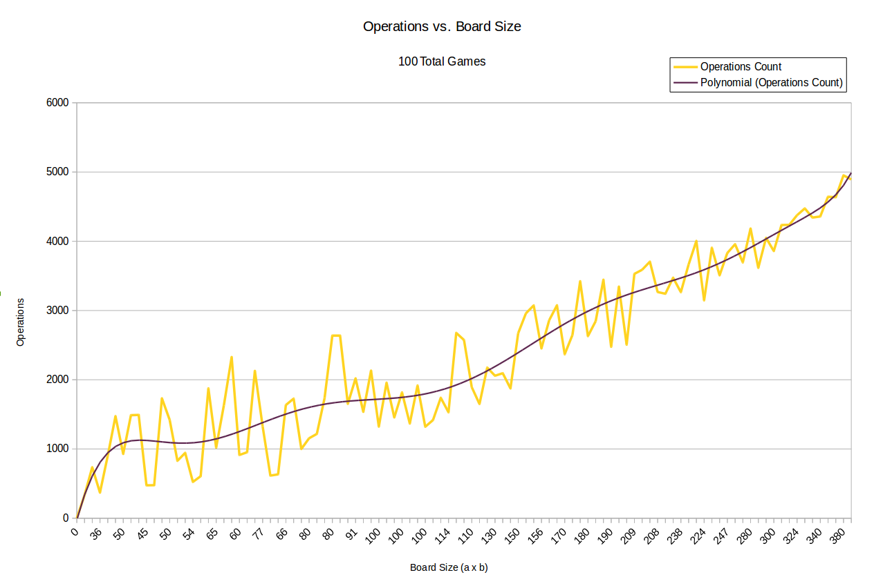
Figure 1: Graph of Operations vs. Board size with a polynomial trend line.

Figure 1 shows the number of operations vs. board size for all 100 games. The operations count hits a high of around 5000 operations for 380 cells. The trend line is a polynomial trend to show how it may be described, but without running this test multiple times it is meaningless and only for showing the trend of the data. The run time for 100 games on my computer was on average 13 ms. This seems to be a fairly optimized implementation, but without comparisons to other algorithms it will be hard to quantify that this is a “fast” program.

