### Christopher Biddle, Craig Fox

### Mr. Patel

### 1/5/2017

### Image Filter Project

# Instructions

To run the program, click the green play button at the top left of the Processing window. A window should pop up. Click the “Load Picture” button at the top right of the window and select the image “Patel.jpg” in the same folder as the program.

Click any of the “Filter Effects” buttons on the right side of the window to alter the image.

To save the image, click the “Save Picture” and choose a destination to save the new photo at.

# Effects

|  |  |
| --- | --- |
| Martian Effect | Code Snippet |

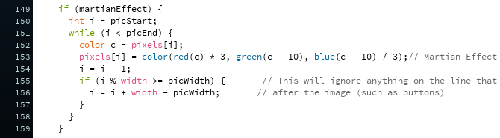

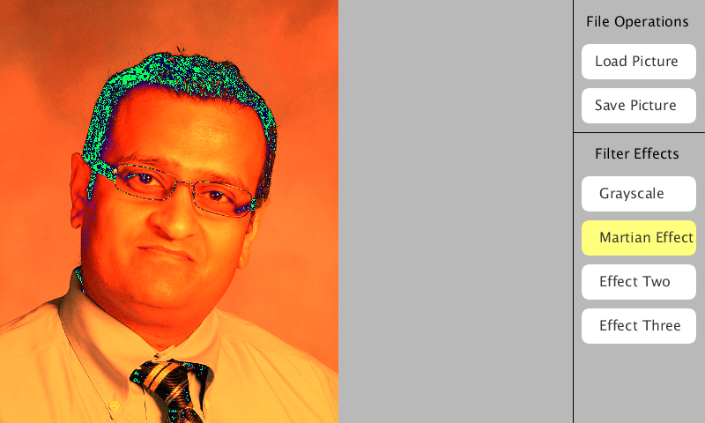Output

The martian effect takes each pixel, seperates its RGB value, and applies a certain effect to each set.

The effect saturates the red part of the pixels by multiplying its value by 3.

It reorders the tenth previous pixel’s green value to be the value of the current pixel. This allows for the blue values in the dark parts of the image to multiply and become a new alien green color in the hair. The effect also changes the background color.

Lastly, the effect reorders the tenth previous pixel’s blue value to be the value of the current pixel. It then divides the blue value by 3. This changes the color of the image by making it a martian orange.

|  |  |
| --- | --- |
| Emphasize Effect | Code Snippet |

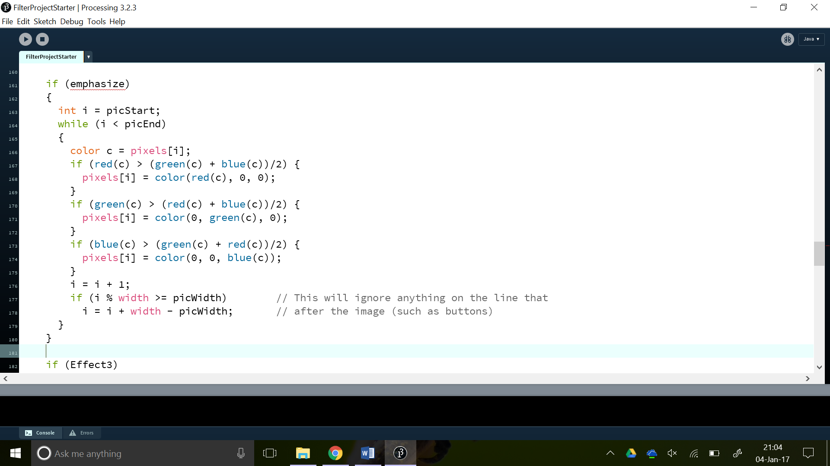

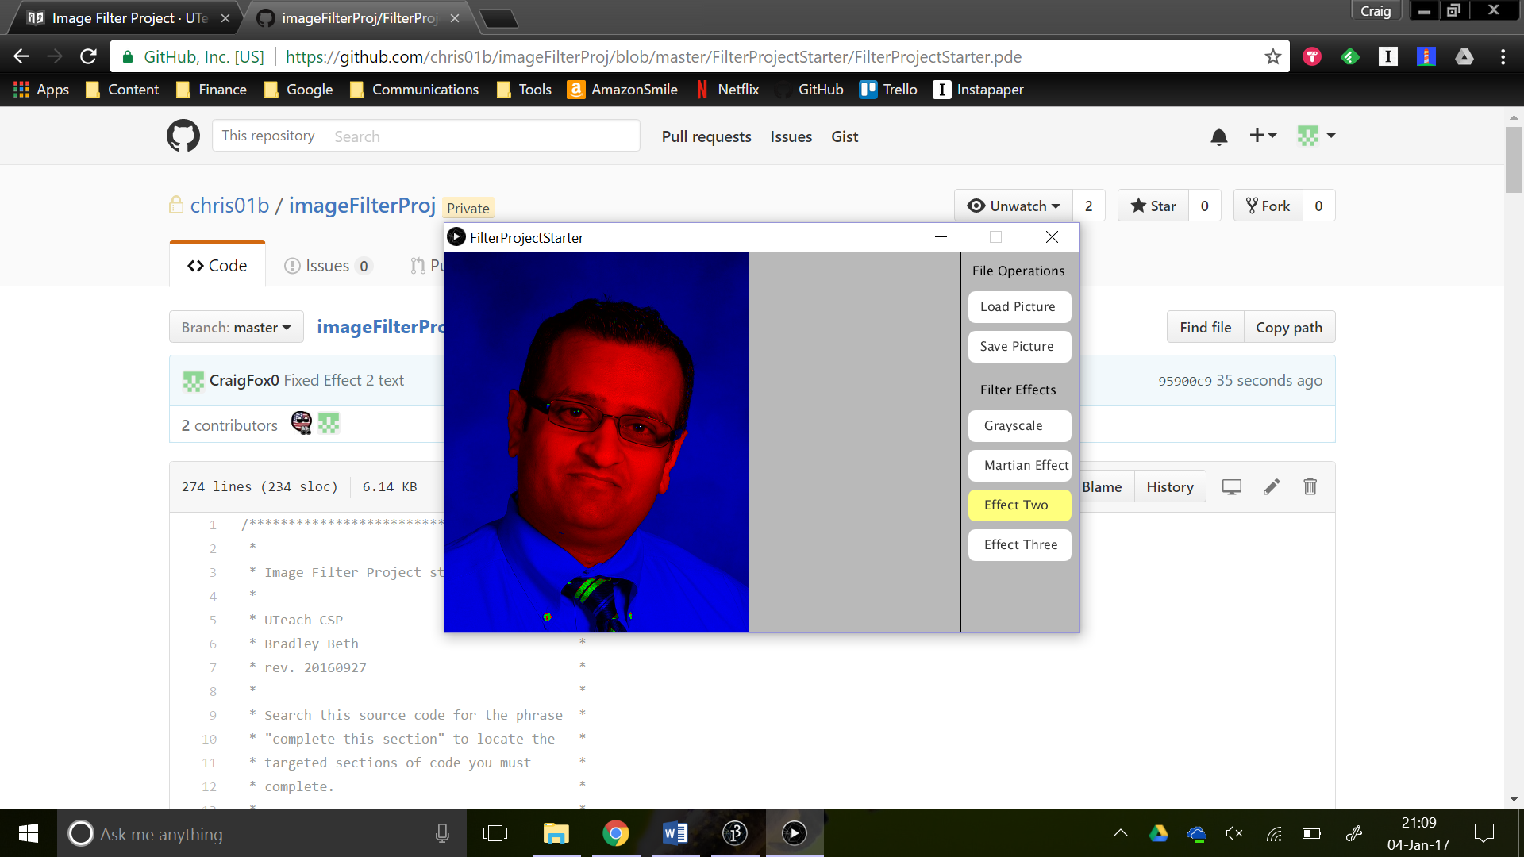Output

The emphasize effect emphasizes either the red, green, or blue in a color.

The emphasize effect will check to see if any pixels have a red, green, or blue value greater than the average of the other two colors.

If they are equal, the current pixel will have a value of 0 for the other two colors.

For example if a pixel has a red value of 234, a green value of 34, and a blue value of 76, the pixel would become (234, 0, 0) because 234 is greater than the average of 34 and 76.

|  |  |
| --- | --- |
| Move Pixels | Code Snippet |

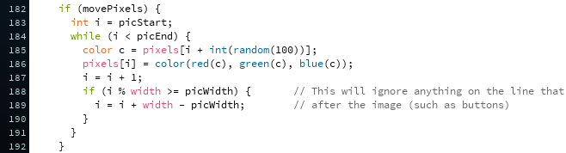

Output

This effect randomly moves the pixels zero to ten places forward every screen refresh.

This is accomplished by putting “i + int(random(10))” inside “pixels[]” on line 185.